Name: OGHAGBON JENNIFER OSATOHANMWNE
Matric no: 17/mhs02/063

Different diagnostic techniques used in pathology

- Immunohistochemistry (IHC)
IHC offers several distinct advantages when compared to traditional identification methods. This technique is rapidly expanding the diagnostic capability of the pathologist.

IHC permits rapid agent identification. The technique employs specific antibodies, which localize to the antigens of the etiologic agent of interest. Since this technique uses formalin-fixed tissues, specimen transport is simplified, allowing retrospective studies and minimizing laboratory worker exposure to infectious agents.

IHC is a sensitive and specific test methodology for many microorganisms, and unlike some traditional staining methods, they result in direct, highly interpretable visual evidence of the presence of an infectious agent within tissues. In addition, IHC detects organisms that are difficult to culture and those that cannot be cultured.

IHC provides invaluable information for clinical diagnosis as well as for the study of pathogenesis. Pathologists have developed many specific IHC assays for emerging or re-emerging infectious diseases. Currently, the Infectious diseases pathology branch (IDPB) has diagnostic IHC assays for more than 100 etiologic agents, including viral, bacterial, parasitic and fungal organisms. For a number of agents, IHC tests may provide the only reliable methods of detection.

- Special Stains
Special stains are useful for detecting bacteria, fungi and parasites in tissues and culture materials. They are processes that generally employ a dye or chemical that has an affinity for the particular tissue component that is to be demonstrated. They allow the presence/or absence of certain cell types, structures and/or microorganisms to be viewed microscopically. However, they may not confer a specific diagnosis of the organism, and each stain differs in its level of sensitivity.

- Molecular tests
In pathology, molecular biological techniques are used to demonstrate qualitative and quantitative changes in human DNA or RNA, as well as for the detection of DNA or RNA of microorganisms in pathologically altered tissues or cells. IDPB currently possesses a battery of PCR-based tests for the detection of many bacteria, viruses, fungi and parasites. IDPB molecular tests have been optimized for formalin-fixed paraffin-embedded tissues.

- Microbiology
Diagnostic microbiology concentrates on the laboratory analysis of clinical specimens in cases when an infectious disease is suspected. For example the diagnosis of staphylococcal infections may involve clinical specimens isolated from humans, animals, or food products, as well as samples collected from the environment. For some cases of unexplained illness, IDPB possesses limited capability for viral culture of etiologic agents. This technique is dependent on freshly frozen tissues or body fluids and permits additional studies such as immunofluorescence methods or electron microscopy.

- Electron Microscopy
Clinical Electron Microscopy (EM) is a powerful diagnostic tool used to assist in the diagnosis of Kidney Disease, Muscle Disorders, Neurological Disorders, Ciliary Dysfunction, Viral Gastroenteritis, Viral Infections or any disorder that may benefit from the analysis of the fine structures of a biopsy. Electron microscopy (EM) studies are conducted on cell cultures, tissues and body fluids. Both thin section and negative stain EM are available to assist in the diagnosis and characterization of pathogens. EM examination is conducted on glutaraldehyde fixed tissues or bodily fluids, formalin-fixed paraffin-embedded tissue blocks, prepared EM sections, images and grids.

Cellular adaptation precedes cell death
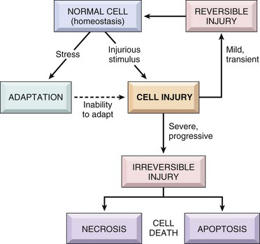
Fig 1.

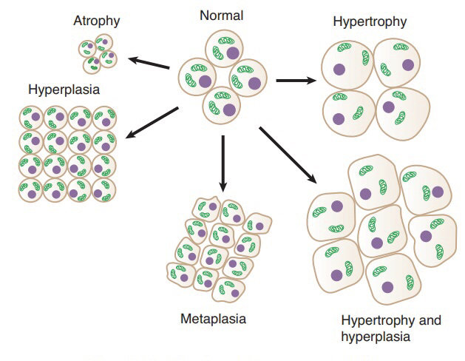
Cellular adaptation is the ability of cells to respond to various types of stimuli and adverse environmental changes. These adaptations include hypertrophy (enlargement of individual cells), hyperplasia (increase in cell number), atrophy (reduction in size and cell number), metaplasia (transformation from one type of epithelium to another), and dysplasia (disordered growth of cells). Tissues adapt differently depending on the replicative characteristics of the cells that make up the tissue. For example, labile tissue such as the skin can rapidly replicate, and therefore can also regenerate after injury, whereas permanent tissue such as neural and cardiac tissue cannot regenerate after injury. If cells are not able to adapt to the adverse environmental changes, cell
Fig 2.
death occurs physiologically in the form of apoptosis, or pathologically, in the form of necrosis.

1) Atrophy
- definition: decrease in the amount of a tissue or organ after normal growth has been attained.It is the adaptive response whereby a tissue or organ undergoes a reduction in mass (size), due to a decrease in the size and/or number of cells.
a) Etiology
- can be physiologic, eg postpartum uterine & mammary gland involution.
- can be pathologic, eg decreased workload (disuse atrophy), loss of innervation (denervation atrophy), loss of hormonal (trophic) stimulation, reduced blood supply / hypoxia, inadequate nutrition, compression (by tumors, etc) persistent cell injury, aging (senile atrophy).
- atrophic cells are not dead or necessarily badly injured but they have a reduced functional capacity (note, may progress to cell injury / death if stimulus persists or worsens).
- retain ability to control their internal environment and produce enough energy to survive.
- given "enough time" and removing the reason for cellular atrophy, the cells can return to 'normal'.
b) Mechanisms and Biochemistry
- decreased amount of substance produced within cell, ie catabolic processes exceed anabolic processes. eg: with muscle atrophy (due to denervation atrophy or disuse atrophy) : myofilaments, mitochondria, endoplasmic reticulum, metabolic activity.
- organelles removed by autophagocytosis and decreased proteins by ubiquitin-proteosome pathway.
- cell shrinks in volume and shuts downs its differentiated functions; decreases its energy requirements.
c) Gross Appearance- tissue/organ is decreased in size.
d) Microscopic Appearance- cells are smaller than normal eg
- endocrine gland, following decreased trophic stimulation
- physiologic: uterus/breast atrophy with decreased hormonal stimulus following pregnancy / lactation
- pathologic: loss of trophic hormone production due to pituitary destruction or reduced trophic hormone production (eg ACTH) due to medical supplementation of a hormone (eg corticosteroid)
- starvation, results in atrophy of fat (eg serous atrophy of fat) and various other tissues (eg muscle, liver).
- there is a definite sequence in which body proteins are broken down during starvation in order to preserve the blood glucose level (via glucogenic amino acids): first digestive enzymes of the gastrointestinal tract and pancreas & various hepatic enzymes that normally process incoming nutrients from the intestine; later, muscle proteins.
- there is a sequential use (& loss) of muscle mass as an endogenous sources of protein and energy; postural muscles (eg supraspinatus) are preserved at the expense of other muscles (eg longissimus dorsi) that are used for locomotion.
- there is also a sequential mobilization of fat depots; in most terrestrial mammals, subcutaneous fat is used first, visceral fat is used next and bone marrow fat is used last.

2) Hypertrophy
- definition: organs are increased in size due to an increase in cell size without cellular proliferation.
- in organs / tissues which have minimal proliferative capacity (cardiac and skeletal muscle) see only hypertrophy, whereas in tissues / organs with cells capable of division see both hypertrophy and hyperplasia.
a) Etiology
- a response to increased work load:
-physiologic: eg with exercise see increase in muscle cell size (grossly muscles increase in size). -pathologic: eg heart failure enlargement of myocardial fibers (grossly heart increases in size).
- a response to trophic signals:
-physiologic hypertrophy (& hyperplasia), eg uterus and mammary gland during pregnancy / lactation.
-pathological hypertrophy, eg myocardial hypertrophy in hyperthyroid cats.
- response to certain drugs or toxins: increased SER in liver (organelle hypertrophy) with phenobarbital.
b) Mechanisms and Biochemistry
- anabolic processes exceed catabolic ones (ie, increased synthesis of cellular constituents).
- increase in organelles / total cellular proteins: mitochondria, endoplasmic reticulum, myofibrils.
- may not always be advantageous (eg myocardial hypertrophy can exceed the limits of vascular supply).
c) Gross Appearance: tissue / organ increased in size / weight.
d) Microscopic Appearance
- cellular enlargement due to a proportional increase in the number and size of organelles.
- must be distinguished from cellular swelling, which is due to an increased intake of fluid by the cell.
3) Hyperplasia
- increase in organ size or tissue mass caused by an increase in the number of constituent cells.
- hypertrophy and hyperplasia are not mutually exclusive and are often seen together in structures which can undergo division (esp reproductive and endocrine organs).
- Pathological hyperplasia if typically the result of excessive endocrine stimulation.
- Hyperplasia is often a predisposing condition to neoplasia.
- Physiological hyperplasia
-Estrogenic stimulation of the endometrium during the menstrual cycle
-Reactive bone marrow hyperplasia in hemolytic anemias
- Pathological hyperplasia
-Endometrial hyperplasia due to excess estrogen stimulation → can progress to dysplasia and cancer
4) Metaplasia
Metaplasia is a “reversible” change in which tissue transforms from one type of epithelium into another (e.g., squamous metaplasia).
• Metaplasia is a cellular adaptation in which indigenous cells are replaced by cells that are better suited to tolerate a specific abnormal environment.
• Because of metaplasia, normal protective mechanisms may be lost.
• Persistence of signals that result in metaplasia often lead to neoplasia.
-Physiological metaplasia: cervical ectopy.
-Pathological metaplasia
- Occurs as a response to chronic chemical or physical stimuli.
- May completely regress or lead to malignant transformation (considered precancerous).
Examples
-Intestinal metaplasia (Barrett metaplasia).
-Squamous metaplasia of the bronchi due to smoking → ciliated pseudo-stratified columnar epithelium is replaced by stratified squamous epithelium.
-Squamous metaplasia of the bladder due to Schistosoma infection, urinary calculi, or indwelling catheters.
5) Dysplasia
- Disordered growth of epithelium (abnormally frequent mitotic figures, loss of cell orientation, size, and shape).
- Precancerous: can progress to carcinoma in situ.
- Examples: congenital dysplasia and acquired dysplasia.
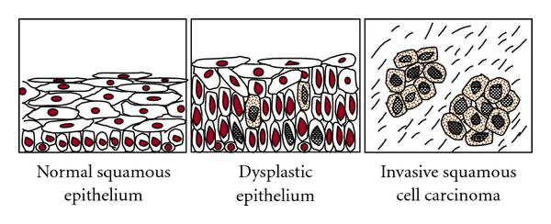
Fig 3.

Cell injury
- Cells actively control the composition of their immediate environment and intracellular milieu within a narrow range of physiological parameters (“homeostasis”)
- Under physiological stresses or pathological stimuli (“injury”), cells can undergo adaptation to achieve a new steady state that would be compatible with their viability in the new environment.
- If the injury is too severe (“irreversible injury”), the affected cells die. (See fig 1)

Causes of cell injury
1) Hypoxia (Oxygen Deficiency)
- one of the most important and common causes of cell injury and cell death.
- hypoxia causes impairment of oxidative respiration, ie it interferes with energy production.
- occurs with:
a) Deficient blood supply
- ischemia = deficiency of blood supply from impeded arterial flow or reduced venous drainage = hypoxia + decreased delivery of nutrients and decreased removal of metabolites.
- cells may adapt to mild ischemia (eg muscle atrophy) or die with severe ischemia.
- infarction = localized area of ischemic necrosis.
b) Reduced oxygen-carrying capacity of the blood
- due to anemia = reduction in numbers or volume of erythrocytes or quantity of hemoglobin (Hb).  due to Hb dysfunction, eg methaemoglobinemia - nitrate / nitrite poisoning, carboxyhaemoglobinemia - carbon monoxide poisoning.
c) Interference with respiratory chain / oxidative phosphorylation
eg, cyanide poisoning inactivates cytochrome oxidase in mitochondria blocks oxidative phosphorylation.

2) Physical agents
- severity of a physical injury may be increased by tissue hypoxia due to associated local vascular injury.
a) Direct mechanical trauma - lacerations or crush injuries.
b) Temperature extremes - heat (thermal burn), cold (frostbite).
c) Radiation - radioactive isotope emissions or electromagnetic radiation (eg UV light, x-rays).
d) Electrocution - pets chewing electric cords, faulty wiring in barns, lightning strike, etc.
e) Sudden changes in atmospheric pressure - marine mammals have mechanisms to mostly avoid the “bends”.

3) Chemicals, Drugs & Toxins
a) Inorganic poisons - eg lead, copper, arsenic, selenium, mercury, etc.
b) Organic poisons - eg nitrate/nitrite, oxalate, hydrocyanic acid, etc.
c) Manufactured chemicals - eg drugs (overdose / idiosyncratic), pesticides, herbicides, rodenticides, etc.
d) Physiologic compounds - eg salt, glucose, oxygen, etc.
e) Plant toxins - eg ragwort, sweet clover, braken fern, etc.
f) Animal toxins - eg snake or spider venom, tick toxin, etc.
g) Bacterial toxins / Mycotoxins - eg botulinum toxin, aflatoxin, ergot, etc

4) Infectious agents (such important causes of disease, you have individual courses to study them in detail!)
a) Viruses
b) Bacteria / rickettsiae / chlamydia
c) Fungi
d) Protozoa
e) Metazoan parasites

5) Immunologic Reactions
a) Immune response - eg cells damaged as “innocent bystanders” in immune / inflammatory response.
b) Hypersensitivity (allergic) reactions - eg anaphylactic reaction to a foreign protein or drug.
c) Autoimmune diseases - reactions to self-antigens.

6) Genetic abnormalities
a) Cytogenetic disorders / chromosomal aberrations - one cause of congenital anomalies.
b) Mendelian disorders (mutant genes)
- enzyme defects, eg lysosomal storage disease.
- structural / transport protein defects - eg collagen dysplasia, cystic fibrosis, sickle cell anemia, etc.
c) Multifactorial inheritance - combined effects of environmental factors and 2 or more mutated genes (eg neoplasia, hypertension, coronary artery disease, etc).

7) Nutritional imbalance
a) Deficiencies - deficiencies of protein-calories (starvation), vitamins (A to E), minerals (eg copper).
b) Overnutrition - eg excess lipids / calories  obesity, diabetes, atherosclerosis, etc.

8) Workload Imbalances
a) Overworked cells - cell injury occurs if stimulus prolonged and/or exceeds ability to adapt.
b) Underworked cells - prolonged lack of stimulation (eg disuse, denervation, lack of trophic hormones) can lead to atrophy and eventually the loss of cells.

9) Cell Aging
-the cumulative effects of a life time of cell damage (chemical, infectious, nutrition, etc) leads to a diminished capacity of aged cells / tissues to maintain homeostasis and adapt to harmful stimuli.

Mechanisms of Cell Injury:
- General Principles
• Cell response to injury is not an all-or-nothing phenomenon.
• Response to a given stimulus depends on the type, status, and genetic make-up of the injured cell.
• Cells are complex interconnected systems, and single local injuries can result in multiple secondary and tertiary effects.
• Cell function is lost far before biochemical and subsequently morphological manifestations of injury become detectable.
a) the cellular response to injurious stimuli is dependent on the type of injury, its duration and its severity. eg, low doses of toxins or brief durations of ischemia may lead to reversible cell injury, whereas larger toxin doses or longer ischemic intervals may result in irreversible injury / cell death.
b) consequences of an injurious stimulus are dependent on the type of cell injured and its current status, ie nutritional, hormonal, metabolic, oxygen requirement, etc.
c) 4 intracellular systems are particularly vulnerable to injury.
- cell membranes - especially ionic / osmotic homeostasis.
- mitochondria - oxidative phosphorylation / ATP production.
- protein synthesis, folding and packaging - structural and functional proteins.
- genetic apparatus - DNA / RNA.
d) interrelationship of structural and biochemical elements means that damage at one focus leads to wide-ranging secondary effects.
eg, impairment of aerobic respiration (eg decreased O2 or mitochondrial damage) -> disruption of the energy-dependent membrane sodium pump -> ionic and fluid imbalance -> cell swelling.

2) Biochemical Mechanisms
• Several molecular / biochemical sites are commonly damaged by a variety of inciting causes.
- Loss of energy (ATP depletion, O2 depletion).
- Mitochondrial damage.
- Loss of calcium homeostasis.
- Defects in plasma membrane permeability.
- Generation of reactive oxygen species (O2 , H2O2, OH•) and other free radicals.

- ATP depletion
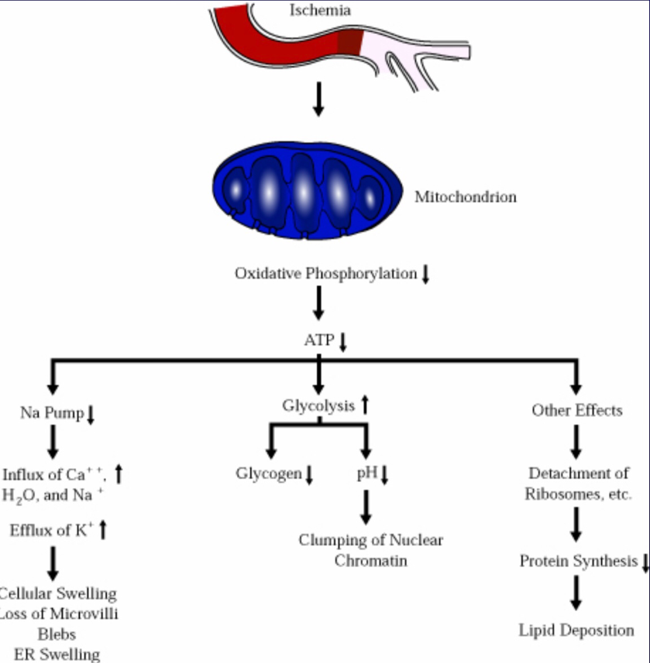
-ATP depletion and decreased ATP synthesis are common consequences of both ischemic and toxic injury.
-Increased AMP activates phosphofructokinase & phosphorylase -> increased anaerobic glycolysis -> depletion of glycogen stores -> increased lactic acid & [Pi] -> decreased intracellular pH -> impaired cell enzyme activity.
-ATP required for membrane transport (Na+/K+ & Ca2+ pumps) / osmotic balance, protein synthesis, protein stability (proper folding), lipogenesis, etc.
-Cells with greater glycolytic capacity (eg liver cells) have an advantage over cells which are more reliant on oxidative phosphorylation (eg neurons).

- Mitochondrial damage
-All cells depend on oxidative metabolism for long term survival, regardless of glycolytic ability.
- Irreparable damage to mitochondria, directly or indirectly, will ultimately kill cells.
- Directly by certain toxins (eg cyanide) or indirectly (decreased O2, increased cytosolic Ca2+ , free radicals/lipid peroxidation, etc).
- Severe injury results in critical mitochondrial damage / dysfunction -> necrosis.
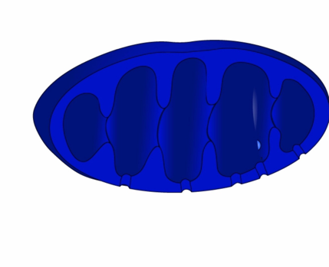
- More mild / subtle injury results in channels in mitochondrial membrane (ie nonselective pore called mitochondrial permeability transition pore = MPTP) which leads to leakage of cytochrome c (and other components) into cytosol -> triggers apoptosis.

- Intracellular calcium and loss of calcium homeostasis
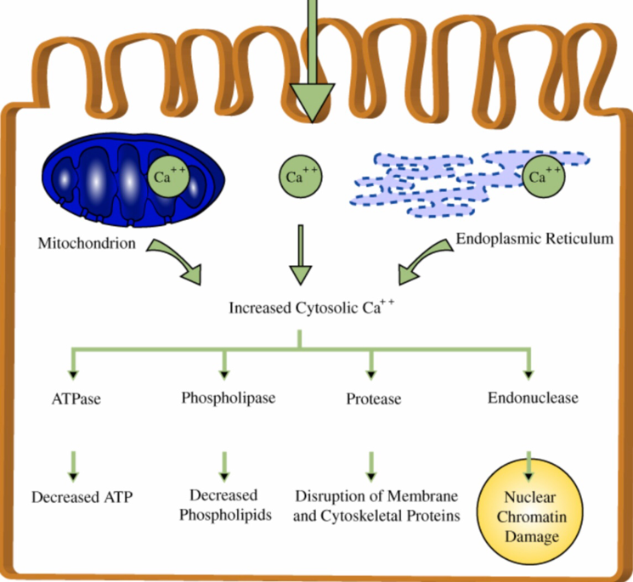
-Cytosolic free Ca2+ is at low concentration compared to extracellular Ca2+ (1:104) due to energy-dependent pumps and sequestration within mitochondria and ER.
-Membrane damage / ischemia or certain toxins cause increased cytosolic [Ca2+] due to influx from ECF / ER / mitochondria.
-Increased cytosolic [Ca2+] causes cell injury by several pathways:
i) activation of deleterious enzymes, eg ATPases (ATP depletion), phospholipases (membrane damage), proteases (breakdown of membrane & cytoskeletal proteins), endonuclease (DNA / chromatin damage).
ii) increases mitochondria permeability, eg opening MPTP (mitochondrial permeability transition pore).
iii) induces apoptosis by directly activating caspases.

- Defects in membrane permeability
- Damage to membranes often critical; eg plasma membrane (eg loss of osmotic balance), lysosomes (leakage of digesting enzymes), mitochondria (no energy / apoptosis), ER (decreased protein production), etc.
-Indirect damage, eg ATP depletion & Ca2+ activation of phospholipases / proteases / etc.
-Direct damage, eg free radicals, physical / chemical agents, bacterial toxins, viruses, lytic complement components, cytotoxic lymphocyte perforins, etc.

- Free radical induced injury (Oxidative Stress)
-Free radicals are chemical species with a single unpaired electron in outer orbit (donate or steal electrons, extremely unstable); readily react with organic or inorganic chemicals, avidly attack/degrade membranes, proteins & nuclei acids.
-Free radical-induced injury, particularly that induced by activated oxygen species, is an important mechanism of cell damage in many disease processes (chemical, radiation, O2 toxicity, inflammation, reperfusion, etc).
- Cell injury occurs when the free radical generation overwhelms antioxidant defense mechanisms.

3) Chemical (Toxic) Injury
Chemicals and certain drugs / toxins produce damage in one of two general ways.
a) Direct interaction
Some chemicals act directly by damaging particular organelles or critical cell molecules.
- eg cyanide -> damages mitochondrial cytochrome oxidase -> blocks oxidative phosphorylation.
- eg fluoroacetate -> converted to fluorocitrate -> prevents citrate from being used in the citric acid cycle.
b) Conversion to reactive toxic metabolites
-Toxic metabolites usually produced by cytochrome P-450 mixed function oxidase (MFO) in the SER of liver.
-Toxic metabolites can be in the form of reactive free radicals (see previous discussion) or adducts (ie
chemicals that form strong covalent bonds with cell molecules, thus damaging them).
-Since liver is a major site of chemical modification of drugs and toxins, it is therefore particularly susceptible to drug / toxin-induced injury.

- Acetaminophen (Tylenol) Toxicity
-In humans & dogs most acetaminophen is detoxified in liver to glucuronide and sulfate conjugates which are then excreted in the urine; only small amounts converted to highly reactive metabolite NAPQI by P450 MFO.
-Cats are relatively deficient in glucuronyl transferase and a large portion of acetaminophen is metabolized to NAPQI, which is electrophilic binds to molecules in hepatocytes (ie adduct formation) and causes necrosis.
-Additionally cats & dogs (compared to humans) produce relatively more of the metabolite para-aminophenol, which is released from the liver cells and results in oxidative damage to hemoglobin (ie methemoglobinemia).

- Carbon Tetrachloride (CCl4) Toxicity
-CCl4 metabolized by P450 MFO enzyme system on the SER of the hepatocyte (CCl4 + e -> CCl3 + Cl). – CCl3 is highly reactive and causes lipid peroxidation (autocatyzing) -> see severe and rapid membrane destruction -> decreased protein synthesis (30 min); ER swelling & ribosomal dissociation (2 hrs).

Morphology of cell injury and necrosis
- Gross morphologic changes usually require hours to develop, ie no sign of myocardial necrosis if an animal dies immediately from a myocardial infarct (however a thrombus would be evident in a coronary artery!)
- in general:
i) cell swelling (reversible injury)
- Can start within minutes of the initial insult.
- Note, loss of function is also rapid, eg heart muscle stops contracting with 60 sec of coronary occlusion.
ii) cell death (irreversible injury)
- eg can occur in the myocardium within 20 to 60 min of coronary artery occlusion.
- Biochemical changes (eg creatine kinase, troponins) within minutes & EM changes within few hrs.
- LM changes in 4 to 12 hrs and gross changes not apparent for 12 to 24 hrs after initial insult.
- The critical transition point to irreversible injury is not known; however two features consistently characterize irreversibility (ie “point of no return” or “lethal hit”):
- inability to reverse mitochondrial dysfunction.
-profound disturbances of membrane function.

I. Reversible Cell Injury
- two main types of reversible cell injury are recognized by LM -> cellular swelling and fatty change.
1) Cellular Swelling
a) Etiology / Pathogenesis of Cellular Swelling
-Early and almost universal manifestation of cell injury.
-Due to loss of ion and fluid homeostasis.
b) Gross Appearance of Cellular Swelling
-Organ swollen with rounded edges, tissue may show slight palor.
-Cut surface: tissue bulges and can not be easily put in correct apposition, heavy.

2) Fatty Change
a) Etiology / Pathogenesis of Fatty Change
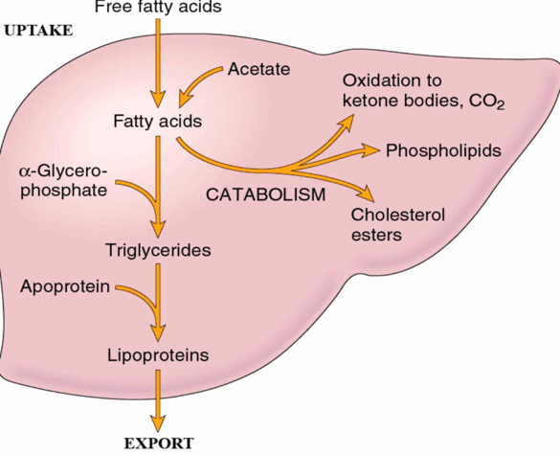
-Occurs in various forms of injury (eg hypoxic, toxic, metabolic).
-Abnormal accumulation of lipids within the cell (ie: intracellular).
-Mainly in cells dependent on fat metabolism, eg liver, less in renal tubular epithelium and myocardium.
-Seen in abnormalities of uptake, utilization (metabolism) and/or mobilization (export) of fat.
-May be an expression of cell injury or a stage of injury in cells that are destined to die.
-May be preceded or accompanied by cell swelling.

II. Irreversible Cell Injury
1) Necrosis
- Term used to describe the range of morphologic changes that occur following cell death in living tissue.
- The morphologic appearance is due to 2 concurrent processes:
a)Denaturation of proteins (ie nonproteolytic structural alteration in 2o or 3o structure).
b) enzymatic digestion of the cell:
- endogenous enzymes derived from the lysosomes of the dying cells = autolysis (self digestion).
- lysosomes of immigrant leukocytes = heterolysis.
- Note, the term autolysis is also often used to describe the changes that occur in all of the cells after an animal has died; however the proper term is postmortem autolysis or postmortem decomposition.
- A mass of necrotic tissue may exhibit distinctive morphologic patterns depending on whether enzyme catabolism or protein denaturation predominates.

2) Apoptosis
a) Definition (derived from the Greek = “falling off”)
- Death of single cells as a result of activation of a genetically programmed "suicide" pathway.
- Differentiating from necrosis is important, in that necrosis indicates widespread tissue injury due to severe pathologic stimuli, while apoptosis indicates selective elimination of cells, due to either physiologic or specific pathologic stimuli.
- Apoptosis involves death of single cells (or small clusters) with intact cell membranes and rapid removal by phagocytosis with little inflammation, while necrosis involves locally extensive areas with loss of cell membrane integrity, enzymatic digestion and an inflammatory response
- Note, intermediate / hybrid forms of cell death exist that share aspects of necrosis & apoptosis (necroptosis).

Conclusion
For a normal cell to maintain homeostasis it has to adapt to environmental factors which cause it to change is shape size and number to do so. If such stimulus is harmful or if the cell is unable to adapt, cell injury occurs. It can be either reversible; meaning the cell would return back to normal or irreversible; meaning the cell would die. Cell death can be physiological in apoptosis which is programmed cell death, or pathological in necrosis which is death due to tissue injury.

