Name: Edidiong Joseph Eyo
Matric No: 17/Mhs02/040
Course no: NSC 308

- Diagnostic Techniques used in pathology

- Histopathological techniques
Histopathological examination studies tissues under the microscope. During this study, the pathologist looks for abnormal structures in the tissue. Tissues for histopathological examination are obtained by biopsy. Biopsy is a tissue sample from a living person to identify the disease. Biopsy can be either incisional or excisional. Once the tissue is removed from the patient, it has to be immediately fixed by putting it into adequate amount of 10% Formaldehyde (10% formalin) before sending it to the pathologist. The purpose of fixation is:
- to prevent autolysis and bacterial decomposition and putrefaction
- to coagulate the tissue to prevent loss of easily diffusible substances
- to fortify the tissue against the deleterious effects of the various stages in the preparation of sections and tissue processing.
- to leave the tissues in a condition which facilitates differential staining with dyes and other reagents.
Once the tissue arrives at the pathology department, the pathologist will exam it macroscopically (i.e. naked-eye examination of tissues). Then, the tissue is processed to make it ready for microscopic examination. The whole purpose of the tissue processing is to prepare a very thin tissue (i.e. five to seven μm or one cell thick tissue) which can be clearly seen under the microscope. The tissue is processed by putting it into different chemicals. It is then impregnated (embedded) in paraffin, sectioned (cut) into thin slices, & is finally stained. The stains can be Hematoxylin/Eosin stain or special stains such as PAS, Immunohistochemistry, etc. The Hematoxylin/Eosin stain is usually abbreviated as H&E stain. The H&E stain is routinely used. It gives the nucleus a blue color & the cytoplasm & the extracellular matrix a pinkish color. Then the pathologist will look for abnormal structures in the tissue. And based on this abnormal morphology he/she will make the diagnosis. Histopathology is usually the gold standard for pathologic diagnosis.
- Molecular techniques
All the DNA/RNA-based molecular techniques employ hybridization (meaning joining together) technique based on recombinant technology. Specific region of DNA or RNA is detected by labelling it with a probe (Probe is a chain of nucleotides consisting of certain number of known base pairs). Probes are of different sizes and sources as under:
- Genomic probes derived from a region of DNA of cells.
- cDNA probe derived from RNA by reverse transcription.
- Oligonucleotide probe is a synthetic probe contrary to genomic DNA and cDNA probe both of which are derived from cellular material.
- Riboprobe is prepared by in vitro transcription system.

MOLECULAR METHODS
Following is a brief account of various molecular techniques available as diagnostic tool in surgical pathology:
A.) IN SITU HYBRIDISATION. In situ hybridization (ISH) is a molecular hybridization technique which allows localization of nucleic acid sequence directly in the intact cell (i.e. in situ) without DNA extraction unlike other hybridization-based methods described below. ISH involves specific hybridization of a single strand of a labelled nucleic acid probe to a single strand of complementary target DNA or RNA in the tissue. The end-product of hybridization is visualized by radioactive- labelled probe (32P, 125I), or non-radioactive-labelled probe (e.g. biotin, digoxigenin).
Applications. ISH is used for the following:
i) In viral infections e.g. HPV, EBV, HIV, CMV, HCV etc.
ii) In human tumors for detection of gene expression and oncogenes.
iii) In chromosomal disorders, particularly by use of fluorescent in situ hybridization (FISH).
B.) FILTER HYBRIDISATION. In this method, target DNA or RNA is extracted from the tissue, which may either be fresh, frozen and unfixed tissue, or formalin-fixed paraffin- embedded tissue. Extracted target DNA or RNA is then immobilized on nitrocellulose filter or nylon. Hybridization of the target DNA is then done with labelled probe. DNA analysis by filter hybridization includes various methods as under:
i) Slot and dot blots in which the DNA sample is directly bound to the filter without fractionation of nucleic acid size. ii) Southern blot which is similar to dot-blot but differs in performing prior DNA-size fractionation by gel electrophoresis (E.M. Southern is the name of scientist who described Southern blot technique).
iii) Northern blot is similar to Southern blot but involves size fractionation of RNA (Northern is, however, opposite direction of southern and not someone’s name).
iv) Western blot is analogous to the previous two methods but is employed for protein fractionation; in this method antibodies are used as probes.
Applications. In view of high degree of specificity and sensitivity of the molecular hybridization techniques, these techniques have widespread applications in diagnostic pathology:
i) In neoplasia, hematologic as well as non-hematologic.
ii) In infectious diseases for actual diagnosis of causative agent, epidemiologic studies and identification of newer infectious agents.
iii) In inherited genetic diseases for carrier testing, prenatal diagnosis and direct diagnosis of the genetic disease.
iv) In identity determination for tissue transplantation, forensic pathology, and parentage testing.
C.) POLYMERASE CHAIN REACTION. Polymerase chain reaction (PCR) is a revolutionary technique for molecular genetic purpose with widespread applications in diagnostics and research. The technique is based on the principle that a single strand of DNA has limitless capacity to duplicate itself to form millions of copies. In PCR, a single strand of DNA generates another by DNA polymerase using a short complementary DNA fragment; this is done using a primer which acts as an initiating template.

A cycle of PCR consists of three steps:
i) Heat denaturation of DNA (at 94°C for 60-90 seconds).
ii) Annealing of the primers to their complementary sequences (at 55°C for 30-120 seconds).
iii) Extension of the annealed primers with DNA polymerase (at 72°C for 60-180 seconds).
Repeated cycling can be done in automated thermal cycler and yields large accumulation of the target sequence since each newly generated product, in turn, acts as template in the next cycle.
Applications: PCR analysis has the same applications as for filter hybridization techniques and has many advantages over them in being more rapid, can be automated by thermal cyclers and requires much lower amount of starting DNA. However, PCR suffers from the risk of contamination; thus extreme caution is required in the laboratory during PCR technique.
- Cytopathologic techniques
Cytopathology is the study of cells from various body sites to determine the cause or nature of disease.
Cytopathologic methods
There are different cytopathologic methods including:
- Fine-needle aspiration cytology (FNAC)
In FNAC, cells are obtained by aspirating the diseased organ using a very thin needle under negative pressure. Virtually any organ or tissue can be sampled by fine-needle aspiration. The aspirated cells are then stained & are studied under the microscope. Superficial organs (e.g. thyroid, breast, lymph nodes, skin and soft tissues) can be easily aspirated. Deep organs, such as the lung, mediastinum, liver, pancreas, kidney, adrenal gland, and retroperitoneum are aspirated with guidance by fluoroscopy, ultrasound or CT scan. FNAC is cheap, fast, & accurate in diagnosing many diseases.

- Exfoliative cytology
Refers to the examination of cells that are shed spontaneously into body fluids or secretions. Examples include sputum, cerebrospinal fluid, urine, effusions in body cavities (pleura, pericardium, peritoneum), nipple discharge and vaginal discharge.

- Abrasive cytology
Refers to methods by which cells are dislodged by various tools from body surfaces (skin, mucous membranes, and serous membranes). E.g. preparation of cervical smears with a spatula or a small brush to detect cancer of the uterine cervix at early stages. Such cervical smears, also called Pap smears, can significantly reduce the mortality from cervical cancer. Cervical cancer is the most common cancer in Ethiopian women.

Applications of cytopathology
The main applications of cytology include the following:
- Screening for the early detection of asymptomatic cancer
For example, the examination of scrapings from cervix for early detection and prevention of cervical cancer.

- Diagnosis of symptomatic cancer
Cytopathology may be used alone or in conjunction with other modalities to diagnose tumors revealed by physical or radiological examinations.
It can be used in the diagnosis of cysts, inflammatory conditions and infections of various organs.

- Surveillance of patients treated for cancer
For some types of cancers, cytology is the most feasible method of surveillance to detect recurrence. The best example is periodic urine cytology to monitor the recurrence of cancer of the urinary tract.

Advantages of cytologic examination
Compared to histopathologic technique it is cheap, takes less time and needs no anesthesia to take specimens. Therefore, it is appropriate for developing countries with limited resources like Ethiopia. In addition, it is complementary to histopathological examination.
- CYTOGENETICS
Karyotyping
Karyotype is defined as the sequence of chromosomal alignment on the basis of size, centromeric location and banding pattern.
Determination of karyotype of an individual is an important tool in cytogenetic analysis. Broad outlines of karyotyping are as under:
- Cell selection. Cells capable of growth and division are selected for cytogenetic analysis. These include: cells from amniotic fluid, chorionic villus (CVS) sampling, peripheral blood lymphocytes, bone marrow, lymph node, solid tumors etc.
- Cell culture. The sample so obtained is cultured in mitogen media. A mitogen is a substance which induces mitosis in the cells e.g. PPD, phytohemagglutinin (PHA), pokeweed mitogen (PWM), phorbol ester etc. The dividing cells are then arrested in metaphase by the addition of colchicine or colcemid, both of which are inhibitory to microtubule formation. Subsequently, the cells are lysed by adding hypotonic solution. The metaphase cells are then fixed in methanol-glacial acetic acid mixture.
- Staining/banding. When stained, chromosomes have the property of forming alternating dark and light bands. For this purpose, fixed metaphase preparation is stained by one of the following banding techniques:
a) Giemsa banding or G-banding, the most commonly used.
b) Quinacrine banding or Q-banding used to demonstrate bands along chromosomes.
c) Constitutive banding or C-banding is used to demonstrate constitutive heterochromatin.
d) Reverse staining Giemsa banding (or R-banding) gives pattern opposite to those obtained by G-banding.
- Microscopic analysis. Chromosomes are then photo- graphed by examining the preparation under the microscope. From the photograph, chromosomes are cut and then arranged according to their size, centromeric location and banding patterns. The pairs of chromosomes are identified by the arm length of chromosomes.
Currently, molecular cytogenetic analysis and characterization of chromosomes is possible by the revolutionary technique of multicolor fluorescence in situ hybridization (FISH) (vide infra under Molecular Pathology).

Applications
The field of cytogenetics has widespread applications in diagnostic pathology (Chapter 10). In brief, karyotyping is employed for the following purposes:
i) Chromosomal numerical abnormalities e.g. Down’s syndrome (trisomy 21 involving autosome 21), Klinefelter’s syndrome (trisomy 46), Turner’s syndrome (monosomy 45, XO), spontaneous abortions.
ii) Chromosome structural abnormalities include translocations {e.g. Philadelphia chromosome t(9;22), cri-du-chat (5p) syndrome, repeated spontaneous miscarriages}, deletions, insertions, isochromosome, and ring chromosome formation.
iii) Cancer is characterized by multiple and complex chromosomal abnormalities which include deletions, amplifications, inversions and translocations, especially in leukemias and lymphomas, germ cell tumors, some sarcomas.
- Immunohistochemistry
Immunohistochemistry (IHC) is the application of immunologic techniques to the cellular pathology. The technique is used to detect the status and localization of particular antigen in the cells (membrane, cytoplasm or nucleus) by use of specific antibodies which are then visualized by chromogen as brown colour. This then helps in determining cell lineage specifically, or is used to confirm a specific infection. IHC has revolutionized diagnostic pathology (“brown revolution”) and in many sophisticated laboratories IHC has replaced histochemistry as an ancillary technique. Besides the different principles underlying immunohistochemistry and histochemistry, these two techniques differ in the end-result: while histochemistry produces variety of colours for different constituents stained depending upon the substance stained, immunohistochemistry characteristically produces brown 15 colour only at the appropriate place in the cell as the end- result for interpretation.
In the last decade, significant advances have been made in techniques for IHC. Now, it is possible to use routinely processed paraffin-embedded tissue blocks for IHC, thus making profound impact on diagnostic surgical pathology. Earlier, diagnostic surgical pathology used to be considered a subjective science with inter-observer variation, particularly in borderline lesions and lesions of undetermined origin, but use of IHC has added objectivity, specificity and reproducibility to the surgical pathologist’s diagnosis.
Overview of IHC
Evolution of IHC can be traced to immunofluorescence methods in which antibodies labelled with fluorescent compound could localize the specific antigen in the cryostat section.
Need for fluorescent microscope was obviated by subsequent development of horseradish peroxidase enzymatic labelling technique with some colorogenic system instead of fluorochrome so that the frozen section with labelled antibody could be visualized by light microscopy. Chromogens commonly used in immunohistochemical reaction are diaminobenzidine tetrahydrochloride (DAB) and aminoethyl carbazole (AEC), both of which produce stable dark brown reaction end-product.
Subsequently, immunoperoxidase technique employing labelled antibody method to formalin-fixed paraffin sections was developed which is now widely used. Currently, the two most commonly used procedures in IHC are as under:
i) Peroxidase-antiperoxidase (PAP) method in which PAP reagent is pre-formed stable immune-complex which is linked to the primary antibody by a bridging antibody.
ii) Avidin-biotin conjugate (ABC) immunoenzymatic technique in which biotinylated secondary antibody serves to link the primary antibody to a large preformed complex of avidin, biotin and peroxidase.
Selection of antibody/antibodies for performing IHC staining is done after making differential diagnosis on H & E sections. Generally, a panel of antibodies is preferable over a single test to avoid errors.
Antibodies for IHC are produced by polyclonal and monoclonal (hybridoma) techniques; the latter is largely used to produce specific high-affinity antibodies. At present, vast number of antibodies against cell antigens for IHC stains are available and the list is increasing at a steady rate.
IHC stains should always be done with appropriate positive controls i.e. tissue which is known to express particular antigen acts as a control, which may be either internal control or separate tissue. ‘Sausage’ tissue block technique combines the staining of multiple tissues in a single slide with a single staining procedure and is quite economical.
For interpretation of results of IHC stains, it is important to remember that different antigens are localized at different sites in cells (membrane, cytoplasm or nucleus) and accordingly positive staining is seen and interpreted at those sites e.g. membranous staining for leucocyte common antigen (LCA), nuclear staining for oestrogen-progesterone receptors (ER- PR), cytoplasmic staining for smooth muscle actin (SMA) etc.
IHC stains cannot be applied to distinguish between neoplastic and non-neoplastic lesions, or between benign and malignant tumors. These distinctions have to be done by traditional methods in surgical pathology.
Major Applications of IHC
At present, IHC stains are used for the following purposes, in order of diagnostic utility:
1. Tumors of uncertain histogenesis. IHC has brought about a revolution in approach to diagnosis of tumors of uncertain origin, primary as well as metastatic from an unknown primary tumor. A panel of antibodies is chosen to resolve such diagnostic problem cases; the selection of antibodies being made is based on clinical history, morphologic features, and results of other relevant investigations. Towards this, IHC stains for intermediate filaments (keratin, vimentin, desmin, neurofilaments, and glial fibrillary acidic proteins) expressed by the tumor cells are of immense value besides others listed in Table 2.2.
2. Prognostic markers in cancer. The second important application of IHC is to predict the prognosis of tumors by detection of micro metastasis, occult metastasis, and by identification of certain features acquired, or products elaborated, or genes overexpressed, by the malignant cells to
predict the biologic behaviour of the tumor. These include: proto-oncogenes (e.g. HER-2/neu overexpression in carcinoma breast), tumor suppressor genes or antioncogenes (e.g. Rb gene, p53), growth factor receptors (e.g. epidermal growth factor receptor or EGFR), and tumor cell proliferation markers (e.g. Ki67, proliferation cell nuclear antigen PCNA). Analysis of tumors by these methods is a significant improvement in management over the conventional prognostic considerations by clinical staging and histologic grading.
3. Prediction of response to therapy. IHC is widely used to predict therapeutic response in two important tumors— carcinoma of the breast and prostate. Both these tumors are under the growth regulation of hormones—oestrogen and androgen, respectively. The specific receptors for these growth regulating hormones are located on respective tumor cells. Tumors expressing high level of receptor positivity would respond favourably to removal of the endogenous source of such hormones (oophorectomy in oestrogen-positive breast cancer and orchiectomy in androgen-positive prostatic carcinoma), or hormonal therapy is administered to lower their levels: oestrogen therapy in prostatic cancer and androgen therapy in breast cancer. The results of oestrogen- receptors and progesterone-receptors in breast cancer have significant prognostic correlation, though the results of androgen-receptor studies in prostatic cancer have limited prognostic value.
4. Infections. IHC stains are now being applied to confirm infectious agent in tissues by use of specific antibodies against microbial DNA or RNA e.g. detection of viruses (HBV, CMV, HPV, herpesviruses), bacteria (e.g. Helicobacter pylori), and parasites (Pneumocystis carinii) etc.

- Adaption and cell death
Adaptations are reversible changes in the size, number, phenotype, metabolic activity, or functions of cells in response to changes in their environment. Cells must constantly adapt, even under normal. Cells must constantly adapt, even under normal conditions, to changes in their environment. These physiological adaptations usually represent responses of cells to normal stimulation by hormones or endogenous chemical substances.

Types of Adaptation
• Pathologic adaptations may share the same underlying mechanisms, but they provide the cells with the ability to survive in their environment and perhaps escape injury. Environment and perhaps escape injury.
• Cellular adaptation is a state that lies intermediate between the normal, unstressed cell and the injured, overstressed cell.

Tissues adapt to chronic injury in positive or negative ways, depending on the nature of the injury and the type of cell. In the case of repetitive or continuous injury that is not inherently or immediately lethal, cells of many different types can survive, even without complete recovery, by adapting. Depending on the cell type—not all cells are capable of all possible responses—cellular adaptations to chronic injury include the following:
1. Hyperplasia
2. Hypertrophy
3. Atrophy
4. Metaplasia
5. Dysplasia

Hyperplasia
Hyperplasia implies an increase in number of the principal cells of a tissue or organ. This response can occur only in a cell population that is capable of mitosis. Many epithelial cells (e.g., hepatocytes and epithelia of the epidermis and intestinal mucosae) are quick to undergo hyperplasia in response to hormonal stimulation, inflammation, or physical trauma. Hyperplasia of glandular epithelium (e.g., thyroid follicular epithelium) can be marked, resulting in striking gross enlargement of the thyroid gland. Importantly, hyperplasia differs from neoplastic cellular proliferation in that it generally subsides if the stimulus is removed. Striated muscle and nervous system tissues have negligible capacity to proliferate and in general do not undergo hyperplasia. Other tissues, such as smooth muscle, bone, and cartilage, are intermediate in their ability to proliferate.

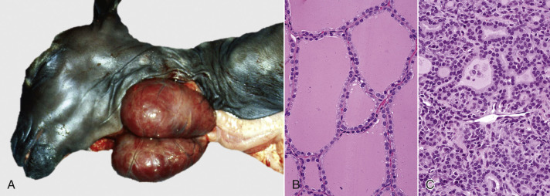

Hyperplasia, Thyroid Gland, Goat.
A, Maternal iodine deficiency caused hyperplasia (and hypertrophy) of thyroid follicular epithelial cells in this neonatal goat, resulting in massive enlargement (goiter) of both lobes. B, Follicular epithelial cells from a normal thyroid gland. H&E stain. C, Thyroid follicular epithelial cells from a case of goiter.

Hyperplasia is considered physiologic when it is a response to cyclic hormonal stimulation as in the endometrial or mammary development of pregnancy and lactation, respectively. The hyperplasia of wound healing is not a normal event, but it is an appropriate and compensatory response of fibroblasts and endothelial cells to traumatic injury. Likewise, hyperplastic goiter is not a normal change in the thyroid gland but is an appropriate response to generate thyroid hormones in the face of iodine deficiency. Idiopathic (of unknown cause) nodular hyperplasia is encountered rather commonly in certain organs (e.g., liver, pancreas, or spleen), especially in older dogs, and often is of no clinical significance

Hypertrophy
Hypertrophy, from the Greek word for increased growth, refers to an increase in size and volume of a tissue or organ due to increase in cell size. Importantly, the increased tissue mass is due to increased size of the parenchymal cells rather than stromal cells or leukocytes. Hypertrophy often accompanies an increase in cell number (hyperplasia) due to cellular proliferation but as a stand-alone phenomenon is observed mainly in organs or tissues such as the heart or skeletal muscle, in which the principal cells are postmitotic and incapable of replication. When the term hypertrophy is applied at the cellular level, it denotes an increase in cell size because of an increase in size or number of organelles as distinguished from increased cell size from hydropic cell swelling (loss of volume control) or from accumulation of endogenous or exogenous substances. Cellular hypertrophy is the process by which postmitotic cells, such as cardiomyocytes or skeletal myocytes, can grow as the juvenile animal grows. It is also the physiologic response of striated muscle to increased workload such as occurs in training of race horses. Smooth muscle cells (e.g., in the tunica media of arteries) also undergo hypertrophy in response to increased workload. Although muscular hypertrophy increases functional capacity in the short term, accompanying changes, such as increased fibrous stroma or decreased vascular perfusion, in myocardium, for example, can lead to decompensation of the affected organ.

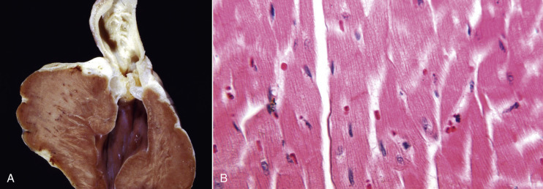

Hypertrophy, Heart, Dog.
A, narrowing of the pulmonary outflow tract caused by pulmonic valve stenosis has forced the right ventricle to contract with much more pressure. This increased workload has caused hypertrophy of the wall of the right ventricle, which is much thicker here than it would normally be. B, Note the increased size (hypertrophy) of myocytes in the overworked heart muscle.

Atrophy
Atrophy is the decrease in the mass of a tissue or organ due to decreased size and/or number of cells after it has reached its normal size. Atrophy must be distinguished from hypoplasia, the term applied to tissues or organs that are smaller than normal because they never developed completely. The shrinkage of atrophied tissue is caused by decreased size or loss of its principal cells. The causes of cellular or tissue atrophy include nutrient deprivation or loss of hormonal stimulation, decreased workload (disuse atrophy), denervation (especially in skeletal muscles), and compression (e.g., adjacent to neoplasms, other masses, or distended body cavities). Autophagy and apoptotic cell death can contribute to the shrinkage or loss of cells, respectively, in an atrophied organ. Histologically, the principal cells of the tissue are small with little to no mitotic activity. Ultra-structurally, atrophied cells have few mitochondria or other organelles.
Atrophy occurs in most organ systems of the animal body. Thyroid atrophy can be idiopathic or the result of autoimmune destruction of follicular cells. Because the portal vein provides most of the blood supply to the liver, a portosystemic shunt results in hepatic atrophy. Atrophy can be particularly striking in the thymus, causing a rapid and drastic loss of tissue through apoptosis of lymphocytes. Thymic atrophy is so consistent and often severe in certain viral infections (e.g., canine distemper or canine and feline parvovirus infections) with a predilection for rapidly dividing cells that it serves as a diagnostically useful, but easily overlooked gross lesion. The serous atrophy of fat in starving animals results in diminished volume and a translucent, semifluid to gelatinous appearance to adipose tissue throughout the body, but especially in the coronary groove of the heart or in the marrow of long bones.

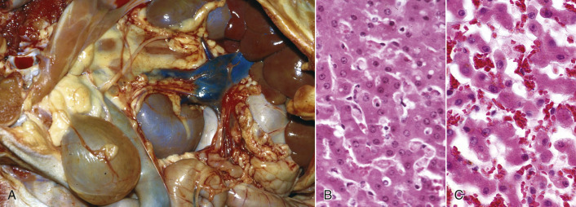

Atrophy, Liver, Dog.
A, Note the small size (up under the rib cage) but normal color of the liver in this dog and the anomalous portocaval shunt between the portal vein and the caudal vena cava. This shunt caused a reduction in blood flow to the liver and therefore atrophy of hepatocytes. B, Normal liver. H&E stain. C, Liver, atrophy. Hepatocytes are smaller, so hepatic cords are narrower than those in the normal liver. Consequently, the sinusoids are wider. H&E stain.

Metaplasia
Metaplasia is a change from one differentiated (mature) cell type to another differentiated cell type of the same germline. Typically, squamous metaplasia is a reparative response to chronic inflammation (e.g., in mammary ducts in chronic mastitis), hormonal imbalance (e.g., estrogen-induced squamous metaplasia in the prostate gland; vitamin A deficiency, or trauma. Although stratified squamous epithelium creates a protective barrier between the irritant and underlying tissue, there are negative consequences. For example, squamous metaplasia of respiratory epithelium in the trachea or bronchi entails a loss of ciliated cells and goblet cells, which are important for mucociliary clearance and resistance to pneumonic diseases.

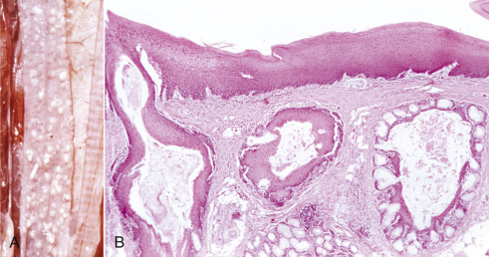

Squamous Metaplasia, Esophagus, Parrot.
A, The esophageal mucosa has multiple white raised nodules from squamous metaplasia of mucosal glands. Metaplasia arose from the lack of dietary vitamin A (avitaminosis A). B, Note the squamous metaplasia of the esophageal glands. Vitamin A is necessary for maintenance of the normal epithelium. Avitaminosis A results in the replacement of normal mucosal epithelium and goblet cells in the glands by keratinized stratified squamous epithelium.

Dysplasia
Dysplasia implies an abnormality in formation of a tissue. For example, renal dysplasia is the abnormal formation of the kidney; hip dysplasia is the abnormal formation of the coxofemoral joint. When applied to epithelium, dysplasia implies an increase in the number of poorly differentiated or immature cells and can be a precursor to neoplasia. Microscopically, dysplastic epithelial cells have atypical features, such as abnormal variation in size (anisocytosis) and shape (poikilocytosis), hyperchromatic nuclei, increased nuclear size (karyomegaly), and increased number of mitotic figures.

The response to injury can be degenerative, adaptive, or completely reversible with restoration of normal structure and function for the affected cell. However, cell death is also a point-of-no-return response to severe injury so with more severe or persistent injury, acute cell swelling can progress to irreversible cell injury and cell death.

Cell Death
Severe or persistent injury can overwhelm the cell's capacity to restore homeostasis, in which case potentially reversible acute cell swelling can become irreversible and progress to cell death. The morphologic features of cell death change with the passage of time and depend on the manner of death (oncotic necrosis versus apoptosis) and the type of cell or tissue. Oncotic necrosis is a process of cell swelling and thereby distinct from cell death by apoptosis, which is a process of cellular shrinkage and fragmentation. If an acutely swollen cell fails to correct the electrolyte imbalance and loss of volume control, then potentially reversible cell injury can become the initial stage of oncotic necrosis. Once thought always to be unregulated, oncotic necrosis, like apoptosis, can be a programmed process (necroptosis). Programmed cell death, whether by necroptosis or apoptosis, has many extrinsic and intrinsic (acting mainly through mitochondria) triggers. Programmed cell death is a complex and varied process that includes stages of initiation, propagation, and execution. Cells that die by oncotic necrosis tend to do so in groups, whereas apoptosis commonly affects individual cells. Furthermore, oncotic necrosis results in rupture of cell membranes and release of cytoplasmic content into the extracellular matrix with ensuing inflammation. In contrast, the cell that dies by apoptosis shrinks and fragments, but the fragments remain membrane bound and therefore do not elicit an inflammatory response although they are marked for phagocytosis.

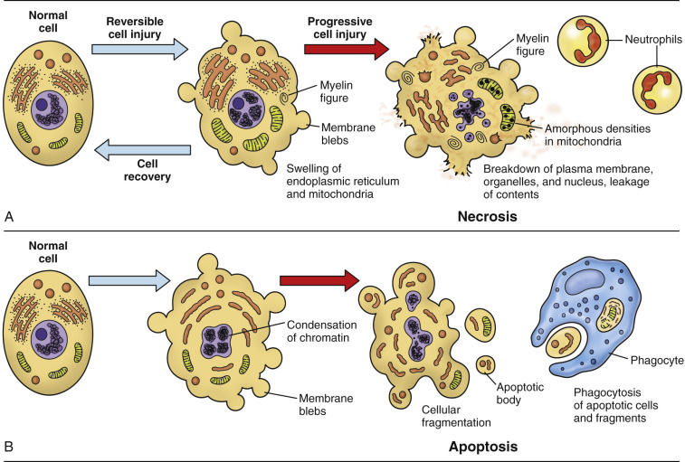

The Sequential Ultrastructural Changes of Necrosis and Apoptosis.

Oncotic necrosis
Oncotic cell death results from irreversible cell injury that, for example, is caused by hypoxia, ischemia, or direct damage to cell membranes. Ischemia causes particularly extensive cell injury because the decreased perfusion results in not only an oxygen deficit (hypoxia) but also a deficiency of glucose and other nutrients, plus an accumulation of toxic metabolic by-products. Cell swelling, resulting from loss of volume control, is the fundamental mechanism of oncotic necrosis and distinguishes it from apoptosis.

Types of necrosis
- Coagulative necrosis
This is a typical early response to hypoxia, ischemia, or toxic injury. It appears that the initial injury or the subsequent cellular acidosis denatures not only structural proteins, but also lysosomal enzymes in the affected cell. Normally, lysosomal enzymes would cause proteolytic disintegration of the entire cell, but as a result of this denaturation, proteolytic disintegration of the cell is delayed. However, the degradation of nucleic acids is not hindered. Thus a cell that has undergone coagulative necrosis has the expected nuclear features of cell death by oncosis (i.e., pyknosis, karyorrhexis, or karyolysis), but the cell outlines are still visible histologically. Coagulative necrosis is most easily recognized in the liver, kidney, myocardium, or skeletal muscle, in which the temporary preservation of cell outlines also preserves tissue architecture so that the outlines of hepatic plates, renal tubules, or muscle bundles are visible at the light microscopic level. Neurons also undergo coagulative necrosis before disappearing by lytic necrosis. Grossly, coagulative necrosis appears pale tan to pale gray, often sharply demarcated from the normal color of adjacent viable tissue, and solid (without apparent crumbling, sloughing, liquefaction, or other obvious loss of structure).Infarction typically begins as coagulative necrosis, especially in tissues such as kidney, where scaffolding provided by tubular basement membranes and interstitial fibrous tissue maintains the tissue structure. Initially the tissue with loss of its blood supply is blanched, but within minutes blood enters the infarcted tissue because blood flow either was restored in the obstructed vessel or arrives from collateral circulation (therefore infarcts in organs with a dual blood supply, such as the lung, are typically hemorrhagic) or leaks from veins in unaffected tissue in and adjacent to the damaged tissue. In an end-artery organ, such as the kidney, macrophages remove the blood from acute hemorrhagic infarcts over the course of a few days, and the infarct becomes pale and sharply demarcated by a red rim, attributable to hyperemia, hemorrhage, and acute inflammation, from adjacent renal parenchyma.

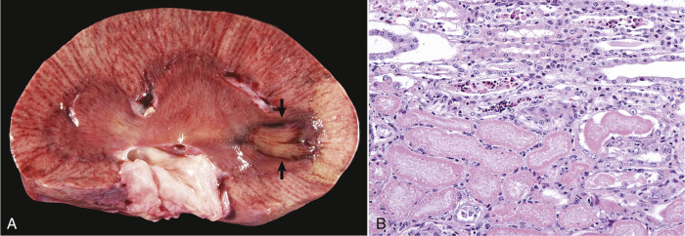

Coagulative Necrosis, Infarct, Kidney, Ox.
A, A pale tan wedge of coagulative necrosis extends from the medulla to the capsular surface of the kidney. The apical (medullary) portion of this renal infarct has a dark red border of reactive hyperemia and inflammation (arrows). B, Coagulative necrosis of renal tubular epithelial cells. Necrotic cells (lower half of figure) have homogeneous eosinophilic cytoplasm and pyknosis or karyolysis, but faint cell outlines and tubular architecture are retained.

- Caseous Necrosis.
Caseous, from the Latin word for cheese, refers to the curdled or cheese-like gross appearance of this form of necrosis. In comparison to coagulative necrosis, caseous necrosis is an older lesion with complete loss of cellular or tissue architecture. Macroscopically, caseation may appear as crumbled, granular, or laminated yellow-white exudate in the center of a granuloma or a chronic abscess. Histologically, the lysis of leukocytes and parenchymal cells converts the necrotic tissue into a granular to amorphous—cell outlines are not visible—eosinophilic substance with basophilic nuclear debris. Calcification of the necrotic tissue can contribute to the basophilic granular appearance. Caseous necrosis is prominent in the granulomas of bovine tuberculosis, caused by Mycobacterium bovis. M. bovis replicates within macrophages, protected by components of its cell wall from destruction by lysosomal enzymes until, with the development of cell-mediated (type IV) hypersensitivity, cytotoxic T lymphocytes destroy the infected macrophages, as well as parenchymal cells of the infected organ. Corynebacterium pseudotuberculosis, the cause of caseous lymphadenitis in sheep and goats, is another bacterium that can replicate in phagosomes of macrophages without being destroyed by lysosomal enzymes. The chronic stage of infection results in caseous abscesses in peripheral or internal lymph nodes or other organs, such as the lungs.

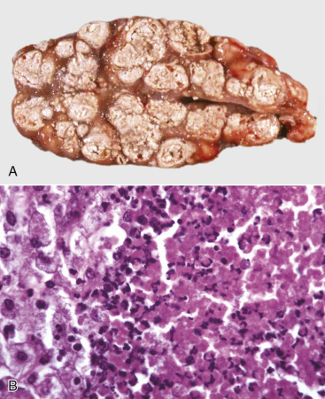

Tuberculosis (Caseous Necrosis), Lymph Node, Transverse Section, Ox.
A, The lymph node contains coalescing caseated granulomas. Caseous necrosis is characterized by off-white, crumbly exudate. B, Granulomatous inflammation in caseous necrosis. Cell walls are disrupted, and tissue architecture is lost. Degenerated or lysed leukocytes, including many neutrophils, are at the center (right) of a granuloma; note epithelioid macrophages at left.

- Liquefactive Necrosis.
In liquefactive necrosis, cells are lysed, and the necrotic tissue is converted to a fluid phase. This manifestation is typically the final stage of necrosis in parenchyma of the brain or spinal cord because of the lack of a fibrous interstitium to uphold tissue structure and because cells of the CNS tend to be rich in lipids and lytic enzymes. The term for the macroscopic (gross) appearance of necrosis in the brain and spinal cord is malacia. Neurons are generally the cells most susceptible to necrosis, especially from hypoxia or ischemia, and develop (early in the process of cell death) the morphologic features of coagulative necrosis. With time, however, the glial cells also undergo necrosis and liquefaction of the neuropil begins. Initially malacia may merely result in a translucency of affected tissue, but within a few days necrotic tissue undergoes yellowing, softening, or swelling. Liquefaction progresses with arrival of macrophages (gitter cells) to phagocytize the myelin debris and other components of the necrotic tissue. Eventually the parenchymal cells are completely lysed or phagocytized, and all that remains is the vasculature with intervening spaces that are partially filled with lipid- and debris-laden gitter cells. In organs or tissues outside the CNS, liquefactive necrosis is most commonly encountered as part of pyogenic (pus-forming) bacterial infection with suppurative (neutrophil-rich) inflammation and is observed at the centers of abscesses or other collections of neutrophils.

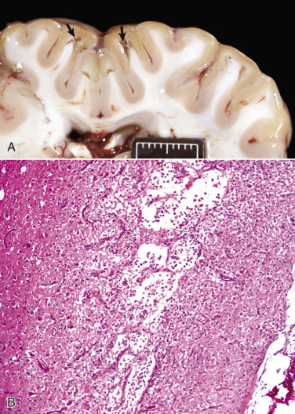

Liquefactive Necrosis.
A, Acute polioencephalomalacia, brain, goat. A thiamine deficiency has resulted in cerebrocortical malacia, which microscopically is liquefactive necrosis with focal tissue separation (arrows). Note yellow discoloration of affected cortex. Scale bar = 2 cm. B, Cortical necrosis, cerebrum, dog.
- Gangrenous Necrosis.
Gangrene denotes a type of necrosis that tends to develop at the distal aspect of extremities, such as the limbs, tail, or pinnae, or in dependent portions of organs, such as the mammary glands or lung lobes. Gangrene can be designated as wet or dry; these forms are unrelated. If the dependent necrotic tissue is infected by certain bacteria, wet gangrene ensues. If those bacteria are gas forming (e.g., Clostridium spp.), then wet gangrene becomes gas gangrene. In the lung, wet gangrene is often a sequel to the lytic necrosis of aspiration pneumonia. The aspirated material could be foreign material (food or medicament) or gastric content (a mixture of ingesta and gastric secretions). Such materials can be caustic in their own right and are also likely to deliver bacteria from the environment or oropharynx into the lung. Staphylococcal infection of the ruminant mammary gland can result in gangrenous mastitis, a form of wet gangrene. Grossly, tissues with wet gangrene are red-black and wet. Histologically, the lesion of wet gangrene resembles that of liquefactive necrosis but is usually accompanied by more numerous leukocytes, especially neutrophils.

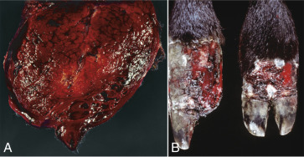

Gangrenous Necrosis.
A, Wet gangrene, mammary gland (longitudinal section through the teat), sheep. Staphylococcal infection caused the gangrenous mastitis in this ewe. Note wet and hemorrhagic necrosis of mammary tissue and overlying skin, especially at the distal (ventral) aspect of the udder. B, Dry gangrene, digits, ox. Vasoconstriction from ergot alkaloids produced by endophyte-infected fescue grass caused this ischemic necrosis of the distal aspects of the hind limbs. Note that one of the claws (left) has been lost due to the process.

Apoptosis
In contrast to oncotic necrosis, in which the dying cell swells until it literally bursts, apoptotic cell death is a process of condensation and shrinkage. Apoptosis is a form of programmed cell death that is important in embryologic development, homeostasis, and involution of organs or tissues deprived of hormonal stimulation or growth factors. It is also a regulated form of cell death that is directed by signaling pathways in response to certain types of injury.

Triggers of Apoptosis.
The triggers of apoptosis include binding of ligands such as TNF to cell surface DRs, various stresses or injury from toxins or ROS, nutrient deprivation or withdrawal of growth factors or hormones, DNA damage, or immune-mediated injury from cytotoxic T lymphocytes or NK cells. Apoptosis proceeds through an extrinsic pathway (initiated by the binding of a ligand to its DR) or an intrinsic pathway (initiated in mitochondria in response to various stresses or DNA damage) and almost always entails activation of caspases. Caspases are cysteine proteases that cleave peptides after aspartate residues. The initiator caspases that start the process of apoptosis include caspase-8 (activated by the death-inducing signaling complex (DISC) of the extrinsic pathway), caspase-9 (activated with the apoptosome in the intrinsic pathway), and caspase-2 (activated by p53 following DNA damage). The initiator caspases activate effector caspase-3, caspase-6, and caspase-7, which then execute apoptosis.

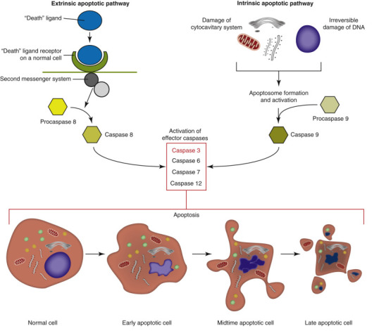

Apoptosis.
In the extrinsic pathway (left), apoptosis is triggered by binding of a ligand to a cell surface death receptor with subsequent formation of a cytoplasmic death-inducing signaling complex that activates an initiator caspase (e.g., caspase-8). The intrinsic pathway (right) of apoptosis is triggered by DNA damage or various cell stressors, especially those that result in permeabilization of the mitochondrial outer membrane, and leads to formation of the caspase-activating complex or apoptosome. The initiator caspase in the intrinsic pathway is usually caspase-9. In both the extrinsic and the intrinsic pathways, initiator caspases activate effector (executioner) caspases, resulting in cell death with the characteristic morphologic features of apoptosis (shown at bottom).

The Extrinsic (Death Receptor–Initiated) Pathway.
Extrinsic apoptosis begins with ligand-induced trimerization of a cell surface DR. The DRs include Fas, tumor necrosis factor receptor (TNFR) 1, and TNF-related apoptosis-inducing ligand receptor (TRAILR). The next step is internalization and recruitment of the intermediate membrane proteins TNF receptor–associated death domain (TRADD), Fas-associated death domain (FADD), and caspase-8 to form the cytoplasmic DISC. Remember that RIPK1, depending on its ubiquitination status, can associate with the trimerized DR and direct the cell toward regulated necrosis (if caspases are inhibited) or toward survival via activation of NFκB, and has an N-terminal death domain (DD) that links it to the apoptotic pathway through adaptor proteins such as TRADD or FADD. TRADD interacts with FADD, which in turn activates procaspase-8. Sufficient active caspase-8 then activates effector (executioner) caspase-3 and caspase-7 to execute apoptosis. Caspase-8 can also truncate Bid, a proapoptotic Bcl-2 protein, which translocates to mitochondria to trigger intrinsic apoptosis (see the next section). Importantly, the protein FLIP blocks the extrinsic pathway by binding procaspase-8 without activating it. If caspase-8 activity is insufficient, DR-mediated apoptosis can be augmented by mitochondria, almost always through Bcl-2 proteins, such as the proapoptotic Bak (Bcl-2 antagonist/killer) and Bax (Bcl-2–associated X protein). Even cells that cannot initiate or propagate apoptotic signaling can still die, but do so via caspase-independent pathways of cell death, such as regulated necrosis.

The Intrinsic (Mitochondrial) Pathway
The intrinsic or mitochondrial pathway of apoptosis does not require ligation of a cell surface DR and can be triggered by a variety of cell stressors or by DNA damage that leads to activation of p53-upregulated modulator of apoptosis (PUMA). The key event of intrinsic apoptosis is mitochondrial outer membrane permeabilization (MOMP). MOMP can be triggered by activation, posttranslational modification, and upregulation of proapoptotic BH3-only proteins (e.g., PUMA protein). The BH3-only proteins usually induce MOMP via oligomerization of Bax and Bak to form channels in the outer mitochondrial membrane. This permeabilization of the outer mitochondrial membrane releases cytochrome c from the intermembrane space into the cytosol. Cytochrome c promotes the assembly of the caspase-activating complex or apoptosome, which consists of caspase-9 plus apoptotic protease activating factor 1 (Apaf-1). MOMP also releases the second mitochondrial activator of caspases (SMAC), as well as the catabolic hydrolases, apoptosis-inducing factor (AIF), and endonuclease G.
Recall from the section on regulated necrosis that opening of the MPT pore is a key event in cell death because it dissipates the proton gradient needed for oxidative phosphorylation. At low concentrations, opening of the MPT pore can induce protective autophagy to remove dysfunctional mitochondria. However, MOMP is a lethal permeabilization that initiates intrinsic apoptosis.

The Execution Phase of Apoptosis.
Initiator caspases (2, 8, 9, or 10) cleave the downstream effector (executioner) caspases (mainly 3, 6, and 7), which then execute apoptosis by cleaving cell proteins after aspartate residues. Granzyme B from cytotoxic T lymphocytes and NK cells can also trigger apoptosis by activating caspase-3 and caspase-7. Effector caspases cleave nuclear and cytoplasmic proteins, leading to disintegration of the nucleus and disruption of the cytoskeleton.

Morphologic Appearance of Apoptosis.
Morphologically, apoptotic cell death is a process of condensation and fragmentation of the nucleus (pyknosis and karyorrhexis) with blebbing of the plasma membrane to form membrane-bound apoptotic bodies that contain nuclear fragments, organelles, and condensed cytosol. The plasma membrane that surrounds apoptotic bodies prevents the inflammation occurring with necrotic cell death but does express factors to attract phagocytes and stimulate heterophagy. Not surprisingly, apoptotic and necrotic cell death can coexist in the same tissue.

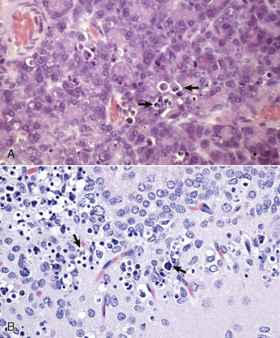

Apoptosis, Cytologic Features.
A, Pancreas, rat. Individual acinar cells are shrunken, condensed, and fragmented (arrows). Apoptotic bodies are in adjacent cells, but inflammation is absent. H&E stain. B, Hippocampus, brain, mouse. Individual neurons are shrunken, condensed, and fragmented (arrows). H&E stain.

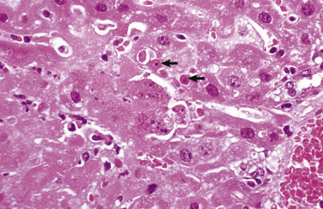

Necrosis and Apoptosis, Mouse Hepatitis Virus Infection, Liver, Mouse.
The virus causes hepatocellular death, typically by oncotic necrosis, but sometimes by apoptosis. Note coagulative necrosis (lower left) with lytic necrosis (center left) and individual cells with features of apoptosis (arrows).

