**NAME: IVOKE BEATRICE CHINONSO**

**MATRIC NUMBER: 19/SMS01/014**

**DEPARTMENT: ECONOMICS**

**COURSE: INTRODUCTION TO STATISTICS**

1.

|  |  |  |  |
| --- | --- | --- | --- |
| CLASS INTERVAL | FREQUENCY | CLASS BOUNDARY | CLASS MARK |
| 300 – 399 | 14 | 299.5 – 399.5 | 349.5 |
| 400 – 499 | 46 | 399.5 – 499.5 | 449.5 |
| 500 – 599 | 58 | 499.5 – 599.5 | 549.5 |
| 600 – 699 | 76 | 599.5 – 699.5 | 649.5 |
| 700 – 799 | 68 | 699.5 – 799.5 | 749.5 |
| 800 – 899 | 62 | 799.5 – 899.5 | 849.5 |
| 900 – 999 | 48 | 899.5 – 999.5 | 949.5 |
| 1000 – 1099 | 22 | 999.5 – 1099.5 | 1049.5 |
| 1100 – 1199 | 6 | 1099.5 – 1199.5 | 1149.5 |

1. 799
2. 1000
3. 949.5
4. 1099.5 – 1199.5
5. 100
6. 76
7. 62/400 ×100 = 15.5%
8. 58 + 46 + 14 = 118/400 ×100 = 29.5%
9. 48 + 22 + 6 = 76/400×100 = 19%
10. 58 + 76 + 68 + 62 + 48 = 312/400×100 = 78%

2a.

2b.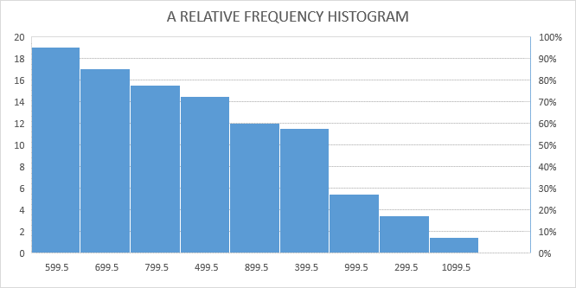

2c.

|  |  |  |
| --- | --- | --- |
| CLASS INTERVAL | FREQUENCY | CUMMULATIVE FREQUENCY |
| 300 – 399 | 14 | 14 |
| 400 – 499 | 46 | 14+46=60 |
| 500 – 599 | 58 | 60+58=118 |
| 600 – 699 | 76 | 118+76=194 |
| 700 – 799 | 68 | 194+68=262 |
| 800 – 899 | 62 | 262+62=324 |
| 900 – 999 | 48 | 324+48=372 |
| 1000 – 1099 | 22 | 372+22=394 |
| 1100 - 1199 | 6 | 394+6=400 |

3.

|  |  |  |
| --- | --- | --- |
| CLASS INTERVAL | FREQUENCY | CLASS BOUNDARY |
| 90-99 | 9 | 89.5-99.5 |
| 80-89 | 32 | 79.5-89.5 |
| 70-79 | 43 | 69.5-79.5 |
| 60-69 | 21 | 59.5-69.5 |
| 50-59 | 11 | 49.5-59.5 |
| 40-49 | 3 | 39.5-49.5 |
| 30-39 | 1 | 29.5-39.5 |
|  | =120 |  |

3a**. Q1= 1N/4**

1×120/4 = 30

30 – 15 =15

59.5 + 15/21 (10) =66.6

**Q2= 2N/4**

2×120/4 = 60

60 – 36= 24

69.5 + 24/43 (10) =384.91

**Q3= 3N/4**

3×120/4 = 90

90 – 79= 11

79.5 + 11/32 (10) =82.94

3b**. P10 =10N/100**

10 × 120/100 =12

49.5 + (12 – 4)/11 ×10

49.5 + 8/11 ×10 = 56.77

**P25 =25N/100**

25 × 120/100 = 30

59.5 + (30 – 15)/21 × 10

= 66.64

**P90 = 90N/100**

90 × 120/100 =108

79.5 + (108 – 79)/32 ×10 = 88.56

**P75 = 75N/100**

75 × 120/100 = 90

79.5 + (90 – 79)/ 32 × 10 = 82.94