NAME: ADAMS SEFINAT OYINDAMOLA
MATRIC NUMBER: 17/MHS02/001
DEPARTMENT: NURSING
COURSE CODE: NSC 308
COURSE TITLE: CELLULAR PATHOLOGY
LEVEL: 300L

QUESTIONS:
- Write explicitly on 5 diagnostic techniques used in pathology, relevant illustrations and examples required.
- Cellular adaptation proceeds cell death, discuss. Diagrams essential.

ANSWER:
- Diagnostic procedures used in cellular pathology include:
-histopathology
-cytopathology
-hemapathology
-immunohistochemistry
-microbiological examination
a) histopathological techniques: this examination study tissues under the microscope. During this study, the pathologist looks for abnormal structures in the tissue. Tissues for histopathological examination are obtained by biopsy. Biopsy is a tissue sample from a living person to identify the diseases. Biopsy can either be incisional or excisional.
Once the tissue is removed from the patient, it has to be immediately fixed by putting it into adequate amount of 10% formaldehyde before sending it to the pathologist. The purpose of fixation is:
-to prevent autolysis and bacterial decomposition and putrefaction
-to coagulate the tissue to prevent loss of easily diffusible substances
-to fortify the tissue against the deleterious effects of the various stages in the preparation of sections and tissue processing.
-to leave the tissue in a condition which facilitates differential staining with dyes and other reagents.
Once the tissue arrives at the pathology department, the pathologist will exam it macroscopically. Then the tissue is processed to make it ready for microscopic examination. The whole purpose of tissue processing is to prepare a very thin tissue which can be clearly seen under the microscope. The tissue is processed by putting it into different chemicals. It is then impregnated in paraffin, sectioned into thin slices and it is finally stained. The stains can be hematoxylin/eosin stain or special stains such as PAS. The hematoxylin/eosin stain is often abbr4viated as H&E stain. The H&E stain is routinely used. It gives the nucleus a blue color and the cytoplasm and the extracellular matrix a pinkish color. Then the pathologist will look for abnormal structures in the tissues, and based on the abnormal structures he/she will make diagnosis. Histopathology is usually the gold standard for pathological diagnosis.
b) Cytopathological techniques: cytopathology is the study of cells from various body sites to determine the cause or nature of disease. The main purpose of cytology include the following:
- screening for the early detection of asymptomatic cancer: for example, the examination of scrapings from cervix for early detection and prevention of cervix for early detection and prevention or cervical cancer.
- diagnosis of symptomatic cancer: cytopathology may be used alone or in with other modalities to diagnose tumors revealed by physical or radiological examinations. It can also be used in diagnose of cysts, inflammatory conditions and infections of various organs
- surveillance of patients treated for cancer: for some types of cancers, cytology is the most feasible method of surveillance to detect recurrence. The best examples is periodic urine cytology to monitor the recurrence of cancer of the urinary tract.
Advantages of cytopathological examination:
- Compared to histopathological technique it is cheap, take less time and needs no anesthesia to take specimens. Therefore, it is appropriate for developing countries with limited resources. In adition, it is complementary to histopathological examination
Methods of cytopathological examinations: there are different methods of cytopathological examinations which include;
- Fine needle aspiration cytology(FNAC) : in this method, cell are obatained by aspirating the diseased organ using a very thin needle under negative pressure. Virtually any organ or tissue can be sampled by fine needle aspiration. The aspirated cells are then stained are studied under the microscope. Sueperficial organs can easily be aspirated. Deep organs are aspirated with guidance by fluoroscopy, ultrasound or CT scan. FNAC is cheap, fast and accurate in diagnosing many disease.
- Exfoliative cytology: refers to the examination of cells that are shed spontaneously into the body fluids or secretions. Examples include sputum, cerebrospinal fluid, urine etc….
- Abrasive cytology: refers to methods by which cells are dislodged by various tools from body surfaces. E.g preparation of cervical smears with a spatula or a small brush to detect cancer of the uterine cervix at early stages.
c) Immunohistochemistry: this is a method used to detect a specific antigen in the tissue in order to identify the type of disease. IHC offers several distinct advantages when compared to traditional methods. This technique is rapidly expanding the diagnostic capability of pathologist. IHC permits rapid identification. The technique employs specific antibodies, which localize to the antigens of the etiological agent of interest. Since this technique uses formalin-fixed tissues, specimen transport is simplified, allowing retrospective studies and minimizing laboratory worker exposure to infectious agents. IHC is a sensitive and specific test methodology for many microorganisms, and unlike some traditional staining methods, they result in direct, highly interpretable visual evidence of the presence of an infectious agent within tissues. In addition, IHC detects organisms that are difficult to culture and those that cannot be cultured. IHC provides invaluable information for clinical diagnosis as well as for the study of pathogenesis. IDPB has developed many specific IHC assays for emerging or re-emerging infectious diseases. Currently, IDPB has diagnostic IHC assays for more than 100 etiologic agents, including viral, bacteria, parasitic and fungal organisms. For a number of agents, IHC tests may provide the only reliable methods of detection.
d) Autopsy: this is an examination of the dead body to identify the cause of death. This can be for forensic or clinical purposes. Autopsies can be performed when any of the following information is desired:
-determine if death was natural or unnatural
- injury source and extent on the corpse
-manner of death must be determined
-time since death
-established identity of the deceased
-retain relevant organs
-if it is an infant, determined live birth and viability
For example, a forensic autopsy is carried out when the cause of death may be a criminal matter, while a clinical or academic autopsy is performed to find the medical cause of death and is used in cases of unknown or uncertain death, or for research purposes.
e) Heamatological techniques: this is amethod by which abnormalities of the cells of the blood and their precursors in the bone marrow are investigated to diagnose the different kinds of anemia and leukemia. The examination is the first step to a haematological diagnosis and treatment of blood disorders such as anemia, abnormalities of the red blood cells, disease related to defective blood clotting, thromboembolic diseases. Such as thrombus formation, and immunoheamatological diseases. Further more it is used to diagnose and identify the best treatment for blood cancer, hodgkin’s disease, acute and chronic leukemias, myeloma and myeoproliferative disorders such as essential thrombocytothemia, polycythemia vera, and myelofibrosis. Others include heamatological disease of the ederly such as myelodysplasia and low malignant lymphoproliferative disorders, arterial thromboembolic disease, thrombophilia, thrombosis and clotting abnormalities. During the visit, a heamatologist collects information about the history and lifestyle of the patient such as nutrition, smoking habits, physical inactivity, pathologies, previous interventions, a family history of similar diseases, and a medication intake. A heamatologist then conducts a thorough clinical examination that can last between 20 and 40 minutes, during which the doctor feels the abdominal area, listens to the heart and lungs, and looks for enlarged lymph nodes. A heamatologist will view prior exams or prescribe them when necessary, to determine an appropriate course of action.

- Cellular adaptation refers to the changes taking place in the cell in response to environmental changes. Normal functioning of the cell is always threatened by various factors such as stress, chemical agents, disease and environmental hazards. The cell still survives and continue the functions by mean of adaptation. Only during extreme conditions, the cell fails to withstand the hazardous factors which results to cell injury/damage.
Cell injury or damage is a variety of changes of stress that a cell suffers due to external as well as internal environmental changes. Cell injury can either be reversible or irreversible depending on the level of injury. Cellular adaptation leads to cellular injury, there are five cellular adaptaion to injury:
- Atrophy: this means decrease in size of a cell. Atrophy of more number of cells result in decreased size or wasting of the concerned tissue, organ or path of the body. There are two types of atrophy; physiological atrophy and pathological atrophy. Examples of physiological atrophy is atrophy of thymus in childhood and tonsils in adolescent. The pathological atrophy is common in skeletal muscle, cardiac muscle.
- Hypertrophy: this is the increase in the size of a cell. Hypertrophy of many cells result in enlargement or overgrowth of an organ or a part of the body. There are 3 types of hypertrophy; physiological hypertrophy (increase in size due to increased workload or exercise. E.g muscular hypertrophy and ventricular hypertrophy), athological hypertrophy (increase in cell size in response to pathological changes. E.g ventricular hypertrophy due pathological conditions as a result of high blood pressure), compensatory hypertrophy (increase in the size of cells of an organ that occurs in order to compensate the loss or dysfunction of another organ of same type. E.g, hypertrophy of one kidney when the other stops working).
- Hyperplasia: increase in number of cells due to increased cell division(mitosis). There are 3 types of hyperplasia; physiologiac hyperplasia (momentary adaptive response to routine physiological changes in the body.), compensatory hyperplasia (is the increase in number of cells in order to replace the damaged cells of an organ ), pathological hyperplasia (increase in munber of cells due to abnormal increase in hormone secretion).
- Dysplasia: this condition is charfacterised by the abnormal change in the size, shape and organization of the cells.
- Metaplasia: is the condition that involves replacement of one type of call with another type of cell.
Cellular injury can either be reversible of irreversible; reversible cellular injury results back to normal cell while irreversible cellular injury results to cellular death.
Cellular death is the event of a biological cell ceasing to carry out its function. Which is as a result of irreversible cellular injury, cell death can occur in two ways;
- Apoptosis: this is a process of programmed cell death that may occur in multicellular organisms. It is an active process characterized by cell shrinkage, nuclear and cytoplasmic condensation, chromatin fragmentation, and phagocytosis of the apoptotic cell. It plays a critical role during the normal development and homeostasis of adult tissues.
- Necrosis: this is a cell death where a cell has been badly damaged through external forces such as trauma or infection and occurs in several different forms. In necrosis a cell undergoes swelling, followed by uncountrollable rupture of the cell membrane with cell contents being expelled.
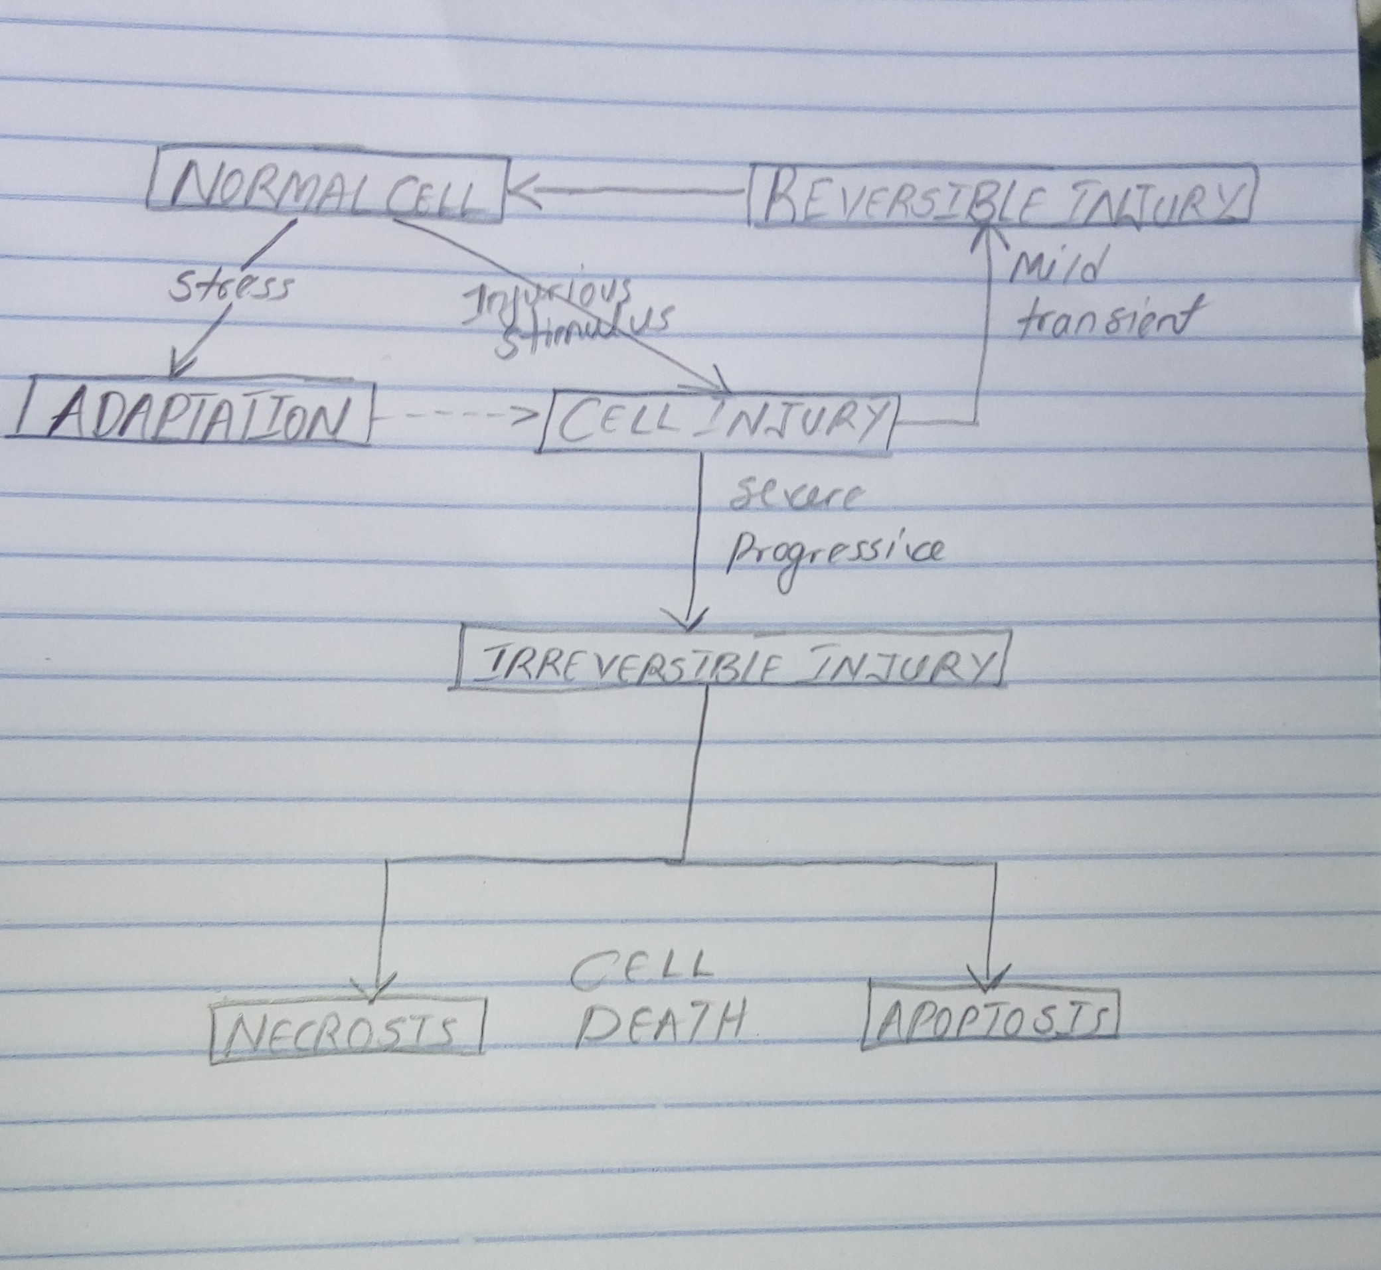
Therefore, cellular adaptation leads cellular injury (irreversible cellular injury) leads to cell death.

