OZOEMENA AUGUSTINE
18/ENG01/027
ASSIGNMENT SUBMITTED FOR PROCESS INSTRUMENTAION

- A process flow diagram (PFD) is a diagram commonly used in chemical and process engineering to indicate the general flow of plant processes and equipment. The PFD displays the relationship between major equipment of a plant facility and does not show minor details such as piping details and designations.^{[1]} Another commonly used term for a PFD is a flowsheet. Process flow diagrams of multiple process units within a large industrial plant will usually contain less detail and may be called block flow diagrams or schematic flow diagrams Typically, process flow diagrams of a single unit process will include the following; Process piping, major equipment items, connection with other systems, major bypass and recirculation (recycle) streams, operational data (temperature, pressure, mass flow rate, density, etc.), often by stream references to a mass balance, process stream name. Process flow diagrams generally do not include: Pipe classes or piping line numbers, instrumentation details. minor bypass lines, instrumentation, controllers like Level Control or Flow Control, isolation and shutoff valves, maintenance vents and drains, relief and safety valves and flanges
An example of a chemical process flow diagram is shown below
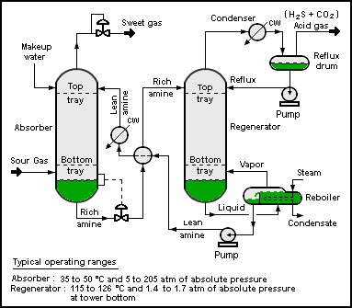
Fig 1; Amine treating plant

2. The purpose of P&ID is it shows all piping, including the physical sequence of branches, reducers, valves, equipment, instrumentation and control interlocks. A P&ID is used to operate the process system, since it shows the piping of the process flow along with the installed equipment and instrumentation
The division of P&ID include;
- Line P&ID symbols
- Piping P&ID symbols
- Valve P&ID symbols
- Instrument P&ID symbols
3 some common examples of P&ID symbols are
1.process flow line
2. Flange
3. Reducer
- Gate valve symbol
- Flow meter symbol 