ONOH JESSICA MOSES
17/MHS02/079
NURSING
CELLULAR PATHOLOGY ASSIGNMENT

- WRITE BRIEFLY ON 5 DIAGNOSTIC TECHNIQUES IN PATHOLOGY RELEVANT ILLUSTRATION AND EXAMPLE
ANSWER
- HISTOPATHOLOGICAL TECHNIQUES: histopathological examination studies tissues under the microscope during this study pathologist look for abnormal structures in the tissues.
Tissues for histopathological examination are obtained through biopsy. Biopsy can be incisional or excisional.
ILLUSTRATION> once the patient is removed from the patient, it has to be immediately fixed by putting it into adequate amount of 10% formaldehyde (10% formalin) before sending it to the pathologist.
Once the tissue arrives at the pathology department, the pathologist will exam it microscopically. The whole purpose of tissue processing is to prepare a very thin tissue (i.e. five to seven nanometer or once cell thick tissues) which can be clearly seen under the microscope. The tissue is processed by putting it into different chemicals it is then impregnated (embedded in paraffin) sectioned into slices and is finally stained. The H&E (hematoxylin/ eosin) stain is routinely used. It gives the nucleus blue color and the cytoplasm and the extracellular matrix a pink color.
Then the pathologist will look for abnormal structures in the tissue and based on this abnormal morphology he/she will make the diagnosis, histopathology is usually the gold standard for pathologic diagnosis.
EXAMPLE>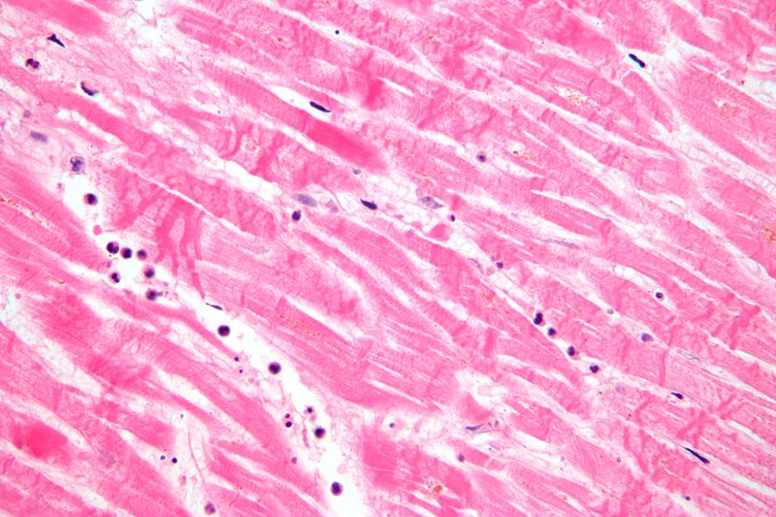

- AUTOPSY: is an examination of the dead body to identify the cause of death, it can be forensic or clinical purpose.
ILLUSTRATION> autopsy can be divided into two namely
- External examination: autopsy begins with a careful inspection of the body which can help establish, identify or cause of the death. The pathologist weigh and measure the body noting the subject cloth, characteristics such as eye color, hair color, sex and age.
Removing the cloth examining the body searching for gunpowder residue, paint flakes or other deposit, identifying marks such as scar, tattoos and injuries, x-ray can sometimes be used to reveal bone abnormalities and location of bullet or other objects.
Example:
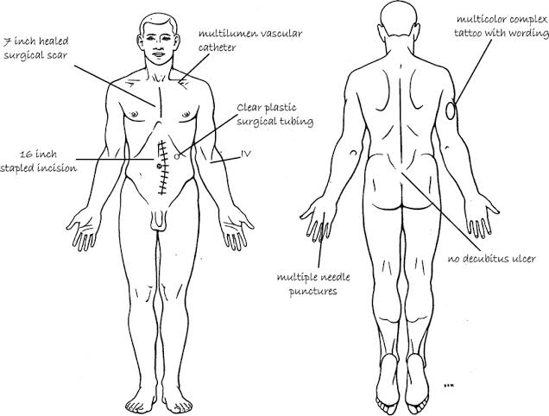
- Internal examination: the pathologist examine the chest, pelvic organ. First of all the pathologist make an incision with the shape from the two end of the shoulder tip extending down to the pubic region examining the organ in situ( in place) which means removing he rib cage. Using a saw or rib cutter he/she cuts along the boundary between the ribs and the cartilage remove the entire frontal ribcage on each organ examined with in the beds removed weigh and examined in further detail, if the brain is to be examined. It is placed in formalin for day or even weeks
EXAMPLE>
- IMMUNOHISTOCHEMISTY: is a method used to detect a specific antigen in the tissue in order to identify the type of diseases.
ILLUSTRATION>

Target antigen detection methods
The direct method is a one-step staining method and involves a labeled antibody (e.g. FITC-conjugated antiserum) reacting directly with the antigen in tissue sections. While this technique utilizes only one antibody and therefore is simple and rapid, the sensitivity is lower due to little signal amplification, in contrast to indirect approaches. However, this strategy is used less frequently than its multi-phase counterpart.
The indirect method involves an unlabeled primary antibody (first layer) that binds to the target antigen in the tissue and a labeled secondary antibody (second layer) that reacts with the primary antibody. As mentioned above, the secondary antibody must be raised against the IgG of the animal species in which the primary antibody has been raised. This method is more sensitive than direct detection strategies because of signal amplification due to the binding of several secondary antibodies to each primary antibody if the secondary antibody is conjugated to the fluorescent or enzyme reporter.
Further amplification can be achieved if the secondary antibody is conjugated to several biotin molecules, which can recruit complexes of avidin-, streptavidin- or NeutrAvidin protein-bound enzyme. The difference between these three biotin-binding proteins is their individual binding affinity to endogenous tissue targets leading to nonspecific binding and high background; the ranking of these proteins based on their nonspecific binding affinities, from highest to lowest, is: 1) avidin, 2) streptavidin and 3) NeutrAvidin protein.
The indirect method, aside from its greater sensitivity, also has the advantage that only a relatively small number of standard conjugated (labeled) secondary antibodies needs to be generated. For example, a labeled secondary antibody raised against rabbit IgG, which can be purchased "off the shelf", is useful with any primary antibody raised in rabbit. With the direct method, it would be necessary to label each primary antibody for every antigen of interest.

EXAMPLE>
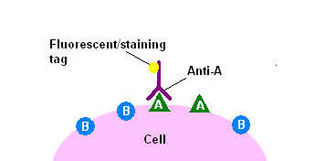
The direct method of immunohistochemical staining uses one labelled antibody, which binds directly to the antigen being stained for.

- BIOCHEMICAL EXAMINATION: is a method by which the metabolic disturbance of disease are investigated by assay of various normal and abnormal compounds in the blood, urine.
ILLUSTRATION
The test method consists of immersing the test strip completely in a well-mixed sample of urine for a short period of time, then extracting it from the container and supporting the edge of the strip over the mouth of the container to remove excess urine. The strip is then left to stand for the time necessary for the reactions to occur (usually 1 to 2 minutes), and finally the colors that appear are compared against the chromatic scale provided by the manufacturer.
An improper technique can produce false results, for example, leukocytes and erythrocytes precipitate at the bottom of the container and may not be detected if the sample is not properly mixed, and in the same way, if an excess of urine remains on the strip after it has been removed from the test sample, may cause the reagents to leak from the pads onto adjacent pads resulting in mixing and distortion of the colors. To ensure that this does not occur it is recommended the edges of the strip are dried on absorbent paper, it can be used to test for either ketone or glucose in the urine

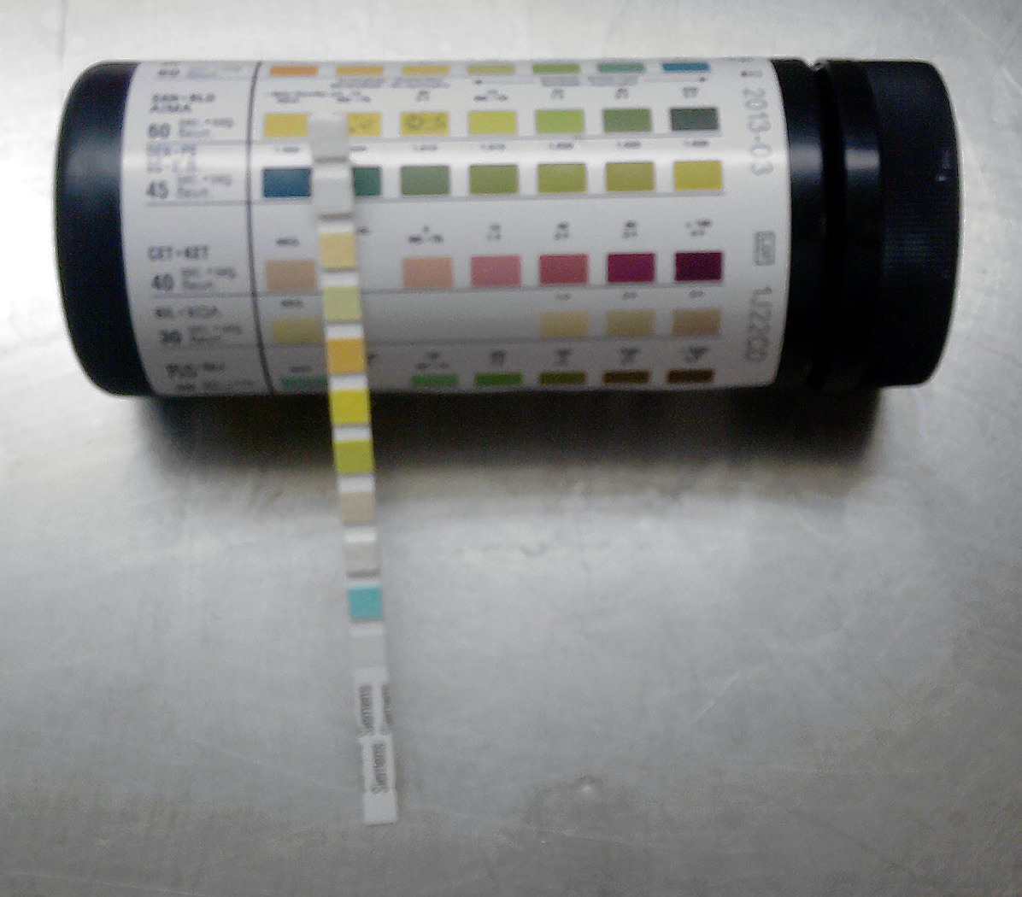

EXMAPLE>
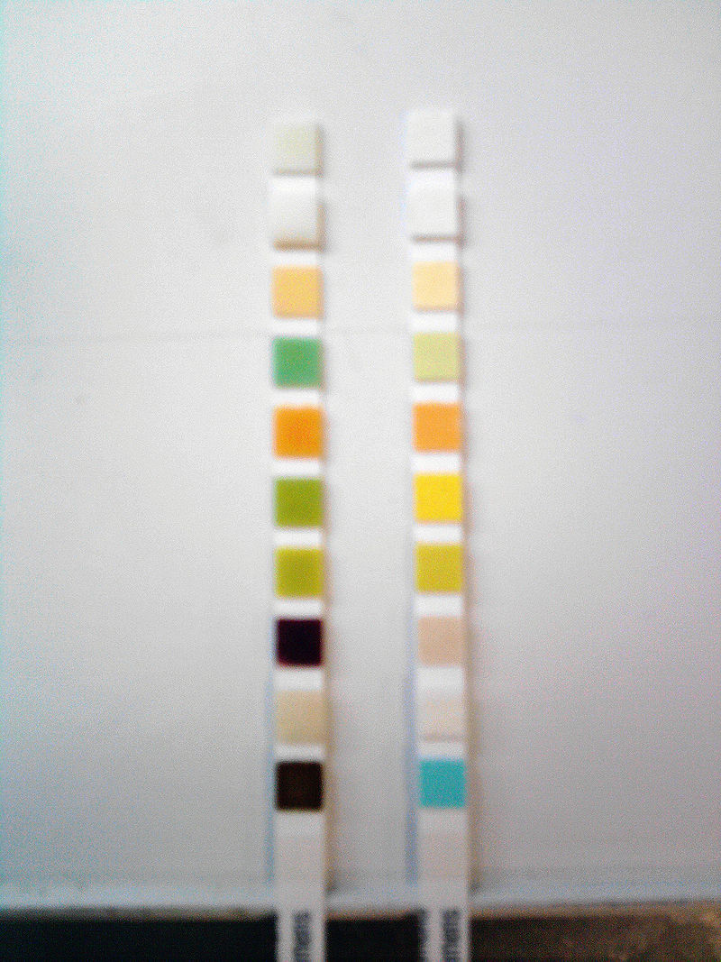
Comparison between two reactive strips, one pathological (to the left, from a patient with uncontrolled diabetes mellitus), and an unreacted strip. From top to bottom the pathological strip shows: Leukocytes (-), nitrites (-), urobilinogen (-), proteins (+), pH (5), hemoglobin (+), specific gravity (1.025), ketones (++++), bilirubin (+), glucose (++

- HEMATOLOGICAL EXAMINATION: is a method by which abnormalities of the cell of the blood and other precursors in the bone marrow are investigated to diagnose the different kind of anemia or leukemia.
ILLUSTRATION>The blood test most commonly done is the complete blood count (CBC). The CBC is an evaluation of all the cellular components (red blood cells, white blood cells, and platelets) in the blood. Automated machines do this test in less than 1 minute on a small amount of blood. The CBC is supplemented in some instances by examination of blood cells under a microscope (blood smear). Abnormal red blood cells may be fragmented or shaped like teardrops, crescents (sickle-shaped), or a variety of other forms. Knowing the specific shape and size of red blood cells can help a doctor diagnose a particular cause of anemia. For example, sickle-shaped cells are characteristic of sickle cell disease, small cells containing insufficient amounts of hemoglobin are likely due to iron deficiency anemia, and large cells suggest anemia due to a deficiency of folate (folic acid) or vitamin B12.
To do this, a drop of blood is smeared across a glass slide to form a thin layer that makes it easy to see individual blood cells. The slide is then stained with colored chemicals to reveal specific characteristics of the blood cells and examined under the microscope.
Once a doctor determines that something is wrong with one or more of the cell types in the blood, many additional tests are available to shed more light on the problem. Doctors can measure the proportion of the different types of white blood cells and can determine subtypes of these cells by assessing certain markers on the surface of the cells. Tests are available to measure the ability of white blood cells to fight infection, to assess the functioning of platelets and their ability to clot, and to measure the contents of red blood cells to help determine the cause of anemia or why the cells are not functioning properly. Most of these tests are done on samples of blood, but some require a sample from the bone marrow.

EXAMPLE>
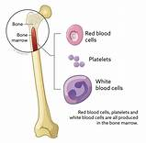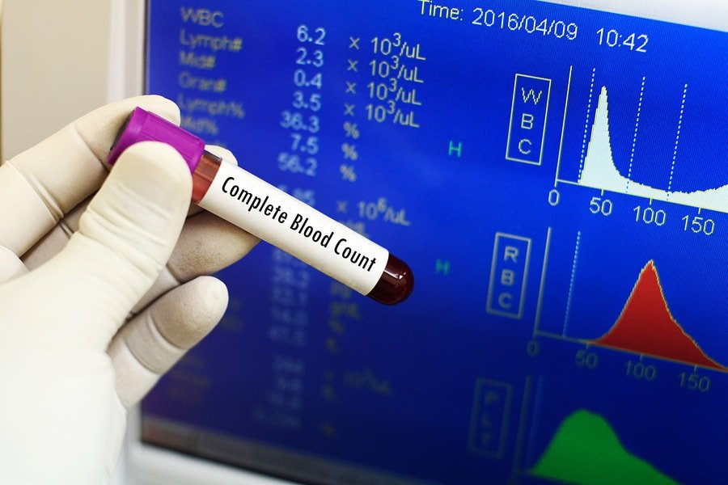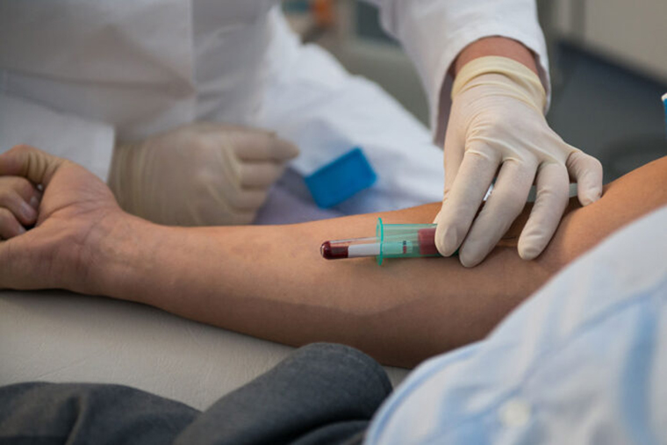 how blood is collected from the vein for examining.

- CELLULAR ADAPTATION PRECEEDED CELL DEATH. DISCUSS DIAGRAMS ESSENTIAL?
ANSWER: cell adaptation is the ability of cells to respond to various types of stimuli and adverse environmental changes.
These adaptation include hypertrophy (enlargement of individual cells), hyperplasia (increase in cell number), atrophy (reduction in size and cell number), metaplasia (transformation from one type of epithelium to another) and dysplasia (disordered growth of cells)
Tissues adapt differently depending on the replicative characteristics of the cells that make up the tissue for example labile tissues such as the skin can rapidly replicate and therefore can also regenerate after injury, where as permanent tissue such as neural and cardiac tissue cannot regenerate after injury ( cell injury). If cells are not able to adapt to the adverse environmental changes cell death occurs physiologically in the form of apoptosis or pathologically in the form of necrosis.
EXAMPLES>

