AFEBABALOLOA UNIVERSITY
COLLEGE OF MEDCINE AND HEALTH SCIENCE
DEPARTMENT
NURSING
COURSE
CELLULAR PATHOLOGY
COURSE CODE
NSC 308
MATRIX NO
17/Mhs01/116
NAME
ENO SUSAN A

ASSIGNMENT
Questions ;
- Explain explicitly 5 diagnostic procedure in pathology with illustration and examples
- Cellular adaptation precedes death? Explain with diagram.

1. The pathologist uses the following techniques to the diagnose diseases:
a. Histopathology
b. Cytopathology
c. Hematopathology
d. Immunohistochemistry
e. Microbiological examination
f. Biochemical examination
g. Cytogenetic
h. Molecular techniques
i. Autopsy

A. Histopathological techniques
Histopathological examination studies tissues under the microscope. During this study, the pathologist looks for abnormal structures in the tissue. Tissues for histopathological examination are obtained by biopsy.
Biopsy is a tissue sample from a living person to identify the disease. Biopsy can be either incisional or excisional. Once the tissue is removed from the patient, it has to be immediately fixed by putting it into adequate amount of 10% Formaldehyde (10% formalin) before sending it to the pathologist.
The purpose of fixation is:
1. To prevent autolysis and bacterial decomposition and putrefaction
2. To coagulate the tissue to prevent loss of easily diffusible substances
3. To fortify the tissue against the deleterious effects of the various stages in the preparation of sections and tissue processing.
4. To leave the tissues in a condition which facilitates differential staining with dyes and other reagents.

Once the tissue arrives at the pathology department, the pathologist will exam it macroscopically (i.e. naked-eye examination of tissues).
Then the tissue is processed to make it ready for microscopic examination. The whole purpose of the tissue processing is to prepare a very thin tissue (i.e. five to seven or one cell thick tissue) which can be clearly seen under the microscope. The tissue is processed by putting it into different chemicals. It is then impregnated (embedded) in paraffin, sectioned (cut) into thin slices, & is finally stained. The stains can be Hematoxylin/Eosin stain or special stains such as PAS, Immunohistochemistry, etc...

The Hematoxylin/Eosin stain is usually abbreviated as H&E stain. The H&E stain is routinely used. It gives the nucleus a blue color & the cytoplasm & the extracellular matrix a pinkish color. Then the pathologist will look for abnormal structures in the tissue. And based on this abnormal morphology he/she will make the diagnosis. Histopathology is usually the gold standard for pathologic diagnosis.

B. Cytopathologic techniques
Cytopathology is the study of cells from various body sites to determine the cause or nature of disease.
Applications of cytopathology:
The main applications of cytology include the following:
1. Screening for the early detection of asymptomatic cancer
For example, the examination of scrapings from cervix for early detection and prevention of cervical cancer.
2. Diagnosis of symptomatic cancer
Cytopathology may be used alone or in conjunction with other modalities to diagnose tumors revealed by physical or radiological examinations. It can be used in the diagnosis of cysts, inflammatory conditions and infections of various organs.
3. Surveillance of patients treated for cancer
For some types of cancers, cytology is the most feasible method of surveillance to detect recurrence. The best example is periodic urine cytology to monitor the recurrence of cancer of the urinary tract.

Advantages of cytologic examination
Compared to histopathological technique it is cheap, takes less time and needs no anesthesia to take specimens. Therefore, it is appropriate for developing countries with limited resources like Ethiopia. In addition, it is complementary to histopathological examination.

Cytopathologic methods
There are different cytopathologic methods including:
1. Fine-needle aspiration cytology (FNAC)
In FNAC, cells are obtained by aspirating the diseased organ using a very thin needle under negative pressure. Virtually any organ or tissue can be sampled by fine-needle aspiration. The aspirated cells are then stained & are studied under the microscope. Superficial organs (e.g. thyroid, breast, lymph nodes, skin and soft tissues) can be easily aspirated. Deep organs, such as the lung, mediastinum, liver, pancreas, kidney, adrenal gland, and retroperitoneal are aspirated with guidance by fluoroscopy, ultrasound or CT scan. FNAC is cheap, fast, & accurate in diagnosing many diseases.
2. Exfoliative cytology
Refers to the examination of cells that are shed spontaneously into body fluids or secretions. Examples include sputum, cerebrospinal fluid, urine, effusions in body cavities (pleura, pericardium, and peritoneum), nipple discharge and vaginal discharge.
3. Abrasive cytology
Refers to methods by which cells are dislodged by various tools from body surfaces (skin, mucous membranes, and serous membranes). E.g. preparation of cervical smears with a spatula or a small brush to detect cancer of the uterine cervix at early stages. Such cervical smears, also called Pap smears, can significantly reduce the mortality from cervical cancer. Cervical cancer is the most common cancer in Ethiopian women.

C. Hematological examination
This is a method by which abnormalities of the cells of the blood and their precursors in the bone marrow are investigated to diagnose the different kinds of anemia & leukemia. The examination is the first step to a hematological diagnosis and treatment of blood disorders such as anemia, abnormalities of the red blood cells, diseases related to detective blood clothing, thromboembolic disease such as thrombus formation, and immunohaematological disease.

Furthermore, it is used to diagnose and identify the best treatment for blood cancer ,Hodgkin’s disease, acute and chronic leukemia, myeloma and myeloproliferative disorders such as essential thrombocythemia, polycythemia Vera, and myelofibrosis .Others include hematological disease of the elderly such as myeldoysplasia, and low malignant lymph proliferative disorder, arterial thromboembolic disease, thrombophilia, thrombosis, and clotting abnormalities.

D. Immunohistochemistry
This is a method is used to detect a specific antigen in the tissue in order to identify the type of disease.It is also a method that uses antibodies to check for certain antigens in a sample of tissue. The antibodies are usually linked to an enzymes or a fluorescent dye. After the antibodies bind to the antigens in the tissue sample, the enzymes or dye is activated, and the antigen can then be seen under a microscope.

The common nuclear counterstains’ are; Hematoxylin, light, green, fast red, toluidine blue and methylene blue. Also an alum-mordant base in Hematoxylin is used in immunohistochemistry as well as gills hematoxylins that are classified as 1,2,23The specimen need to be well fixed one of the most popular fixatives is 10 percent neutral formalin and zinc formalin. Also in immunochemistry, a transport solution is needed to transport the specimen. The most popular is Michel’s immunofluorescence working. Immnohistolochemistry is used to help diagnose disease, such as cancer.it may also be used to help tell the difference between different types of cancer.

Immune histolochemical methods
The enzymatic method uses reagent like calcium chloride, sodium hydroxide, hydrochloric acid solutions, xylenes for dewaxing, and methanol.
Direct method
Direct method is one step staining method, and involves a labeled antibody.it utilizes only one antibody and the procedure is short and quick. However, it is insensitive due to little signal amplification and rarely used since the introduction of indirect method.
Indirect method
It involves an unlabeled primary antibody which reacts with tissue antigens, and a labeled secondary antibody reacts with primary antibody

E. Biochemical examination
This is a method by which the metabolic disturbances of disease are investigated by assay of various normal and abnormal compounds in the blood, urine, etc. Biochemical test are most often applied to samples of serum, plasma and urine where levels of specific chemical are measure and results compared with those representative of a healthy individual

An increase or decrease in any particular components can help to identify a disease process. Measurement of blood glucose and lipids are among the commonly performed test in the biochemistry lab. Panels of test can be used to assess the function of major body organs such as liver, kidneys and heart. Specialized assays are used to measure the levels of various hormones in the blood.

2. How does cell adaptation precedes cell death
Cell adaptation refers to changes made by a cell in response to adverse or varying environmental changes. The adaptation many be physiologic or pathologic. Four types of morphological adaptations include atrophy, hypertrophy, hyperplasia, and metaplasia. Cellular adaptations can be induced and/or regulated at any of a number of regulatory steps including receptor binding, signal transduction, gene transcription or protein synthesis.

CELL DEATH

The most common morphologically apparent adaptive changes are;
–Atrophy (decrease in cell size)
Atrophy
•Atrophy is the shrinkage in cell size by loss of cellular substance
•With the involvement of a sufficient number of cells, an entire organ can become atrophic •Causes of atrophy include decreased workload, pressure, diminished blood supply or nutrition, loss of endocrine stimulation, and aging
•Mechanisms of atrophy are not specific, but atrophic cells usually contain increased autophagic vacuoles with persistent residual bodies such as lipofuscin

–Hypertrophy(increase in cell size)
Hypertrophy
•Hypertrophy is an increase in cell size by gain of cellular substance
•With the involvement of a sufficient number of cells, an entire organ can become hypertrophic •Hypertrophy is caused either by increased functional demand or by specific endocrine stimulations
•Not only the size, but also the phenotype of individual cells can be altered in hypertrophy
•With increasing demand, hypertrophy can reach a limit beyond which degenerative changes and organ failure can occur

–Hyperplasia(increase in cell number)
Hyperplasia
•Hyperplasia constitutes an increase in the number of indigenous cells in an organ or tissue •Pathological hyperplasia if typically the result of excessive endocrine stimulation
•Hyperplasia is often a predisposing condition to neoplasia

–Metaplasia(change in cell type)
Metaplasia
•Metaplasia is a “reversible” change in which one adult cell type is replaced by another adult cell type
•Metaplasia is a cellular adaptation in which indigenous cells are replaced by cells that are better suited to tolerate a specific abnormal environment
•Because of metaplasia, normal protective mechanisms may be lost
•Persistence of signals that result in metaplasia often lead to neoplasia

CoagulativeNecrosis vs. Apoptosis

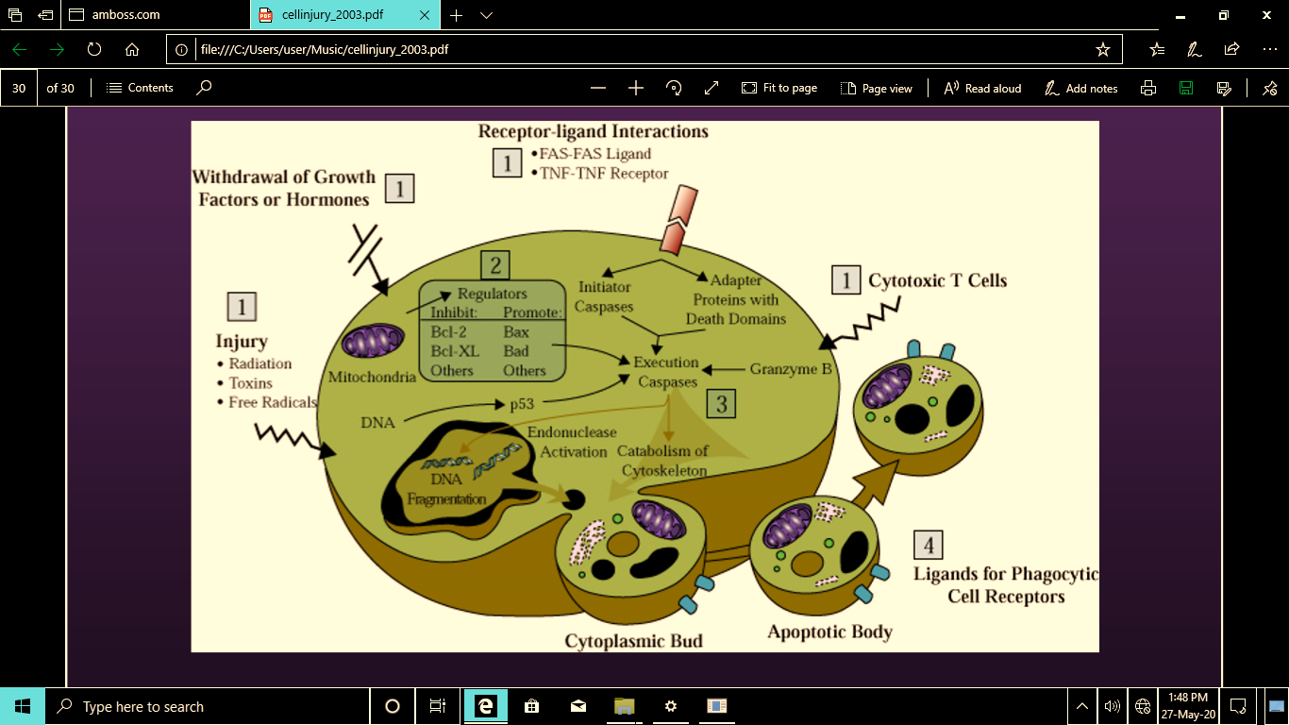
Highlight of Events in Apoptosis

