MATRIX NUMBER; 17/MHS02/045
COURSE TITLE; CELLULAR PATHOLOGY
COURSE CODE; NSC308
SEMESTER; 2ND
SESSION; 2019/2020
STUDENT’S NAME; INEGBEDION OMONE
LECTURER’S NAME; DR EKUNDINA VO

QUESTION
- Write explicitly on 5 diagnostic techniques use in pathology, relevant illustrations and examples required.
- Cellular adaptation precedes cell death, discuss with diagram essential.
ANSWER
Diagnostic techniques used in pathology are
- Histopathology
- Cytopathology
- Hematopathology
- Immunohistochemistry
- Autopsy

- HISTOPATHOLOGICAL TECHNIQUES
Histopathological examination studies tissues under the microscope. During this study, the pathologist looks for abnormal structures in the tissue. Tissues for histopathological examination are obtained by biopsy. Biopsy is a tissue sample from a living person to identify the disease. Biopsy can be either incisional or excisional.
Illustration; Once the tissue is removed from the patient, it has to be immediately fixed by putting it into adequate amount of 10% Formaldehyde (10% formalin) before sending it to the pathologist. The purpose of fixation is:
1. to prevent autolysis and bacterial decomposition and putrefaction
2. to coagulate the tissue to prevent loss of easily diffusible substances
3. to fortify the tissue against the deleterious effects of the various stages in the preparation of sections and tissue processing.
4. to leave the tissues in a condition which facilitates differential staining with dyes and other reagents.
Once the tissue arrives at the pathology department, the pathologist will exam it macroscopically (i.e. naked-eye examination of tissues). Then the tissue is processed to make it ready for microscopic examination. The whole purpose of the tissue processing is to prepare a very thin tissue (i.e. five to seven μm or one cell thick tissue) which can be clearly seen under the microscope. The tissue is processed by putting it into different chemicals. It is then impregnated embedded) in paraffin, sectioned (cut) into thin slices, & is finally stained. The stains can be Hematoxylin/Eosin stain or special stains such as PAS, Immunohistochemistry, etc. The Hematoxylin/Eosin stain is routinely used. It gives the nucleus a blue color & the cytoplasm & the extracellular matrix a pinkish color. Then the pathologist will look for abnormal structures in the tissue. And based on this abnormal morphology he/she will make the diagnosis. Histopathology is usually the gold standard for pathologic diagnosis. And an example is
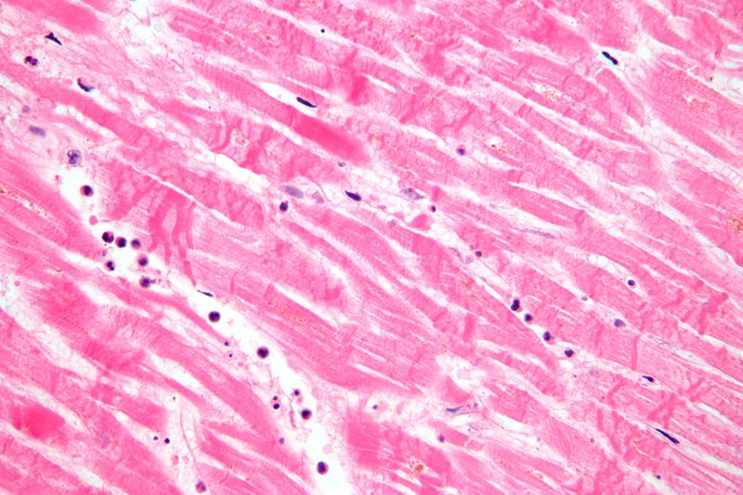

- CYTOPATHOLOGIC TECHNIQUES
Cytopathology is the study of cells from various body sites to determine the cause or nature of disease. The main applications of cytology include the following:
1. Screening for the early detection of asymptomatic cancer. For example, the examination of scrapings from cervix for early detection and prevention of
cervical cancer.
2. Diagnosis of symptomatic cancer. Cytopathology may be used alone or in conjunction with other modalities to diagnose tumors revealed by physical or radiological examinations. It can be used in the diagnosis of cysts, inflammatory conditions and infections of various organs.
3. Surveillance of patients treated for cancer. For some types of cancers, cytology is the most feasible method of surveillance to detect recurrence. The best example is periodic urine cytology to monitor the recurrence of cancer of the urinary tract. There are different cytopathologic methods including:
1. Fine-needle aspiration cytology (FNAC); In FNAC, cells are obtained by aspirating the diseased organ using a very thin needle under negative pressure. Virtually any organ or tissue can be sampled by fine-needle aspiration. The aspirated cells are then stained & are studied under the microscope. Superficial organs (e.g. thyroid, breast, lymph nodes, skin and soft tissues) can be easily aspirated. Deep organs, such as the lung, mediastinum, liver, pancreas, kidney, adrenal gland, and retroperitoneum are aspirated with guidance by fluoroscopy, ultrasound or CT scan. FNAC is cheap, fast, & accurate in diagnosing many diseases.
2. Exfoliative cytology; Refers to the examination of cells that are shed spontaneously into body fluids or secretions. Examples include sputum, cerebrospinal fluid, urine, effusions in body cavities (pleura, pericardium, peritoneum), nipple discharge and vaginal discharge.
3. Abrasive cytology; Refers to methods by which cells are dislodged by various tools from body surfaces (skin, mucous membranes, and serous membranes). E.g. preparation of cervical smears with a spatula or a small brush to detect cancer of the uterine cervix at early stages. Such cervical smears, also called Pap smears, can significantly reduce the mortality from cervical cancer. Cervical cancer is the most common cancer in Ethiopian women.

- HEMATOLOGICAL EXAMINATION
This is a method by which abnormalities of the cells of the blood and their precursors in the bone marrow are investigated to diagnose the different kinds of anemia & leukemia.
Illustration is that the blood test most commonly done is the complete blood count (CBC). The CBC is an evaluation of all the cellular components (red blood cells, white blood cells, and platelets) in the blood. Automated machines do this test in less than 1 minute on a small amount of blood. The CBC is supplemented in some instances by examination of blood cells under a microscope (blood smear). Abnormal red blood cells may be fragmented or shaped like teardrops, crescents (sickle-shaped), or a variety of other forms. Knowing the specific shape and size of red blood cells can help a doctor diagnose a particular cause of anemia. For example, sickle-shaped cells are characteristic of sickle cell disease, small cells containing insufficient amounts of hemoglobin are likely due to iron deficiency anemia, and large cells suggest anemia due to a deficiency of folate (folic acid) or vitamin B12.
To do this, a drop of blood is smeared across a glass slide to form a thin layer that makes it easy to see individual blood cells. The slide is then stained with colored chemicals to reveal specific characteristics of the blood cells and examined under the microscope.
Once a doctor determines that something is wrong with one or more of the cell types in the blood, many additional tests are available to shed more light on the problem. Doctors can measure the proportion of the different types of white blood cells and can determine subtypes of these cells by assessing certain markers on the surface of the cells. Tests are available to measure the ability of white blood cells to fight infection, to assess the functioning of platelets and their ability to clot, and to measure the contents of red blood cells to help determine the cause of anemia or why the cells are not functioning properly. Most of these tests are done on samples of blood, but some require a sample from the bone marrow. And an example is
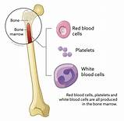

- IMMUNOHISTOCHEMISTRY
This is a method is used to detect a specific antigen in the tissue in order to identify the type of disease. It has several advantage when compared to traditional identification method. It is a technique that is expanding the diagnostic capability of the pathologist. Immunohistochemistry permits rapid agent identification. It employs specific antibodies, which localizes the antigens of the etiologic agent of interest. Since the technique uses formalin fixed tissues, specimen transport is simplified, allowing workers exposure to infectious agent. Immunohistochemistry is a sensitive and specific test that methodology for many microorganism, and unlike some traditional staining methods, they result in direct, highly interpretable visual evidence of the presence of an infectious agent within the tissue.
Illustration for immunohistochemistry is that The tissue and cells must be fixed using a chemical like formaldehyde. This stabilizes the structural properties of cells, preventing them from changing throughout the process. Cells need to be permeated using a detergent such as Triton X, which allows antibodies to enter tissue and bind to epitopes within the cell. Primary antibodies against a protein of interest are added and secondary antibodies with enzymes like horseradish peroxides (HRP) conjugated to their Fc domain are added to target the primary antibody.
Enzymes like HRP can target certain substrates molecules like diaminobenzidine (DAB) and catalyze an oxidation which results in the creation of a colorful compound. This colorful compound will stay localized to the area near the protein of interest; a different color from the rest of the tissue. Tissues are counter stained using a dye like hematoxylin to create contrast between the tissue stained using IHC and non colored regions for better visualization. And example is
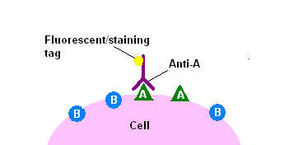

- AUTOPSY
Autopsy/post mortem/obduction/necropsy/autopsia cadeverum is an examination of the dead body to identify the cause of death or injury that may be present or research or educational purpose. This can be for forensic or clinical purposes.
Illustration for an autopsy can be divided into two namely
External examination: autopsy begins with a careful inspection of the body which can help establish, identify or cause of the death. The pathologist weigh and measure the body noting the subject cloth, characteristics such as eye color, hair color, sex and age.
Removing the cloth examining the body searching for gunpowder residue, paint flakes or other deposit, identifying marks such as scar, tattoos and injuries, x-ray can sometimes be used to reveal bone abnormalities and location of bullet or other objects.
Example:
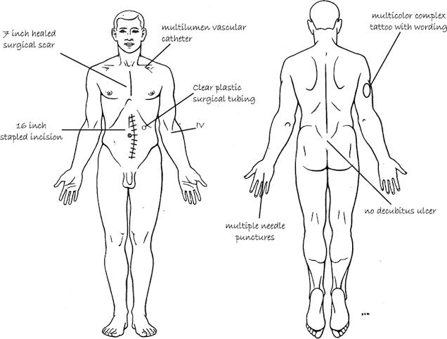
Internal examination: the pathologist examine the chest, pelvic organ. First of all the pathologist make an incision with the shape from the two end of the shoulder tip extending down to the pubic region examining the organ in situ( in place) which means removing he rib cage. Using a saw or rib cutter he/she cuts along the boundary between the ribs and the cartilage remove the entire frontal ribcage on each organ examined with in the beds removed weigh and examined in further detail, if the brain is to be examined. It is placed in formalin for day or even weeks
EXAMPLE>
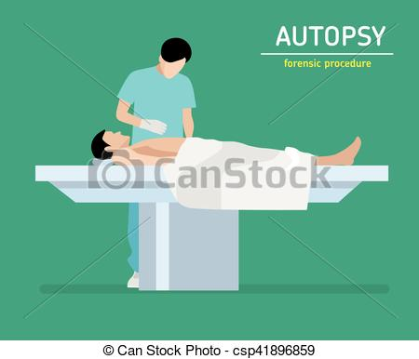

2. The diagram below explains this sequence. Cellular adaptation is the ability of cells respond to various types of stimuli and adverse environmental changes. These adaptations include Hypertrophy (enlargement of individual cells), Hyperplasia (increase in the number of cells), Atrophy (reduction in the number and size of cells), Metaplasia (transformation of one epithelium to another) and Dysplasia (disordered growth of cells). Tissues adapt differently depending on the replicative characteristics of the cells that make up the tissue. For example, labile tissue such as the skin can rapidly replicate and therefore can also regenerate after injury whereas permanent tissue such as neural and cardiac tissue cannot regenerate after injury. Its cells are not able to adapt to the adverse environmental changes. Cellular adaptation could be normal (physiological) or abnormal (pathological).
When cells are injured, one or two patterns will gradually occur; reversible cell injury leading to adaptation of the cells and tissues, or irreversible cell injury leading to cell death and tissue damage. Injured cells may accumulate materials including fat, cholesterol, protein, glycogen or pigment. When cells are irreversibly injured and dying, specific nuclear changes may be visible including pyknosis, karyrrhexis and karyolysis. If large number of cells dies, tissue necrosis may occur. Observable patterns of necrosis include; coagulative, liquefactive, fibrinous, gummatous, fat, gangrene and caseous necrosis.

