CHM210
18/SCI03/008
- Activation energy is the minimum amount of energy required to activate atoms or molecules (reactants) in order to undergo a specific reaction.
- K=A$e^{-Ea/RT}$
K=rate constant
A= pre exponential or Arrhenius factor
Ea= activation energy
R= 8.314J/K which is a constant
T= temperature in Kelvin
b.i) The exponential term in the Arrhenius equation implies that the rate constant of a reaction decreases exponentially when the activation energy is increases. Because the rate of reaction is directly exponential to the rate of the reaction, the rate decreases exponentially as well. Because a reaction with high activation energy requires a lot of energy to reach the transition state, it proceeds slower than a reaction with larger activation energy.
ii) The Arrhenius equation can be used to determine the effect of change in temperature on the rate constant and consequently the rate of reaction. For a temperature change from 293K to 303K, the frequency factor is approximately constant but the quantity$e^{-Ea/RT}$, the fraction of molecules with energies equal to or in excess of the activation energy. With activation energy of 50KJ/mol, at 293K, the value of the fraction is 1.21${x10}^{-9}$ raising the temperature by 10K makes the fraction 2.38${x10}^{-9}$. The fraction of the molecules able to react has almost doubled by increasing the temperature by 10K, the rate of reaction is nearly doubled.
- Table of the graph
In K | 1/T
-10.9 | 0.00335
-9.6 | 0.00324
-10.5 | 0.00314
-9.4 | 0.00304
-10.6 | 0.00295

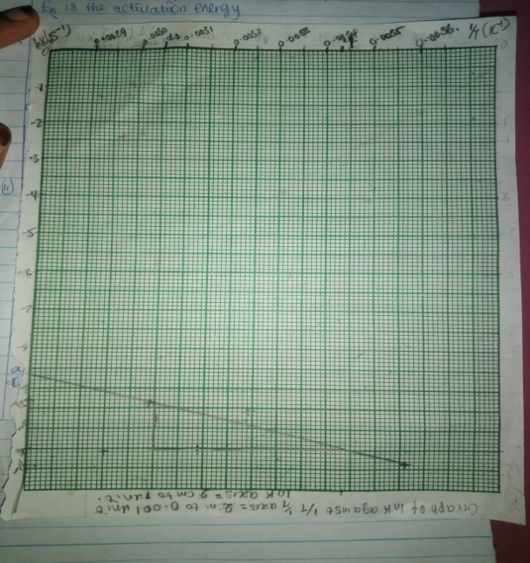
Slope=lnK1-lnK2/1/t1-1/t2
Slope=-9.4-(-10.5)/0.00305-0.00343 = 1.1/-0.00038 = -2894.7368
Slope=$-Ea/R$ = -2894.7368
Ea= -8.314x-2894.7368 =24066.84211 J/mol
Ea= 24.066KJ/mol.

