NWABINELI EMELDA CHISOM
15/ENG05/016
MECHATRONICS ENGINEERING
MCT 510

Assignment.

1. Single phase Half wave controlled Rectifier
Single Phase Half Wave Controlled Rectifier, as the name suggests, is a rectifier circuit which converts AC input into DC output only for positive half cycle of the AC input supply. The word “controlled” means that, we can change the starting point of load current by controlling the firing angle of SCR. These words might seem a lot technical. But firing of SCR simply means, the SCR turn ON at certain point of time when it is forward biased.
A Single Phase Half Wave Controlled Rectifier circuit consists of SCR / thyristor, an AC voltage source and load. The load may be purely resistive, Inductive or a combination of resistance and inductance. For simplicity, we will consider a resistive load. A simple circuit diagram of Single Phase Half Wave Controlled Rectifier is shown in figure below.
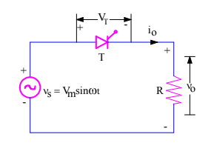
v0 = Load output voltage
i0 = Load current
VT = Voltage across the thyristor T

2. Single phase Full wave controlled Rectifier using a centre tapped transformer
When an additional wire is connected across the exact middle of the secondary winding of a transformer, it is known as a center tapped transformer. The full-wave rectifier circuit using two diodes and a centre-tapped transformer shown in Figure 1-1. The centre-tap is usually taken as the ground or zero voltage reference point.
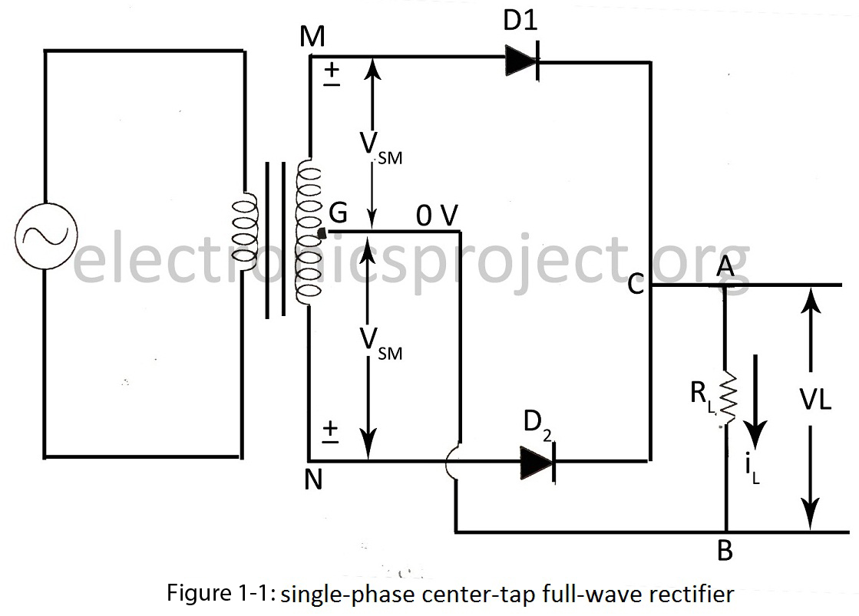
When input ac supply is switched on, the ends M and N of the transformer secondary become +ve and -ve alternately. During the positive half-cycle of the ac input, terminal M is +ve, G is at zero potential and N is at –ve potential. Hence, being forward-biased, diode D1 conducts (but not D2 which is reversed-biased) and current flows along MD1CABG. As a result, positive half-cycle of the voltage appears across RL.
During the negative half-cycle, when the terminal N becomes +ve, then D2 conducts (but not D1) and current flows along ND2CABG. So, we find that the current keeps on flowing through RL in the same direction (i.e. from A to B) in both half-cycles of ac input. It means that both half-cycles of the input ac supply are utilized as shown in figure 1-2. Also, the frequency of the rectified output voltage is twice the supply frequency. Of course, this rectified output consists of a dc component and many ac components of diminishing amplitudes.
3. Single phase Full wave Rectifier (Semi -converter Bridge configuration)
In a single-phase, half-controlled bridge converter, two of the bridge arm thyristors are diodes. A third, freewheeling, diode is normally used to prevent the load current from circulating through two devices in a bridge arm. Note that the output voltage for this converter can not become negative, because whenever it tends to do so, the load current commutates to the freewheeling diode and the output voltage becomes zero. The input AC source is then relieved from supplying the lagging component of the load current. The absence of this lagging component of the source current implies that this converter operates with a higher power factor than the fully controlled converter.

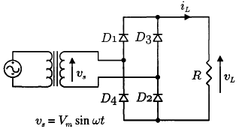

4. Three phase full wave Rectifier (semi-converter Bridge configuration)
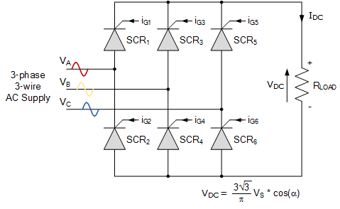

Three-phase rectification is the process of converting a 3-phase AC supply into a pulsating DC voltage as rectification converts the input power supply of a sinusoidal voltage and frequency into a fixed voltage DC power. Thus power rectification changes an alternating supply into a unidirectional supply.
But we have also seen that 3-phase half-wave uncontrolled rectifiers, which use one diode per phase, require a star connected supply as a fourth neutral (N) wire to close the circuit from load to source. The 3-phase full-wave bridge rectifier which use two diodes per phase requires just three mains lines, without neutral, such as that provided by a delta connected supply.
Another advantage of a full-wave bridge rectifier is that the load current is well balanced across the bridge improving efficiency (the ratio of output DC power to input power supplied) and reducing the ripple content, both in amplitude and frequency, as compared to the half-wave configuration.
By increasing the number of phases and diodes within the bridge configuration it is possible to obtain a higher average DC output voltage with less ripple amplitude as for example, in 6-phase rectification each diode would conduct for only one-sixth of a cycle

5. Single phase full wave Rectifier (Full converter Bridge configuration)
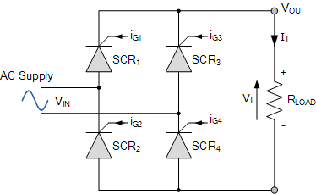
Single phase fully-controlled bridge rectifiers are known more commonly as AC-to-DC converters. Fully-controlled bridge converters are widely used in the speed control of DC machines and is easily obtained by replacing all four diodes of a bridge rectifier with thyristors as shown.
In the fully-controlled rectifier configuration, the average DC load voltage is controlled using two thyristors per half-cycle. Thyristors SCR1 and SCR4 are fired together as a pair during the positive half-cycle, while thyristors SCR3 and SCR4 are also fired together as a pair during the negative half-cycle. That is 180o after SCR1 and SCR4.
Then during continuous conduction mode of operation the four thyristors are constantly being switched as alternate pairs to maintain the average or equivalent DC output voltage.

6. Three phase full wave Rectifier (Full converter bridge configuration)
three phase full converter is a fully controlled bridge controlled rectifier using six thyristors connected in the form of a full wave bridge configuration. All the six thyristors are controlled switches which are turned on at a appropriate times by applying suitable gate trigger signals.
The three phase full converter is extensively used in industrial power applications upto about 120kW output power level, where two quadrant operations is required.
The figure shows a three phase full converter with highly inductive load. This circuit is also known as three phase full wave bridge or as a six pulse converter.
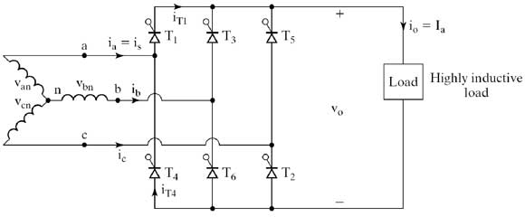

7. Single phase half wave uncontrolled Rectifier
This is the simplest and probably the most widely used rectifier circuit albeit at relatively small power levels. The output voltage and current of this rectifier are strongly influenced by the type of the load. The switching device is diode which is turned on and off by the electrical circuit only, therefore it called uncontrolled rectifier.
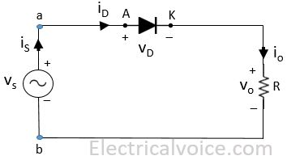
8. Single phase full wave uncontrolled Rectifier
In full wave rectifiers we can obtain output voltage during the positive and negative half cycles. Therefore it delivers improved efficiency than the half wave rectifiers. It produces an output voltage that is purely DC. For the full wave rectifiers the average direct current output voltage is higher than that of half wave, the output of the full wave rectifier has much less ripple than that of the half wave rectifier producing a smoother output waveform.
In a single phase, Full Wave uncontrolled Rectifier circuit two diodes are now used. Only one diode will be forward biased and conducts during each half cycle.
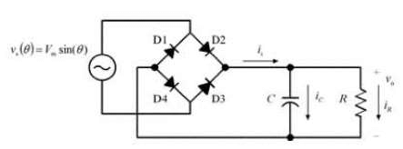
9. Single phase full wave uncontrolled Rectifier using centre tapped transformer
When an additional wire is connected across the exact middle of the secondary winding of a transformer, it is known as a center tapped transformer.
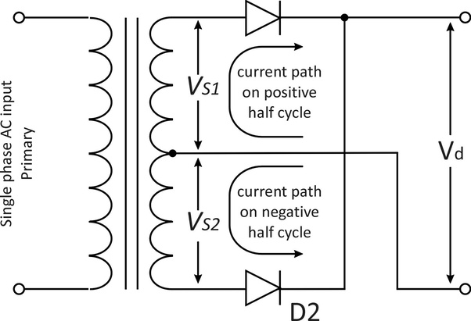
10.Single phase full wave uncontrolled Rectifier using bridge configuration
This bridge configuration of diodes provides full-wave rectification because at any time two of the four diodes are forward biased while the other two are reverse biased. Thus there are two diodes in the conduction path instead of the single one for the half-wave rectifier. Therefore there will be a difference in voltage amplitude between VIN and VOUT due to the two forward voltage drops of the serially connected diodes. Here as before, for simplicity of the maths we will assume ideal diodes.
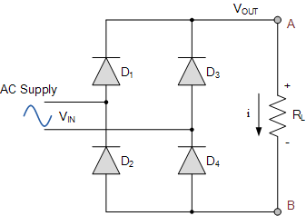
11. Three phase full wave uncontrolled Rectifier using the bridge configuration.

The full-wave three-phase uncontrolled bridge rectifier circuit uses six diodes, two per phase in a similar fashion to the single-phase bridge rectifier. A 3-phase full-wave rectifier is obtained by using two half-wave rectifier circuits. The advantage here is that the circuit produces a lower ripple output than the previous half-wave 3-phase rectifier as it has a frequency of six times the input AC waveform.
Diodes D1 D3 D2 and D4 form a bridge rectifier network between phases A and B, similarly diodes D3 D5 D4 and D6 between phases B and C and D5 D1 D6 and D2 between phases C and A.
Thus diodes D1 D3 and D5 feed the positive rail and depending on which one has a more positive voltage at its anode terminal conducts. Likewise, diodes D2 D4 and D6 feed the negative rail and whichever diode has a more negative voltage at its cathode terminal conducts.
Then we can see that for three-phase rectification, the diodes conduct in matching pairs giving a conduction pattern for the load current of: D1-2 D1-6 D3-6 D3-6 D3-4 D5-4 D5-2 and D1-2 as shown.
