Name: Okpiri Regina Tamara-meisinde

Department: Biochemistry

Course code: Bch 308

Assignment

Norepinephrine Synthesis and Release
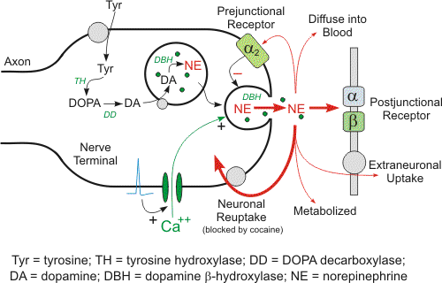
Norepinephrine (NE) is the primary neurotransmitter for postganglionic sympathetic adrenergic nerves. It is synthesized inside the nerve axon, stored within vesicles, then released by the nerve when an action potential travels down the nerve. Below are the details for release and synthesis of NE:
- The amino acid tyrosine is transported into the sympathetic nerve axon.
- Tyrosine (Tyr) is converted to DOPA by tyrosine hydroxylase (rate-limiting step for NE synthesis).
- DOPA is converted to dopamine (DA) by DOPA decarboxylase.
- Dopamine is transported into vesicles then converted to norepinephrine (NE) by dopamine β-hydroxylase (DBH); transport into the vesicle can by blocked by the drug reserpine.
- An action potential traveling down the axon depolarizes the membrane and causes calcium to enter the axon.
- Increased intracellular calcium causes the vesicles to migrate to the axonal membrane and fuse with the membrane, which permits the NE to diffuse out of the vesicle into the extracellular (junctional) space. DBH, and depending on the nerve other secondary neurotransmitters (e.g., ATP), is released along with the NE.
- The NE binds to the postjunctional receptor and stimulates the effector organ response.

