OBERHIRHI FAVOUR OGHENENYORE
17/ENG01/019
PROCESS INSTRUMENTATION ASSGNMENT
CHEMICAL ENGINEERING

- BRIEFLY DESCRIBE CHEMICAL PROCESS DIAGRAM

Basically there are three types of process diagrams in chemical engineering context.
- BFD - Block Flow Diagrams.
- PFD - Process Flow Diagrams.
- P&ID - Piping and Instrumentation Diagrams.

In a brief BFD represents entire process in a single sheet, where as in PFD you can find some detailed information like plant operating conditions, process flow. It uses symbols to represent the equipment. P&IDs provide detail information when compared to above two drawings. They use standard nomenclature, symbols, and tag numbers to fully describe the process.
These drawings are very useful as they convey the right amount of process information as needed during various stages of bidding, engineering design, procurement, construction, operating & decommissioning phases of the process.

BFD-Block Flow Diagram

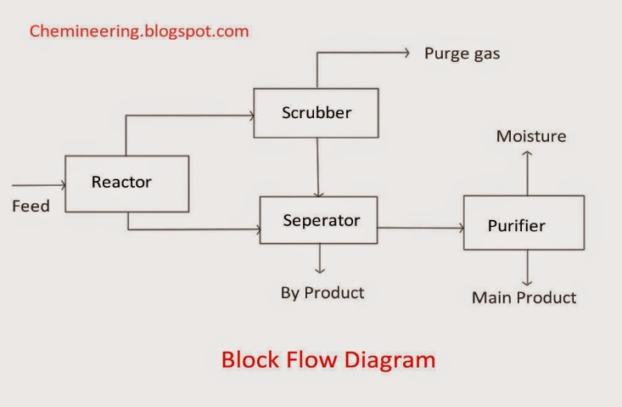

A BFD has the ability to represent the complete process on a little more than a single sheet. It contains mainly text enclosed by boxes, interconnecting lines with flow arrows. In some BFDs mass flow rates may be mentioned so as to describe the material balance over the entire plant.

PFD-Process Flow Diagram
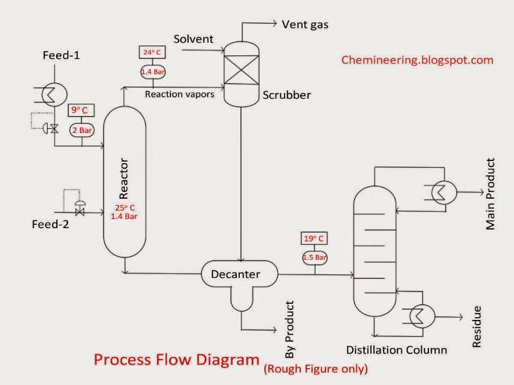

PFDs contain more information than the block flow diagrams from which they are derived. They show more detail about major equipment, subsystems and the flow of product between them. A typical PFD contains equipment symbols connected by process lines where temperature and pressure information are shown on the line itself. You can easily refer the properties of a particular stream through stream number. For designing a P&ID, equipment layout PFD is mandatory.

P&ID-Piping and Instrumentation Diagram
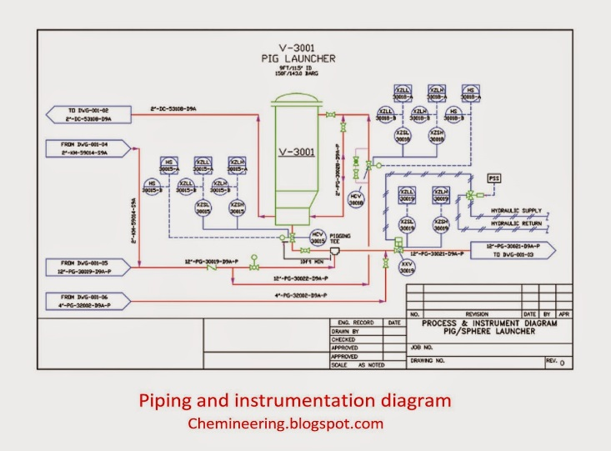

P&IDs carry a lot of information to define the process. Derived from PFD it is the best way of accurately documenting the operation of a process. P&ID takes the conceptual aspects of PFD and expand them by adding

1. Detailed symbols.
2. Detailed equipment information.
3. Equipment order and process sequence.
4. Process and utility piping.
5. Process flow direction.
6. Major and minor bypass lines.
7. Line numbers, Pipe spec, Pipe size.
8. Isolation and shut off valves.
9. Instrumentation controls.
10. Types of process component connections.

A piping and instrumentation diagram (P&ID) is defined as follows:
- A diagram which shows the interconnection of process equipment and the instrumentation used to control the process. In the process industry, a standard set of symbols is used to prepare drawings of processes. The instrument symbols used in these drawings are generally based on International Society of Automation (ISA) Standard S5.1
- The primary schematic drawing used for laying out a process control installation.
They usually contain the following information:
- Mechanical equipment, including
  - Pressure vessels, columns, tanks, pumps, compressors, heat exchangers, furnaces, wellheads, fans, cooling towers, turbo-expanders, pig traps (see 'symbols' below)
  - Bursting discs, restriction orifices, strainers and filters, steam traps, moisture traps, sight-glasses, silencers, flares and vents,flame arrestors, vortex breakers, eductors

- OUTLINE THE PURPOSE OF P&ID AND LIST ITS DIVISION

PURPOSE OF P&ID

A piping and instrumentation diagram (P&ID) is a drawing in the process industry.
A P&ID shows all piping, including the “physical sequence of branches, reducers, valves, equipment, instrumentation and control interlocks.”
A P&ID is used to operate the process system, since it shows the piping of the process flow along with the installed equipment and instrumentation. P & IDs play a key role in maintaining and modifying the process they describe, because it is important to demonstrate the physical sequence of equipment and systems, including how these systems connect.
In terms of processing facilities, a P&ID is a visual representation of key piping and instrument details, control and shutdown schemes, safety and regulatory requirements, and basic start-up and operational information.

ii) ITS DIVISION
- Instrumentation and designations
- Mechanical equipment with names and numbers
- All valves and their identifications
- Process piping, sizes, and identification
- Vents, drains, special fittings, sampling lines, reducers, increasers, and swaggers
- Permanent start-up and flush lines
- Flow directions
- Interconnections references
- Control inputs and outputs, interlocks
- Interfaces for class changes
- Computer control system
- Identification of components and subsystems delivered by the process

3) GIVE FIVE COMMON P&ID SYMBOLS WITH THE INSTRUMENT ABBREVIATIONS USED IN INSTRUMENT DIAGRAM.

SYMBOLS | INSTRUMENT ABBREVIATIONS
 | GV
 | FI
 | FR
 | PRC
 | PSV

REFRENCE
    - https://1.bp.blogspot.com/-NbmlW7nmwrM/Tc_LuuQa15I/AAAAAAAAAKI/euYRzMUYyK8/s1600/P%2526ID+Symbols.jpg
    - https://www.instrumentationtoolbox.com/2011/05/how-to-construct-instrument.html
    - https://www.informit.com/articles/article.aspx?p=1915161&seqNum=2
    - https://www.camcode.com/asset-tags/what-is-p-id/
    - https://www.google.com/search?sxsrf=ALeKk02vJPFI1sw16lfWAOZNcPX0jWLtJg%3A1590683747696&lei=Y-jPXtT4KYyxUJi1s9AE&q=p%26id%20drawings%20explained&ved=2ahUKEwiUtuzd_tbpAhWMGBQKHZjaDEoQsKwBKAV6BAgTEAY&biw=1360&bih=667
    - https://www.google.com/search?q=Different+types+of+chemical+process+diagrams&oq=Different+types+of+chemical+process+diagrams&aqs=chrome..69i57.7095j0j4&sourceid=chrome&es_sm=93&ie=UTF-8

