FASINA MOFOLUWAKE
17/MHS06/033
Questions
- Write explicitly on 5 diagnostic techniques use in pathology, relevant illustrations and examples required.
Answer
- Histopathology
Histopathological examination studies tissues under the microscope. During this study the pathologist looks for abnormal structures in the tissue. Tissues for histopathological examination is obtained from biopsy. Biopsy is a tissue sample from a living person to identify the disease, once the tissue is removed from the patient, it is immediately fixed by putting it into adequate amount of 10% formaldehyde before sent to the pathologist.
Purpose of fixation is
- To prevent autolysis and bacterial decomposition and putrefaction
- To coagulate the tissue to prevent loss of easily diffusible substance
- To leave tissues in a condition which facilities differential staining with dye and another reagent
The tissue is processed to make it ready from microscope examination. The whole purpose of the tissue processing is to prepare a very thin tissue which can be clearly seen under the microscope. The tissue is processed by putting it into different chemical. It is then embedded in paraffin, sectioned into thin slices and its finally strained. The stain can be hematoxylin/eosin strain or special strain.
The hematoxylin/eosin strain are usually abbreviated as H&E stain. It gives the nucleus a blue color. The pathologist will look for abnormal structure in the tissue. And the based on this morphology. Histopathology is usually the gold standard for pathologic diagnosis.
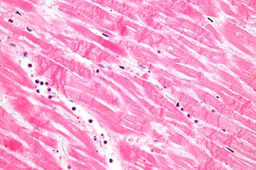
Micrograph showing contraction band necrosis, a histopathologic finding of myocardial infarction (heart attack).

- Cytopathology
Cytopathology is the study of cell from various body site to determine the cause or nature of disease.
Application
- Screening from the early detection of asymptomatic cancer: For example, the examination of scraping cervix for early detection and prevention of cervical cancer.
- Diagnosis of symptomatic cancer: Cytopathology may be used alone or in conjunction with other modalities to diagnose tumor revealed by physical or radiological examination. It can be used in the diagnosis of cysts, inflammatory condition and infection of various organs.
- Surveillance of patient treated for cancer: for some type of cancer, cytology is the most feasible method of surveillance to detect recurrence. Example: periodic urine cytology to monito the recurrence of cancer of urinary tract.
Advantage of cytological examination: it is cheap, less time and no anesthesia to the specimen.
Cytopathology method
- Fine- needle aspiration cytology (FNAC): cells are obtained by aspiration the disease organ using a very thin needle under negative pressure. The aspiration cell is then strained and are studied e.g. breast thyroid skin kidney. It is cheap, fast and accurate
- Exfoliative cytology: refers to the examination of cell that are shed spontaneously into body fluid or secretion e.g. sputum, cerebrospinal fluids nipple and vaginal discharge
- Abrasive cytology: this is a method by which cell are dislodged by various tools from body surface e.g. preparation of cervical smear with a spatula or brush to detect cancer of the uterine cervix at early stage. Such as pap smear can scientifically reduce mortality from cervical cancer.
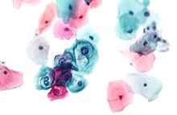
A micrograph of an exfoliative cytopathology specimen (Pap test, Pap stain)

- Hematopathology
This is method by which abnormalities of the cell of the blood and their precursor int the bone marrow is investigated to diagnose the different kind of anemia and leukemia. Hematopathology is the study of diseases of the cells that make up our blood. For example, White blood cells are present in many important structures of the body, like lymph nodes, and are major components of the immune system. When disease invades, the body sends these cells to fight bacteria and viruses by producing antibodies against the infection.
The role of an hemapathologist is they are specially trained to diagnose diseases of the blood cells. They use specialized tests such as flow cytometry studies and immunohistochemistry. The hematopathologist uses the results of these tests to diagnose infections and diseases of the blood, lymph nodes and bone marrow.
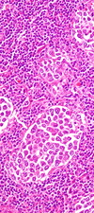
Mature B-cell Neoplasms

- Immunohistochemistry
This is a method is used to detect a specific antigen in the tissue to identify the type of disease. It is the application of immunological techniques to cellular pathogen. It is used to detect the status and localization of antigen in the cell by use of specific antibodies which are then visualized by chromogen as brown color. This then helps in determining cells lineage specifically or is used to confirm a specific infection. IHC has revolutionized diagnostic pathology
It can be traced to immunofluorescent method in which antibodies labelled with fluorescent compound could localized the specific antigen in the cryostat section. Selection of antibodies for performing immunohistochemistry staining is done after making differentiate diagnosis on H&E section
Procedure
- Peroxidase anti-peroxidase (PAP): this is a method where the reagent is pre-formed stable immune – complex which is linked to the primary antibody by bridge antibody
- Avidin-biotin conjugate (ABC) immunoenzymatically technique in which biotinylated secondary antibody serves to link the primary antibody to a large performed complex of avidin, biotin and peroxidase
Application of immunohistochemistry
- Tumor of uncertain histogenesis: this is the diagnosis od tumor of uncertain origin as well as metastatic from a primary unknown primary tumor. A panel of antibodies is resolving such diagnosis problem cases, the selection of antibodies being made history.
- Prognostic markers in cancer: this is to predict the prognosis of tumor by detection of micro metastasis, occult metastasis and by identification of certain feature acquired or product elaborated, or gene overexpressed by the malignant
- Predication to response to therapy: it used to predict therapeutic response in two important tumor carcinoma of the breast and prostate.
- Infection: stain is now being applied to confirm infectious agent in tissue by use of specific antibodies against microbial DNA or RNA e.g. detection of virus and parasite

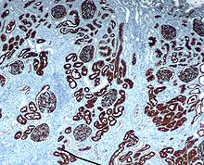
Chromogenic immunohistochemistry of a normal kidney targeting the protein CD10.

- Cytogenetic
This is a method in which inherited chromosomal abnormalities in the germ cell or acquired chromosomal abnormalities in somatic cells are investigated using the techniques of molecular biology. Human somatic cell are diploids and contains 46 chromosomes :22 pairs of autosomes and one pair of sex chromosome XX in the case of female and XY in the male. Karyotyping is defined as the sequence of chromosome alignment based on size, centromeric location and banding pattern.
Cytogenic analysis include Cell selection, cell culture, staining /banding, microscopic analysis
Application
- Chromosomal numerical abnormalities E.g. down syndrome (trisomy 21 involving autosome 21. Khnefelt syndrome
- Chromosomal structural abnormalities including translocation E.g. Philadelphia chromosome, deletion, insertion, isochromosomes and ring chromosome formation
- Cancer is characteristic by multiple and complex chromosome abnormalities which incuse deletion, application inversion and translocation, especially in leukemia and lymphomas, germs cells tumor and some sarcomas
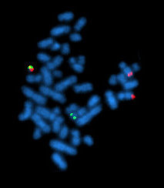
A metaphase cell positive for the BCR/ABL rearrangement using FISH

- Cellular Adaptation precedes cell death, discuss. Diagrams essential.
Cells can die in 2 ways 1. Neurosis and 2. Apoptosis
- Neurosis: 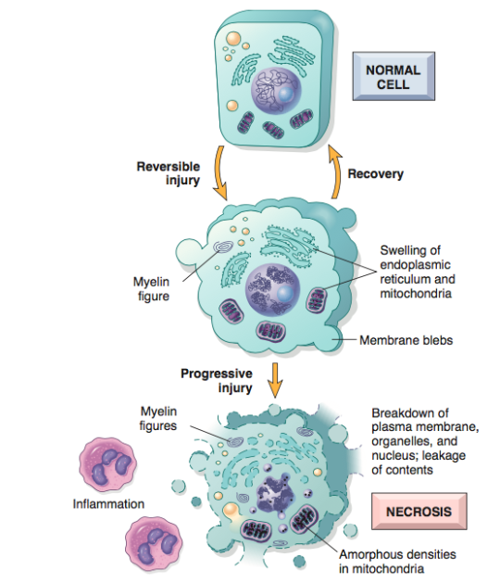
This is when excess fluid enters the cell, swells it and ruptures its membrane which kills it. After the cell has died intracellular degradative reactions occur within a living organism. Necrosis does not occur in dead organism, it takes place in
- Hypoxia: it is decreased oxygen supply to tissue which is caused by
- Ischemia: this is decreased blood flow to or from an organ. It can be caused by obstruction of arterial blood flow or by decreased perfusion of tissue by oxygen carrying blood
- Anemia: this is reduction of number of oxygens carrying red blood cells.
- Carbon monoxide poisoning: co decrease the oxygen capacity of red blood cell by chemical alteration of hemoglobin
- Poor oxygenation of blood due to pulmonary disease: the cell injury that result following hypoxia which is divided into early and late stage synthesis
Early stage (reversible) leads to Failure of the cell membrane which leads to increased intracellular Na and water which causes cellular and organelles swelling and Disaggregation of ribosome and failure of protein synthesis
Late stage(irreversible) leads to Activation of enzymes which damage the cell membrane and organelles membrane
- Cell membrane damage: like extreme temperature, toxin or virus or indirect membrane case of hydroxyl can lead to cell death by disrupting the homeostasis of the cell
- Increased intracellular calcium level: is a common pathway which different cause of cell injury operate e.g. the cell membrane damage leads to increased intracellular calcium
Types of necrosis
- Coagulative necrosis: it results from sudden interruption of blood supply to an organ especially to the heart. It is marked by following nuclear change: pyknosis (which is chromatin clumping and shrinking with increased basophilia, karyorrhexis (fragmentation of chromatin) and kryolysis (fading of the chromatin material.
- Liquefactive necrosis: characterized by digestion of tissues. It shows softening and liquefaction of tissue. It characteristically results from ischemic injury to the cns
- Fat neurosis: it is caused by trauma to the tissues with high fat content such as the breast or it can also be caused by acute hemorrhagic pancreatitis in which pancreatic enzyme diffuse into the inflamed pancreatic tissues and digest it.
- Caseous necrosis: it has a cheese like appearance to the naked eye. And it appears as an amorphous eosinophilic material on microscopic examination
- Gangrenous necrosis: due to vascular occlusion and most often affect the lower extremities and the bowel. It called wet gangrene if its complicated by bacterial infection which leads to superimposed liquefactive neurosis
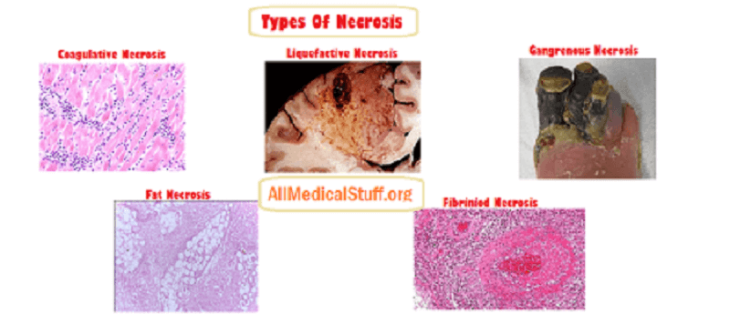

- Apoptosis
This is the death of a single cell within cluster of other cells. In apoptosis the cell show shrinkage and increase acidophilic staining of the cell. This is followed by fragmentation of the cell which is called apoptotic bodies. It occurs as physiologic process of removal cells during embryogenesis etc.
Pathological calcification
- Metastatic calcification
This is caused by hypercalcemia resulting from hyperparathyroidism, milk alkali syndrome etc.
- Dystrophic calcification
This is occurring in previously damaged tissue such as area of old trauma, tuberculous lesion, sacred heart valves and atherosclerotic lesions. Unlike metastatic calcification, it is not caused by hypercalcemia.
