NAME: AYINDE WALIAT ODUNAYO.
MATRIC NO: 17/MHS02/028.
DEPARTMENT: NURSING.
COURSE TITLE: CELLULAR PATHOLOGY.
COURSE CODE: NSC 308.

(1) DIAGNOSTIC TECHNIQUES USED IN PATHOLOGY.
The pathologist uses the following techniques to diagnose diseases:
(1). Cytopathology.
(2). Histopathology.
(3). Hematopathology.
(4). Immunohistochemistry.
(5). Molecular techniques.

(1).CYTOPATHOLOGICTECHNIQUES.
Cytopathology is the study of cells from various body sites to determine the cause or nature of disease.
Applications of cytopathology:
The main applications of cytology include the following:
1. Screening for the early detection of asymptomatic cancer: For example, the examination of scrapings from cervix for early detection and prevention of cervical cancer.
2. Diagnosis of symptomatic cancer: Cytopathology may be used alone or in conjunction with other modalities to diagnose tumours revealed by physical or radiological examinations. It can be used in the diagnosis of cysts, inflammatory conditions and infections of various organs.
3. Surveillance of patients treated for cancer.
For some types of cancers, cytology is the most feasible method of surveillance to detect recurrence. The best example is periodic urine cytology to monitor the recurrence of cancer of the urinary tract.
Advantages of cytologic examination
Compared to Histopathological technique, it is cheap, takes less time and needs no anaesthesia to take specimens. Therefore, it is appropriate for developing countries with limited resources like Ethiopia. In addition, it is complementary to Histopathological examination.
Cytopathologic methods
There are different Cytopathologic methods including:
1. Fine-needle aspiration cytology (FNAC): In FNAC, cells are obtained by aspirating the diseased organ using a very thin needle under negative pressure. Virtually any organ or tissue can be sampled by fine-needle aspiration. The aspirated cells are then stained & are studied under the microscope. Superficial organs (e.g. thyroid, breast, lymph nodes, skin and soft tissues) can be easily aspirated .Deep organs, such as the lung, mediastinum, liver, pancreas, kidney, adrenal gland, and retroperitoneum are aspirated with guidance by fluoroscopy, ultrasound or CT scan. FNAC is cheap, fast, & accurate in diagnosing many diseases.
2. Exfoliative cytology: Is the examination of cells that are shed spontaneously into body fluids or secretions. Examples include sputum, cerebrospinal fluids, urine, nipple discharge, vaginal discharge.
3. Abrasive cytology: Refers to methods by which cells are dislodged by various tools from the body surfaces (skin, mucous membrane, serous membrane) e.g. preparation of cervical smears with a spatula or small brush to detect cancer of the uterine cervix at early stages.
(2). HISTOPATHOLOGICAL TECHNIQUE.
Histopathological examination studies tissues under the microscope. During this study, the pathologist looks for abnormal structures in the tissue. Tissues for histopathological examination are obtained by biopsy. Biopsy is a tissue sample from a living person to identify the disease. Biopsy can be either incisional or excisional. Once the tissue is removed from the patient, it has to be immediately fixed by putting it into adequate amount of 10% Formaldehyde (10% formalin) before sending it to the pathologist. The purpose of fixation is:
1. To prevent autolysis and bacterial decomposition and putrefaction
2. To coagulate the tissue to prevent loss of easily diffusible substances
3. To fortify the tissue against the deleterious effects of the various stages in the preparation of sections and tissue processing.
4. To leave the tissues in a condition that facilitates differential staining with dyes and other reagents.
Once the tissue arrives at the pathology department, the pathologist will exam it macroscopically (i.e. naked-eye examination of tissues).Then the tissue is processed to make it ready for microscopic examination. The whole purpose of the tissue processing is to prepare a very thin tissue (i.e. five to seven μm or one cell thick tissue) which can be clearly seen under the microscope. The tissue is processed by putting it into different chemicals. It is then impregnated (embedded) in paraffin, sectioned (cut) into thin slices, & is finally stained. The stains can be Hematoxylin/Eosin stain or special stains such as PAS, Immunohistochemistry, etc.
The Hematoxylin/Eosin stain is usually abbreviated as H&E stain. The H&E stain is routinely used. It gives the nucleus a blue colour & the cytoplasm & the extracellular matrix a pinkish colour. Then the pathologist will look for abnormal structures in the tissue. And based on this abnormal morphology he/she will make the diagnosis. Histopathology is usually the gold standard for pathologic diagnosis.
(3). HEMATOLOGICAL EXAMINATION.
This is a method by which abnormalities of the cells of the blood and their precursors in the bone marrow are investigated to diagnose the different kinds of anaemia & leukaemia.
(4). IMMUNOHISTOCHEMISTYR.
This is a method is used to detect a specific antigen in the tissue in order to identify the type of disease.
(5). MOLECULARTECHNIQUES.
Different molecular techniques such as fluorescent in situ hybridization, Southern blot, etc. can be used to detect genetic diseases.
(B). CELLULAR ADAPTATION PRECEDES CELL DEATH DISCUSS!!!
The diagram below explains this sequence. Cellular adaptation is the ability of cells respond to various types of stimuli and adverse environmental changes. These adaptations include Hypertrophy (enlargement of individual cells), Hyperplasia (increase in the number of cells), Atrophy (reduction in the number and size of cells), Metaplasia (transformation of one epithelium to another) and Dysplasia (disordered growth of cells). Tissues adapt differently depending on the replicative characteristics of the cells that make up the tissue. For example, labile tissue such as the skin can rapidly replicate and therefore can also regenerate after injury whereas permanent tissue such as neural and cardiac tissue cannot regenerate after injury. Its cells are not able to adapt to the adverse environmental changes. Cellular adaptation could be normal (physiological) or abnormal (pathological).
When cells are injured, one or two patterns will gradually occur; reversible cell injury leading to adaptation of the cells and tissues, or irreversible cell injury leading to cell death and tissue damage. Injured cells may accumulate materials including fat, cholesterol, protein, glycogen or pigment. When cells are irreversibly injured and dying, specific nuclear changes may be visible including pyknosis, karyrrhexis and karyolysis. If large number of cells dies, tissue necrosis may occur. Observable patterns of necrosis include; coagulative, liquefactive, fibrinous, gummatous, fat, gangrene and caseous necrosis.
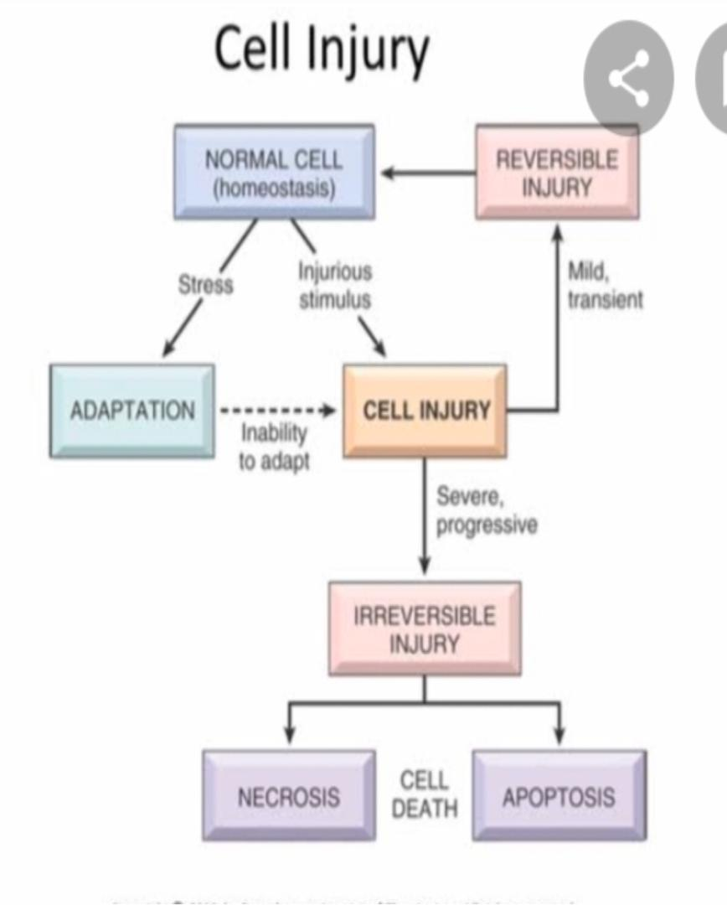

References
Bezabeh M.; Tesfaye A.; Ergicho, B.; Erke, M.; Mengistu, S.and Bedane, A.; Desta, A. (2004).
General Pathology. Jimma University, Gondar University Haramaya University, Dedub University.

