NAME: OLOFINTOYE ODUNAYO CHRISTIANAH
MATRIC NO: 17/ MHS02/ 072
DEPT: NURSING
LEVEL: 300LVL
COURSE CODE: NSC 308
TITLE: CELLULAR PATHOLOGY

DIAGNOSTIC TECHNIQUES USED IN PATHOLOGY
1. Histopathology
2. Cytopathology
3. Cytogenetics
4. Immunohistochemistry
5. Microbiological examination
1. Histopathology: Histopathological examination studies tissues under the microscope. The aim of this study is for the pathologist to look for abnormal structures in the tissue. Tissues for this examination are obtained by biopsy. Biopsy is a tissue sample from a living person to identify the disease. Biopsy can either be incisional or excisional. Once the tissue is removed from the patient, it has to be immediately fixed by putting it into 10% formaldehyde (10% formalin) before sending to the pathologist. The purpose of fixation is:
- to prevent autolysis and bacterial decomposition and putrefaction
- to coagulate tissues to prevent loss of easily diffusible substances
- to fortify the tissues against the deleterious effects of various stages in the preparation of sections and tissue processing
- to leave the tissues in a condition which facilitates differential staining with dyes and other reagents
Once the tissue gets to the pathology department, the pathologist begins to examine it macroscopically. The tissue is then processed to make it ready for microscopic examination. The whole purpose of processing is to prepare a very thin tissue (5-7um or one cell thick tissue) which can be seen clearly under the microscope. The tissue is processed by putting in different chemicals; it is then impregnated in paraffin, sectioned into thin slices and is finally stained. The stains can be Hematoxylin/Eosin stains, such as PAS, immunohistochemistry e.t.c. It gives the nucleus a blue color and the extracellular matrix a pinkish color. Then the pathologist will make a diagnosis based on abnormal morphology observed.
2. Cytopathologic techniques: Cytopathology is the study of cells from various body sites to determine the cause or nature of disease. Cytopathology can be applied in screening for the early detection of asymptomatic cancer, diagnosis of symptomatic cancer, cysts, inflammatory conditions and infection of various organs, surveillance of patients treated for cancer. Compared to histopathology, it is cheap, takes less time to complete and it needs no anesthesia to take specimen. Cytopathological methods include:
- Fine-needle aspiration cytology: cells are obtained by aspirating the diseased organ using a very thin needle under negative pressure. The aspirated cells are the stained and studied under the microscope, superficial organs like breast, thyroid, and lymph nodes e.t.c can be easily aspirated while deep organs like lungs, kidney, and mediastinum are aspirated with guidance by fluoroscopy, ultrasound or CT scan. Fine-needle aspiration cytology is fast, cheap, and accurate in diagnosing many diseases.
- Exfoliative cytology: Is the examination of cells that are shed spontaneously into body fluids or secretions. Examples include sputum, cerebrospinal fluids, urine, nipple discharge, vaginal discharge.
- Abrasive cytology: Refers to methods by which cells are dislodged by various tools from the body surfaces (skin, mucous membrane, serous membrane) e.g. preparation of cervical smears with a spatula or small brush to detect cancer of the uterine cervix at early stages.
3. Cytogenetics (clinical genetics): this is a method in which inherited chromosomal abnormalities in the germ cells or acquired chromosomal abnormalities in somatic cells are investigated using the techniques of molecular biology.
4. Immunohistochemistry: This is a method used to detect a specific antigen in the tissue in order to identify the type of the disease. E.g. antigen-antibody tests.
5. Microbiological examinations: this is a method by which the body fluid, excised tissue are examined by microscopical, cultural, and serological techniques to identify micro-organisms responsible for many diseases.
CELLULAR ADAPTATION PRECEDES CELL DEATH, DISCUSS.
Cellular adaptation is the ability of cells respond to various types of stimuli and adverse environmental changes. These adaptations include Hypertrophy (enlargement of individual cells), Hyperplasia (increase in the number of cells), Atrophy (reduction in the number and size of cells), Metaplasia (transformation of one epithelium to another) and Dysplasia (disordered growth of cells). Tissues adapt differently depending on the replicative characteristics of the cells that make up the tissue. For example, labile tissue such as the skin can rapidly replicate and therefore can also regenerate after injury whereas permanent tissue such as neural and cardiac tissue cannot regenerate after injury. Its cells are not able to adapt to the adverse environmental changes. Cellular adaptation could be normal (physiological) or abnormal (pathological).
When cells are injured, one or two patterns will gradually occur; reversible cell injury leading to adaptation of the cells and tissues, or irreversible cell injury leading to cell death and tissue damage. Injured cells may accumulate materials including fat, cholesterol, protein, glycogen or pigment. When cells are irreversibly injured and dying, specific nuclear changes may be visible including pyknosis, karyrrhexis and karyolysis. If large number of cells dies, tissue necrosis may occur. Observable patterns of necrosis include; coagulative, liquefactive, fibrinous, gummatous, fat, gangrene and caseous necrosis.

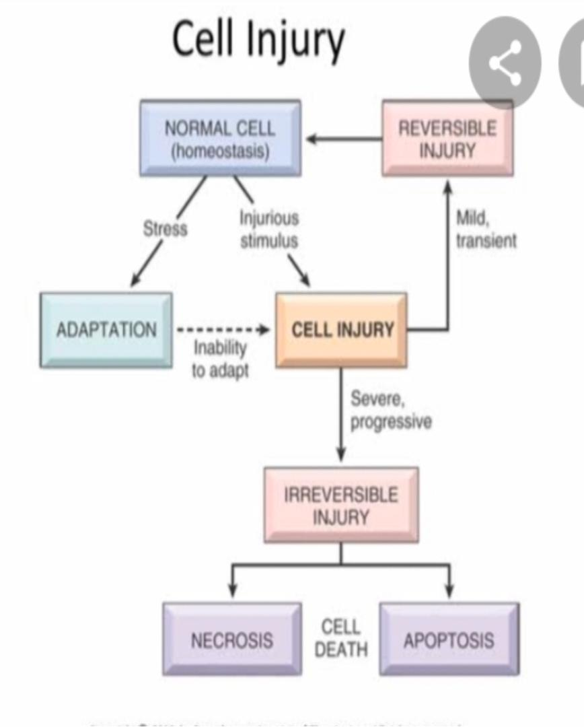
References
Bezabeh M.; Tesfaye A.; Ergicho, B.; Erke, M.; Mengistu, S.and Bedane, A.; Desta, A. (2004).
General Pathology. Jimma University, Gondar University Haramaya University, Dedub University.

