DATE: 28/05/2020
NAME: ADEKUNLE GLORIA. J
MATRIC. NO: 16/SCI01/001
COURSE CODE: CSC406
COURSE TITLE: HUMAN COMPUTER INTERACTION
LMS ASSIGNMENT 6
Explain the term Color Context Write briefly on the following (i) Complementary Colors (ii) Natural Harmony (iii) Analogous Colors
Solution
- The term color context is defined basically as how a viewer feel when he sees colors and how they behave in relation to other colors and shapes e.g. to compare the contrast effects of different color backgrounds for a red square. Red appears more brilliant against a black background and somewhat duller against the white background. In contrast with orange, the red appears lifeless; in contrast with blue-green, it exhibits brilliance. In one sentence, colors look different depending upon what colors they’re placed with, that’s what the term color context means.

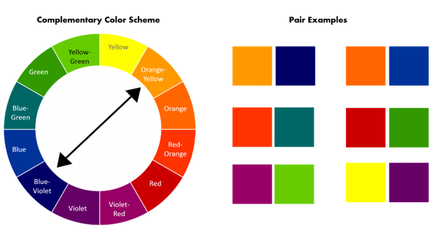
- COMPLEMENTARY COLORS: Complementary colors, also be called opposite colors, are two colors that are on opposite sides of the color wheel. When combined or mixed the colors cancel each other out (lose hue) by producing a grayscale color like white or black. As an artist, knowing which colors are complementary to one another can help you make good color decisions. For instance, complementary can make each other appear brighter, they can be mixed to create effective neutral hues, or they can be blended together for shadows. Also, when placed next to each other, they create the strongest contrast for those two colors.

- NATURAL HARMONY: Natural Harmony is when we use two colors located directly across from each other on the color wheel. For example: yellow and purple. This harmony creates a visually exciting effect when colors are used at full saturation.

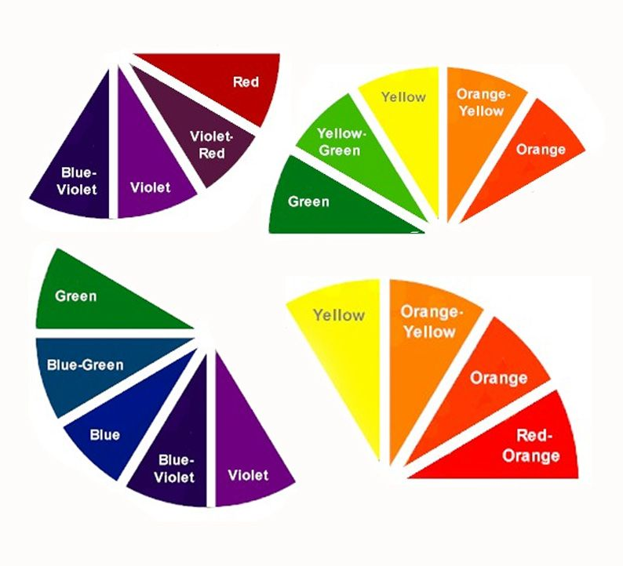
- ANALOGOUS COLORS: The word 'analogous' is defined as two things with a similar function or feature that are comparable to one another. Analogous colors are groups of three colors that are next to each other on the color wheel, and a tertiary. Red, orange, and red-orange are examples. The term analogous also refers to having analogy, or corresponding to something in particular. An analogous color scheme creates a rich, monochromatic look. For example, yellow, green-yellow, and green are categorized as analogous colors.

