Osanyintuyi oluwatobi Deborah
15/eng/06/059
Mechanical engineering
- Product/project design
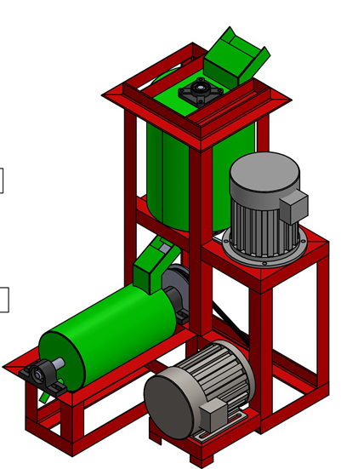
- Materials selection
The materials include:
- Starch
- Dilute hydrochloric (HCL) acid
- Sodium tetraborate decahydrate or borax
- Urea
- Sodium formaldehyde, all of commercial grade
- factors considered in choosing the materials
- Cost of the material
- Its ability to manufacture
- Environmental considerations
- Chemical properties
- Physical properties
- Mechanical attributes

- design specifications
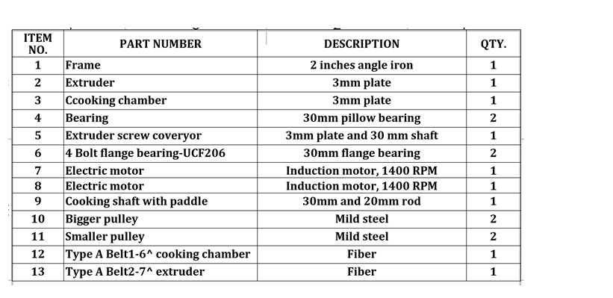
- details design
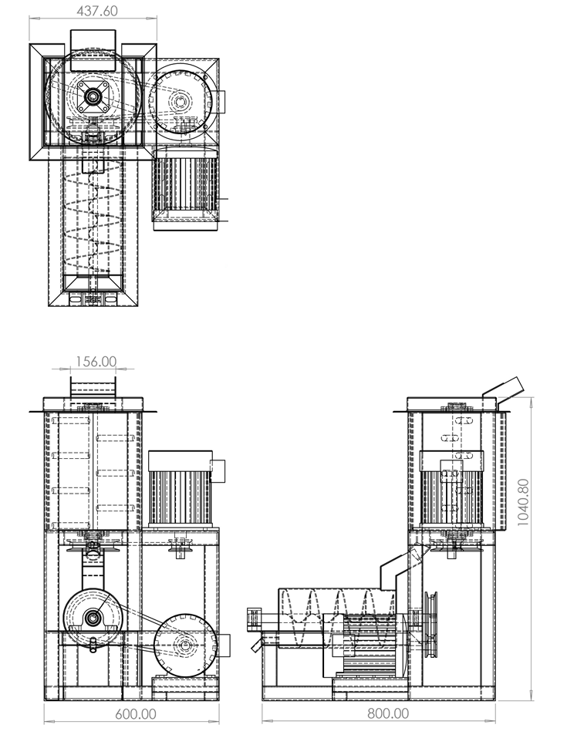

S/N | MATERIALS | DESCRIPTION | UNIT | COST(N)
1 | 3mm plate | Mild steel | 2 | 37,000
2 | Electric motor | Induction motor | 2 | 100,000
3 | 2 inches angle iron | Mild steel | 9 | 85,500
4 | Cutting and grinding disc | - | 8 | 8,000
5 | Painting | - | - | 6,000
6 | Shaft | Mild steel | 3 | 15,000
7 | Bearing | 25mm pillow bearing | 4 | 10,000
8 | Control unit | Electrical connections, heating element | - | 40,000
9 | Transport | - | - | 15,000
10 | Logistics | - | - | 15,000
11 | workmanship | - | - | 30,000
total |  | 361,000

- Design calculations
Design of The Mixer
The machine consists of two sections. The first section has a change-can mixer that incorporates a heating jacket. The design of the mixer comprises several steps as outlined below:
- Selection of a suitable vessel material and size:
an aluminum pot was selected as the mixing vessel. The vessel is well rounded with smooth surfaces.
- Selection of blade materials:
The blade was made of two materials, steel and Perspex. The steel bars were welded to anchor impeller frame while the Perspex bars were bolted to the steel bars. The Perspex bars (since it can be adjusted) ensured maintenance of very small clearances between the vessel surface and the vertical and horizontal pitched blades.
- Selection of mixing speed:
The production of dextrin gum involved heating starch slurry with excess acid until dextrinization was attain. For a controlled process, it was desired that the mixing should take place in the laminar zone, it was necessary to consider the impeller speed with respect to the viscosity of the mixture in the mixer and also on the intende discharge rate.
For fluid mixing, Reynolds Number was defined as (McCabe et al.,2001)
$Re=\frac{nD^{2}ρ}{μ}$ (1)
Where
Re = Reynolds number
n = Revolutions per minute
D = Impeller Diameter
ρ = Density
µ = Viscosity F
The power needed by the impeller is given by the relation as:
$Re=N_{P}n^{3}D^{5}ρ$ (2)
Where N_{p} = power number
For Re<10, flow is in the laminar range and density plays no factor and
$$N_{p}=\frac{K_{L}}{Re}$$
K_{L} = 44.5 for four pitched blade turbine mixer
Hence, $P= K_{L}n^{2}D^{3}μ$ (3)
Where P = Power
Design of the extruder
Two factors determined the design considerations of the screw extruder and these were the screw size and rotational speed(rpm) of the screw. The choice of screw size depends on the screw diameter, shaft diameter, radial clearance and pitch type of helical flight. The conveying of gummy substances may not be characterized by the presence of lumps and as such the screw size has no limitation of any kind and may depend on the projected throughput. The throughput may thus depend on the size of feed chute and discharge port size. A screw conveyor casting of internal diameter, ‘d’ was selected based on the size of the casing desired of the machine, the conveyor trough is taken to be maximally filled to 30% of its volume.
The cross-sectional area of moving bed of paste (gum) is given as
$A_{x}= \frac{{(d_{x})}^{2}A}{d}$ (4)
Where A_{x} = Cross sectional area of moving bed of paste (gum) at 30% height
A = Cross sectional area of moving bed of paste at 50% height
d and d_{x} are the respective heights for A and A_{x}
$A= \frac{πd^{2}}{2}$
Where
U = Average velocity
λ = Screw pitch
N = Revolutions per minute
Volumetric throughput of the screw conveyor of the screw extruder is given by the relation
$V^{\&}=A_{X}λN$ (5)
Or
$V^{\&}=A_{X}U$
Where V&= Volumetric throughput of screw extruder
A_{x} = Cross sectional area of moving bed of paste (gum) at 30% height
λ = Screw pitch
N = Revolutions per minute
Mass flow rate of gum;
${M^{\&}}_{s}=ρ{V^{\&}}_{s}$ (6)
M&_{s}= Mass flowrate in screw extruder
ρ= Density
V&_{s} = Volumetric flowrate of the screw extruder
For a ribbon flight screw extruder, the capacity factor CF_{f} of the flight (Thompson 1973) is
CF_{f} =1.15 (7)
Hence, the modified mass flowrate is
${M^{\&}}_{g}=\frac{{M^{\&}}_{s}}{{CF}_{f}}$ (8)
M&_{g} = mass flowrate of gum
M&_{s}= mass flowrate in screw extruder
CF_{f} = capacity factor
Power requirement for the extruder motor is given as
$P_{T}=P_{gum}+P_{friction}$
P_{T}= Power required to transport gum
P_{gum} = Power to transport gum freely
P_{friction} = Power to overcome friction during gum transportation
Where, $P_{friction}=50D_{sc}L$
D_{sc} = Screw diameter
L = Screw length
$P_{gum}=F_{S}F_{m}gm_{g}L$
Where, F_{S} = Screw factor =1.7
F_{m} = Material factor =1.8
L = Screw length
g = Acceleration due to gravity
Power required by extruder motor is given as
$P_{motor}=\frac{P_{T}F_{0}}{η}$
Where p = Power required by extruder motor
F =Overload factor
P = Power to transport gum in the extruder
η = Drive efficiency

