NAME: GOODHEAD ENEFAGHA ISAAC

MATRIC NO: 17/MHS01/136

DEPARTMENT: NURSING

LEVEL: 300LEVEL

CELLULAR PATHOLOGY ASSIGNMENT

- Diagnostic techniques used in pathology are :
The pathologist uses the following techniques to the diagnose diseases:
a. Histopathology
b. Cytopathology
c. Hematopathology
d. Immunohistochemistry
e. Microbiological examination
f. Biochemical examination
g. Cytogenetics
h. Molecular techniques
i. Autopsy
A. Histopathological techniques
Histopathological examination studies tissues under the microscope. During this study, the pathologist looks for abnormal structures in the tissue.
Tissues for histopathological examination are obtained by biopsy. Biopsy is a tissue sample from a living person to identify the disease. Biopsy can be either incisional or excisional.
Once the tissue is removed from the patient, it has to be immediately fixed by putting it into adequate amount of 10% Formaldehyde (10% formalin) before sending it to the pathologist.
The purpose of fixation is:
1. To prevent autolysis and bacterial decomposition and putrefaction
2. To coagulate the tissue to prevent loss of easily diffusible substances
3. To fortify the tissue against the deleterious effects of the various stages in the preparation of sections and tissue processing.
4. To leave the tissues in a condition which facilitates differential staining with dyes and other reagents.
Once the tissue arrives at the pathology department, the pathologist will exam it macroscopically (i.e. naked-eye examination of tissues).
Then the tissue is processed to make it ready for microscopic examination. The whole purpose of the tissue processing is to prepare a very thin tissue (i.e. five to seven μm or one cell thick tissue) which can be clearly seen under the microscope. The tissue is processed by putting it into different chemicals. It is then impregnated (embedded) in paraffin, sectioned (cut) into thin slices, & is finally stained. The stains can be Hematoxylin/Eosin stain or special stains such as PAS, Immunohistochemistry, etc...
The Hematoxylin/Eosin stain is usually abbreviated as H&E stain. The H&E stain is routinely used. It gives the nucleus a blue color & the cytoplasm & the extracellular matrix a pinkish color. Then the pathologist will look for abnormal structures in the tissue. And based on this abnormal morphology he/she will make the diagnosis. Histopathology is usually the gold standard for pathologic diagnosis.
B. Cytopathologic techniques
Cytopathology is the study of cells from various body sites to determine the cause or nature of disease.
Applications of cytopathology:
The main applications of cytology include the following:
1. Screening for the early detection of asymptomatic cancer
For example, the examination of scrapings from cervix for early detection and prevention of cervical cancer.
2. Diagnosis of symptomatic cancer
Cytopathology may be used alone or in conjunction with other modalities to diagnose tumors revealed by physical or radiological examinations.
It can be used in the diagnosis of cysts, inflammatory conditions and infections of various organs.
3. Surveillance of patients treated for cancer
For some types of cancers, cytology is the most feasible method of surveillance to detect recurrence. The best example is periodic urine cytology to monitor the recurrence of cancer of the urinary tract.
Advantages of cytologic examination
Compared to histopathological technique it is cheap, takes less time and needs no anesthesia to take specimens. Therefore, it is appropriate for developing countries with limited resources like Ethiopia. In addition, it is complementary to histopathological examination.
Cytopathologic methods
There are different cytopathologic methods including:
1. Fine-needle aspiration cytology (FNAC)
In FNAC, cells are obtained by aspirating the diseased organ using a very thin needle under negative pressure. Virtually any organ or tissue can be sampled by fine-needle aspiration. The aspirated cells are then stained & are studied under the microscope. Superficial organs (e.g. thyroid, breast, lymph nodes, skin and soft tissues) can be easily aspirated. Deep organs, such as the lung, mediastinum, liver, pancreas, kidney, adrenal gland, and retroperitoneum are aspirated with guidance by fluoroscopy, ultrasound or CT scan. FNAC is cheap, fast, & accurate in diagnosing many diseases.
2. Exfoliative cytology
Refers to the examination of cells that are shed spontaneously into body fluids or secretions. Examples include sputum, cerebrospinal fluid, urine, effusions in body cavities (pleura, pericardium, peritoneum), nipple discharge and vaginal discharge.
3. Abrasive cytology
Refers to methods by which cells are dislodged by various tools from body surfaces (skin, mucous membranes, and serous membranes). E.g. preparation of cervical smears with a spatula or a small brush to detect cancer of the uterine cervix at early stages. Such cervical smears, also called Pap smears, can significantly reduce the mortality from cervical cancer. Cervical cancer is the most common cancer in Ethiopian women.
C. Hematological examination
This is a method by which abnormalities of the cells of the blood and their precursors in the bone marrow are investigated to diagnose the different kinds of anemia & leukemia.
D. Immunohistochemistry
This is a method is used to detect a specific antigen in the tissue in order to identify the type of disease.
E. Microbiological examination
This is a method by which body fluids, excised tissue, etc. are examined by microscopical, cultural and serological techniques to identify micro-organisms responsible for many diseases.
F. Biochemical examination
This is a method by which the metabolic disturbances of disease are investigated by assay of various normal and abnormal compounds in the blood, urine, etc.
G. Clinical genetics (cytogenetics),
This is a method in which inherited chromosomal abnormalities in the germ cells or acquired chromosomal abnormalities in somatic cells are investigated using the techniques of molecular biology.
H. Molecular techniques
Different molecular techniques such as fluorescent in situ hybridization, Southern blot, etc... can be used to detect genetic diseases.
I. Autopsy
Autopsy is examination of the dead body to identify the cause of death. This can be for forensic or clinical purposes.
The relative importance of each of the above disciplines to our understanding of disease varies for different types of diseases. For example, in diabetes mellitus, biochemical investigation provides the best means of diagnosis and is of greatest value in the control of the disease. Whereas in the diagnosis of tumors, FNAC & histopathology contribute much. However, for most diseases, diagnosis is based on a combination of pathological investigations.

- Cellular adaptation precedes cell death discuss.

Cellular adaptation
In cell biology and pathophysiology, cellular adaptation refers to changes made by a cell in response to adverse or varying environmental changes. The adaptation may be physiologic (normal) or pathologic (abnormal). Four types of morphological adaptations include:
- Atrophy
- Hypertrophy
- Hyperplasia
- Metaplasia

- ATROPHY
Atrophy is a decrease in cell size. If enough cells in an organ undergo atrophy the entire organ will decrease in size. Thymus atrophy during early human development (childhood) is an example of physiologic atrophy. Skeletal muscle atrophy is a common pathologic adaptation to skeletal muscle disuse (commonly called "disuse atrophy"). Tissue and organs especially susceptible to atrophy include skeletal muscle, cardiac muscle, secondary sex organs, and the brain.

- HYPERTROPHY
Hypertrophy is an increase in cell size and volume. If enough cells of an organ hypertrophy the whole organ will increase in size. Hypertrophy may involve an increase in intracellular protein as well as cytosol (intracellular fluid) and other cytoplasmic components. For example, adipocytes (fat cells) may expand in size by depositing more lipid within cytoplasmic vesicles. Thus in human adults, increases in body fat tissue occurs mostly by increases in the size of adipocytes, not by increases in the number of adipocytes. Hypertrophy may be caused by mechanical signals (e.g., stretch) or trophic signals (e.g., growth factors).

- HYPERPLASIA
Hyperplasia is an increase in the number of cells. It is the result of increased cell mitosis or division (also referred to as cell proliferation). The two types of physiologic hyperplasia are : Compensatory and Hormonal.
Compensatory hyperplasia permits tissue and organ regeneration. It is common in epithelial cells of the epidermis and intestine, liver hepatocytes, bone marrow cells, and fibroblasts. It occurs to a lesser extent in bone, cartilage, and smooth muscle cells.
Hormonal hyperplasia occurs mainly in organs that depend on estrogen. For example, the estrogen-dependent uterine cells undergo hyperplasia and hypertrophy following pregnancy.

- METAPLASIA
Metaplasia occurs when a cell of a certain type is replaced by another cell type, which may be less differentiated. It is a reversible process thought to be caused by stem cell reprogramming. Stem cells are found in epithelia and embryonic mesenchyme of connective tissue. A prominent example of metaplasia involves the changes associated with the respiratory tract in response to inhalation of irritants, such as smog or smoke.

- DYSPLASIA
Dysplasia refers to abnormal changes in cellular shape, size, and/or organization. Dysplasia is not considered a true adaptation; rather, it is thought to be related to hyperplasia and is sometimes called "atypical hyperplasia". Tissues prone to dysplasia include cervical and respiratory epithelium, where it is strongly associated with the development of cancer; it may also be involved in the development of breast cancer. Although dysplasia is reversible, if stress persists, then dysplasia progresses to irreversible carcinoma.

CELL DEATH
Cell death is the event of a biological cell ceasing to carry out its functions. This may be the result of the natural process of old cells dying and being replaced by new ones, or may result from such factors as disease, localized injury, or the death of the organism of which the cells are part. Apoptosis or Type I cell-death, and autophagy or Type II cell-death are both forms of programmed cell death, while necrosis is a non-physiological process that occurs as a result of infection or injury.

APOPTOSIS
Apoptosis is the process of programmed cell death (PCD) that may occur in multicellular organisms. Biochemical events lead to characteristic cell changes (morphology) and death. These changes include blebbing, cell shrinkage, nuclear fragmentation, chromatin condensation, and chromosomal DNA fragmentation. It is now thought that in a developmental context cells are induced to positively commit suicide whilst in a homeostatic context; the absence of certain survival factors may provide the impetus for suicide. There appears to be some variation in the morphology and indeed the biochemistry of these suicide pathways; some treading the path of "apoptosis", others following a more generalized pathway to deletion, but both usually being genetically and synthetically motivated.

NECROSIS
Necrosis is cell death where a cell has been badly damaged through external forces such as trauma or infection and occurs in several different forms. In necrosis, a cell undergoes swelling, followed by uncontrolled rupture of the cell membrane with cell contents being expelled. These cell contents often then go on to cause inflammation in nearby cells. A form of programmed necrosis, called necroptosis, has been recognized as an alternative form of programmed cell death. It is hypothesized that necroptosis can serve as a cell-death backup to apoptosis when the apoptosis signaling is blocked by endogenous or exogenous factors such as viruses or mutations. Necroptotic pathways are associated with death receptors such as the tumor necrosis factor receptor.

CELL ADAPTATION PRECEDS CELL DEATH

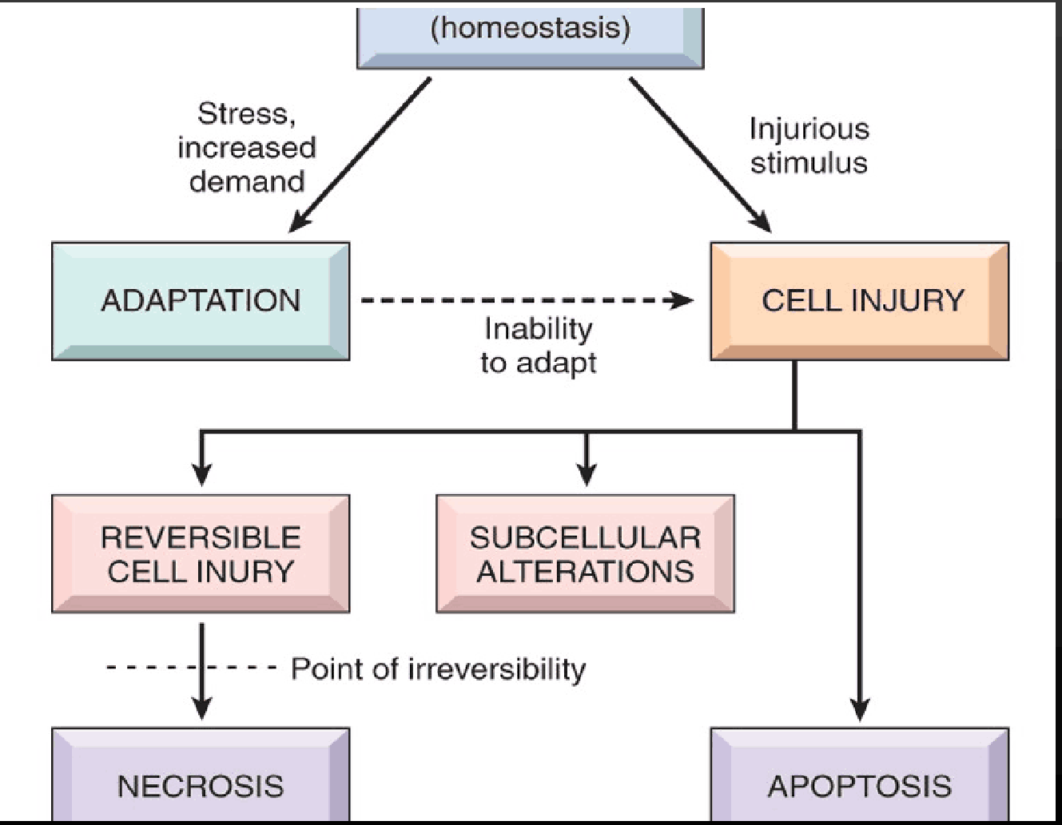Cellular adaptation is the ability of cells respond to various types of stimuli and adverse environmental changes. When cells are injured, one of two patterns will generally result: reversible cell injury leading to adaptation of the cells and tissue, or irreversible cell injury leading to cell death and tissue damage. When cells adapt to injury, their adaptive changes can be atrophy, hypertrophy, hyperplasia, or metaplasia. Injured cells may also accumulate materials including fat, cholesterol, protein, glycogen, or pigment. When cells are irreversibly injured and dying, specific nuclear changes may be visible, including pyknosis, karyorrhexis, and karyolysis. If large numbers of cells die, tissue necrosis may occur. Observable patterns of necrosis include coagulative, liquefactive, caseous, gummatous, fat necrosis, and fibrinous necrosis; these may hint at the underlying mechanism of injury. Understanding the cellular and tissue level aspects of necrosis is foundational to the understanding of disease processes and conditions.
