NAME:OJUMU JOYCE
MATRIC NO:17/MHS02/112

Flow cytometry (FCM) :This a technique used to detect and measure physical and chemical characteristics of a population of cells or particles.
Flow cytometry
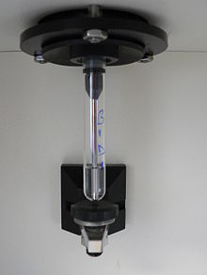
A flow cytometer tube with suction straw
In this process, a sample containing cells or particles is suspended in a fluid and injected into the flow cytometer instrument. The sample is focused to ideally flow one cell at a time through a laser beam, where the light scattered is characteristic to the cells and their components. Cells are often labeled with fluorescent markers so light is absorbed and then emitted in a band of wavelengths. Tens of thousands of cells can be quickly examined and the data gathered are processed by a computer.
Flow cytometry is routinely used in basic research, clinical practice, and clinical trials. Uses for flow cytometry include:
- Cell counting
- Cell sorting
- Determining cell characteristics and function
- Detecting microorganisms
- Bio marker detection
- Protein engineering detection
- Diagnosis of health disorders such as blood cancers.
A flow cytometry analyzer is an instrument that provides quantifiable data from a sample. Other instruments using flow cytometry include cell sorters which physically separate and thereby purify cells of interest based on their optical properties.
B)
Immunohistochemistry (IHC): Using the principle of antibodies binding specifically to antigens in biological tissues to detect the antigens (e.g.proteins) in cells of a tissue section.Immunohistochemistry (IHC) is a process used to diagnose some types of cancer including mesothelioma. The procedure involves locating antigens in biopsy tissue through the use of a visual marker. Common markers include fluorescent dye, enzymes, colloidal gold and radioactive elements. If cellular events associated with cancerous tumors – such as an increase in cell death – are evident in the tissue, then the abnormal activity will be highlighted by the stained tissue sample. Immunohistochemistry cannot only help in the identification of a tumor, but it can also distinguish whether or not a tumor is benign or malignant.

C)An electron microscope is a microscope that uses a beam of accelerated electrons as a source of illumination. As the wavelength of an electron can be up to 100,000 times shorter than that of visible light photons, electron microscopes have a higher resolving power than light microscope and can reveal the structure of smaller objects. A scanning transmission electronscope has achieved better than 50 pm resolution in annular dark field imaging mode and magnifications of up to about 10,000,000× whereas most light microscope are limited by diffraction to about 200 nm resolution and useful magnifications below 2000×.
Electron microscopes use shaped magnetic fields to form optical lens systems that are analogous to the glass lenses of an optical light microscope.
Electron microscopes are used to investigate the ultrastructure of a wide range of biological and inorganic specimens including microorganisms , cells, large molecules , biopsy samples, metals, and crystals. Industrially, electron microscopes are often used for quality control and failure analysis. Modern electron microscopes produce electron micrographs using specialized digital cameras and frame grabbers to capture the images.

D) Enzyme histochemistry serves as a link between biochemistry and morphology. It is based on metabolization of a substrate provided to a tissue enzyme in its orthotopic localization. Visualization is accomplished with an insoluble dye product. It is a sensitive dynamic technique that mirrors even early metabolic imbalance of a pathological tissue lesion, combined with the advantage of histotopographic enzyme localization. With the advent of immunohistochemistry and DNA-oriented molecular pathology techniques, the potential of enzyme histochemistry currently tends to be underrecognized. This review aims to draw attention to the broad range of applications of this simple, rapid and inexpensive method. Alkaline phosphatase represents tissue barrier functions in brain capillaries, duodenal enterocyte and proximal kidney tubule brush borders. Decrease in enzyme histochemical alkaline phosphatase activity indicates serious functional impairment. Enzyme histochemical increase in lysosomal acid phosphatase activity is an early marker of ischemic tissue lesions. Over the last four decades, acetylcholinesterase enzyme histochemistry has proven to be the gold standard for the diagnosis of Hirschsprung disease and is one of the most commonly applied enzyme histochemical methods today. Chloroacetate esterase and tartrate-resistant phosphatase are both resistant to formalin fixation, EDTA decalcification and paraffin embedding. Early enzyme histochemical insight into development of a pathologic tissue lesion and evaluation of function and vitality of tissue enhance our understanding of the pathophysiology of diseases. In this process, enzyme histochemistry constitutes a valuable complement to conventional histology, immunohistochemistry and molecular pathology for both diagnostic and experimental pathology.

Immunocytochemistry (ICC) is a common laboratory technique that is used to anatomically visualize the localization of a specific protein or antigen in cells by use of a specific primary antibody that binds to it. The primary antibody allows visualization of the protein under a fluorescence microscope when it is bound by a secondary antibody that has a conjugated fluorophore. ICC allows researchers to evaluate whether or not cells in a particular sample express the antigen in question. In cases where an immunopositive signal is found, ICC also allows researchers to determine which sub cellular compartment are expressing the antigen.
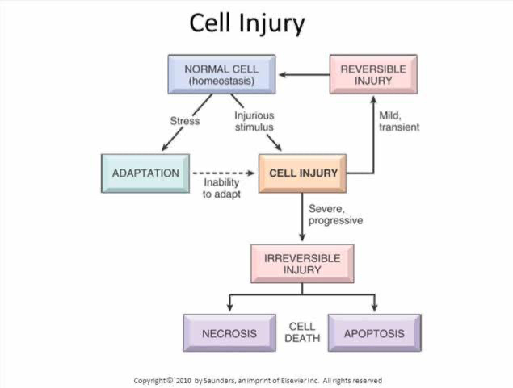
2.Cellular adaptation is the ability of cells to respond to various types of stimuli and adverse environmental changes. These adaptations include hypertrophy (enlargement of individual cells), hyperplasia (increase in cell number), atrophy (reduction in size and cell number), metaplasia (transformation from one type of epithelium to another), and dysplasia (disordered growth of cells).
When cells are injured or exposed to adverse environmental changes it may either be reversible cell injury leading to adaption or irreversible cell injuries which occurs cells are not able to adapt to the adverse environmental changes, which leads cell death that occurs physiologically in the form of apoptosis, or pathologically, in the form of necrosis

