NAME: KAYODE MUINAT ADEBUKOLA
MATRIC NO: 17/SCI14/016
DEPT: CHEMICAL ENGINEERING
COURSE CODE: CHE 312
COURSE TITLE: PROCESS INSTRUMENTATION
ASSIGNMENT 2
- Briefly describe Chemical Process Diagrams
- Outline the purpose of P&ID and list its division
- Give five common P&ID symbols with the instrument abbreviations used in instrument diagram.

- Briefly describe Chemical Process Diagrams

The components of a chemical process diagram include:

- COMPRESSOR: A compressor is a mechanical device that increases the pressure of a gas by reducing its volume. An air compressor is a specific type of gas compressor.
Compressors are similar to pumps: both increase the pressure on a fluid and both can transport the fluid through a pipe. As gases are compressible, the compressor also reduces the volume of a gas. Liquids are relatively incompressible; while some can be compressed, the main action of a pump is to pressurize and transport liquids. Those that are powered by an electric motor can also be controlled using a VFD or power inverter, however many (hermetic and semi-hermetic) compressors can only work at certain speeds, since they may include built-in oil pumps. The oil pumps are connected to the same shaft that drives the compressor and forces oil into the compressor and motor bearings. Many compressors can be staged, that is, the fluid is compressed several times in steps or stages, to increase discharge pressure. Often, the second stage is physically smaller than the primary stage, to accommodate the already compressed gas. Each stage further compresses the gas and increases pressure.
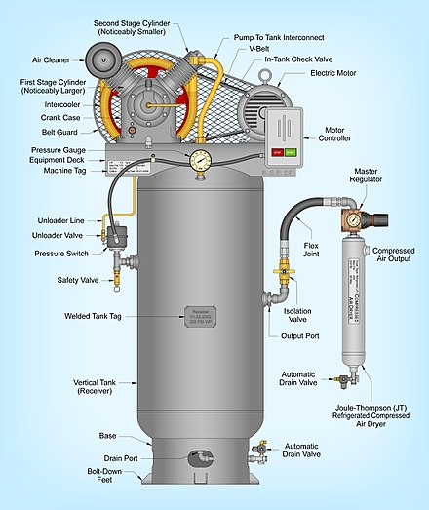
- HEAT EXCHANGER: A heat exchanger is a system used to transfer heat between two or more fluids. Heat exchangers are used in both cooling and heating processes. The fluids may be separated by a solid wall to prevent mixing or they may be in direct contact. They are widely used in space heating, refrigeration, air conditioning, power stations, chemical plants, petrochemical plants, petroleum refineries, natural-gas processing, and sewage treatment. The classic example of a heat exchanger is found in an internal combustion engine in which a circulating fluid known as engine coolant flows through radiator coils and air flows past the coils, which cools the coolant and heats the incoming air. Another example is the heat sink, which is a passive heat exchanger that transfers the heat generated by an electronic or a mechanical device to a fluid medium, often air or a liquid coolant.

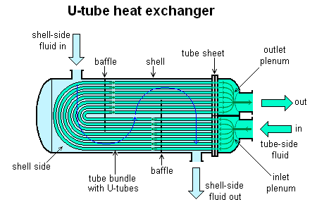
- REACTOR: A chemical reactor is an enclosed volume in which a chemical reaction takes place. In chemical engineering, it is generally understood to be a process vessel used to carry out a chemical reaction,[5] which is one of the classic unit operations in chemical process analysis. The design of a chemical reactor deals with multiple aspects of chemical engineering. Chemical engineers design reactors to maximize net present value for the given reaction. Designers ensure that the reaction proceeds with the highest efficiency towards the desired output product, producing the highest yield of product while requiring the least amount of money to purchase and operate. Normal operating expenses include energy input, energy removal, raw material costs, labor, etc. Energy changes can come in the form of heating or cooling, pumping to increase pressure, frictional pressure loss or agitation.
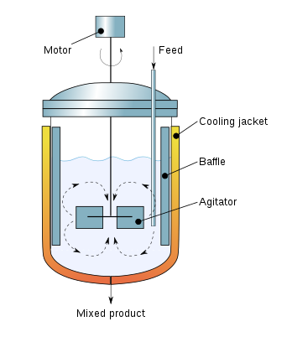
- CONDENSER: A condenser is a device or unit used to condense a gaseous substance into a liquid state through cooling. In so doing, the latent heat is released by the substance and transferred to the surrounding environment. Condensers are used for efficient heat rejection in many industrial systems. Condensers can be made according to numerous designs, and come in many sizes ranging from rather small (hand-held) to very large (industrial-scale units used in plant processes). For example, a refrigerator uses a condenser to get rid of heat extracted from the interior of the unit to the outside air.
The condenser relies on the efficient heat transfer that occurs during phase changes, in this case during the condensation of a vapor into a liquid. The vapor typically enters the condenser at a temperature above that of the secondary fluid. As the vapor cools, it reaches the saturation temperature, condenses into liquid and releases large quantities of latent heat. As this process occurs along the condenser, the quantity of vapor decreases and the quantity of liquid increases; at the outlet of the condenser, only liquid remains. Some condenser designs contain an additional length to sub cool this condensed liquid below the saturation temperature.
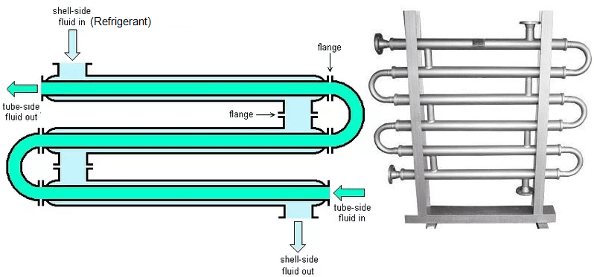

- The purpose of P&ID and list its division
A Piping and Instrumentation Diagram (P&DI) is a graphic representation of a process system that includes the piping, vessels, control valves, instrumentation, and other process components and equipment in the system. A P&ID shows all piping, including the “physical sequence of branches, reducers, valves, equipment, instrumentation and control interlocks.” A P&ID is used to operate the process system, since it shows the piping of the process flow along with the installed equipment and instrumentation. P & IDs play a key role in maintaining and modifying the process they describe, because it is important to demonstrate the physical sequence of equipment and systems, including how these systems connect. The P&ID is the primary schematic drawing used for laying out a process control system's installation. It shows the necessary graphical elements to execute, monitor and control specific processes. The P&ID diagram does not describe the chemical reactions involved in the process nor does it describe procedures of the same. It is an essential document in the process industry.
The objective of the P&ID diagram is to show the necessary information in order to understand the relationship between the conceptual design of the process, developed through the Process Flow Diagram (PFD) and Heat and Material Balance (HMB) diagrams, with reality.
PFD and HMB have only a minimum of information related to the physical aspects of the pipeline or the instrumentation of a system. The P&ID provides the link between the conceptual and the actual.
The following list outlines the items that typically are found in a P&ID:
- Instrumentation and designations
- Mechanical equipment with names and numbers
- All valves and their identifications
- Process piping, sizes, and identification
- Vents, drains, special fittings, sampling lines, reducers, increasers, and swaggers
- Permanent start-up and flush lines
- Flow directions
- Interconnections references
- Control inputs and outputs, interlocks
- Interfaces for class changes
- Computer control system
- Identification of components and subsystems delivered by the process.
The divisions of P&IDs include;
- Equipment & valves identified
- Instrumentation type & location identified
- Path between instruments & control devices indicated
- Piping size and type identified for all lines

- Five common P&ID symbols with the instrument abbreviations used in instrument diagram.
- Agitators
Symbol:
Abbreviation: A

- Vacuum Pump

Symbol: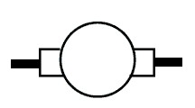
Abbreviation: VP

- Storage Tanker

Symbol:
Abbreviation: TK

- Column/Tower

Symbol: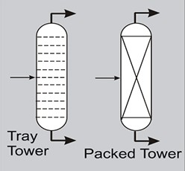
Abbreviation: T

- Heat Exchangers
Symbol: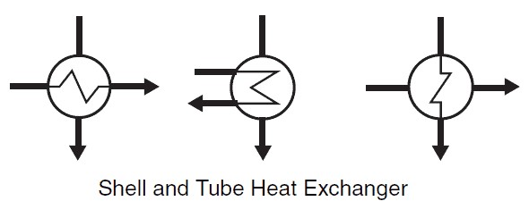

Abbreviation: HX

REFERENCES
- Perry's Chemical Engineer's Handbook 8th edition Perry, Green, page 10-45 section 10-76
- Coulson, J. & Richardson, J. (1983), Chemical Engineering – Design (SI Units), Volume 6, Pergamon Press, Oxford.
- BATTIKHA,N. E. (2006) Condensed Handbook of Measurement and Control
- DOUGLAS,O.J. (2005) Applied Technology and Instrumentation for Process Control
- SAMSON (2013) Terminology and Symbols in Control Engineering
- ANDREW,W.G. (1974) Applied Instrumentation in the Process Indust Resource Material – William G. Andrew & H. B. Williams
- https://en.wikipedia.org
- https://www.britannica.com/science/chemical-reaction

