NAME: NWAZUE OLGA AMARACHI

MATRIC NO: 18/MHS02/206

DEPARTMENT: NURSING SCIENCE

LEVEL: 300

COURSE TITLE: CELLULAR PATHOLOGY

Question 1
Write explicitly on 5 diagnostic techniques used in pathology, relevant illustrations and examples required.
Answer
- Necroscopy: This is the examination of a body after death to perform a necropsy, or a pathological examination of A dead body; post-mortem examination. The purpose of a necropsy is typically to determine the cause of death or extent of disease. This involves a careful process of dissection, observation, interpretation and documentation. Findings are documented either in writings, photographs, or both. Autopsy has been reserved mainly for human patients while necropsy is used for animal species.

- Radiography: This is the art and science of using radiation to provide images of tissues, organs, bones and vessels that comprise the human body. Most times, treatment of patients depend on the accurate and precise production of radiographic images. Radiography includes the diagnostic radiography as well as additional imaging modalities such as Mammography, Computer tomography(CT), Magnetic resonance imaging(MRI), Sonography etc.

- Urinalysis: A urinalysis is a test of your urine. A urinalysis is used to detect and manage a wide range of disorders, such as urinary tract infections, kidney disease and diabetes. A urinalysis involves checking the appearance, concentration and content of urine. Abnormal urinalysis results may point to a disease or illness. It can be also used to check your overall health and to monitor a medical condition.

- Haematological tests- A haematology test is a measurement of blood to help diagnose and monitor numerous conditions involving blood and its components. They can also be used to diagnose inflammation, anaemia , infection, haemophilia, blood-clotting disorders, leukaemia, and response to chemotherapy, among many other things. Some of these tests are; Complete blood count (CBC) which include: White blood cell count (WBC),Red blood cell count (RBC), Platelet count, Hematocrit red blood cell volume (HCT), Haemoglobin concentration (HB). This is the oxygen-carrying protein in red blood cells, Differential white blood count, Red blood cell indices (measurements) and also bone marrow biopsy.

Question 2
Cellular Adaptation precedes cell death, Discuss. Diagrams essential.
Answer
When cells are injured, one of two patterns will generally result: reversible cell injury leading to adaptation of the cells and tissue, or irreversible cell injury leading to cell death and tissue damage. Cellular adaptation is the ability of cells to respond to various types of stimuli and adverse environmental changes.
When cells adapt to injury, their adaptive changes can be atrophy, hypertrophy, hyperplasia, metaplasia, or dysplasia. Tissues adapt differently depending on the replicative characteristics of the cells that make up the tissue.

- Atrophy- A decrease in tissue mass. Can be caused by decreases in cell size (due to cytoskeleton degradation or decreases in protein synthesis) or decreases in cell number (due to apoptosis). Etiologies include lack of use (e.g., in muscle), denervation, loss of blood supply, loss of hormonal stimulation, poor nutrition, and drug adverse effects (e.g., skin thinning from chronic topical steroid use

- Hypertrophy- Increased tissue size via enlargement of cells caused by increase in cell numbers. E.g. Hypertrophic cardiomyopathy due to arterial hypertension.

- Hyperplasia- Increased tissue size via an increase in cell numbers

- Metaplasia- This is the transformation of tissues from one epithelium to another.E.g. Intestinal metaplasia( barett metaplasia), squamous metaplasia of the bronchi due to smoking; collated pseudostratified columnar epithelium is replaced by stratified squamous epithelium.

- Dysplasia- A disordered growth of epithelium characterised by abnormally frequent mitotic figures and loss of cell orientation and uniformly (size,shape).

If cells are not able to adapt to the adverse environmental changes, cell death occurs physiologically in the form of apoptosis, or pathologically, in the form of necrosis.

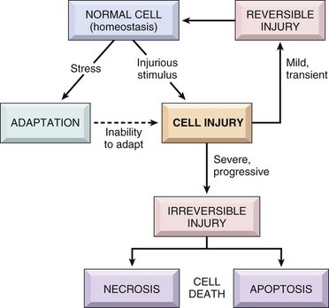
DIAGRAM

