MATRIC NO: 17/MHS02/074
DEPARTMENT: NURSING SCI.
COURSE TITLE: CELLULAR PATHOLOGY
COURSE CODE: NSC 308
1 Write explicitly on 5 diagnostic techniques use in pathology ,relevant illustration and examples required

Histopathology techniques
Histopathology is the branch of pathology which concerns with the demonstration of minutes structural alterations in tissue as a result of disease.
The pathologist looks for abnormal structures in the tissue. Histopathological examination is the studying of tissues under the microscope.
Biopsy is a tissue sample from a living person to identify the disease. Biopsy can be either incisional or excisional. Tissues for histopathological examination are obtained by biopsy.

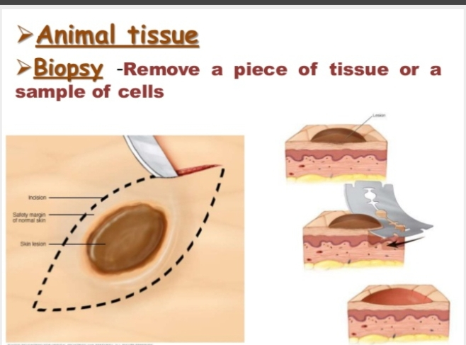
Once the tissue is removed from the patient, it has to be immediately fixed by putting it into adequate amount of 10% Formaldehyde (10% formalin) before sending it to the pathologist. The purpose of fixation is:
1. to prevent autolysis and bacterial decomposition and putrefaction
2. to coagulate the tissue to prevent loss of easily diffusible substances
3. to fortify the tissue against the deleterious effects of the various stages in the preparation of sections and tissue processing.
4. to leave the tissues in a condition which facilitates differential staining with dyes and other reagents.
The whole purpose of the tissue processing is to prepare a very thin tissue (i.e. five to seven μm or one cell thick tissue) which can be clearly seen under the microscope. The tissue is processed by putting it into different chemicals. It is then impregnated (embedded) in paraffin, sectioned (cut) into thin slices, & is finally stained. The stains can be Hematoxylin/Eosin stain or special stains such as PAS, Immunohistochemistry, etc... The Hematoxylin/Eosin stain is usually abbreviated as H&E stain.

Cytopathologic techniques
Cytopathology is the study of cells from various body sites to determine the cause or nature of disease.
Are methods used in the study or manipulation of cells .which include cell biology to culture, track, phenotypes, sort and screen cells in population or tissue, and molecular method to understand cellular function .
Which include the collection and examinationof exfoliation cells such as vaginal scrapes, sputum, urine, body fluid etc collection of cells by brushing, scraping or abrasive techniques is usually employed to confirm or exclude malignancy.

Applications of cytopathology:
The main applications of cytology include the following:
1. Screening for the early detection of asymptomatic cancer For example, the examination of scrapings from cervix for early detection and prevention of cervical cancer.
2. Diagnosis of symptomatic cancer Cytopathology may be used alone or in conjunction with other modalities to diagnose tumors revealed by physical or radiological examinations.
It can be used in the diagnosis of cysts, inflammatory conditions and infections of various organs.
3. Surveillance of patients treated for cancer For some types of cancers, cytology is the most feasible method of surveillance to detect recurrence. The best example is periodic urine cytology to monitor the recurrence of cancer of the urinary tract.

Advantages of cytologic examination
Compared to histopathologic technique it is cheap, takes less time and needs no anesthesia to take specimens. Therefore, it is appropriate for developing countries with limited resources like Ethiopia. In addition, it is complementary to histopathological examination.
Cytopathologic methods There are different cytopathologic methods including:
1. Fine-needle aspiration cytology (FNAC)
In FNAC, cells are obtained by aspirating the diseased organ using a very thin needle under negative pressure. Virtually any organ or tissue can be sampled by fine-needle aspiration. The aspirated cells are then stained & are studied under the microscope. Superficial organs (e.g. thyroid, breast, lymph nodes, skin and soft tissues) can be easily aspirated. Deep organs, such as the lung, mediastinum, liver, pancreas, kidney, adrenal gland, and retroperitoneum are aspirated with guidance by fluoroscopy, ultrasound or CT scan. FNAC is cheap, fast, & accurate in diagnosing many diseases.
.
Autopsy
An autopsy (post-mortem examination, obduction, necropsy, or autopsiacadaverum) is a surgical procedure that consists of a thorough examination of a corpse by dissection to determine the cause, mode, and manner of death or to evaluate any disease or injury that may be present for research or educational purposes.
Autopsy is examination of the dead body to identify the cause of death. This can be for forensic or clinical purposes.
The relative importance of each of the above disciplines to our understanding of disease varies for different types of diseases. For example, in diabetes mellitus, biochemical investigation provides the best means of diagnosis and is of greatest value in the control of the disease. Whereas in the diagnosis of tumors, FNAC & histopathology contribute much. However, for most diseases, diagnosis is based on a combination of pathological investigations.
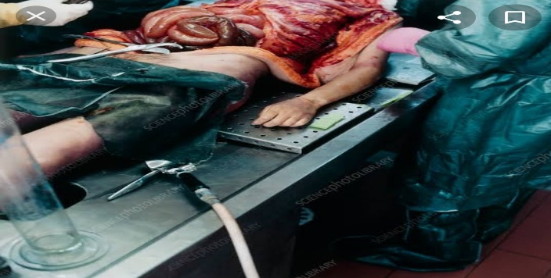

.HEMATOLOGICAL EXAMINATION: This is a method by which abnormalities of cells of the blood and their precursors in the bone marrow are investigated to diagnose the different kinds of anemia & leukemia
CYTOGENETICS: This is a method in which inherited chromosomal abnormalities in the germ cells or acquired chromosomal abnormalities in somatic cells are investigated using the techniques of molecular biology
Question 2
Cellular adaptation precedes cell death, discuss .diagram essential.?
Cellular adaptation refers to changes made by a cell in response to adverse or varying environment changes, adaptation may be physiologic (normal) or pathologic (abnormal). Four types of morphological adaptations include atrophy, hypertrophy, hyperplasia, and metaplasia.
Cellular adaptation is important because changes usually make cell more tolerable an adverse environment to which they are exposed. it occur when the cell respond to stress,environmental stimulus or changes
Hypertrophy
A Hypertrophy is increase in the size of cells. Increased workload leads to increased protein synthesis & increased size & number of intracellular organelles which, in turn, leads to increased cell size. The increased cell size leads to increased size of the organ.
Examples: the enlargement of the left ventricle in hypertensive heart disease & the increase in skeletal muscle during sternous exercise.
B. Hyperplasia
Hyperplasia is an increase in the number of cells. It can lead to an increase in the size of the organ. It is usually caused by hormonal stimulation. It can be physiological as in enlargement of the breast during pregnancy or it can pathological as in endometrial hyperplasia.
C. Metaplasia
This is the conversion of one type tissue into another. Is the transformation of one epithelium differentiated cell type. The change from in type cell to another may be part of a normal maturation process,or caused by some sort of abnormal stimulus, Glandular metaplasia can occur as a response to injury, as can occur in the distal oesophagus with acid reflux from the stomach.
D. Atrophy
Atrophy is a decrease in the size and the number of a cell, replication done in abnormal way. This can lead to decreased size of the organ. The atrophic cell shows autophagic vacuoles which contain cellular debris from degraded organelles. Atrophy can be caused by:
1. Disuse
2. Undernutrition
3. Decreased endocrine stimulation
4. Denervation
5. Old age

E. Dystrophy
This is a disorder in which an organ or tissue of the body washes away. Its is also a major disorder in the growth of the cell.
Irreversible Cell Injury and Cell Death
The major mechanisms of acute cell swelling are hypoxia, including ischemia, and membrane injury, often by toxins. Cell swelling can be reversible if the extent and duration of injury is not excessive. But if the injury exceeds certain limits (discussed shortly), cell death occurs
Not all cell injury results in cell death. Cell injury may be sublethal and result in a variety of types of cell degenerations and/or adaptations by the cell to the injury. In essence, cells or tissues respond to injury (or stress) in three important ways.
Cell death can occur in many ways. For example, extremes of temperature or direct trauma may result in nearly instantaneous destruction or death of cells. On the other hand, death of an animal (somatic death) results in eventual death of all cells that make up the animal (postmortem autolysis).
Stages in the cellular response to stress and injurious stimuli.
