Name: Onwuli Uchechukwu
Level:300
Department: Nursing
Course: cellular pathology
17/mhs02/077

- Write explicitly on 5 diagnostic techniques used in pathology, relevant illustrations and examples required.
- Discuss how cellular adaptation precedes cellular death and diagrams is essential.

- Diagnostic technique: This is a of method or test used to help diagnose a disease or condition. Imaging tests and tests to measure blood pressure, pulse, and temperature are examples of diagnostic techniques.
There are different types of diagnostic techniques used in pathology and they include;
- Necroscopy,
- Radiography
- Urinalysis
- microscopic examination of tissues
- hematological tests
- anatomical pathology

Necroscopy: This is the examination of an animal after death. The purpose of a necropsy is typically to determine the cause of death, or extent of disease. This involves a careful process of dissection, observation, interpretation, and documentation. This involves a careful process of dissection, observation, interpretation, and documentation. A thorough knowledge of normal anatomy is critical in distinguishing lesions from normal variations. Necropsy main purpose is to determine the cause of the animals death.
The Importance of the Necropsy
- Necropsy contributes to the body of scientific knowledge by increasing our understanding of anatomy and physiology in health and disease.
- Necropsies helps save lives .They can alert us to the presence of diseases that may be transmissible to other animals (or humans!), and guide treatment decisions for at-risk individuals.
- In some cases, necropsy findings can give comfort or closure to an owner, especially in the case of a seemingly sudden or unexplained death.
- Necropsy complements clinical medicine. Pre-mortem diagnoses can be confirmed, refuted or augmented on the necropsy floor, providing an invaluable educational tool for both clinicians and students.
Necropsy has been often confused with autopsy. Necropsy has to do with the examination of dead animals while autopsy has to do with the examination of dead human beings.
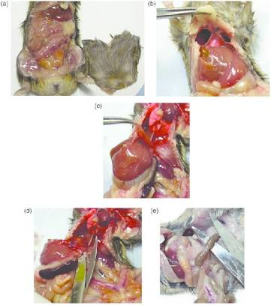
Eg of an illustration of necropsy

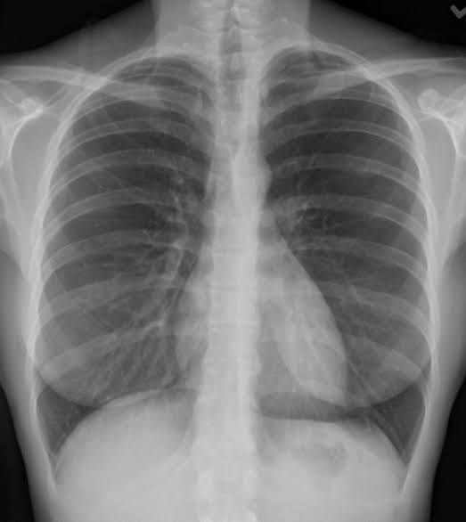
Radiography : Radiography is an imaging technique using X-rays, gamma rays, or similar ionizing radiation and non-ionizing radiation to view the internal form of an object. Applications of radiography include medical radiography ("diagnostic" and "therapeutic") and industrial radiography. Similar techniques are used in airport security (where "body scanners" generally use backscatter X-ray). To create an image in conventional radiography, a beam of X-rays is produced by an X-ray generator and is projected toward the object. A certain amount of the X-rays or other radiation is absorbed by the object, dependent on the object's density and structural composition.
Radiographic testing is an important type of NDT technique which utilizes x-rays and gamma rays for inspecting the internal structure of a component. This can be accomplished by, placing the test specimen between the radiation source and a piece of film. When the radiation is applied, the part will stop some radiation according to the thickness. The penetrated radiation will excite the film and generate the pattern of the defect.
Types Of Rays In Radiographic Testing includes;
- X- Rays
- Gamma Rays
They are high-frequency electromagnetic radiation. X-ray is produced artificially by X-ray generator and gamma rays are produced by radioactive material. X-rays and gamma rays cannot be seen, felt or heard and it has no mass and electrical charge.
Types of radiography
- Conventional Radiography: Conventional radiography. Radiography is the use of x-rays to visualize the internal structures of a patient. X-Rays are a form of electromagnetic radiation, produced by an x-ray tube. The x-rays are passed through the body and captured behind the patient by a detector; film sensitive to x-rays or a digital detector
Illustration of conventional radiography

.
- Digital Radiography: Digital radiography is a form of radiography that uses x-ray–sensitive plates to directly capture data during the patient examination, immediately transferring it to a computer system without the use of an intermediate cassette.

Illustration of digital radiography .

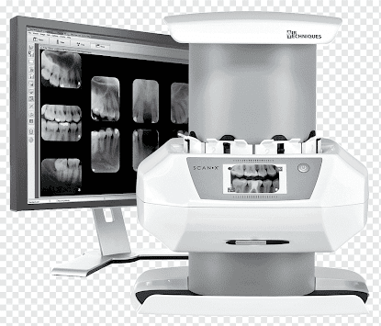

Importance of radiography
- Radiography is a key diagnostic tool for several diseases, helps with monitoring treatment and can even help with predicting specific outcomes.
- It is necessary for medical care because of its ability to use imaging to see inside the body, diagnose a broken bone, diagnose diseases and so much more.
- It is used to inspect new product and weld joints to ensure that they meet the requirements of relevant standards and measurements.
- Radiographic testing is also used to detect and measure the internal flaw of a component in service.
- It is used to inspect pipelines in oil and gas plant, storage containers, corrosion in material, etc.
Examples of diagnostic radiology include: Ultrasound. Computed Tomography (CT) Scans. Magnetic Resonance Imaging (MRI) Scans. Nuclear Medicine Scans.
Urinalysis : urinalysis also known as urine microscopy test is a test of your urine. A urinalysis is used to detect and manage a wide range of disorders, such as urinary tract infections, kidney disease and diabetes. A urinalysis involves checking the appearance, concentration and content of urine.
This test identifies and measures the byproducts of normal and abnormal metabolism, that are eliminated from your body in urine.
Urinalysis consists of two distinct testing phases:
- Chemical examination, which tests chemically for a number of substances that provide valuable information about health and disease.
- Microscopic examination, which identifies and counts the type of cells, casts, crystals, and other components (bacteria, mucus ) that can be present in urine.
Why get tested?
Urinalysis is used to look for metabolic and kidney disorders
When to get tested?
On admission to a hospital; preparation for surgery; as part of a medical examination; or when evaluating a new pregnancy. It may be done if you have stomach or back pain, frequent or painful urination, or blood in the urine
Sample required?
Sample of urine (20-50 mls) in a sterile container
How is the sample collected for testing?
Urine for urinalysis can be collected at any time. The first morning sample is the most valuable because it is more concentrated and more likely to yield abnormal results.Because of the potential (particularly in women) to contaminate urine with bacteria and cells from the surrounding skin, it is important to first clean the genitalia. Men should wipe the tip of the penis; women should spread the labia of the vagina and clean from front to back.As you start to urinate, let the urine fall into the toilet, then collect a sample of urine in the container provided.
Examples of specific urinalysis tests that may be done to check for problems include:
- Red blood cell urine test.
- Glucose urine test.
- Protein urine test.
- Urine pH level test.
- Ketones urine test.
- Bilirubin urine test.
- Urine specific gravity test.
Importance of urinalysis
- To check your overall health. Your doctor may recommend a urinalysis as part of a routine medical exam, pregnancy checkup, pre-surgery preparation, or on hospital admission to screen for a variety of disorders, such as diabetes, kidney disease and liver disease.
- To monitor a medical condition. If you've been diagnosed with a medical condition, such as kidney disease or a urinary tract disease, your doctor may recommend a urinalysis on a regular basis to monitor your condition and treatment.
- To diagnose a medical condition. Your doctor may suggest a urinalysis if you're experiencing abdominal pain, back pain, frequent or painful urination, blood in your urine, or other urinary problems. A urinalysis may help diagnose the cause of these symptoms.

Illustration of urinalysis
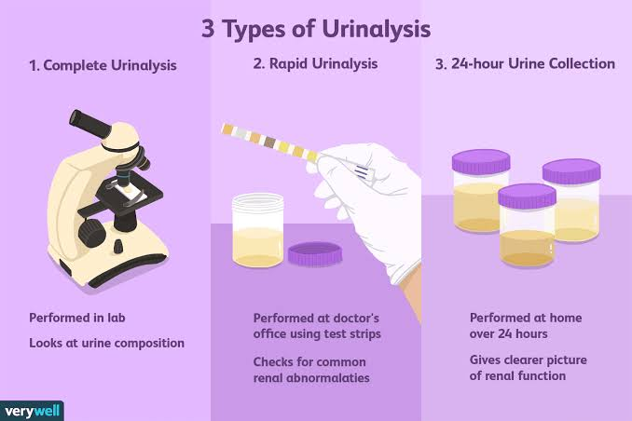
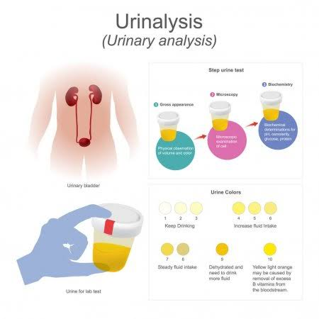

Haemotological tests: Hematology is the branch of medicine concerning the study of blood, the blood-forming organs, and blood diseases. Hematological tests can evaluate numerous conditions involving blood and its components. They can also be used to diagnose inflammation, anemia, infection, hemophilia, blood-clotting disorders, leukemia, and response to chemotherapy, among many other things.Hematology tests include laboratory assessments of blood formation and blood disorders.
Some examples of these tests are;
- Full blood count - A count of the total number of red blood cells, white blood cells and platelets present in blood.
White blood cells (WBC) make up the body's primary defense system, and knowing their number is an important tool in diagnosing and monitoring infection and leukemic disorders
Red blood cells (RBC) are responsible for the transport and exchange of oxygen. Measurement of RBCs is important in monitoring the effects of blood loss and the progression of chronic disease. Normal counts of RBCs are 3,900,000 - 5,800,000 per mm³ of blood.
Hemoglobin (HgB) is the oxygen-carrying protein in red blood cells. Hemoglobin levels are a direct reflection of the amount of oxygen in the blood. A normal hemoglobin concentration is 11-15 grams per deciliter of blood.Increased HgB is seen in those with dehydration, chronic obstructive pulmonary disease, or COPD, and congestive heart failure, or CHF, and those at high altitude. A decreased HgB value is seen in anemia, blood loss, liver disease, as well as leukemia and lymphomas.
- Blood film - Blood is smeared over a glass slide that is stained with specific dyes and viewed under a microscope. The number, shape and size of blood cells and the presence of any abnormal cells or immature cells are noted. The stain used for reticulocytes or immature red blood cells is Heilmeyer's reticulocyte stain. Staining may flag up abnormally shaped red blood cells such as sickle cells or spherocytes. Staining may also detect blood parasites such as malaria, toxoplasmosis, and microfiliariasis.
- Assessment and staining of immature platelets or megakaryocytes may also be performed.
- Assessment of granulocytosis
- The erythrocyte sedimentation rate (ESR) may be tested.

Importance of haemotological tests
- It is responsible for the diagnosis and management of a wide range of benign and malignant disorders of the red and white blood cells, platelets and the coagulation system in adults and children.
- They can also be used to diagnose inflammation, anemia, infection, hemophilia, blood-clotting disorders, leukemia, and response to chemotherapy, among many other things.

Illustration of haemotological tests

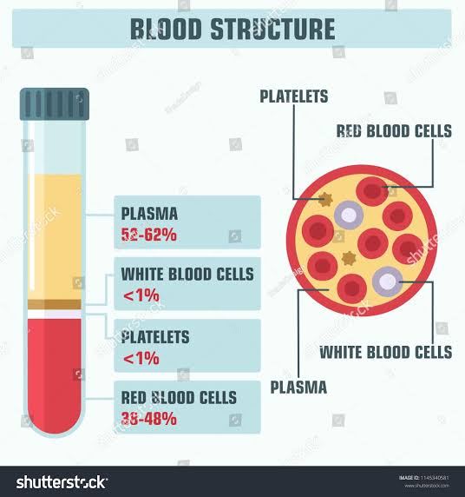

Anatomical pathology: Anatomic pathology is a medical specialty that is concerned with the diagnosis of disease based on the macroscopic, microscopic, biochemical, immunologic and molecular examination of organs and tissues.
Anatomical pathology is one of two branches of pathology, the other being clinical pathology, the diagnosis of disease through the laboratory analysis of bodily fluids or tissues.
Anatomic pathology relates to the processing, examination, and diagnosis of surgical specimens by a physician trained in pathological diagnosis while clinical pathology is the division that processes the test requests more familiar to the general public; such as blood cell counts, coagulation studies, urinalysis, blood glucose level determinations and throat cultures.
In addition to describing the study of disease, the word pathology can also be used to describe characteristics of a disease itself (e.g. “the pathology of cancer”). The three broad subtypes of pathology are anatomical pathology, clinical pathology, and molecular pathology.
Anatomical pathology is itself divided in subspecialties, the main ones being surgical pathology (breast, gynecological, endocrine, gastrointestinal, genitourinary, soft tissue, head and neck, dermatopathology), neuropathology, hematopathology cytopathology, and forensic pathology.
There are three main subtypes of pathology are;
- anatomical pathology
- clinical pathology
- molecular pathology.
Importance of anatomical pathology
- is to identify abnormalities that can help to diagnose disease and manage treatment.
- It underpins every aspect of patient care, from diagnostic testing and treatment advice to using cutting-edge genetic technologies and preventing disease

Illustration of anatomical pathology of a gout

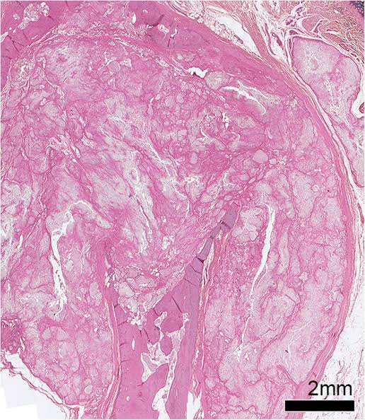

- A cell can adapt to a certain point, but if the stimulus continues beyond that point, failure of the cell, and hence the organ, can result. If cells cannot adapt to the pathologic stimulus, they can die.
cellular adaptation refers to changes made by a cell in response to adverse or varying environmental changes] The adaptation may be physiologic or pathologic. Four types of
morphological adaptations include atrophy, hypertrophy, hyperplasia, and metaplasia.
Cellular adaptation is the ability of cells to respond to various types of stimuli and adverse environmental changes. If cells are not able to adapt to the adverse environmental changes, cell death occurs physiologically in the form of apoptosis, or pathologically, in the form of necrosis.
Cellular adaptation is the ability of cells to respond to various types of stimuli and adverse environmental changes. These adaptations include hypertrophy (enlargement of individual cells), hyperplasia (increase in cell number), atrophy (reduction in size and cell number), metaplasia (transformation from one type of epithelium to another), and dysplasia (disordered growth of cells). Tissues adapt differently depending on the replicative characteristics of the cells that make up the tissue. For example, labile tissue such as the skin can rapidly replicate, and therefore can also regenerate after injury, whereas permanent tissue such as neural and cardiac tissue cannot regenerate after injury. If cells are not able to adapt to the adverse environmental changes, cell death occurs physiologically in the form of apoptosis, or pathologically, in the form of necrosis. This learning card provides an overview of the main cellular adaptive mechanisms and their different consequences in the human body.
Cell death is the event of a biological cell ceasing to carry out its functions. This may be the result of the natural process of old cells dying and being replaced by new ones, or may result from such factors as disease, localized injury, or the death of the organism of which the cells are part. Cells can die because they are damaged, but most cells die by killing themselves. Some cell death processes leave no trace of the dead cell, whereas others activate the immune system with substances from the dead cell. Apoptosis: is a form of cell death that prevents immune activation. Two main types of cell death have been identified: apoptosis and necrosis. Necrosis occurs when cells are irreversibly damaged by an external trauma. In contrast, apoptosis is thought to be a physiological form of cell death whereby a cell provokes its own demise in response to a stimulus

