NAME: OPARA RAYMOND NNAMDI
MATRIC NO.: 17/ENG01/024
COURSE: CHE 312 – PROCESS INSTRUMENTATION

ASSIGNMENT
QUESTIONS
- Briefly describe chemical process diagrams.
- Outline the purpose of P&ID and list its division.
- Give five common P&ID symbols with the instrument abbreviations used in instrument diagram.

ANSWERS
QUESTION 1
Chemical process diagrams are specialized types of flowchart which help to us understand the chemical process with the help of diagrams. There are three different types namely;
- Block Flow Diagram: This is simplest form of flow diagram which provides an overall view of a process. This type of diagram includes the chemical process flow along with equipment to provide overview of the chemical plant and process.
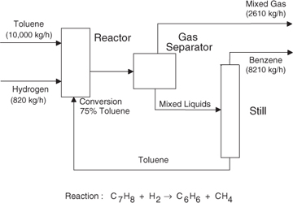

- Process Flow Diagram: This type goes a little deep than the block flow diagram in that it provides more detail about major equipment, sub systems and process flow path. The process flow diagram may or may not include the process parameters like pressure and temperature information as well as main parameters of chemical plant and process.
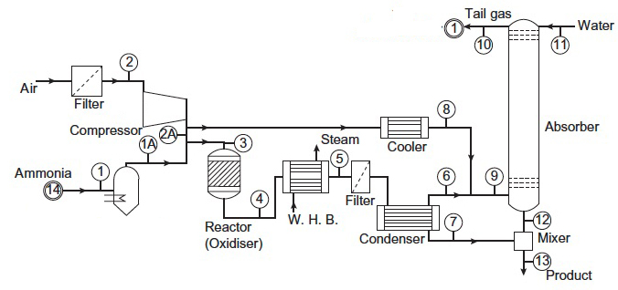

- Piping & Instrumentation Diagram (P&ID): This is also known process & instrumentation diagram. This P&ID diagram is the detailed process flow diagram that includes more details about the process industry like pipes diameter including pipe types and identifications, valve types, control valve and interlocks and all the pipes flow i.e. vents, drain line special fittings tapping and sampling lines etc.
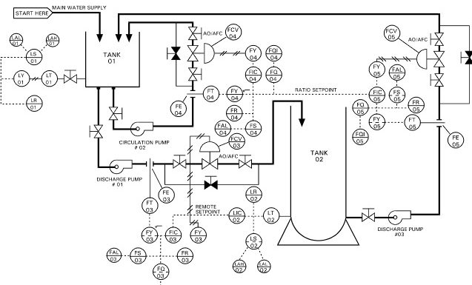

QUESTION 2
The objective of the P&ID diagram is to show the necessary information in order to understand the relationship between the conceptual designs of the process, developed through the process flow diagrams. They are thus divided into two: at design stage and during operation
At design stage:
- Serves to show the interface with equipment/package vendors.
- Serves to show and agree the operating and maintenance features between Engineer and Owner or between Engineer and Vendor.
During operation:
- Support document in the development of operation and maintenance procedures.
- During SAT, as a checklist against which each item in the plant is checked.
- Instrument engineers will specify, install and check control systems.
- Piping engineers will develop plant layout and elevation drawings.
- Project engineers will develop plant and construction schedules.

QUESTION 3
S/N | NAME | SYMBOL | ABBREVIATION
1. | Flow Transmitter | 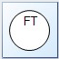 | FT
2. | Temperature Transmitter | 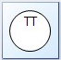 | TT
3. | Pressure Indicator | 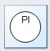 | PI
4. | Temperature Indicator | 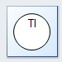 | TI
5. | Temperature  Transmitter |  | TT

