CHINEDUM PRUDENCE ESE
CHEMICAL ENGINEERING
17/ENG01/007
CHE 312
ANSWERS
1. QUESTION ONE
Process Flow Diagram widely used in modeling of processes in the chemical industry. A Chemical Process Flow diagram (PFD) is a specialized type of flowchart. With the help of Chemical Process Flow Diagram engineers can easily specify the general scheme of the processes and chemical plant equipment. Chemical Process Flow Diagram displays the real scheme of the chemical process, the relationship between the equipment and the technical characteristics of the process. Chemical Process Flow Diagram illustrates the connections between the basic equipment as well as the overall structure of pipelines and other supporting equipment. The purpose of the PFD is to build the image of the basic idea of ​​the chemical process. ConceptDraw DIAGRAM together with its Chemical and Process Engineering solution delivers the possibility to design Chemical Process Flow diagrams. It is designed for chemical industry engineers and designers.
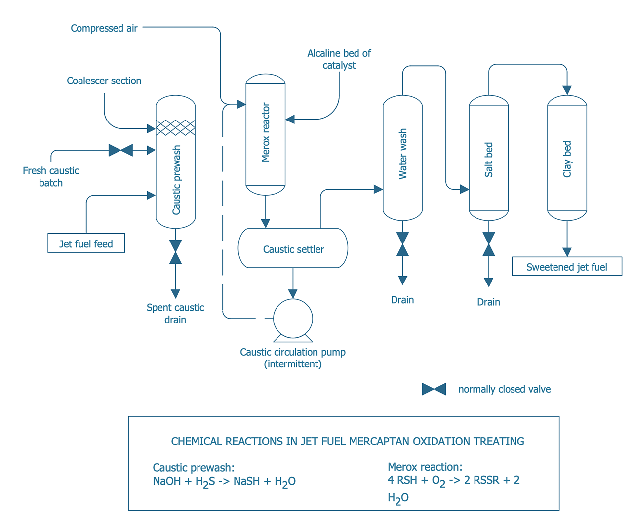

QUESTION TWO
A piping and instrumentation diagram (P&ID) is defined as follows:
- A diagram which shows the interconnection of process equipment and the instrumentation used to control the process. In the process industry, a standard set of symbols is used to prepare drawings of processes. The instrument symbols used in these drawings are generally based on International Society of Automation (ISA) Standard S5.1
- The primary schematic drawing used for laying out a process control installation.
They usually contain the following information:
- Mechanical equipment, including:
  - Pressure vessels, columns, tanks, pumps, compressors, heat exchangers, furnaces, wellheads, fans, cooling towers, turbo-expanders, pig traps (see 'symbols' below)
  - Bursting discs, restriction orifices, strainers and filters, steam traps, moisture traps, sight-glasses, silencers, flares and vents, flame arrestors, vortex breakers, eductors
- Process piping, sizes and identification, including:
  - Pipe classes and piping line numbers
  - Flow directions
  - Interconnections references
  - Permanent start-up, flush and bypass lines
  - Pipelines and flowlines
  - Blinds and spectacle blinds
  - Insulation and heat tracing
- Process control instrumentation and designation (names, numbers, unique tag identifiers), including:
  - Valves and their types and identifications (e.g. isolation, shutoff, relief and safety valves, valve interlocks)
  - Control inputs and outputs (sensors and final elements, interlocks)
  - Miscellaneous - vents, drains, flanges, special fittings, sampling lines, reducers and swages
- Interfaces for class changes
- Computer control system
- Identification of components and subsystems delivered by others
P&IDs are originally drawn up at the design stage from a combination of process flow sheet data, the mechanical process equipment design, and the instrumentation engineering design. During the design stage, the diagram also provides the basis for the development of system control schemes, allowing for further safety and operational investigations, such as a Hazard and operability study (HAZOP). To do this, it is critical to demonstrate the physical sequence of equipment and systems, as well as how these systems connect.
P&IDs also play a significant role in the maintenance and modification of the process after initial build. Modifications are red-penned onto the diagrams and are vital records of the current plant design.
They are also vital in enabling development of;
- Control and shutdown schemes
- Safety and regulatory requirements
- Start-up sequences
- Operational understanding.

QUESTION THREE
The most common P&ID symbols are listed below:
- lines
- piping components (pipes, flanges, and fittings)
- valves
- filters
- instruments and instrumentation
LINES P&ID SYMBOL
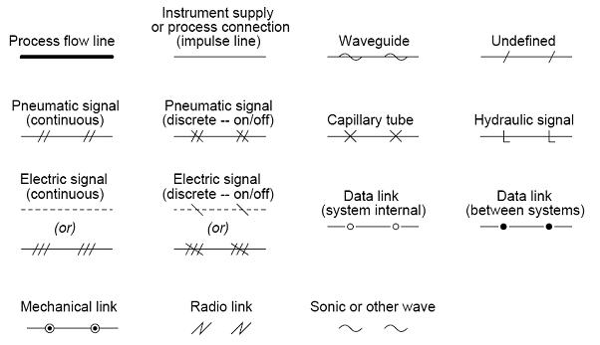

PIPE P&ID SYMBOLS
 | Clamped Flange Coupling symbol
 | Coupling symbol
 | End Caps 01 symbol
 | End Caps 02 symbol
 | Flange symbol
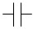 | Flanges symbol

VALVES P&ID SYMBOLS
Gate Valve symbol
Normally Closed Gate Valve symbol
Ball Valve symbol | 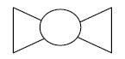
Normally Closed Ball Valve symbol
Globe Valve symbol | 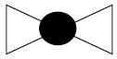

FILTERS P&ID SYMBOLS
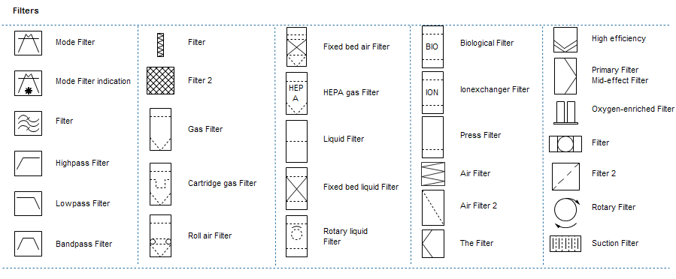

INSTRUMENTS P&ID SYMBOLS
 | Analyzer Transmitter symbol
 | AND Gate symbol
 | Averaging Pitot Tube symbol
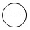 | Behind Control symbol
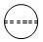 | Behind Local Control symbol
 | Computer symbol

SOME ABBREVIATIONS
