FEASIBILITY STUDY FOR THE SET-UP OF A HAND SANITIZER PRODUCTION FIRM AT ANY SELECTED LOCATION IN NIGERIA

PREPARED BY
GODSWILL SHOFARASIN

(15/ENG06/063)

MECHANICAL ENGINEERING
TECHNOLOGICAL POLICY AND PLANNING
MEE 582

PURPOSE
The main purpose of this study is to know the different variables involved in the production of hand sanitizers and how it would thrive in the open market.
SCOPE
This evaluation will examine the need and feasibility of meeting the demands of the public community as well as making the company profitable in any terms.
NAME OF THE FIRM
Pere Pons produces hand sanitizers that are much needed during a crisis such as this ongoing coronavirus.
LOCATION
The office and production site would be situated in the southern region of Kaduna state.
ABOUT THE PRODUCT
Hand sanitizer is a liquid, gel, or foam generally used to decrease infectious agents on the hands. In most settings, hand washing with soap and water is generally preferred. Hand sanitizer is less effective at killing certain kinds of germs, such as norovirus and unlike soap and water, cannot remove harmful chemicals. Sanitizers are of varying types:

- Liquid Alcohol Based Hand Sanitizers: Alcoholics hand sanitizer generally contain alcohols or isopropanols as the active ingredient that killed germs and bacteria. The contents of alcohols in the hand sanitizing products usually ranges between 60% and 95%, which is considering by FDA to be effectively killing germ and bacteria, including corona viruses, MRSA, and Ecoli. Alcohol based hand sanitizers are considering to be more potent and rapid in killing germ, virus and bacteria, compared to alcohols-free hand sanitizer. However, alcohol based hand sanitizer could be worrisome to some consumer for its risks of flammability intoxications, and damages to the users’ skins.
- Gel Alcohol-Based Hand Sanitizers: Experiment have been done to exams the efficiency of liquid hand sanitizers and gel hand sanitizer. In general, liquid hand sanitizer fare better than gel hand sanitizers. Scientists proved that liquid hand sanitizer in liquid form reacts more rapidly compared to gel hand sanitizers. On average, it took the liquid ones 15 seconds and the latter the double of the time to act. In addition, liquid hand sanitizers leave less residual substance on hands and are generally more effective in terms of killing germs and bacteria, compared to gel hand sanitizers.
- Foam Alcohol-Based Hand Sanitizer: Some believe that foam hand sanitizers are more economical compared to liquid or gel ones, for the airy and incompact texture of the products. In addition, foam is more clinging to hands and will not easily drop, which could cause damage to the floor or the carpet. Therefore, we have witnessed the gaining popularity of foam hand sanitizers in recent years.
- Spray Alcohol-Based Hand Sanitizer: Similar to foam hand sanitizers, there are some arguments regarding the economic efficiency of spray hand sanitizers. Some argue that spray is wasteful compared to liquid and gel since the drops might miss your hands or be deflected into the air when spraying, some hold the opposite opinion saying that spray is more cost-effective, for the liquid is condensed by the nozzle and thus delivers fewer doses, although this might lead to the dilution of active ingredients.
- Alcohol-free sanitizers often contain benzalkonium chloride, as its main ingredient in killing bacteria and viruses. As mentioned in the previous sections, non-alcohol hand sanitizers are proven to work less efficiently in killing bacteria and germs, compared to its alcohol counterpart. On the other hand, such products are not as flammable and toxic to the human body compared to alcohol-based hand sanitizers.

According to the NCDC, when using an alcohol-based sanitizer, one should:
- Apply product to the palm of one hand
- Rub hands together
- Rub the product over all surfaces of hands and fingers until hands are dry
- Do not go near flame or gas burner or any object during application of hand sanitizer.
BRIEF DESCRIPTION OF WHAT WE DO
With the high demand of hand sanitizers not just nationwide, but worldwide, we have decided to take it upon ourselves to producing affordable, quality hand sanitizers that can be used to fight against germs and diseases as we aim to come out of this pandemic.
APPROACH
The company shall be carrying out surveys in the neighboring surroundings in order to evaluate the project.
CONSIDERATION
OBJECTIVES
The company aims to meet the demands of the current society. The competitiveness in the present economy shall urge the company to exceed its expectations and surpass the assumptions. The objective of this firm is to produce as much hand sanitizers as possible and subsequently circulate it both statewide and nationwide.

FEASIBILITY CRITERIA
ECONIMIC ASPECT
MARKET STUDY
The target market is interacting and travelling community. Considering the current demand, the working class and others who are currently involved in daily outdoor activities are our major targets.
DEMAND
The demand for hand sanitizers has been pretty low in the past years and if not for this pandemic, a lot of producers wouldn’t have gotten much recognition. The major consumers of this product would be those heavily involved in daily activities that include a lot of contact with not just objects, but also people.

SUPPLY
The product will be easily supplied to major supermarkets statewide and as well as to neighboring states.

RESOURCES
The raw materials needed in the production can easily be found in the market. Given the high demand, suppliers should not be hard to come by. Beaker, Filter funnel, Filter paper, foil paper, paper tape, Packaging bottle, analytical weighing balance, Lavender oil, glycerin, camphor, wild spinach, garlic, turmeric, Ethanol, distilled water.

OPERATIONAL
This project will help reduce and/or avoid the transmissions of diseases that can be transferred from one person to another
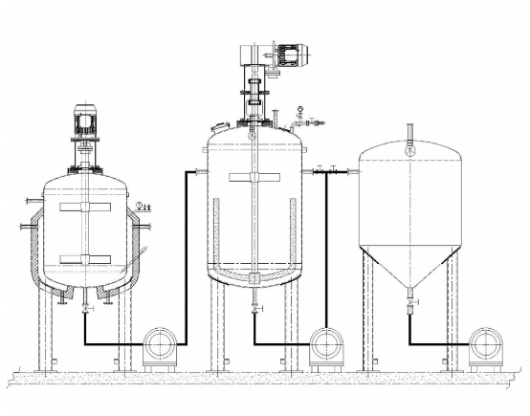
Figure 1 hand sanitizer pot
The hand sanitizers pot is the main device needed. It is composed of the inner containers, steams and cooling water, outer insulating layer, upper-sapped adjustable mixing devices, and material feeding and discharge devices.

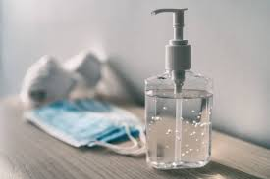
Figure 2 a bottle of hand sanitizer

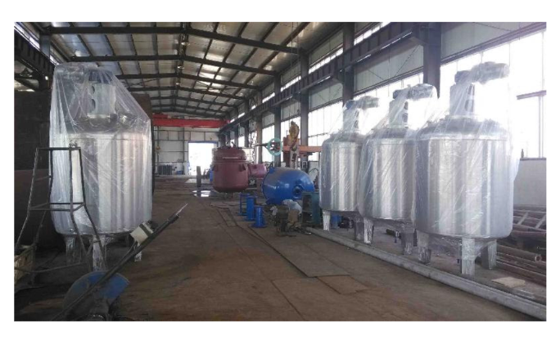
Figure 3 various sorting pots
METHOD
Camphor, wild spinach, garlic and turmeric were grounded into powder form camphor and wild spinach give dry fine particle; while garlic and turmeric was in moisten form. 5000g of each medicinal plants (wild spinach garlic turmeric) and camphor was weighed using analytical weighing balance and poured into four different beakers. 10000ml of ethanol was poured into each of the beakers and covered with foil paper seal with paper tape labelled and left for 24 hours, 48 hours and 72 hrs.
The content in the beakers was filtered into a new four different beakers by the use of filter paper and filter funnel. 10000ml of ethanol was then poured into these beakers and sealed with foil paper and left for another 72hrs. This procedure was repeated twice and the filtrate was collected. 10mlof each extract was measured into four different beakers that had been labeled. 9000ml of ethanol was measured and poured into each of the beakers. To each of the beakers, a drop of lavender oil was added and 1000ml of glycerine was measured and to it 9000ml of ethanol was added and two drops of lavender oil. This mix gets prepared in the sanitizer pot and gets discharged into filling bottles as they are immediately ready for use.

ORGANIZATION AND MARKET STUDY
The company will be run by a project manager, director of sales and marketing. There will also be a HR head to assess the efficiency of the employees
Utilities: Electricity, fuel, water, stream and supplies specifying the users, quantity required, balance of utilities, availability, sources and alternative sources and costs.

Water Disposal: There would not be a lot of waste resources and the little that would arise would be properly excreted through the factory waste line.

CONSUMER PREFERENCE
Handy sizes and affordable prices are attractive to most customers. Making the market people our prime targets, the ideal option is to make it cheap and affordable.
How to use hand sanitizer
Two things to be aware of when using hand sanitizer is that you need to rub it into your skin until your hands are dry. And, if your hands are greasy or dirty, you should wash them first with soap and water. With that in mind, here are some tips for using hand sanitizer effectively. Spray or apply the sanitizer to the palm of one hand. Thoroughly rub your hands together. Make sure you cover the entire surface of your hands and all your fingers. Continue rubbing for 30 to 60 seconds or until your hands are dry. It can take at least 60 seconds, and sometimes longer, for hand sanitizer to kill most germs.

