NAME: Harrison James
MATRIC NUMBER: 17/ENG03/024
DEPARTMENT: Civil Engineering
COURSE NAME: Basic Hydrology
COURSE NAME: CVE (302)

Map from Google earth

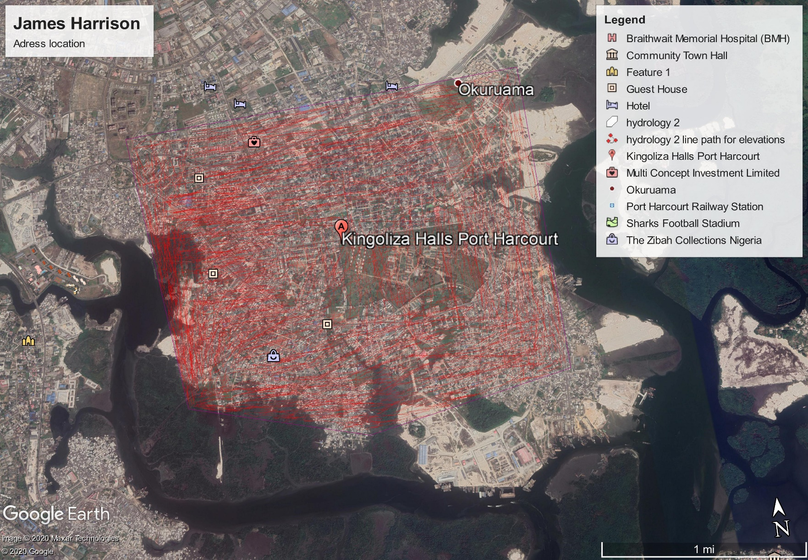
Project Raster from ArcMap

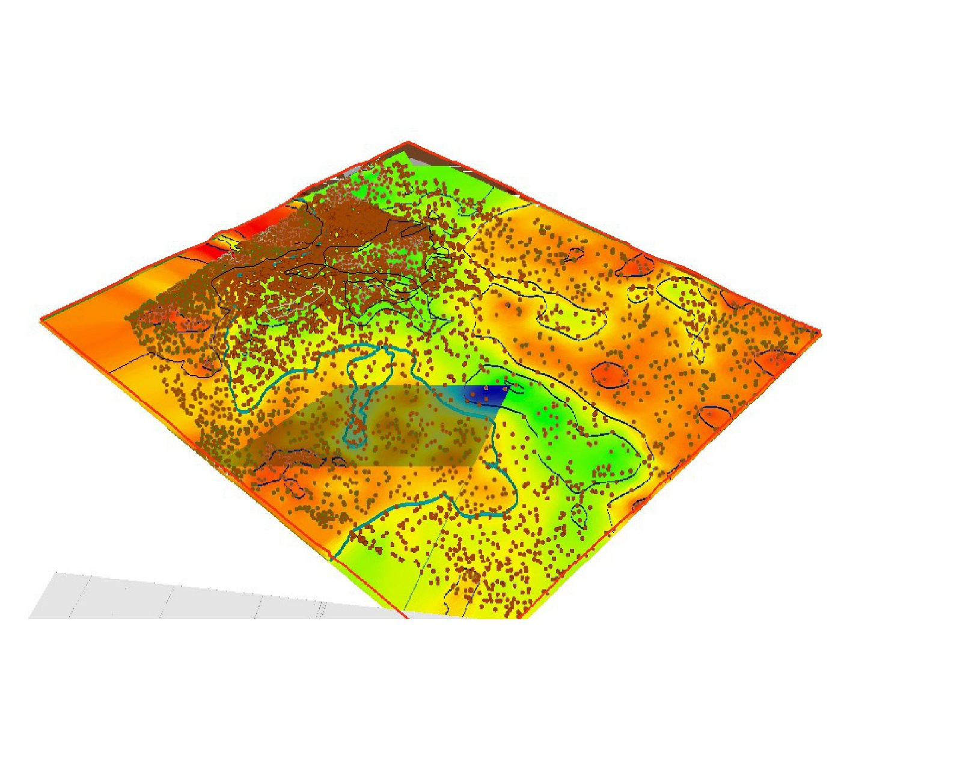
Elevation from ArcScene

