1.) They are responsible for the decay of organic materials
They are important in the food industry for the production of yeast and the production of antibiotics
They mediate the spoilage of wood, food, paper, and clothes 2.) A well labelled of a unicellular fungi (Yeast) 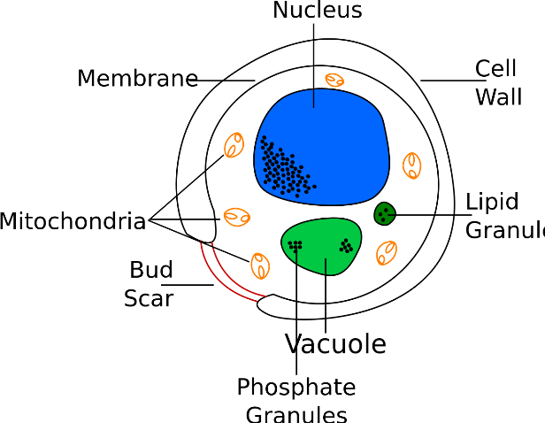
3.) It occurs by two mating hyphae having a chemical interaction which cause the perpendicular growth of gametangia. The two gamentagia on the hyphae’s then fuse(plasmogamy) to form a zygote at the prolonged dormancy or resting stage. Meiosis then occur with the two fuse nuclei in each zygote. The zygote then grows under favourable condition to produce a fruiting which at maturity liberates the haploid spores.
4.) Their body is divided into an aerial and subterranean portion used for the water area and absorbing of nutrients from the soil.
The aerial portion prevents excess loss of water to the atmosphere through the body
There are also openings on the aerial parts of the plant for gas exchange
5.) a.) eusteles: when the vascular bundles are discrete, concentric collateral bundles of xylem and phloem which is found in herbaceous dicotyledons.
b.) atactostele: the vascular bundles are scattered present in grasses and many monocotyledons
c.) siphonostele: the stele is cylinder enclosing a parenchymatous pith, present in stems, ferns and higher vascular plants
d.) dictyotene: the vascular supply to leaves is associated with a leaf gap and the conducting cylinder is dissected.

