Akpan Idara Solomon
16/MHS01/032
ANA 404: Introduction of Histopathology.
Lecturer: Mr Edem E. Edem
QUESTION 1: Write on cancers epidemiology in Africa generally, and Nigeria in particular.
Cancer is the name given to a collection of related diseases. Cancer can start almost anywhere in the human body, which is made up of trillions of cells. Cancers form solid tumours, which are masses of tissue. Cancer has been a huge problem in Africa because of aging and growth of the population, as well as increased prevalence of risk factors. In 2012, the United Nations estimated the population of Africa between 2010 and 2030 is projected to increase from 1.03 billion to 1.63 billion, and for those at the age that cancer usually occurs (60 and older) to increase from 55 million to 103 million. (United Nations, 2012). Deaths due to cancer have surpassed those caused by AIDS, tuberculosis and malaria combined. Over 6% of the world’s total new cancer cases and 7.2% of the world’s total cancer death were estimated to have taken place in Africa. The rate of incidence and mortality of cancer are much lower than the global average because of the African young age. However, the total mortality rate in African women is greater than the global average. The numbers and rates of cancer for individual African countries are estimates based on data of varying quality, ranging from population based close-to-complete and valid observed counts of cases and deaths. They represent the best estimates that can be attained given existing information sources, and, although it is often suggested that the numbers of cases are underestimates of the true situationthere is no reason to suppose that this is the case. The country-specific cancer incidence rates (and mortality using the 5-year survival method) are usually based on data reported by local cancer registries that generally cover the capital city or predominantly urban areas. Adjustments are made for known causes of under- enumeration of cancer cases, but this remains a possibility, particularly in some of the unpublished datasets that have been used. Of more concern, however, is the very sparse data available for rural Africa (where life expec- tancy was less than 50 years in 2000), and the likelihood that incidence rates for most cancers are much lower in rural areas than those reported by the cancer registries covering urban areas. If the urban:rural incidence rate ratios that are reported by Indian cancer registries (Ferlay et al, 2008)) were applicable to African countries, then the 2012 estimates for Africa would be overestimated, as only 40% of the population is urban (United Nations, 2010). The estimates presented in GLOBOCAN 2012 are the most accurate that can be made at present, although there is obviously a need for more reliable cancer registry data, especially in Sub-Saharan Africa, and promoting population-based cancer registration systems for assessing local cancer control priorities in these countries is clearly very important. Breast cancer is the most commonly diagnosed cancer in Africa, and in Sub-Saharan Africa, and is also the leading cause of death from cancer (63,100 deaths in 2012). Apart from the island populations of Mauritius and Reunion, the highest rates are seen in Egypt, Algeria, Nigeria, and Republic of South Africa. Although the reasons for the increasing importance of breast cancer must be speculative, they most likely include increases in the prevalence of risk factors such as early menarche, late child bearing, having fewer chil- dren, obesity, and increased awareness and detection, which are associated with urbanization and economic development. There have been rapid increases in the incidence of breast cancer in Sub-Saharan Africa; rates of increase in the last 20 years were 3.6% per year in Kampala (Uganda) and 4.9% per year in the Black population of Harare (Zimbabwe; refs. 12, 13). In North Africa, the increase in Central Tunisia was 2.5% annually in the last 15 years (14). Early age at onset and aggressive clinical features have frequently been documented in clinical series from Africa and case series from several centers in Africa have reported that hormone receptor–negative cases are pre- dominant. Indeed, a more recent prospective case-series study in South African Black women found that only 35% of breast cancer cases were ER negative (McCormack et al, 2013), which was comparable with those which had been reported in U.S. Black women.
Cervical cancer. Cervical cancer is the second most frequently diagnosed cancer in Africa (99,000 cases) and Sub-Saharan Africa (93,200, 25.2% of cancers in women) in 2012, but is much rarer in North Africa (only 5800 cases, 5.1% of cancers in women). These high rates reflect a high prevalence of the causative virus, HPV (23) as well as a lack of screening services for the prevention and early detection of the disease (24). It is noteworthy that before the introduction and wide dissemination of Pap testing in the 1960s in the United States, the incidence of cervical cancer (cumulative risk, 0–74) in ten selected metropolitan areas in 1947–48 [3.1% in whites and 6.7% in non-whites (24)] was of the same order of magnitude as the highest rates found in Eastern Africa today. There is little evidence for any decline in incidence in recent years.
Prostate cancer. With almost 60,000 new cases esti- mated in 2012, cancer of the prostate is the most frequently diagnosed cancer in men, although in North Africa, it lies in fourth position (after lung, liver, and bladder). It is the third most common neoplasm overall (after breast and cervix), both in Africa as a whole and in Sub-Saharan Africa. In the latter region, the risk of developing prostate cancer before age 75 (3.4%, affecting almost 1 in 30 men) is in fact not dissimilar to the equivalent risks for breast (3.5%) and cervical cancer (3.8%) among women. As is evident in Fig. 4, the disease is the leading cause of cancer among men in many African countries (23 of 54). Most cancer registries are situated in major cities or urban populations on the continent, and it thus remains difficult to ascribe such geographical and temporal differences to risk factors linked to increasing affluence (a westernization of life- style), or to inherent and well-known artifacts [enhanced diagnostic capabilities, notably via the increasing avail- ability (and affordability) of PSA testing].
Liver cancer. Given the poor prognosis of liver cancer, the number of new cases (58,500) and deaths (56,000) estimated in 2012 are rather similar, and in terms of both indicators, liver cancer (predominantly hepatocellular carcinoma) ranks as the fourth most frequent cancer on the African continent and in Sub-Saharan Africa, account- ing for about 7% of the total cancer burden. Rates are 2- fold greater in North Africa than in Sub-Saharan Africa largely because of the very high incidence rates in Egypt and indeed liver cancer rates tends to be low elsewhere in the region; compare, for example, the cumulative incidence in Morocco (0.2%), Algeria (0.2%), and neighboring Libya (0.7%) among men with those estimated for Egypt (4.6%). The incidence and mortality rates are also elevated elsewhere, particularly in Western Africa, where liver cancer is the most common malignan- cy of men in 12 countries (Fig. 4) with a cumulative risk ranging from 1% to 3% in 2012.
Colorectal cancer. Colorectal cancer is the fifth most common malignancy in Africa according to estimates for 2012, with 41,000 new cases and around 29,000 deaths, and a slight preponderance of cases in men. It is certainly more common in Northern Africa (Fig: 6D), where, in Algeria, it ranks second only to breast cancer in terms of incidence when both sexes are combined. In Tunisia and Libya, colorectal cancer takes second place among women, and lifetime risk (0–74) is above 1%. Cumulative risk is even higher in the Indian Ocean islands of Mauritius and Reunion, as well as in Republic of South Africa. Given the relative diagnostic biases associated with prostate and breast cancer, cancers of the large bowel may be considered a more robust marker of the extent of transition in a given population, probably linked to a number of ill-defined dietary factors as well as nutritional correlates (sedentary lifestyle and obesity).
Lung cancer. About 30,300 new lung cancer cases and 27,000 deaths were estimated to have occurred in 2012 in Africa, with men accounting for over 70% of the total cases and deaths. There is over a 30-fold difference in incidence and mortality rates between countries in both males and females, with the lowest rates found in the Western Africa and Middle Africa and the highest rates in Southern and Northern Africa. Notably, lung cancer is the most com- monly diagnosed cancer among males in most countries in Northern Africa, including Tunisia, Libya, Morocco, and Algeria. Data on time trends in lung cancer rates in Africa are sparse. The decrease in men may reflect reduction in tobacco use due to antitobacco policies over the past decades, including increased excise tax on cigarettes and banning smoking in public places. In general, tobacco consumption and lung cancer rates are expected to increase in many parts of Africa because of continued tobacco promotion and lack of comprehensive tobacco control policies in the region. According to data from the Global Youth Tobacco Survey, initiation of smoking increased from 1999 to 2008 in some African countries.
Esophageal cancer. About 27,500 new cancer cases and 25,200 deaths from esophageal cancer were esti- mated to have occurred in Africa in 2012, 89% of these in Sub-Saharan Africa (It is more common in males than females (sex ratio 1⁄4 1.4) and incidence rates are particularly high in East Africa Exceptionally high incidence rates have been recorded in the East Cape Province (former Transkei) area of South Africa (Somdyala, 2010). Almost all of the esophageal cancers in these high risk areas are squamous cell carcinomas (Forman et al, 2012). The reasons for the high burden of esophageal cancers in several parts of Eastern Africa and Southern Africa are not fully understood. Tobacco and alcohol are, as elsewhere, clear risk factors (Pacella, 2002), but obviously do not explain the dramatic regional variation within Africa. Many other hypotheses have been advanced, including nutritional deficiencies secondary to poor dietary patterns such as consumption of a maize-based diet that is low in fruits and vegetables, and the contamination of maize with fungi that produces fumonisins, a cancer-initiating agent in experimental animals. Although a small decline in registered death rates from esophageal cancer in males was recorded in the Republic of South Africa between 1999 and 2006 (Mayosi et al, 2009), no decline in incidence has been seen in cancer registries in the high risk popula- tions of the Eastern Cape, Harare, Zimbabwe and Kampala, Uganda.
Bladder cancer. Bladder cancer is the fourth most common cancer of men in North Africa, with a cumu- lative risk of 1.1% (Fig. 2), but the incidence elsewhere in Africa is much lower (Fig. 6F). Incidence and mortality rates among men in Northern Africa are twice as high as those in Southern Africa, which has the second highest regional rates (cumulative risk 0.8%). Egyptian men have by far the highest bladder cancer incidence rates in Africa (cum risk 2.6%). A large proportion of bladder cancer cases in Africa are squamous cell carcinoma (Parkin, 2008), and between 30% and 60% of all bladder cancer cases in this region are caused by chronic infection with the parasite Schistosoma haematobium (Mostafa et al, 1999). Treatment of schistosomiasis with the drug praziquantel coupled with lower infection rates (probably because of urban- ization) are thought to have contributed to the substan- tial decrease in incidence of Schistosoma-associated bladder cancer in Egypt over the past few decades (Gouda et al, 2007).

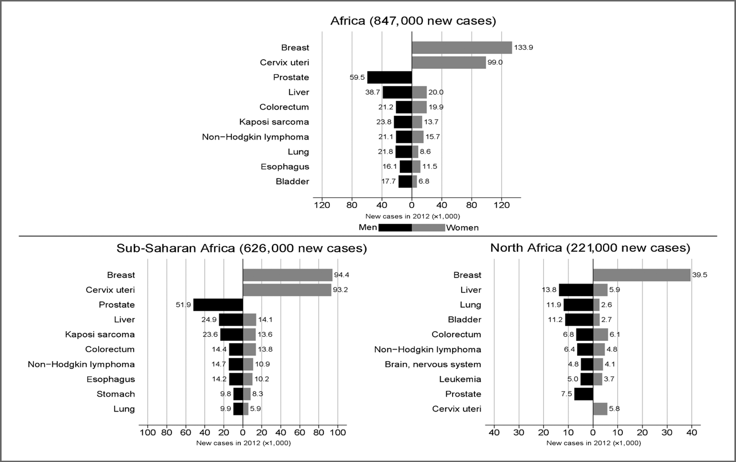
Figure 1: The estimated numbers of cases of the 10 most frequent cancers, by sex, in Africa, Sub-Saharan Africa, and North Africa.
In Nigeria, estimates of cancer incidence were calculated for 2009-2010 based on data from two population based cancer registries, The Ibadan Cancer Registry and Abuja Cancer registry. A total of 4521 cases of invasive cancer in both registries were recorded, 66% in females and 34% in males. The most cancers are breast and cervical cancer in women and prostate cancer in men (Elima, 2012).
QUESTION 2: Examine the involvement of angiogenic genes in the development and progression of osteosarcomas.
Angiogenesis is used to describe a normal yet complex process of the formation of new blood vessels by remodelling of pre-existing blood vessels. Osteosarcoma is one of the most malignant bone tumours that occurs frequently in children and adolescents. Angiogenesis is mainly triggered by hypoxia. The overexpression of prolyl hydroxylase-4 stimulates the expression of tumour growth factor-α in OS cells, which is necessary and sufficient to promote angiogenic sprouting of endothelial cells. In addition, some chemokines modulate angiogenesis and metastasis to facilitate cancer development in tumour microenvironment. Angiogenesis is regulated by the balance between proangiogenic and antiangiogenic factors. The proangiogenic factors are usually overexpressed in osteosarcoma. Connective tissue growth factor is a cysteine-rich protein that increases the production of angiopoietin and induces angiogenesis in osteosarcoma cells via the phospholipase C/PKCδ signalling pathway. Reportedly, insulin like growth factor 1 also promotes angiogenesis. Relaxin promotes tumour growth, invasion and angiogenesis of human Saos-2 OS cells. The multifunctional cytokineIL-6 functions through ASK1 and p38, which in turn activate AP-1, resulting in the activations of VEGF expression and contributing to the angiogenesis of human OS cells. IL-34 may also play a key role in tumour development by promoting new blood vessel formation and immune cell extravasation. IL-34 overexpression contributes to OS growth by increasing neoangiogenesis and the recruitment of M2 tumour-associated macrophages into the tumour tissue. Apurinic/apyrimidinic endonuclease 1, a dually functional protein that possesses both base excision repair and redox activities can indirectly promote angiogenesis in osteosarcoma cells by upregulating fibroblast growth factor 2 and its receptor. The Ying Yang 1 protein is also overexpressed in OS. Chemokines and chemokine receptor 4 interact with Ying Yang 1, indicating that they play a central role in the angiogenesis of osteosarcoma cells. The flowchart below gives a visual explanation of the involvement of angiogenic genes in the development and progression of osteosarcomas.
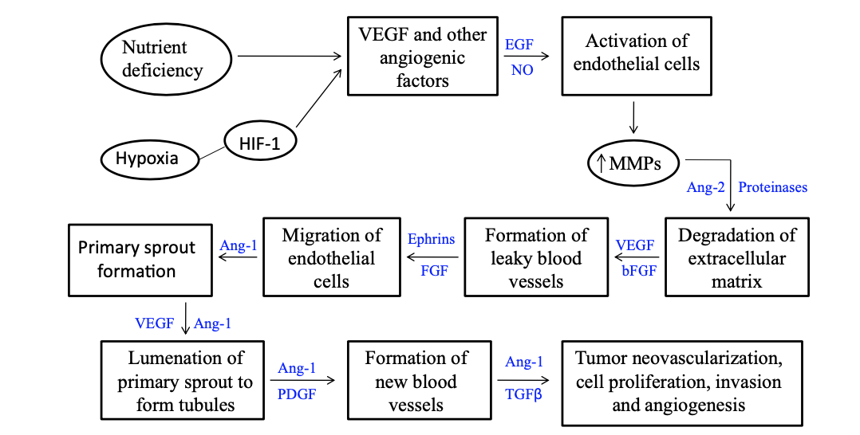

References
Pacella-Norman, R., Urban, M. I., Sitas, F., Carrara, H., Sur, R.,… Hale, M. (2002). Risk factors for oesophageal, lung, oral and laryngeal cancers in black South Africans. Br J Cancer, 86, 1751–6.
Somdyala, N. I., Bradshaw, D., Gelderblom, W. C., & Parkin, D. M. (2010). Cancer incidence in a rural population of South Africa, 1998–2002. International Journal of Cancer, 127, 2420–9.
Parkin, D. M., Whelan, S., Ferlay, J., Bah, E., & Hamdi-Cherif, M. (2003). Cancer in Africa: Epidemiology and prevention. IARC Scientific Publications 153 Lyon, France: IARC.
United Nations Population Division. World population prospects, the 2012 revision. Available from: http://esa.un.org/wpp/index.htm
Ferlay, J., Shin, H. R., Bray, F., Forman, D., Mathers, C., & Parkin, D. M. (2010). Estimates of worldwide burden of cancer in 2008: GLOBOCAN 2008. International Journal of Cancer, 127, 2893–917.

