UDOBANG, ODOTEKOM PETER

CIVIL ENGINEERING

17/ENG03/052

HYDROLOGY – CVE 302

GIS ASSIGNMENT 2 SOLUTION;

30TH MAY, 2020

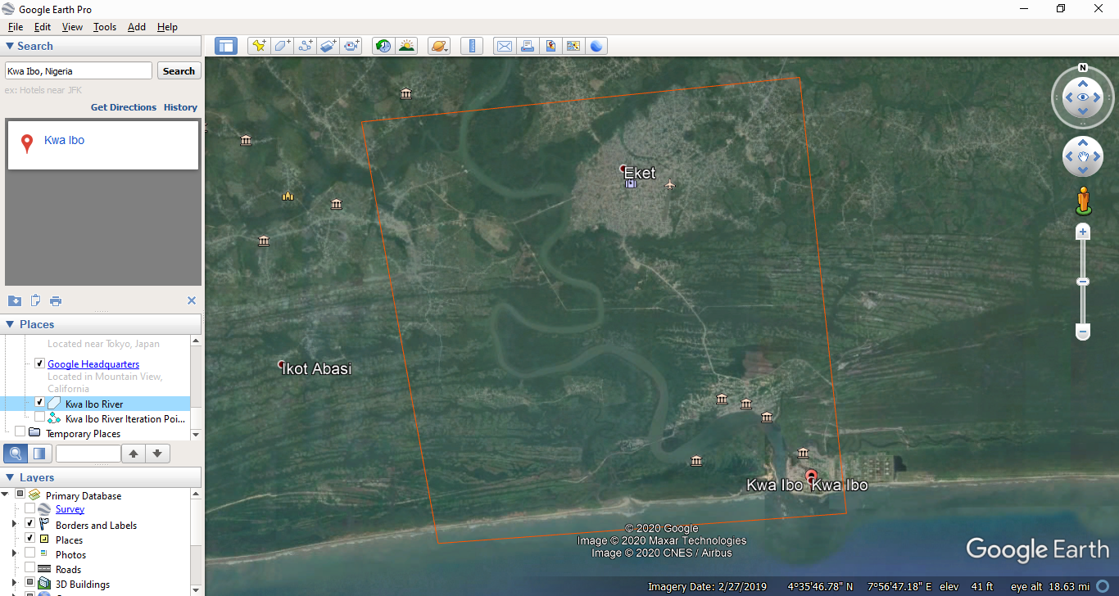
Kwa Ibo River - Google Earth Snap

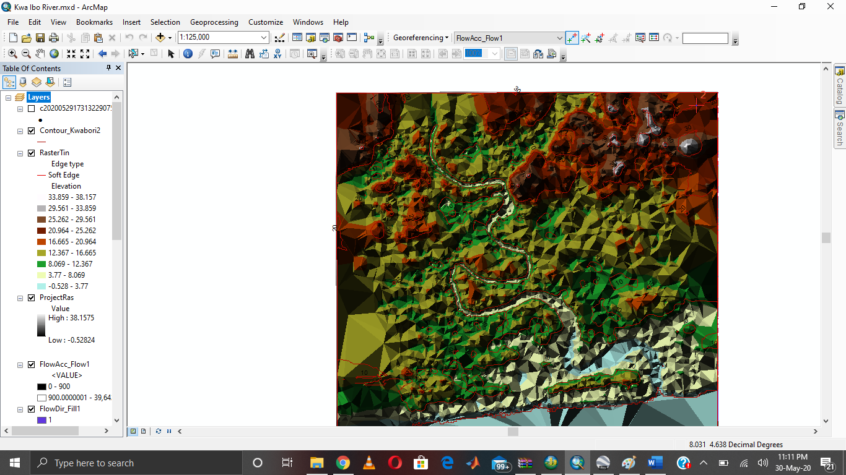
Kwa Ibo River – Arcmap Snap

