OKPESEYI SIMILOLUWA BLOSSOM
16/SCI01/033
CSC 406

Color Context
How color behaves in relation to other colors and shapes is a complex area of color theory. Compare the contrast effects of different color backgrounds for the same red square.

©Color Voodoo Publications
Red appears more brilliant against a black background and somewhat duller against the white background. In contrast with orange, the red appears lifeless; in contrast with blue-green, it exhibits brilliance. Notice that the red square appears larger on black than on other background colors.
Different readings of the same color
©Color Voodoo Publications
If your computer has sufficient color stability and gamma correction (link to Is Your Computer Color Blind?) you will see that the small purple rectangle on the left appears to have a red-purple tinge when compared to the small purple rectangle on the right. They are both the same color as seen in the illustration below. This demonstrates how three colors can be perceived as four colors.
Observing the effects colors have on each other is the starting point for understanding the relativity of color. The relationship of values, saturations and the warmth or coolness of respective hues can cause noticeable differences in our perception of color.
Complementary colors:
Are pairs of colors which, when combined or mixed, cancel each other out (lose hue) by producing a grayscale color like white or black. When placed next to each other, they create the strongest contrast for those two colors. Complementary colors may also be called "opposite colors."
Which pairs of colors are considered complementary depends on the color theory one uses:
- Modern color theory uses either the RGB additive color model or the CMY subtractive color model, and in these, the complementary pairs are red–cyan, green–magenta, and blue–yellow.
- In the traditional RYB color model, the complementary color pairs are red–green, yellow–purple, and blue–orange.
- Opponent process theory suggests that the most contrasting color pairs are red–green, and blue–yellow.

Natural color:
This was a term used in the beginning of film and later on in the 1920s, and early 1930s as a color film process that actually filmed color images, rather than a color tinted or colorized movie. The first natural color processes were in the 1900s and 1910s and were two color additive color processes or red and green missing primary color blue, one additive process of time was Kinemacolor. By the 1920s, subtractive color was mostly in use with such processes as Technicolor, Prizma and Multicolor, but Multicolor was mostly never in use in the late 1920s, Technicolor was mostly in use. The only one who cared to mess with Multicolor was William Fox, probably because Multicolor was cheaper of a process and at the time in 1929 William Fox was in debt. The difference between additive color and subtractive color were that an additive color film required a special projector that could project two components of film at the same time, a green record and a red record. But additive color didn't required a special projector, the two pieces of film were chemically formed together and was projected in one strip of film.
Analogous colors :
This are colors that are next to each other on the color wheel. For example, yellow, green-yellow, and green are categorized as analogous colors. The word ‘analogous’ is defined as two things with a similar function or feature that are comparable to one another.
What Are Analogous Colors?
In this case, the two colors green and yellow are relatable to one another because they are neighbors on the color wheel. If you mix these two colors, you create a new color, yellow–green, that has attributes of both. Thus, the three colors are analogous because of their close relationship to one another. Interior designers often use analogous colors to decorate a room because it gives it a sense of harmony.
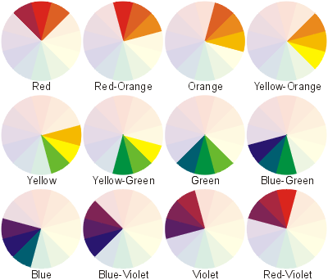
How Do You Use Them?
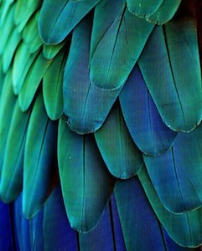Whether you are decorating a room, designing a pamphlet, or picking out an outfit, you can incorporate analogous colors to create a balanced and serene look. Analogous colors are pleasing to the human eye and are found abundantly in nature. Just take a walk through the woods, and you will start to notice this natural-occurring trend.
When picking out your analogous color scheme, you want to pick a set of colors that have enough of a tonal contrast that you can easily identify each one. For example, if you have blue, blue-green, and green colors next to each other in a design, your blue-green mix should be an even mix of the two for a balanced look. If your middle color is too blue or too green, it will throw off your harmonious trio of colors.

