PHILIP LYDIA
17/ENG07/019
PETROLEUM ENGINEERING
PTE 312 (RESERVOIR ENGINEERING)
SUMMARY OF ELECTRICAL CONDUCTIVITY OF FLUID SATURATED ROCKS

Porous rocks are comprised of aggregate of minerals, rock fragments, and void spaces, the solids except certain clay minerals are non-conductors. The electrical properties of a rock depend on the geometry of the voids and the fluids with those voids are filled. The fluids in petroleum reservoirs are oil, gas and water. Oil and gas are non-conductors while water is a conductor when it contains salts. Current is conducted in water by the movement of ions and this is called electrolytic conduction. The resistivity of a material is the reciprocal of conductivity and it is mostly used to define the ability of a material to conduct electricity. The resistivity of a material is represented by the following equation:
$ρ=\frac{rA}{L}$ ………………………………………… (1.1)
Where $ρ$ = resistivity
r = resistance
A = cross-sectional area of the conductor
L = length of the conductor
For electrolytes, $ρ$ is commonly expressed in ohm-centimeters, r is expressed in ohms, A in square centimeters. In the oil and gas industry, the resistivity in ohm-meters is represented by the symbol R with an appropriate subscript to define the conditions to which R applies
Formation Factor: this is the most fundamental concept in electrical properties of rocks. As defined by Archie, the formation factor is:
F = $\frac{ RO }{RW}$ ……………………………………… (1.2)
Where R_{O} is the resistivity of the rock when saturated with water having a resistivity of R_{W.} the relationship between the electrical and other physical properties of the rock are complex.
Resistivity index: if the cube of the porous rock contains both water and hydrocarbons, the water is still the only conductor. The cross sectional area for conduction is reduced further to A’_{a} and the path length changed to L’_{a}. therefore, the resistivity is given as
$r=\frac{RwL'a}{A'a}$ ……………………………………… (1.3)
The resistivity of a partially water-saturated rock is defined as
R_{t} = $\frac{ rA }{L}$ ……………………………………… (1.4)
R_{t} = $\frac{ RwL'aA }{LA'a}$ ……………………………………… (1.5)
The second fundamental notion of electrical properties of porous rocks is that of the resistivity index I:
I = $\frac{ Rt }{Ro}$ ……………………………………… (1.6)
Therefore I = $\frac{ Aa/A'a }{La/L'a}$ ……………………………………… (1.7)
Both the formation factor and the resistivity index are shown to be functions of effective path length and effective cross sectional area. The cross sectional areas of the pore openings vary along their lengths but in such manner that the sum of the areas of the pores is constants.
A model was presented by Wyllie which is shown below. In the model, it is considered that the various pore openings are continuous. The cross sectional areas of the pore openings vary along their lengths but in such manner that the sum of the areas of the pore is constant.
A_{a} = A₁ +A₂ = ɸA ……………………………………… (1.8)
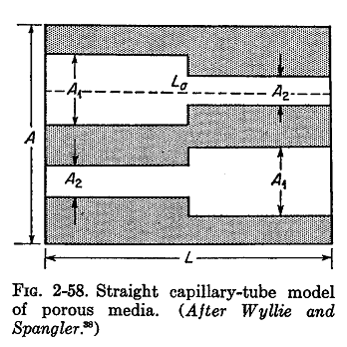

If a hydrocarbon is introduced into the pores, the water saturation S_{W} can be expressed as a fraction of the pore volume. Presence of the hydrocarbons further reduces the effective cross sectional area available for flow to A’_{a}, and the average path length is altered to L’_{a}.
A’_{a} = ɸS_{W}A ……………………………………… (1.9)
Then substituting ɸS_{W}A into eqn.
I = $\frac{ɸA/ɸSWA}{La/L'a}$ = $\frac{L'a}{La}$ $\frac{1}{Sw}$ …………………(2.0)
Cornell and Katz presented a slightly different model as shown below. The pores can be considered uniform in cross sections but oriented so that they have an effective length L_{a}. the cross sectional area available for flow is once again considered at each plane in the model.
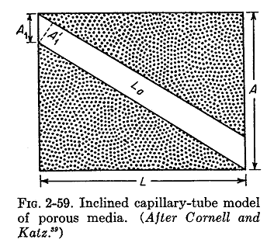

Wyllie and Gardner have recently introduced a third model which is shown. In this model, the cross sectional area of the pores is again considered constant. However, it is conceived that the effective flow cross section is only the net exit area at each plane. Thus the probability that a selected point will fall in a pore opening in one plane is ɸ, that is will fall also in a pore opening in the contiguous plane is (ɸ)², therefore
A_{a} = (ɸ)² A ……………………………………… (2.1)
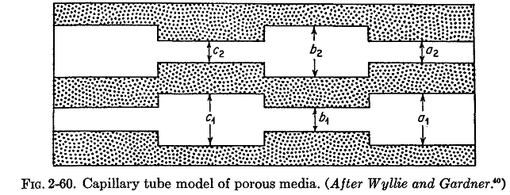
From the analysis of the electrical properties of the foregoing models, general relationships between electrical properties and other physical properties of the rock can be deduced. The formation factor has been shown to be some function of the porosity and the internal geometry of the rock.
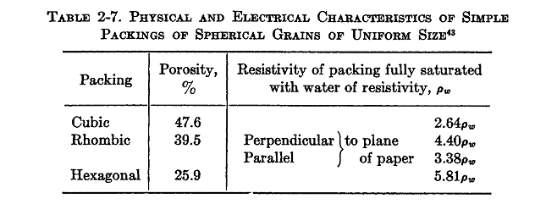

The table above summarizes Sundberg’s computations for uniform sphere arranged systematically. Archie, in 1942 suggested that the correlation with porosity was better correlation and that the formation factor could be expressed as
F = ɸ^{-m} ……………………………………… (2.2)
Where ɸ is the fractional porosity and m is the cementation factor. He further reported that the cementation factor probably ranged from 1.8 to 2.0 for consolidated sandstones and for clean unconsolidated sands was about 1.3. the figure below shows the family of curves by equation (2.2) and cementation factors ranging from 1.3 to 2.2. the dashed lines indicate the values computed for systematic packing of uniform spheres.
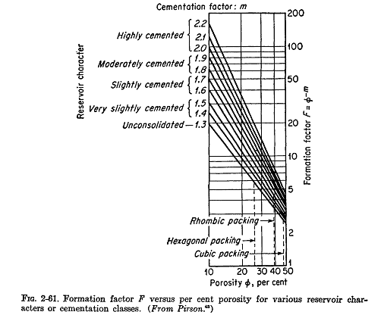

Measurement of Electrical Resistivity of Rocks
Laboratory measurement of electrical properties of rocks have been made with a variety of devices. The measurement requires a knowledge of the dimension of the rock, fluid saturation, the resistivity of the water contained in the rock, and suitable resistivity cell in which to test the sample.

Effective of conductive solids: it was said earlier that clay minerals might act as conductors and contribute to the conductivity of a water saturated porous rock. Investigations by Wyllie indicate that clays contribute substantially to the conductivity of a rock when the rock is saturated with a low-conductivity water. The effect of water resistivity on formation factor for sands containing clay minerals is shown below.
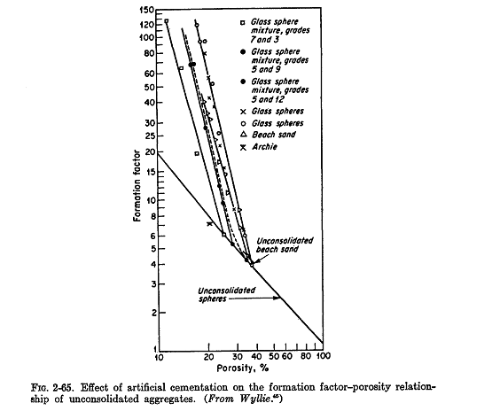

Resistivity of partially water-saturated rocks: a rock containing both water and hydrocarbon has a higher resistivity than the rock when fully saturated with water. The resistivity of partially water-saturated rocks has been shown to a function of the water saturation S_{w}.
The resistivity index introduced earlier is convenient function for correlating experimental data on the resistivity of rocks with water saturation.

Use of electrical parameters in characterizing porous media: Kozeny generated an equation as follows
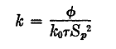……………………………………… (2.3)
Where k is the permeability, ɸ is the porosity fraction, k₀ is the shape factor, S_{p} is the internal surface area per unit pore volume, and r is the Kozeny tortuosity.

