EDIDIONG IME- ESSIEN
17/SCI01/041
CSC 302 (Assignment 2)
1.With the aid of a schema distinguish between a modular and an object oriented programming paradigm.

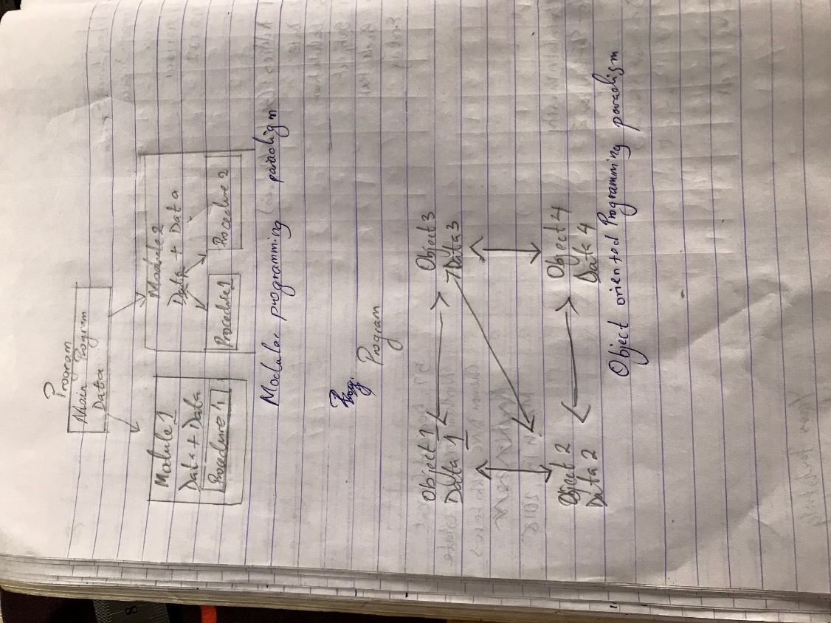

2. Use this schema to illustrate the modifications required to translate an airline reservation program from a modular to an object oriented design
