Name: Etuk UdemeAbasi Aniefiok
Matric Number: 16/SCI01/011
Assignment

- The concepts of operational laws as applied to computer and network system performance evaluation.
A number of laws are derived which establish relationships between throughput, response time, device utilization, space-time products and various other factors related to computer system performance. These laws are obtained through the operational method of computer system analysis. The operational method, which is formally introduced in this paper, differs significantly from the conventional stochastic modeling approach and is based on a set of concepts that correspond naturally and directly to observed properties of real computer systems. The operational laws presented in this paper apply with complete precision to all collections of observational data.

2. Eight operational laws that are widely employed in computer system performance evaluation.
i.) Response Time:
A functioning computer environment comprises millions of data transmission cycles consisting of user requests and system responses. The response time is defined as the total time lapse between the completion of an inquiry or demand made on a system resource and the receipt of a response. In real life, it can be compared to the time between placing an order to receiving a delivery.

ii) Latency:
Latency is the term used to describe the state of existence of something in transition. Every transmitted piece of information on a computer system travels over some sort of medium. Computer latency is defined as the time it takes to communicate a message, or the time the message spends traveling the geographical distance ('on the wire') before it gets to its desired destination. This can be compared to the time one spends on an aircraft, traveling from one geographical location to another.

iii) Speed:
The term speed is usually in reference to the clock speed of the processor. The clock speed is defined as the clock cycles per second, which determines the rate at which instruction processing takes place. It is usually measured in megahertz (MHz) or gigahertz (GHz). Computer speed is one of the leading parameters in assessing a computer's performance. It can be compared to the horsepower of an engine. The higher the horsepower, the faster the car can move.

iv) Throughput:
Computer function consists of millions of data transmissions between devices and components. The computer's throughput is defined as the number of units of information that can be successfully processed at any given time. The throughput is commonly measured using bits per second (bps)—more specifically, megabits per second (Mbps) and gigabits per second (Gbps). For example, if the post office can receive and process a maximum of 1000 items per day, then that’s its throughput.

v) Channel capacity:
Channel capacity is the tightest upper bound on the rate of information that can be reliably transmitted over a communications channel. By the noisy-channel coding theorem, the channel capacity of a given channel is the limiting information rate (in units of information per unit time) that can be achieved with arbitrarily small error probability.

vi) Scalability: Scalability is the ability of a system, network, or process to handle a growing amount of work in a capable manner or its ability to be enlarged to accommodate that growth.

vii) Power consumption:
The amount of electricity used by the computer. This becomes especially important for systems with limited power sources such as solar, batteries, human power.

viii) Environmental impact:
The effect of a computer or computers on the environment, during manufacturing and recycling as well as during use. Measurements are taken with the objectives of reducing waste, reducing hazardous materials, and minimizing a computer's ecological footprint.

3. The differences between the Forced Flow Law and the Residence Time Law from a systems perspective
Forced Flow Law
- Relates the system throughput to individual device throughputs.
- In an open model, System throughput = # of jobs leaving the system per unit time
- In a closed model, System throughput = # of jobs traversing OUT to IN link per unit time.
- If observation period T is such that Ai = Ci⇒ Device satisfies the assumption of job flow balance.
- Each job makes Vi requests for ith device in the system
- Ci = C0 Vi or Vi =Ci/C0 Vi is called visit ratio

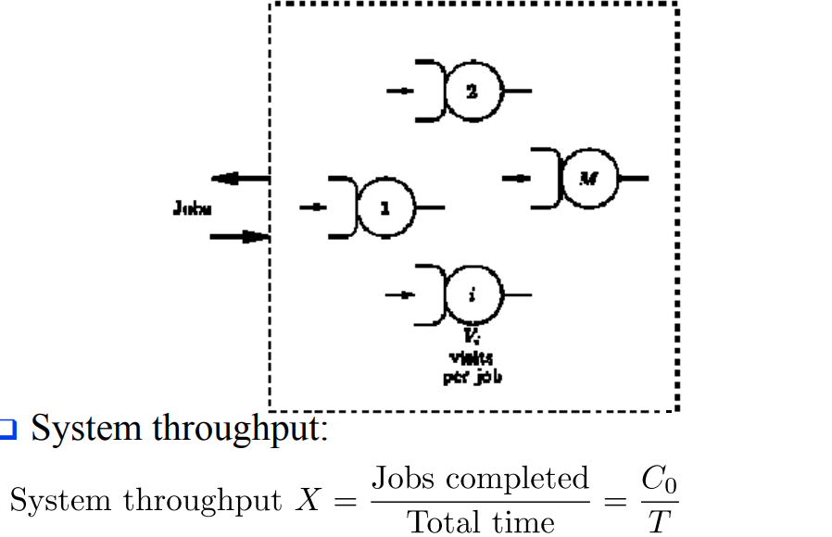

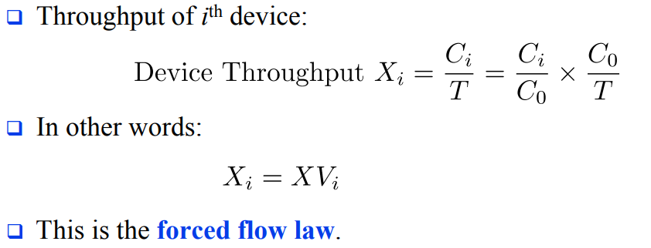

WHILE

Residence Time Law

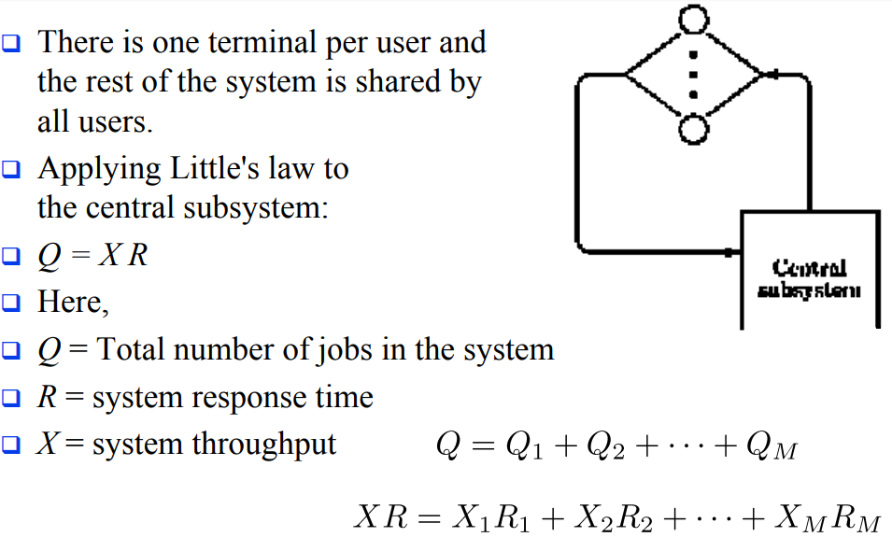

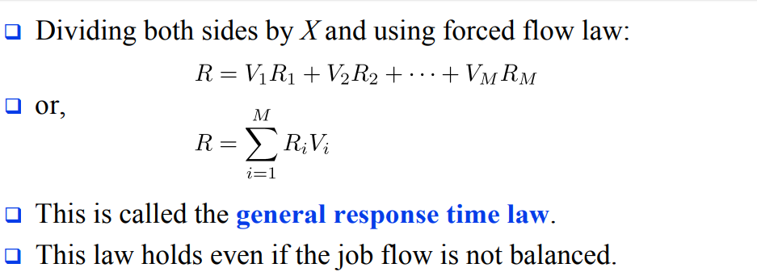

4. Discuss some basic queuing models and basic queuing disciplines.
Some basic queuing models:
Arrival process: The arrival process is simply how customers arrive. They may come into a queue alone or in groups, and they may arrive at certain intervals or randomly.
Behavior: How do customers behave when they are in line? Some might be willing to wait for their place in the queue; others may become impatient and leave. Yet others might decide to rejoin the queue later, such as when they are put on hold with customer service and decide to call back in hopes of receiving faster service.
How customers are serviced: This includes the length of time a customer is serviced, the number of servers available to help the customers, whether customers are served one by one or in batches, and the order in which customers are serviced, also called service discipline.
Service discipline: refers to the rule by which the next customer is selected. Although many retail scenarios employ the “first come, first served” rule, other situations may call for other types of service. For example, customers may be served in order of priority, or based on the number of items they need serviced (such as in an express lane in a grocery store). Sometimes, the last customer to arrive will be served first (such s in the case in a stack of dirty dishes, where the one on top will be the first to be washed).

Waiting room: The number of customers allowed to wait in the queue may be limited based on the space available.

Basic queuing discipline:

First In First Out (FIFO): First In, First Out, commonly known as FIFO, is an asset-management and valuation method in which assets produced or acquired first are sold, used, or disposed of first. For tax purposes, FIFO assumes that assets with the oldest costs are included in the income statement's cost of goods sold (COGS). The remaining inventory assets are matched to the assets that are most recently purchased or produced.

Last In First Out (LIFO): Last in, first out (LIFO) is a method used to account for inventory that records the most recently produced items as sold first. Under LIFO, the cost of the most recent products purchased (or produced) are the first to be expensed as cost of goods sold (COGS)—which means the lower cost of older products will be reported as inventory.

Shortest Remaining Time(SRT): Shortest remaining time, also known as shortest remaining time first, is a scheduling method that is a preemptive version of shortest job next scheduling. In this scheduling algorithm, the process with the smallest amount of time remaining until completion is selected to execute.

5. Discuss how to resolve some basic queuing problems.
Firstly, queuing problems are the problems that occur when the service rendered doesn’t match the level of demand i.e. waiting for some time till the service is rendered to a customer. These customers might be humans at a bank on a queue or even airplanes ready to take off/ land or jobs waiting to be processed. An example could be when a supermarket doesn't have enough cashiers on a busy morning or when requests reach a system faster than it can process them.
Generally, no two businesses’ queuing problems are the same but some basic queuing problems that exist include; more customers entering the queues than leaving, when the queues are too long and strenuous, where queues are idle and not moving due to many queues and limited service providing stands to ease the queues etc.
We can then solve these various problems by:
- Let Customers Know How Long The Wait Is: The uncertainty of how long it will take to wait is often the cause of queue anxiety. Because of this the customers are impatient and this is a major cause of queuing problems as people want to jump the queues or altogether leave the queue.

- Assess and improve your queue management strategy: How do you currently handle a long line of customers? Think about what works well and what doesn’t. Assessing the tactics used to manage the queue in the particular organization will really help solve the queuing problems being encountered.

- Design Your Environment To Be Able To Accommodate Queues: Studies have shown that one of the most common issues found in lines is queue anxiety. A well-designed queuing area can help organize waiting lines, remove the possibility of queue jumpers and generally ease customer flow management.

- Implement Digital Queuing Software: Long queues can inspire customer’s irritation even disgust. But anyone can learn how to reduce queues the use of a nifty technology called a queue management system (QMS).Automating the queuing process creates more labor efficient customer lines, decreases the overall amount of walkaways as well as ultimately reducing queue times. When it’s their turn, a teller calls them to the counter to be served. They can see where they are in line by observing HDTVs hung on the walls of the organization and therefore customers are free to sit or wander and maybe grab a coffee across the street as they wait. They’re not corralled into the line like sheep. By giving customers back their time (their autonomy) one enable customers to wait in leisure. Now that’s effective queue management.
- Occupy Customers in The Queue: Boredom in the queue can often lead to longer perceived waiting times. Queue solutions is to provide a distraction to people in the queue and help them continue shopping while waiting, easing up frustrations etc. Display entertaining programming on HDTVs. Prompt customers to answer surveys to report on their experience. Engaging customers is the best way to reduce the tension inherent in queueing. Because it’s typically the psychology behind queueing rather than the queues themselves that makes queues feel unbearable.

- Keep The Rules Of Queuing Fair And Consistent: One of the most important characteristics of any queue problem solving method is the queuing discipline used. Simply put, the queuing discipline is the rule used to decide who goes next in a queue.
  - Two of the most commonly used rules are:
    - First in, First out.
    - Last in, First out.
  - Bottom line, people expect queues to be fair. It’s not like they’re happy to be stuck waiting in line, to begin with. But when everyone abides by the same rules, we can’t help but follow them too.

- Reduce Response times: So when it comes to providing service, be quick as possible. It's not possible to solve every problem immediately, but customers don’t expect that from you. What they do expect is that you give them some kind of response quickly. Having all information at your fingertips is the next step as these steps will help improve the flow of the queues and have less waiting times.

6.
A project management infrastructure that would be needed to support a software development consulting team working at a client site
A project management infrastructure, consists of systems of policies, standards, procedures and guidelines that define how project management work is to be performed. From my research, I suggest that there are four key components that are part of a project management framework or infrastructure
- Portfolio Management System
A Portfolio Management System ensures that the initiation of the project management process is grounded in sound strategic business decisions. A Portfolio Management System has five subsystems: a Solicitation Process (doing the right projects), a Selection Process (stopping the wrong ones), a Prioritization Process (doing them in the right order), a Registration Process (codifying them in a central repository), and an Enterprise Resource Planning Process (staffing them with the right people).
First, a Solicitation Process provides a consistent model for all proponents to follow; in other words, requestors of projects to follow. This model defines how a proponent prepares a business case that will be evaluated by the organization's business decision-makers. Then comes the Selection Process during which time the decision-makers approve those projects that add value to the organization and reject those projects that do not. After certain projects are approved, this same group of decision-makers prioritizes these projects relative to predefined business criteria, thus signifying those projects that will be given higher visibility and support and those that will not. Pertinent information such as project client, project scope, and team members is entered into a centralized database for all to access. In addition, these approved and prioritized projects are staffed (or resourced) relative to all the projects within the portfolio mix and relative to where the project sits within the prioritization ranking.
This part of the infrastructure allows the enterprise to manage the inventory of projects within the enterprise.

- Process Management System
A Process Management System takes the approved and prioritized project through the Definition, Planning, Execution/Control, and Closeout phases.
The approved project from the Portfolio Management System goes into the Definition phase, which creates a project charter. The project charter becomes the input to the Planning phase, which creates a work plan; that is, schedule, staffing plan, project budget, and so on. The charter and the work plan then become the baseline in the Execution/Control phase of the project process. During this phase, the project team creates status reports and product deliverables. Once the project is over, these outputs from the execution/control phase are the input into the Closeout phase from which lessons learned are documented and archived for reference when starting the project management process all over again.
Various auxiliary processes such as a risk management process, a change management process, a quality assurance and control process, and a vendor/ contractor management process augment the above “core” process.
This component of the infrastructure ensures that the discipline of project management is performed in a consistent and professional manner throughout the entire organization.
- Organizational Management System
An Organizational Management System is the governance structure defining roles, responsibilities, and authorities and reporting relationships.
From almost the beginning of project management, the applied organization structure that supported a project environment was a matrix structure. A matrix structure consists of representatives from various functional areas working together in an ad hoc team to accomplish certain business objectives producing specified deliverables. These cross-functioning teams work within the constraints of multiple bosses and often multiple priorities; however, they create a better and more “acceptable” product because of everyone's involvement in the project effort.
Today the “Project Office” is the newest version of the matrix project organizational structure. This autonomous department, staffed by project management subject matter experts, becomes the focal point for the project management discipline. As time evolves, the project office gains credibility, builds expertise, grows in self-confidence, and simultaneously increases its responsibility within the organization.
The organization platform of the infrastructure indicates the political interactions among departments and among people within the project community.

- Performance Management System
A Performance Management System supports the three systems described above. This process sets project management performance objectives for project managers and for project team members and sees that these folks are rewarded for their successes and given development plans to improve their areas of deficiencies. The Performance Management System consists of a performance improvement process in which performance expectations and personal developmental plans are established and agreed upon.
During the appraisal review cycle, typically of 12 months, project managers have interim dialogues with their functional managers, with input from the project client. At the same time, project team members are having interim dialogues with their functional managers, with input from their project managers. The interim dialogues focus on whether or not project players are attaining their performance objectives and whether they are working toward their developmental plan. If they are not, the objectives or the plans need to be changed or the project players need to readdress themselves to these commitments.
As the performance improvement process comes to a close, the performance appraisal review process takes over. In this process, the functional manager of the project player prepares an official review document, with final input from the appropriate project client or project manager. The functional manager then executes the performance appraisal, and the cycle begins all over again.
This piece of the infrastructure sees that the people are guided, directed and rewarded.

The concept of learning cycles to briefly explain how project teams should work in a massive IT project to avoid conflicts
Concrete Experience - a new experience or situation is encountered, or a reinterpretation of existing experience.
Reflective Observation of the New Experience - of particular importance are any inconsistencies between experience and understanding.
Abstract Conceptualization reflection gives rise to a new idea, or a modification of an existing abstract concept (the person has learned from their experience).
Active Experimentation - the learner applies their idea(s) to the world around them to see what happens.

The relationship that exist between Project Life Cycle (PLC) and Software Development Life Cycle (SDLC)
The SDLC is really part of the PLC because many of the activities for developing the information system occur during the execution phase. The last two stages of the PLC, closing and evaluating the project, occur after the implementation of the information system. The integration of project management and system development activities is one important component that distinguishes IT projects from other types of projects.

