TITLE: THE USE OF CORE DETERMINED FLUID SATURATIONS

ETUK GABRIEL EDIMA

17/ENGO7/011

PTE312

SUBMITTED TO THE

DEPARTMENT OF CHEMICAL AND PETROLEUM ENGINEERING
COLLEGE OF ENIGINEERING

THE USE OF CORE-DETERMINED FLUID SATURATIONS
The determination of contacts is made by carefully studying the residual oil saturation of the ores as a function of depth. In the oil-saturated region the samples will have essentially a constant value for residue oil saturations, probably 15 per cent or greater. In the gas region the oil saturation is small or vanishes. Thus the depth of the gas-oil contact is defined by a sharp increase in oil saturation. In the water zone, the oil saturation gradually disappears with depth. By observing these changes in oil saturation, it is possible to choose the depth of the water-oil contact.
It is possible to establish a correlation of the water content of cores and permeability from which it can be determined whether a formation will be productive of hydrocarbons, Such a correlation is shown in Fig. 2-56
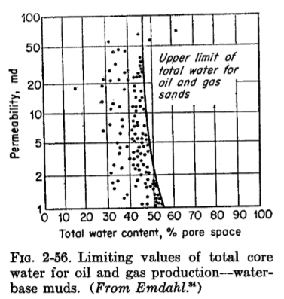
ELECTRICAL CONDUCTIVITY OF FLUID-SATURATED ROCKS
Resistivity Relations
Porous rocks are comprised of an aggregate of minerals, rock fragments, and void space. The solids, with the exception of certain clay minerals, are nonconductors. The electrical properties of a rock depend on the geometry of the voids and the fluids with which those voids are filled. The fluids of interest in petroleum reservoirs are oil, gas, and water. Oil and gas are nonconductors. The resistivity of a material is the reciprocal of conductivity and is commonly used to defense the ability of a material to conduct current. The resistivity of a material is defined by the following equation.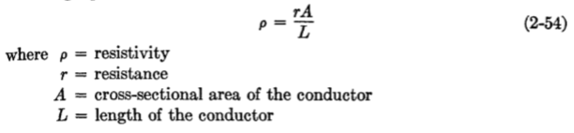
Formation Factor. The most fundamental concept in considering electrical properties of rocks is that of formation factor.
As defined by Archie³⁶, the formation factor is
Where R_{o} is the resistivity of the rock when saturated with water having a resistivity of R_{w}.
Consider a cube of salt water (cube 1, Fig. 2-57) having a cross-sectional area A, a length L, and a resistivity R_{w}. If an electrical current is caused to flow across the cube through an area A and a length L, the resistance of the cube can be determined. Let this resistance be r₁. Then
In Fig. 2-57 cube 2 represents a cube of porous rock of the same dimensions of cube 1 and 100 percent saturated with water of resistivity Rw.
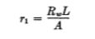
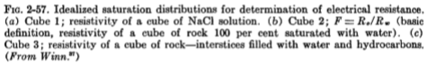
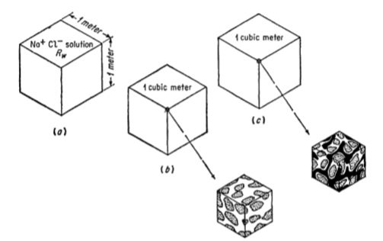
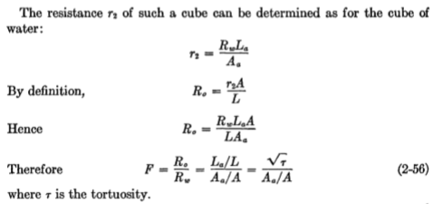
Resistivity Index. If the cube of porous rock contains both water and hydrocarbons (Fig. 2-57, cube 3), the water is still the only conductor. The cross-sectional area available for conduction is reduced further to A/_{a}, and the path length changed to l/_{a.} In a similar manner to the foregoing examples, the resistance of the cube is given by
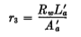
The resistivity of a partially water-saturated rock is defined as
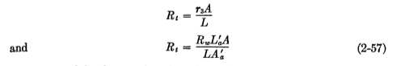
The second fundamental notion of electrical properties of porous rocks is that of the resistivity index I:
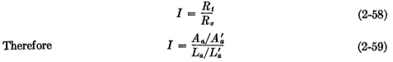
Both the formation factor and the resistivity index mare shown to be functions of effective path length and effective cross-sectional area. It is desirable to relate these quantities with other physical parameters of the rock.
The first of these models was presented by Wyllie³⁸ et al. and is as shown in Fig. 2-58. In the model, it is considered that the various pore openings vary along their length but in such a manner that the sum of the areas of the pores is constant. La in such a model represents the average path length through the pores.
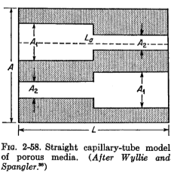
In such a model,
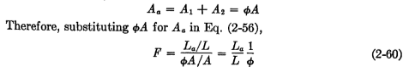
If a hydrocarbon is introduced into the pores, the water saturation Sw can be expressed as a fraction of the pore volume. Presence of the hydrocarbon further reduces the effective cross-sectional area available for flow to A/_{a}, and the average path length is altered L/_{a}. Again considering that the cross-sectional area available for flow is the same at each plane in the cube,
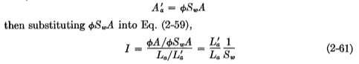
Cornell and Katz³⁹ have presented a slightly different model as presented a slightly different model as illustrated
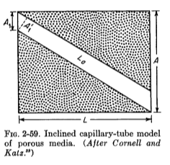
Cornel and Katz 39 have presented a slightly different model as illustrated in Fig. 2-59. In the simplest form of this model, the pores can be considered uniform in cross-sectional area available for flow is once again considered constant at each plane in the model.
The effective cross-sectional area A_{o} is the area normal to the direction of flow in the pore;
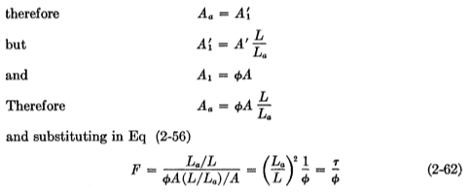
Following the same reasoning as above and considering a hydrocarbon saturation present,
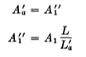
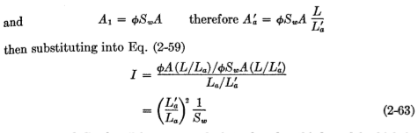
Wyllie and Gardner⁴⁰ have recently introduced a third model which is shown in Fig. 2-60. In this model, the cross-sectional area of the pores is
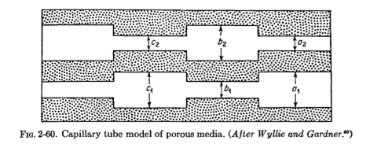
Again considered constant, However, it is conceived that the effective flow cross section is only the net exit area at each plane. Thus the probability that a selected point will fall in a pore opening in one plane is , that it will fall also in a pore opening in the contiguous plane is ,
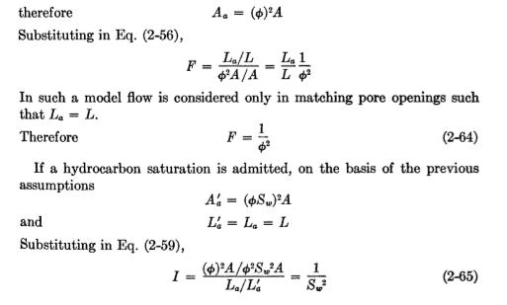
From the analysis of the electrical properties of the foregoing models, general relationships between electrical properties and other physical properties of the rock can be deduced. The formation factor has been shown to be some function of the porosity and the internal geometry of the rock system. In particular, it can be stated from examination of Eqs. (2-60), (2-62), and (2-64) that the formation factor can be expressed in the following form:
Where C is some function of the tortuosity and m is a function of the number of reductions in pore opening sizes or closed-off channels. Since C is a function of the ratio L_{a}/L_{g} it is suggested that C should be 1a or greater.
The value of m has been shown from theory to range from 1 to 2.
Both the formation factor F and the resistivity index I depend on ratios of past length or tortuosities. Therefore, to compute the formation factor or resistivity index from the equations developed above, it is necessary to determine the electrical tortuosity Direct measurement of the path length is impossible. Therefore, reliance has been placed primarily on empirical correlations based on laboratory measurements. Winsauer⁴¹ et al. devised a method of determining tortuosity by transit time of ions flowing through the rock under a potential difference. The observed tortuosities were believed to be reliable. The data obtained were correlated with the product as suggested by Eq. (2-62), rearranged as follows:
The deviation from the theory is believed to be an indication of the greater complexity of the actual pore system than that of the model on which the theory was based.
The dependence of the formation factor on porosity was suggested by Sundberg⁴² in 1932. Table 2-7 summarizes Sundberg’s computations for
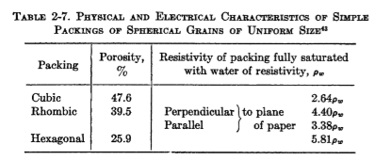
Uniform spheres arranged systematically. Archie36, in 1942, correlated observed formation factors with porosity and permeability. He suggested that the correlation with porosity was the better correlation and that the formation factor could be expressed
Whereis the fractional porosity and m is the cementation factor. Archie further reported that the cementation factor probably ranged from 1.8 to 2.0 for consolidated sandstones and for clean unconsolidated sands was about 1.3. Figure 2-61 presents the family of curves defined by Eq. (2-68)
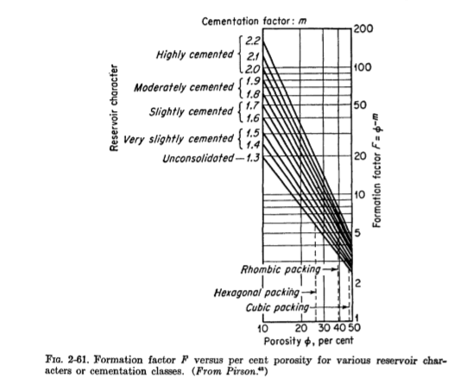
And cementation factors ranging from 1.3 to 2.2. The dashed lines indicate the value computed for systematic packing of uniform spheres.
Measurement of Electrical Resistivity of Rocks
Laboratory measurements of electrical properties of rocks have been made with a variety of devices. The measurements require a knowledge of the dimension of the rock, the fluid saturation of the rock, and a suitable resistivity cell in which to test the sample. A simple cell is shown in Fig. 2-62. A sample cut to suitable size is placed in the cell and clamped between electrodes. Current is the passed
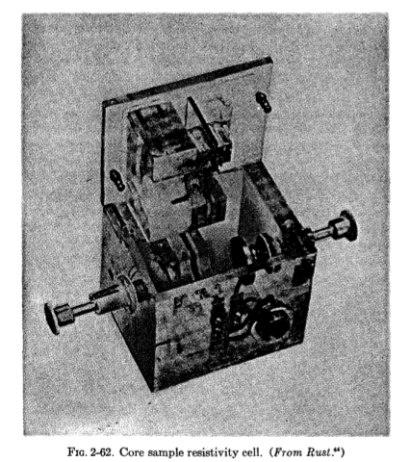
Through the sample, and the potential drop observed. The resistance of the sample is composed from Ohm’s law:
and R (the resistivity) is computed from
where A is the cross-sectional area of the sample and L is the length of the sample. The saturation conditions of the test can be established at known values prior to measurement or determined by an extraction procedure after measurement.
A second type of cell is shown in FIG. 2-63 which is a combined capillary pressure and resistivity cell. This device has the advantage that two different tests can be performed simultaneously. The disadvantages is the length of time required for a capillary-pressure test. Capillary-pressure tests are discussed in Chap. 3 of this volume.
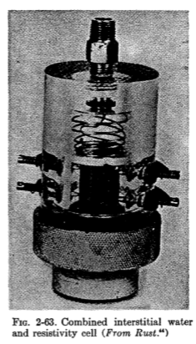
Empirical Correlation of Electrical Properties
Archie, as previously mentioned, reported the results of correlating laboratory measurements of formation factor with porosity. He expressed his results in the form
Archie derived from experimental data that Slawinki and Maxwell⁴⁶ derived theoretical expressions for the formation factor based on models of unconsolidated spheres. Slawinski stated that for spheres in contact

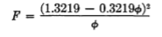
For dispersed sphered, not necessarily in contact, Maxwell states that
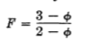
Wyllie⁴⁵ investigated the influence of particle size and cementation on the formation factor of a variety of materials. Unconsolidated materials were packed in tubes, and some were artificially considered.
Wyllie’s experimental data are compared with the results calculated using Archie’s and Slawinski’s equations fit the data reasonably well except for the aggregate of cubes. The data for the cubes fall above the other data as well as above all three lines calculated from the equation. This could possibly be indicative of a greater tortuous path length in such a system.
Observed formations factors for artificially cemented aggregates are shown in Fig. 2-66. It may be noted that cementation results in increased values of formation factor over that observed for uncemented aggregates. Furthermore, the cemented aggregates exhibit a greater change in porosity than the unconsolidated aggregates. The curves no longer pass through the point
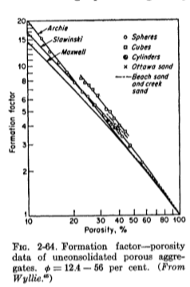

From these data Wyllie concluded that the general form of the relation between formations
This is identical with the general form [Eq. (2.66)] deduced theoretically using simple models.
Winsauer⁴¹ et al. reported a similar relationship based on correlations of data from a large number of sandstone cores. This equation, commonly referred to as the Humble relation, is
A comparison of suggested relationships between porosity and the formation factor is shown in Fig. 2-66.
Since the formation factor is a function of porosity and some unknown effect of the complex internal geometry, it is suggested that the constants in formulas similar to Eq. (2-71) are functions of the depositional environment and must be determined on each formation to yield the most reliable results. Of the correlation presented in Fig. 2-66, the Humble relation appears to be greatest general utility.
Effect of Conductive Solids. Investigations by Wyllie48 indicate that clays contribute substantially to the conductivity of a rock when the rock is saturated with a low-conductivity water. The effect of water resistivity on the formation factor for sands containing clay minerals is shown in Fig. 2-67. The formation factor for a comparable clean (clay free) sand is a constant. The formation factor for clayey sand increases
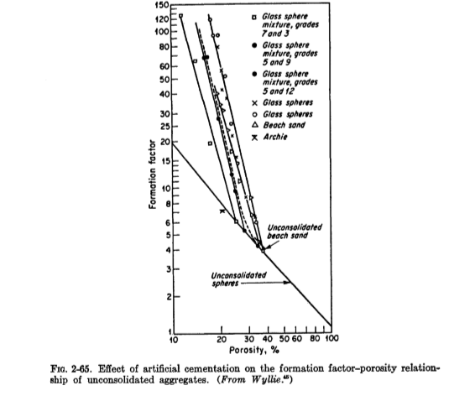
Wyllie proposed that the observed effect of clay minerals was similar to having two electrical circuits in parallel: the conduction clay minerals and the water-filled pores. Thus
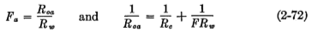
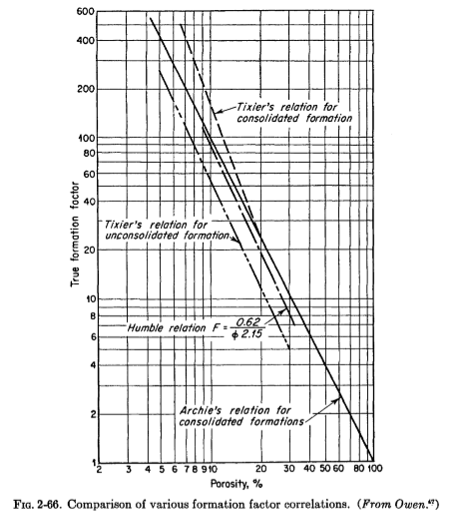

The graphs where plotted by deWitte49 from data presented by hill and Milburn.50 The plots are linear and are of the general form
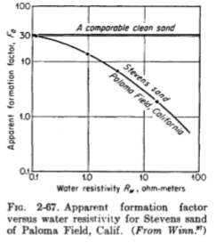
Equation (2-72) can be rearranged to express the apparent formation factor in terms of Rc and FR_{w}
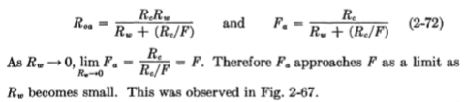
Little data are available on the electrical properties of limestone. Tixie⁵¹ states that a cementation factor m of 2.0 in Archie’s formula yields a satisfactory correlation.
Little data are available on the electrical properties of limestone. Tixier⁵¹ states that a cementation factor m of 2.0 in Archie’s formulae yields a satisfactory correlation.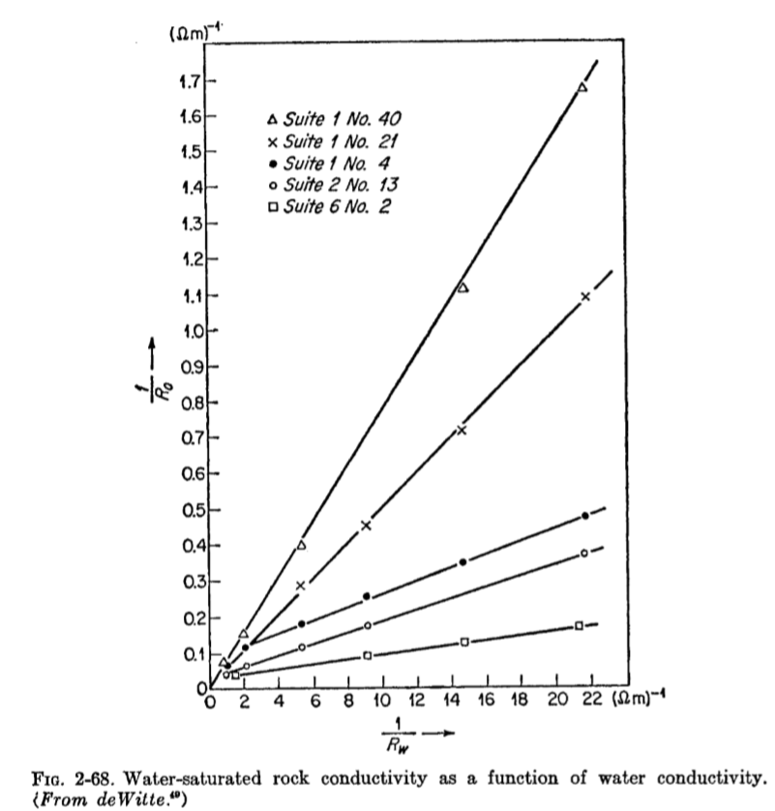
Resistivity of Partially Water-saturated Rocks. A rock containing both water and hydrocarbons has a higher resistivity than the rock when fully saturated with water.
The equations (2-61), (2-63), (2-65) indicate that the resistivity index is a function of the water saturation and the path length. From the theoretical developments, the following generalization can be drawn:
Where I=R_{t}/Ro, the resistivity index; C/ is some function of tortuosity; and n is the saturation exponent.
Archie complied and correlated experimental data from Wyckoff, ⁵² Leverett,⁵³ Jakosky,⁵⁴ and Martin⁵⁵ from which he suggested that the data could be represented by
Williams⁵⁶ studied consolidated sands, the results for which are shown in Fig. 2-69. The solid line was fitted to the data points by the method of least squares. The equation of the best fitting line is
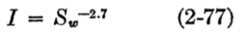
The dashed line is a plot of Archie’s relation [Eq. (2-76)] for comparison.
In Fig. 2-70 are presented results obtained by Rust⁴⁴ on consolidated samples from Woodbine sand outcrop. The saturation exponent n ranges from 2.31 to 2.40.
All the equation s fitted to the experimental data have assumed that both C/ and n of EQ. (2-75) were constants and furthermore that C/=1. From the theory, it would be expected that C/ is a function of saturation and that n would range between 1 and 2. Additional study is required to ascertain the discrepancy between theory and experiment.
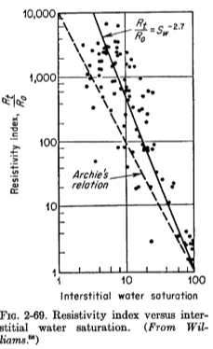
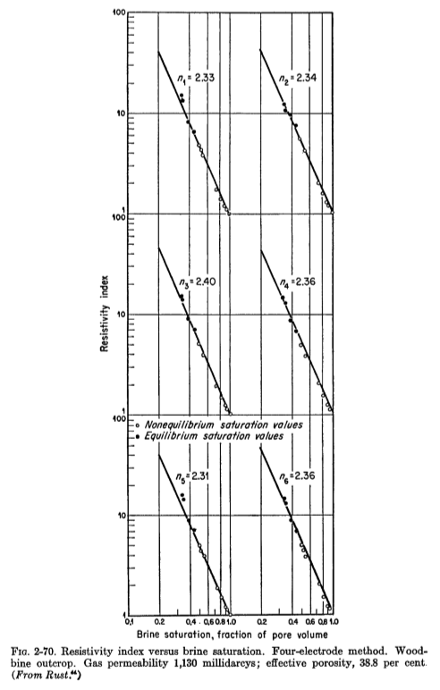
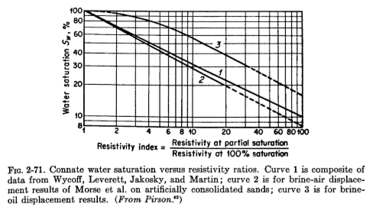
The data are presented in Fig. 2-72. The resistivity ratio plotted is the reciprocal of the resistivity index. The effect of the methods of changing the saturation in the test specimens were:
- Dynamic air brine in which the desired water saturation was obtained by flowing air and water simultaneously through the sample
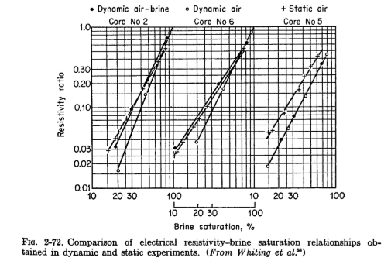
2. Dynamic air in which only air was introduced at the inlet, displacing both air and water from the outlet.
3. Static air in which air displaced water from the sample through a capillary barrier which prevent the flow of air from the sample
It may be noted that the dynamic air procedure consistently yielded lower values of the resistivity ratio. This effect may be attributed to a difference in water distribution.
Conductive clays affect the saturation-resistivity relationship as shown in Fig. 2-73. The conducting path through the clay is little affected by
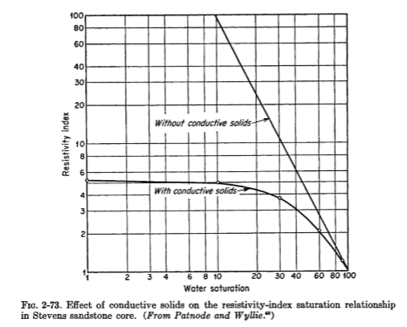
the presence of hydrocarbons. Thus as the water saturation is reduced to zero, the resistivity approaches the resistivity of the clay path rather than approaching infinity as in clean sands. The relationship of saturation and resistivity in shaly sands is complex and will not be considered at greater length.
Use of Electrical parameters in Characteristics Porous Media.
In the section on permeability, the Kozeny equation was developed as follows:
Where k is the permeability, is the porosity fraction, k_{0 is} a shape factor S_{p} is the internal surface area per unit pore volume, and r is the Kozeny tortuosity.
