DATE: 30/05/2020
NAME: ADEKUNLE GLORIA. J
MATRIC. NO: 16/SCI01/001
COURSE CODE: CSC410
COURSE TITLE: COMPUTER SYSTEM PERFORMANCE EVALUATION

ASSIGNMENT 2
A
1. Explain the concepts of operational laws as applied to computer and network system performance evaluation.
2. Exhaustively describe at least eight operational laws that are widely employed in computer system performance evaluation.
3. Distinguish between the Forced Flow Law and the Residence Time Law from a systems perspective (not by definition).
4. Discuss some basic queuing models and basic queuing disciplines.
5. Discuss how to resolve some basic queuing problems.
6. You have been presented with some systems performance evaluation report; the first was done using measurement technique only, the second was done with simulation technique only, the third was done using analytical technique only, then the fourth was done using measurement and simulation technique only, while the fifth was done using simulation and analytical technique only and the sixth was done using measurement and analytical technique only. You are the director of information technology infrastructure in your firm and your firm is about to acquire the information infrastructure concerned in this report
i. What specific motive will you consider imperative in general?
ii. Why do you consider this metric important?
iii. If they are not in this report, what will you do in such a report?
iv. If they are part of the report, what is the first action to take with that report and why?
v. Which reports or combination of report will you adopt and why?
B
- Based on the perspectives of the operational laws you have studied, discuss the possibility of achieving an accurate performance report using the three major evaluation techniques

SOLUTION
A
- A number of laws are derived which establish relationships between throughput, response time, device utilization, space-time products and various other factors related to computer system performance. These laws are obtained by using the operational method of computer system analysis.
Operational laws are equations which may be used as an abstract representation of a model of the average behavior of any system. The operational method, which differs significantly from the conventional stochastic modeling approach, is based on a set of concepts that correspond naturally and directly to observed properties of real computer systems.
Operational methods simply refer to methods of physical observation and measurement, in other words, they are directly measurable or directly measured. Except for measurement errors, the operational laws apply with complete precision to all collections of observational data, and they are similar to fundamental laws found in other areas of engineering and applied science.

- Utilization Law
Utilization law can be used to verify the internal consistency of a set of empirical data collected during some observation interval.
Its formula is given as $\frac{Bi}{T}$ which can be denoted as $\frac{Busy Time}{Total Time}$
It is derived from the equation $\frac{Ci}{T} × \frac{Bi}{Ci}$ which is $\frac{Completions}{Time} × \frac{Busy Time}{Completions}$
The formula above can be simplified into Throughput $×$ Mean Service Time

- Forced Flow Law
Forced Flow Law relates the system throughput to individual device throughputs.
According to the Forced Flow law, the following is proven
- In an open model, System throughput is equal to the number of jobs leaving the system per unit time
- In a closed model, System throughput is equal to the number of jobs traversing out to in link per unit time.
- If observation period T is such that Ai = Ci, then the Device satisfies the assumption of job flow balance.
- Each job makes Vi requests for ith device in the system.
- Ci = C0 Vi or Vi = $\frac{Ci}{C0}$ is called visit ratio
- System Throughput (X) = $\frac{Jobs Completed}{Total Time}$ = $\frac{C0}{T}$
- Device Throughput (Xi) = $\frac{Ci}{T}$ = $\frac{C0}{T} × \frac{Ci}{C0}$ which can be simplified to Xi = X $×$Vi
Where Ci and C0 = The Jobs completed
T = Total Time
Ai = Number of arrivals
Vi = $\frac{Ci}{C0}$

- Little’s Law
Little’s Law is a theorem that determines the average number of items in a stationary queuing system based on the average waiting time of an item within a system and the average number of items arriving at the system per unit of time.
The law provides a simple and intuitive approach for the assessment of the efficiency of queuing systems. The concept is hugely significant for business operations because it states that the number of items in the queuing systems primarily depends on two key variables, and it is not affected by other factors such as the distribution of the service or service order.
Little’s Law can only be used in queuing systems. Almost any queuing system and even any sub-system can be assessed using the law. In addition, the theorem can be applied in different fields, from running a small coffee shop to the maintenance of the operations of a military airbase.
The Formula for Little’s Law:
Mean Number in the device = Arrival Rate $×$ Mean Time in the device
Which can be denoted as Qi = λi $×$ Ri
If the job flow is balanced, the arrival rate is equal to the throughput and we can write:
Qi = Xi $×$ Ri

- General Response Time Law
According to General Response Time Law, there is one terminal per user and the rest of the system is shared by all users.
When applying Little's law to the central subsystem, the formula is Q = X R
Where, Q = Total number of jobs in the system
R = system response time
X = system throughput
The General Response Time Formula is R = X1R1 + X2R2 + … + XMRM
When dividing both sides by X and using forced flow law, the formula is
R = V1R1 + V2R2 + … + VMRM
- Interactive Response Time Law
According to Interactive Response Time Law:
- If Z = think-time, R = Response time
The total cycle time of requests is R+Z
Each user generates about T/(R+Z) requests in T
- If there are N users:
System Throughput = $\frac{Total Number of Requests}{Total Time}$ = ${N(T/(R+Z))}/T$
This can be further simplified into $N/{(R+Z}$)
Or R = ${(N}/{X)-Z}$

- Bottleneck Analysis
From forced flow law, the formula is Ui α Di
According to the Bottleneck Analysis,
- The device with the highest total service demand Di has the highest utilization and is called the bottleneck device.
- Note: Delay centers can have utilizations more than one without any stability problems. Therefore, delay centers cannot be a bottleneck device.
- Only queueing centers used in computing Dmax.
- The bottleneck device is the key limiting factor in achieving higher throughput.
- Improving the bottleneck device will provide the highest payoff in terms of system throughput.
- Improving other devices will have little effect on the system performance.
- Identifying the bottleneck device should be the first step in any performance improvement project.
Throughput and response times of the system are bound as follows:
$$X\left(N\right) ≤\min{\{\frac{1}{Dmax}, \frac{N}{D+Z}\}}$$
And
$R\left(N\right)≥\max{\{D, N Dmax-Z\}}$
Here, D = $Σ Di$ is the sum of total service demands on all devices except terminals.
These are known as asymptotic bounds
Bottle Neck Analysis Proof:
The asymptotic bounds are based on the following observations:
The utilization of any device cannot exceed one. This puts a limit on the maximum obtainable throughput.
The response time of the system with N users cannot be less than a system with just one user. This puts a limit on the minimum response time.
The interactive response time formula can be used to convert the bound on throughput to that on response time and vice versa.
For the bottleneck device b we have: Ub = XDmax
Since Ub cannot be more than one, we have: XDmax $≤$ 1
X $≤ \frac{1}{Dmax}$
With just one job in the system, there is no queueing and the system response time is simply the sum of the service demands:
R(1) = D1 + D2 + … + DM = D
Here, D is defined as the sum of all service demands. ! With more than one user there may be some queueing and so the response time will be higher. That is:
Applying the interactive response time law to the bounds:
R(N) $≥$ D
Combining these bounds we get the asymptotic bounds
$$R\left(N\right)= \frac{N}{X(N)} -Z ≥N D\max{-Z}$$
$$X\left(N\right) ={\frac{N}{R\left(N\right)+Z} ≥ \frac{N}{D+Z}}$$

- Space-Time Product Throughput Law
The Space-Time Product Throughput Law states that the throughput is equal to the average amount of memory in use are divided by average space-time product.
The formula is:
$$X=\frac{M}{Y}$$
Where X = Throughput (i.e. number of job completions per unit time)
M = Average amount of memory in use during the observation interval
Y = Average space-time product (i.e. space-time product completed per job

- Space-Time Product Response Time Law
The Space-Time Product Response Time Law is obtained by a similar relationship between average space-time product and average response time in the asymptotic case.
The formula is:
$$R= \frac{NY}{M}-Z$$
Where R = response time (i.e. average amount of time in system state per interaction)
N = Number of interactive terminals. It is assumed that N is constant throughout the observation interval.
Y = Average space-time product (i.e. space-time product completed per job
M = Average amount of memory in use during the observation interval
Z = Average think time (i.e. average amount of think time per transition from think state to system state).
- Forced Flow Law
Relates the system throughput to individual device throughputs.
In an open model, System throughput = # of jobs leaving the system per unit time
In a closed model, System throughput = # of jobs traversing OUT to IN link per unit time.
If observation period T is such that Ai = Ci⇒ Device satisfies the assumption of job flow balance.
Each job makes Vi requests for ith device in the system
Ci = C0 Vi or Vi =Ci/C0 Vi is called visit ratio

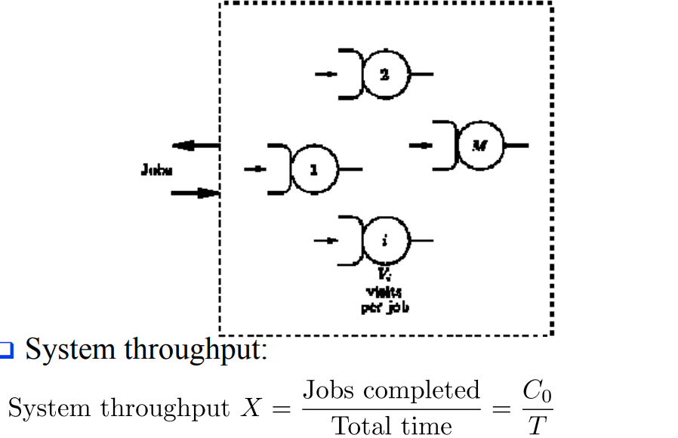

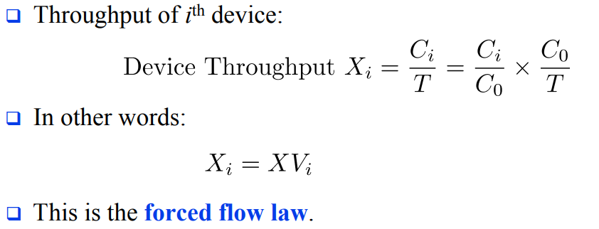

Residence Time Law

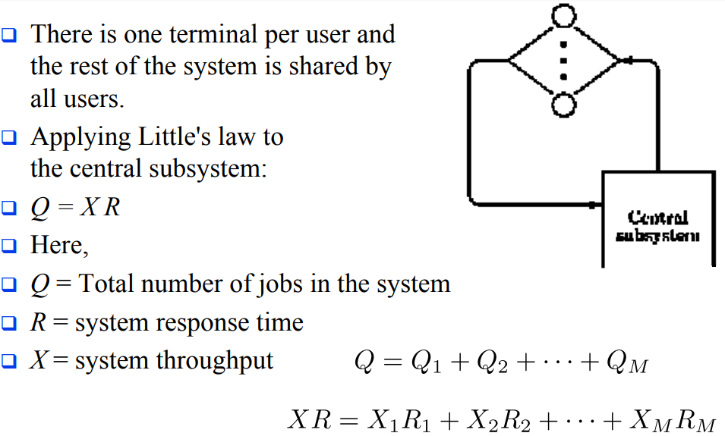

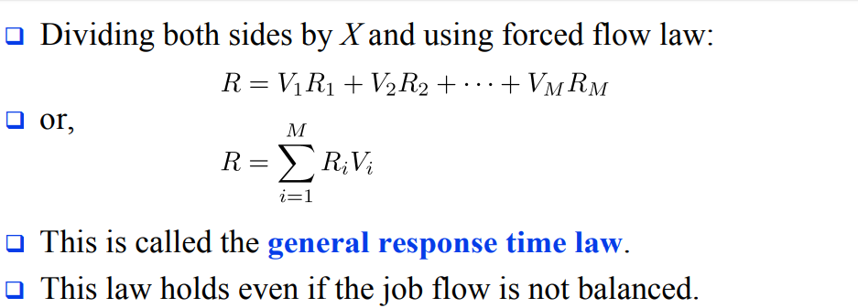

- QUEUING MODELS
M/M/1 queue represents the queue length in a system having a single server, where arrivals are determined by a Poisson process and job service times have an exponential distribution. The model name is written in Kendall's notation. The model is the most elementary of queuing models and an attractive object of study as closed-form expressions can be obtained for many metrics of interest in this model. An extension of this model with more than one server is the M/M/c queue

- The (M/M/1) system This is a queuing model in which the arrival is Marcovian and departure distribution is also Marcovian, number of server is one and size of the queue is also Marcovian, no. of server is one and size of the queue is infinite and service discipline is 1st come 1st serve (FCFS) and the calling source is also finite.
- M/M/1 queue is a useful approximate model when service times have standard deviation approximately equal to their means.

M/M/c/∞/∞ queue: c servers operating in parallel
- Arrival process is Poisson with rate λ
- Each server has an independent and identical exponential service time distribution, with mean 1/μ.
- To achieve statistical e q, (equilibrium, the offered load (λ/μ) y must satisfy λ/μ < c, where λ/ (cµ) = ρ is the server utilization.
M/M/c queue (or Erlang–C model) is a multi-server queuing model. In Kendall's notation it describes a system where arrivals form a single queue and are governed by a Poisson process, there are c servers and job service times are exponentially distributed It is a generalization of the M/M/1 queue which considers only a single server. The model with infinitely many servers is the M/M/∞ queue.’
M/M/M/s/N/N queue: here the arrival distribution of customers follows Poisson distribution and the distribution for service time follows exponential distribution with s number of parallel serves. The number of population and the queuing capacity is limited to N. this situation often happens in queuing for machine repair system where the number of population is equal to the number of machine = N’
M/M/s/s/n queue: Consider the loss system (no waiting places) in the case where the arrivals originate from a finite population of sources: the total number of customers is n.
- To be specific, think of the customers being telephone users.
- Assume that the time to the next call attempt by the customer, so called thinking time (idle time) of the customer obeys the distribution Exp (γ).
- Blocked calls are lost – does not lead to reattempts – starts a new thinking time: again, the time to the next attempt ∼ Exp (γ) – the holding time X ∼ Exp (µ)
QUEUING DISCIPLINES
Are listed as follows;
1. First come first services (FCFS)
2. First in First out (FIFO)
3. Last in First out (LIFO)
4. Service in Random order (SIRO)
First Come First Serve (FCFS) is an operating system scheduling algorithm that automatically executes queued requests and processes in order of their arrival. It is the easiest and simplest CPU scheduling algorithm. In this type of algorithm, processes which requests the CPU first get the CPU allocation first. This is managed with a FIFO queue. The full form of FCFS is First Come First Serve.
As the process enters the ready queue, its PCB (Process Control Block) is linked with the tail of the queue and, when the CPU becomes free, it should be assigned to the process at the beginning of the queue

Characteristics of FCFS method
- It supports non-pre-emptive and pre-emptive scheduling algorithm.
- Jobs are always executed on a first-come, first-serve basis.
- It is easy to implement and use.
- This method is poor in performance, and the general wait time is quite high.

Example of FCFS scheduling
A real-life example of the FCFS method is buying a movie ticket on the ticket counter. In this scheduling algorithm, a person is served according to the queue manner. The person who arrives first in the queue first buys the ticket and then the next one. This will continue until the last person in the queue purchases the ticket. Using this algorithm, the CPU process works in a similar manner.
First in First out (FIFO)
Stands for "First In, First Out." FIFO is a method of processing and retrieving data. In a FIFO system, the first items entered are the first ones to be removed. In other words, the items are removed in the same order they are entered.
To use a real world analogy, imagine a vending machine where the items are loaded from the back. When someone selects a Milky Way bar from row E5, the machine churns out the candy bar closest to the front. The next Milky Way in line then moves to the front. Therefore, using the FIFO method, the candy bars are dispensed in the order they were placed in the machine.
Computers often implement the FIFO system when extracting data from an array or buffer. If the first data entered into the buffer must be extracted first, the FIFO method is used. The opposite of FIFO is LIFO, in which the last data entered is the first to be removed.

Last in First out (LIFO)

Stands for "Last In, First Out." LIFO is a method of processing data in which the last items entered are the first to be removed. This is the opposite of LIFO is FIFO (First In, First Out), in which items are removed in the order they have been entered.
To better understand LIFO, imagine stacking a deck of cards by placing one card on top of the other, starting from the bottom. Once the deck has been fully stacked, you begin to remove the cards, starting from the top. This process is an example of the LIFO method, because the last cards to be placed on the deck are the first ones to be removed.
The LIFO method is sometimes used by computers when extracting data from an array or data buffer. When a program needs to access the most recent information entered, it will use the LIFO method. When information needs to be retrieved in the order it was entered, the FIFO method is used.

Service in Random order (SIRO)
When the system chooses one of the data to execute at random. Such a system is known as service in random order (SIRO).

- Firstly, queuing problems are the problems that occur when the service rendered doesn’t match the level of demand i.e. waiting for some time till the service is rendered to a customer. These customers might be humans at a bank on a queue or even airplanes ready to take off/ land or jobs waiting to be processed. An example could be when a supermarket doesn't have enough cashiers on a busy morning or when requests reach a system faster than it can process them.
Generally, no two businesses’ queuing problems are the same but some basic queuing problems that exist include; more customers entering the queues than leaving, when the queues are too long and strenuous, where queues are idle and not moving due to many queues and limited service providing stands to ease the queues etc.
We can then solve these various problems by:
- Let Customers Know How Long The Wait Is: The uncertainty of how long it will take to wait is often the cause of queue anxiety. Because of this the customers are impatient and this is a major cause of queuing problems as people want to jump the queues or altogether leave the queue.

- Assess and improve your queue management strategy: How do you currently handle a long line of customers? Think about what works well and what doesn’t. Assessing the tactics used to manage the queue in the particular organization will really help solve the queuing problems being encountered.

- Design Your Environment To Be Able To Accommodate Queues: Studies have shown that one of the most common issues found in lines is queue anxiety. A well-designed queuing area can help organize waiting lines, remove the possibility of queue jumpers and generally ease customer flow management.

- Implement Digital Queuing Software: Long queues can inspire customer’s irritation even disgust. But anyone can learn how to reduce queues the use of a nifty technology called a queue management system (QMS).Automating the queuing process creates more labor efficient customer lines, decreases the overall amount of walkaways as well as ultimately reducing queue times. When it’s their turn, a teller calls them to the counter to be served. They can see where they are in line by observing HDTVs hung on the walls of the organization and therefore customers are free to sit or wander and maybe grab a coffee across the street as they wait. They’re not corralled into the line like sheep. By giving customers back their time (their autonomy) one enable customers to wait in leisure. Now that’s effective queue management.
- Occupy Customers in The Queue: Boredom in the queue can often lead to longer perceived waiting times. Queue solutions is to provide a distraction to people in the queue and help them continue shopping while waiting, easing up frustrations etc. Display entertaining programming on HDTVs. Prompt customers to answer surveys to report on their experience. Engaging customers is the best way to reduce the tension inherent in queueing. Because it’s typically the psychology behind queueing rather than the queues themselves that makes queues feel unbearable.

- Keep The Rules Of Queuing Fair And Consistent: One of the most important characteristics of any queue problem solving method is the queuing discipline used. Simply put, the queuing discipline is the rule used to decide who goes next in a queue.
Two of the most commonly used rules are:
- First in, First out.
- Last in, First out.
Bottom line, people expect queues to be fair. It’s not like they’re happy to be stuck waiting in line, to begin with. But when everyone abides by the same rules, we can’t help but follow them too.

Reduce Response times: So when it comes to providing service, be quick as possible. It's not possible to solve every problem immediately, but customers

- I. Don’t trust the result of a simulation model until they have been validated by other performance evaluation techniques
II. it’s important so as to know if the system is correctly defined and if the goals are clearly stated.
iii. Such report is invalid
iv. Go through the report to check if there are any mistakes
V. The forth report (measurement and simulation) because measurement technique requires more effort and it is the most accurate; simulation method requires relatively lesser effort and it is averagely accurate while analytical method is very quick and often very less accurate.

B
Three major performance evaluation techniques could be; Performance measurement, Analytic performance modelling and Simulation performance modelling.

Using these performance techniques, we can achieve an accurate performance report:

• On-chip Performance Monitoring Counters:
All state-of-the-art high performance microprocessors including Intel's Pentium III and Pentium IV, IBM's POWER 3 and POWER 4 processors, AMD's Athlon, Compaq's Alpha, and Sun's Ultra SPARC processors incorporate on-chip performance monitoring counters which can be used to understand performance of these microprocessors while they run complex, real-world workloads. This ability has overcome a serious limitation of simulators, that they often could not execute complex workloads. Now, complex run time systems involving multiple software applications can be evaluated and monitored very closely. All microprocessor vendors nowadays release information on their performance monitoring counters, although they are not part of the architecture. For illustration of on-chip performance monitoring, we use the Intel Pentium processors. The microprocessors in the Intel Pentium contain two performance monitoring counters. These counters can be read with special instructions (e.g.: RDPMC) on the processor. The counters can be made to measure user and kernel activity in combination or in isolation. A variety of performance events can be measured using the counters

• Off-chip hardware measurement:
Instrumentation using hardware means can also be done by attaching off-chip hardware, two examples of which are described in this section.
Speed-Tracer from AMD: AMD developed this hardware tracing platform to aid in the design of their x86 microprocessors. When an application is being traced, the tracer interrupts the processor on each instruction boundary. The state of the CPU is captured on each interrupt and then transferred to a separate control machine where the trace is stored. The trace contains virtually all valuable pieces of information for each instruction that executes on the processor. Operating system activity can also be traced. However, tracing in this manner can be invasive, and may slow down the processor. Although the processor is running slower, external events such as disk and memory accesses still happen in real time, thus looking very fast to the slowed-down processor. Usually this issue is addressed by adjusting the timer interrupt frequency. Use of this performance monitoring facility can be seen in Merten and Bhargava. Logic Analysers: Poursepanj and Christie use a Tektronix TLA 700 logic analyser to analyse 3D graphics workloads on AMD-K6-2 based systems. Detailed logic analyser traces are limited by restrictions on sizes and are typically used for the most important sections of the program under analysis. Preliminary coarse level analysis can be done by performance monitoring counters and software instrumentation. Poursepanj and Christie used logic analyser traces for a few tens of frames which covered a second or two of smooth motion.

• Software Monitoring:
Software monitoring is often performed by utilizing architectural features such as a trap instruction or a breakpoint instruction on an actual system, or on a prototype. The VAX processor from Digital (now Compaq) had a T-bit that caused an exception after every instruction. Software monitoring used to be an important mode of performance evaluation before the advent of on-chip performance monitoring counters. The primary advantage of software monitoring is that it is easy to do. However, disadvantages include that the instrumentation can slow down the application. The overhead of servicing the exception, switching to a data collection process, and performing the necessary tracing can slow down a program by more than 1000 times. Another disadvantage is that software monitoring systems typically only handle the user activity.

• Micro coded Instrumentation:
Digital (now Compaq) used micro coded instrumentation to obtain traces of VAX and Alpha architectures. The ATUM tool [14] used extensively by Digital in the late 1980s and early 1990s uses micro coded instrumentation. This is a technique lying between trapping information on each instruction using hardware interrupts (traps) and software traps. The tracing system essentially modified the VAX microcode to record all instruction and data references in a reserved portion of memory. Unlike software monitoring, ATUM could trace all processes including the operating system. However, this kind of tracing is invasive, and can slow down the system by a factor of 10 without including the time to write the trace to the disk.
Using the Analytical performance modelling, we can achieve an accurate performance report: Performance measurement as described in the previous section can be done only if the actual system or a prototype exists. It is expensive to build prototypes for early stage evaluation. Hence one needs to resort to some kind of modelling in order to study systems yet to be built. Performance modelling can be done using simulation models or analytical models.

Using the following Simulation performance modelling techniques, we can achieve also an accurate performance report:
• Trace-driven simulation:
Consists of a simulator model whose input is modelled as a trace or sequence of information representing the instruction sequence that would have actually executed on the target machine. A simple trace driven cache simulator needs a trace consisting of address values. Depending on whether the simulator is modelling a unified instruction or data cache, the address trace should contain addresses of instruction and data references. Cachesim5 and Dinero IV are examples of cache simulators for memory reference traces. These simulators are not timing simulators. There is no notion of simulated time or cycles, only references. They are not functional simulators. Data and instructions do not move in and out of the caches. The primary result of simulation is hit and miss information. The basic idea is to simulate a memory hierarchy consisting of various caches. The various parameters of each cache can be set separately (architecture, mapping policies, replacement policies, write policy, statistics). During initialization, the configuration to be simulated is built up, one cache at a time, starting with each memory as a special case. After initialization, each reference is fed to the appropriate top-level cache by a single simple function call. Lower levels of the hierarchy are handled automatically. One does not need to store a trace while using cachesim5, because Shade can directly feed the trace into cachesim5.

• Execution Driven Simulation:
There are two meanings in which this term is used by researchers and practitioners. Some refer to simulators that take program executables as input as execution driven simulators. These simulators utilize the actual input executable and not a trace. Hence the size of the input is proportional to the static instruction count and not the dynamic instruction count. Mispredicted branches can be accurately simulated as well. Thus, these simulators solve the two major problems faced by trace-driven simulators. The widely used Simple-scalar simulator is an example of such an execution driven simulator. With this tool set, the user can simulate real programs on a range of modern processors and systems, using fast execution-driven simulation. There is a fast-functional simulator and a detailed, out-of-order issue processor that supports non-blocking caches, speculative execution, and state-of-the-art branch prediction.

• Complete system simulation:
Many execution and trace driven simulators only simulate the processor and memory subsystem. Neither I/O activity nor operating system activity is handled in simulators like Simple scalar. But in many 9 workloads, it is extremely important to consider I/O and operating system activity. Complete system simulators are complete simulation environments that model hardware components with enough detail to boot and run a full-blown commercial operating system. The functionality of the processors, memory subsystem, disks, buses, SCSI/IDE/FC controllers, network controllers, graphics controllers, CD-ROM, serial devices, timers, etc. are modelled accurately in order to achieve this. While functionality stays the same, different microarchitectures in the processing component can lead to different performance. Most of the complete system simulators use micro architectural models that can be plugged in and out. For instance, SimOS, a popular complete system simulator provides a simple pipelined processor model and an aggressive superscalar processor model. SimOS and SIMICS can simulate uniprocessor and multiprocessor systems.

• Stochastic Discrete Event Driven Simulation:
It is possible to simulate systems in such a way that the input is derived stochastically rather than as a trace/executable from an actual execution. For instance, one can construct a memory system simulator in which the inputs are assumed to arrive according to a Gaussian distribution. Such models can be written in general purpose languages such as C, or using special simulation languages such as SIMSCRIPT. Languages such as SIMSCRIPT have several built-in primitives to allow quick simulation of most kinds of common systems. There are built-in input profiles, resource templates, process templates, queue structures, etc. to facilitate easy simulation of common systems. An example of the use of event-driven simulators using SIMSCRIPT may be seen in the performance evaluation of multiple-bus multiprocessor systems in Kurian et al.

• Program Profilers:
There are a class of tools called software profiling tools, which are similar to simulators and performance measurement tools. These tools are used to generate traces, to obtain instruction mix, and a variety of instruction statistics. They can be thought of as software monitoring on a simulator. They input an executable and decode and analyse each instruction in the executable. These program profilers can be used as the front end of simulators. A popular program profiling tool is Shade for the Ultra SPARC.

