Name: Ige Samuel.A
Matric: 17/sci01/039
Course: csc302(Survey of Programming Language).
Question
1. With the aid of a shema distinguish between a modular and an object oriented programming paradigm.
2. Use this schema to illustrate the modifications required to translate an airline reservation program from a modular to an object oriented design
Solution

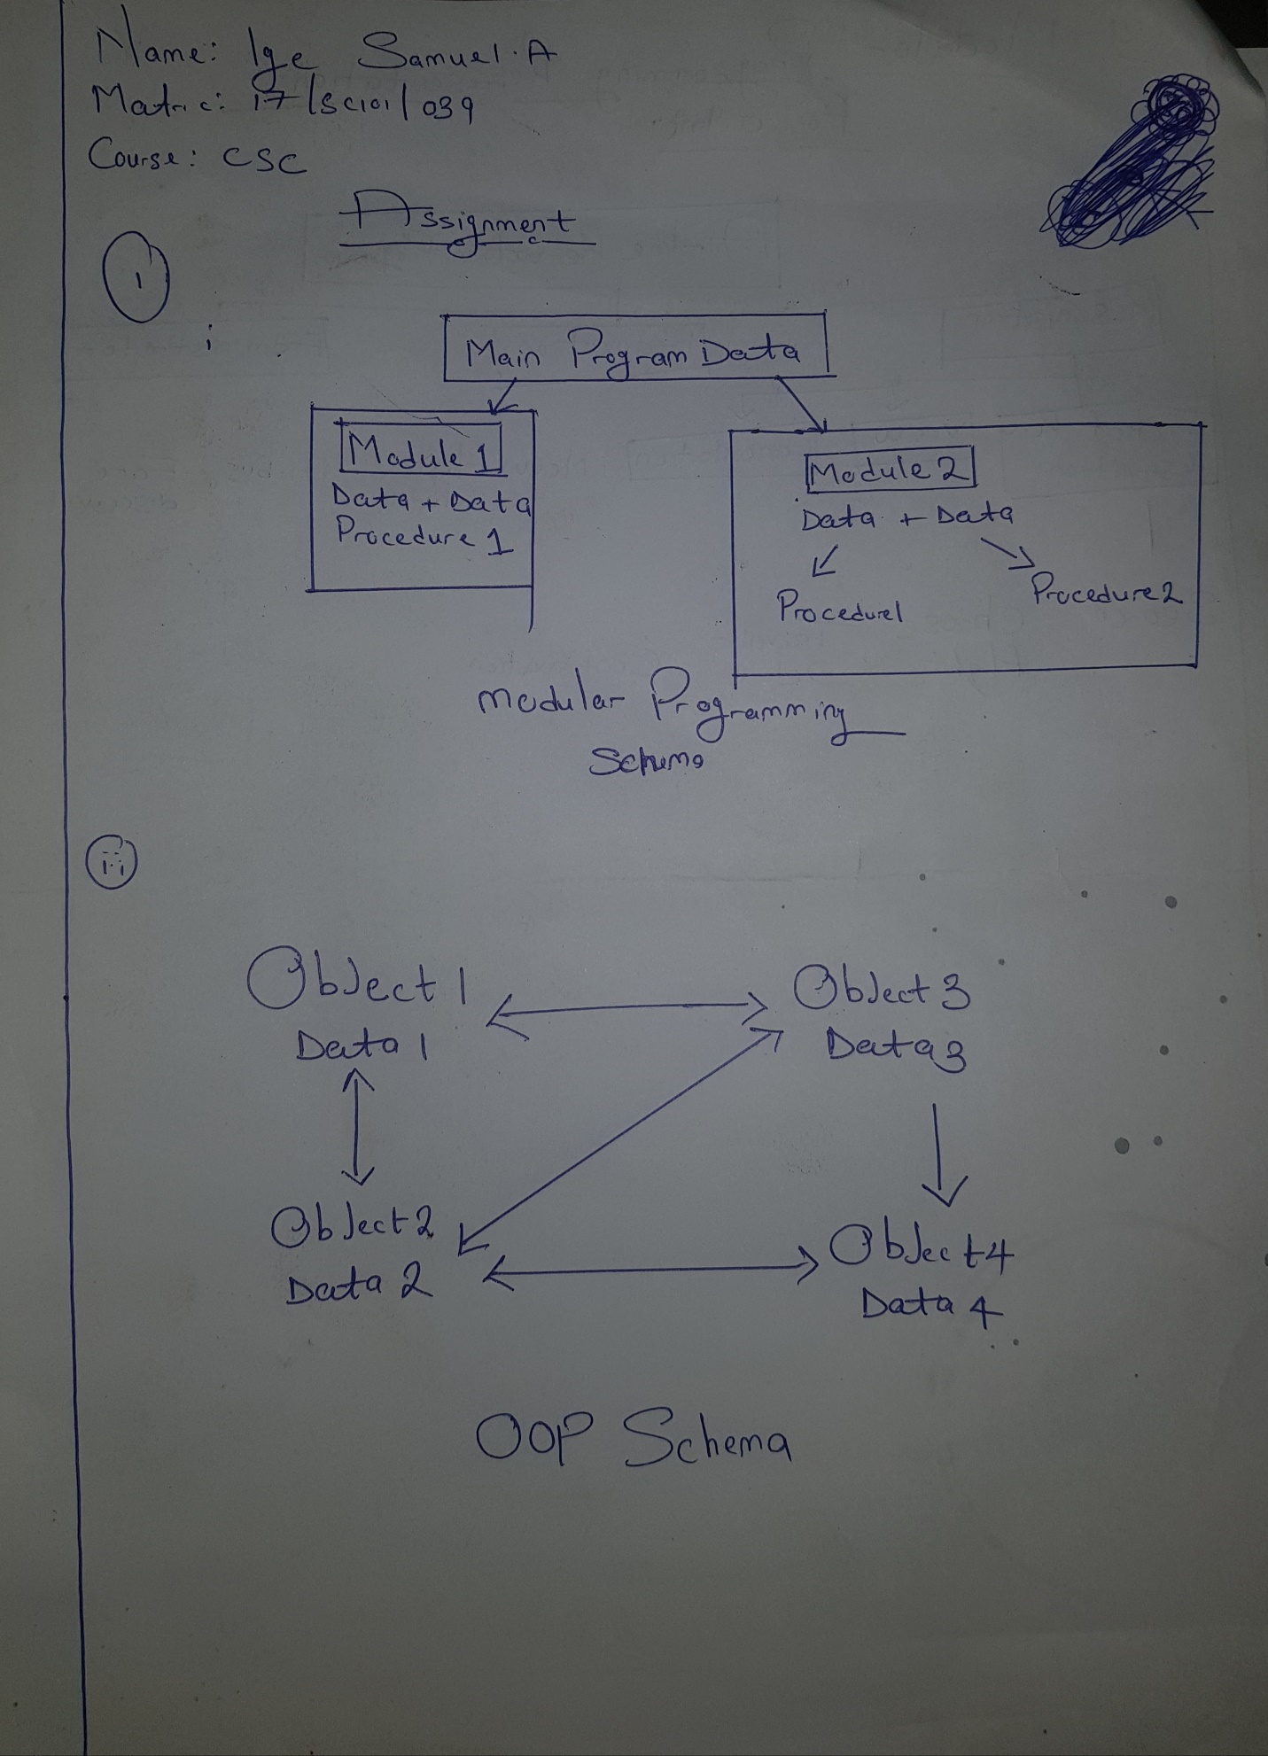
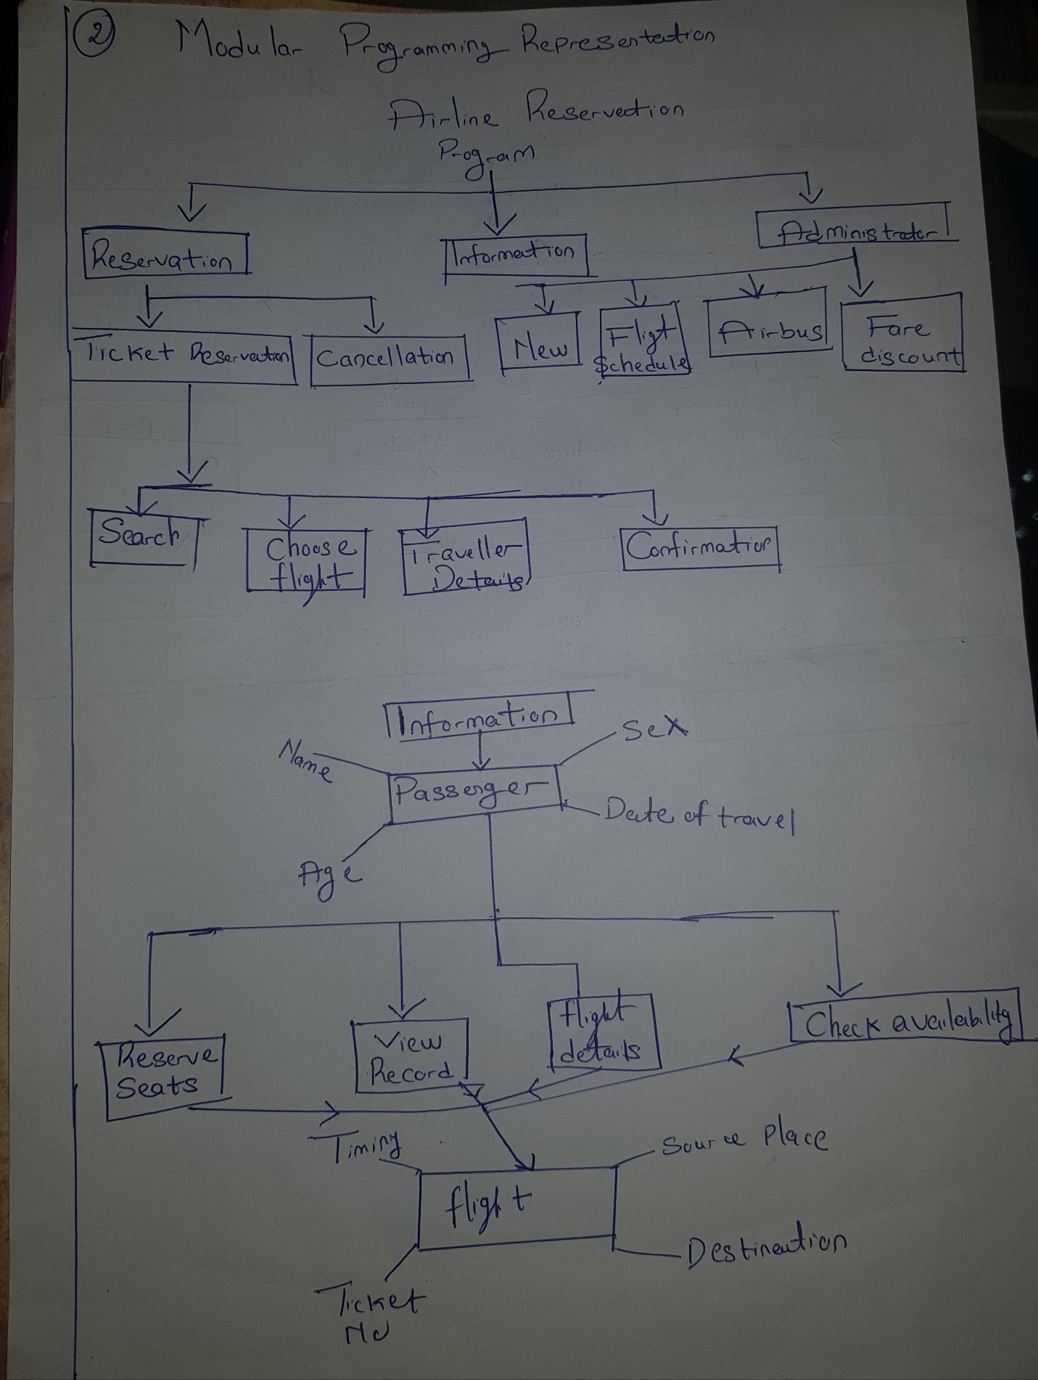

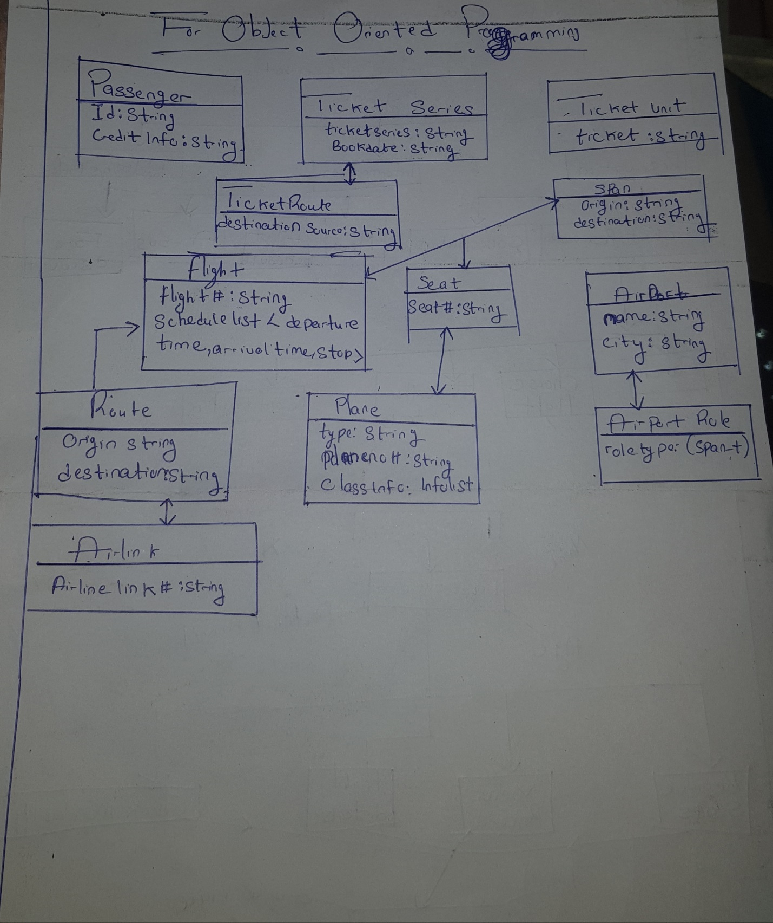

In addition to the previous assignment
Programming languages
Programming languages are grouped into three major categories: scientific, non- scientific and object oriented programming languages.
Scientific programming language: Scientific programming languages are procedural languages. They are command driven or statement-oriented languages. Their basis concept is the machine state. For scientific programming language, FORTRAN and PASCAL would be used
Non-scientific programming language Non-scientific programming languages are also procedural languages. They are closer and similar too most of human language. Basic and COBOL will be examined in this class.
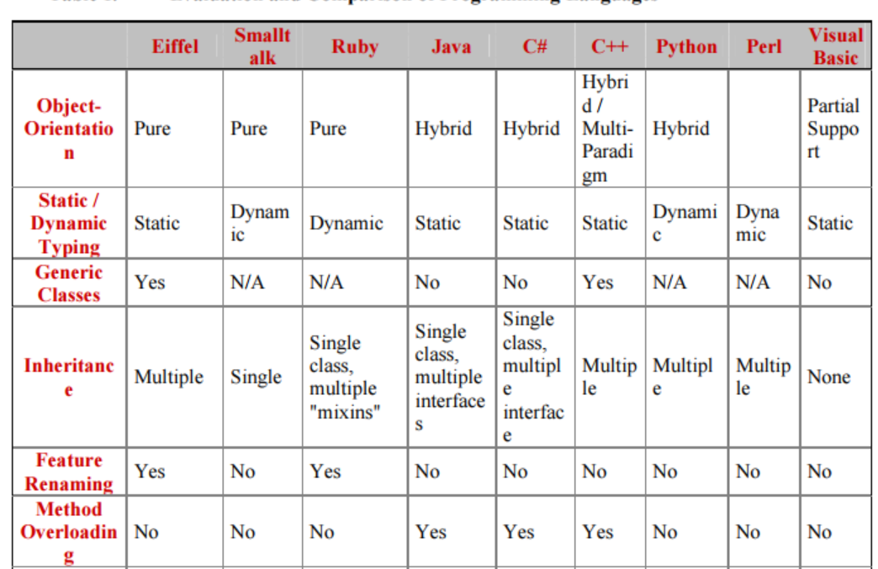
Fig above and below is an evaluation of some programming language.
