- With the aid of a schema diagram distinguish between a modular and an object-oriented programming paradigm.

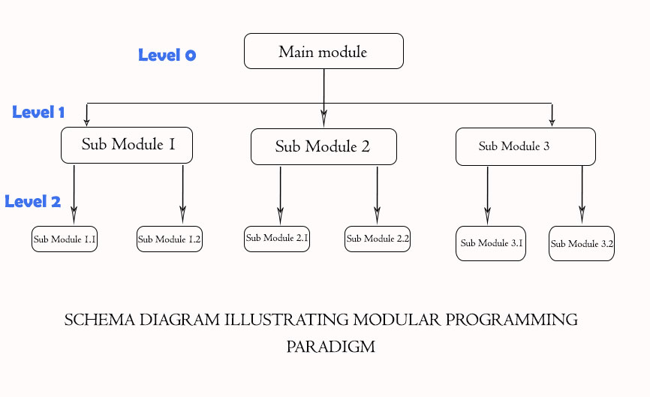
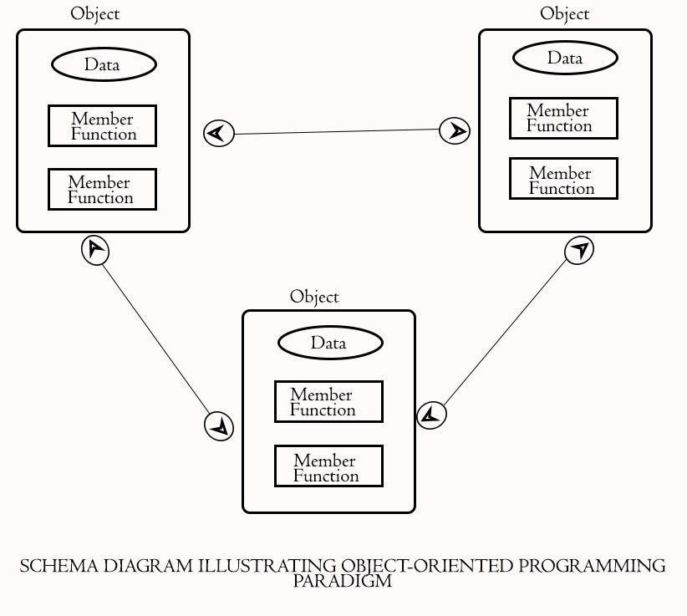

Mohammed Olufemi Rafiu

