A PRESENTATION ON GASTROINTESTINAL TRACT REFLEXES BY

GROUP 5

AFOLABI TOLUWANIMI 17/MHS01/028
UMAR BAABA FATIMA 17/MHS05

GASTROINTESTINAL TRACT REFLEXES
The anatomical arrangement of the enteric nervous system and its connections with the sympathetic and parasympathetic systems support three types of gastrointestinal reflexes that are essential to gastrointestinal control. They are the following:
- Reflexes that are integrated entirely with in the gut wall enteric nervous system. These include reflexes that control much gastrointestinal secretion, peristalsis, mixing contractions, local inhibitory effects.
- Reflexes from the gut to the prevertebral sympathetic ganglia and then back to the gastrointestinal tract. They are reflexes that transmit signals long distances to other areas of the gastrointestinal tract such as signals from the stomach to cause evacuation of the colon (gastrocolic reflex),signals from the colon and small intestine to inhibit stomach motility and stomach secretion (the enterogastric reflexes). Reflexes from the colon to inhibit emptying of ileal contents into the colon ( the colonileal reflex).
- Reflexes from the gut to the spinal cord or brain stem and then back to the gastrointestinal tract. These include reflexes from the stomach and duodenum to the brain stem and back to the stomach by way of the vagus nerves, to control gastric motor and sensory activity. Pain reflexes that cause general inhibition of the entire gastrointestinal tract and defecation reflexes.
THE GASRTOILEAL REFLEX
It intensifies peristalsis in the ileum and forces the remaining chyme through the ileocecal valve into the cecum of the large intestine.
APPEARANCE OF MASS MOVEMENTS AFTER MEALS IS FACILITATED BY GASTROCOLIC AND DUODENOCOLIC REFLEXES
The reflexes result from distention of the stomach and duodenum. They occur hardly when the extrinsic autonomic nerves to the colon have been removed, therefore the reflexes almost certainly are transmitted by way of the autonomic nervous system.

INHIBITORY EFFECT OF ENTEROGASTRIC NERVOUS REFLEXES FROM THE DUODENUM
When food enters the duodenum, multiple nervous reflexes are initiated from the duodenal wall. They pass back to the stomach to slow or even stop stomach emptying if the volume of chyme in the duodenum becomes too much. These reflexes are mediated by three routes;
- Directly from the duodenum to the stomach through the enteric nervous system in the gut wall.
- Through extrinsic nerves that go to the prevertebral sympathetic gangalia and then back through inhibitory sympathetic nerve fibers to the stomach.
- Probably to a slight extent through the vagus nerves all the way to the brain stem, where they inhibit the normal excitatory signals transmitted to the stomach through the vagi.
All these parallel reflexes have two effects on stomach emptying: First they strongly inhibit the pyloric pump, propulsive contractions and second they increase the tone of the pyloric sphincter.
The type of factors that are continually monitored in the duodenum and that can initiate enterogastric inhibitory reflexes include the following:
- The degree of distention of the duodenum.
- The presence of any degree of irritation of the duodenal mucosa.
- The degree of acidity of the duodenal chyme.
- The degree of osmolality of the chyme.
- The presence of certain break down products in the chyme, especially breakdown products of the proteins and perhaps to a lesser extent, of fats.
Defecation Reflexes
Ordinarily defecation is initiated by defecation reflexes. One of these reflexes is an intrinsic reflex mediated by the local enteric nervous system in the rectal wall. This can be described as follows: When feces enter the rectum, distention of the rectal wall initiates afferent signals that spread through the myenteric plexus to initiate peristaltic waves in the descending colon, sigmoid, and rectum, forcing feces toward the anus. As the peristaltic wave approaches the anus, the internal anal sphincter is relaxed by inhibitory signals from the myenteric plexus; if the external anal sphincter is also consciously voluntarily relaxed at the same time, defecation occurs.
The intrinsic myenteric defecation reflex functioning by itself normally is relatively weak to be effective in causing defecation, it usually must be fortified by another type of defecation reflex, a parasympathetic defecation reflex that involves the sacral segments of the spinal cord. When the nerve endings in the rectum are stimulated, signals are transmitted first into the spinal cord and then reflexly back to the descending colon, sigmoid, rectum and anus by way of parasympathetic nerve fibers in the pelvic nerves. These parasympathetic signals greatly intensify the peristaltic waves and relax the internal anal sphincter, thus converting the intrinsic myenteric defecation reflex from a weak effort into a powerful process of defecation that is sometimes effective in emptying the large bowel all the way from the splenic flexure of the colon to the anus.
Defecation signals entering the spinal cord initiate other effects, such as taking a deep breath, closure of the glottis and contraction of the abdominal wall muscles to force the fecal contents of the colon downward and at the same time cause the pelvic floor to relax downward and pull outward on the anal ring to evaginate the feces. When it becomes convenient for the person to defecate, the defecation reflexes can purposely be activated by taking a deep breath to move the diaphragm downward and then contracting the abdominal muscles to increase the pressure in the abdomen, thus forcing fecal contents into the rectum to cause new reflexes. Reflexes initiated in this way are almost never as effective as those that arise naturally, for which reason people who too often inhibit their natural reflexes are likely to become severely constipated.
In newborn babies and in some people with transected spinal cords, the defecation reflexes cause automatic emptying of the lower bowel at inconvenient times during the day because of lack of conscious control exercised through voluntary contraction or relaxation of the external anal sphincter.

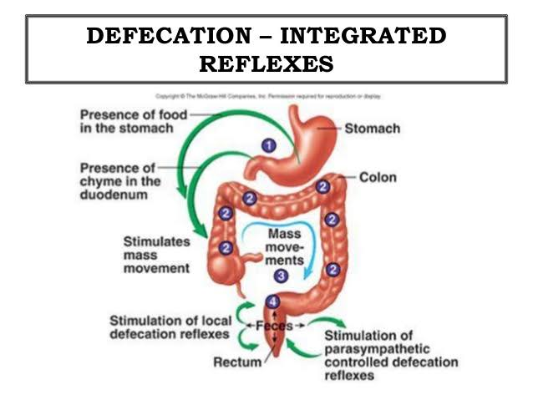
OTHER AUTONOMIC REFLEXES THAT AFFECT BOWEL ACTIVITY
There are several other important nervous reflexes that can affect the overall degree of bowel activity. They are the peritoneointestinal reflex, renointestinal reflex and vesicointestinal reflex. The peritoneointestinal reflex results from irritation of the peritoneum; it strongly inhibits the excitatory enteric nerves and thereby can cause intestinal paralysis especially in patients with peritonitis. The renointestinal and vesicointestinal reflexes inhibit intestinal activity as a result of kidney or bladder irritation.

