NAME : EZEOBIDI CLEMENTINA ONYINYECHUKWU
MATRIC NUMBER : 17/ENG04/027
DEPARTMENT: ELECTRICAL AND ELECTRONICS ENGINEERING
COURSE: ELECTRICAL MACHINES ( EEE326)
POWER FACTOR CORRECTION
ASSIGNMENT II

SECTION A: THEORETICAL FRAMEWORK

1.

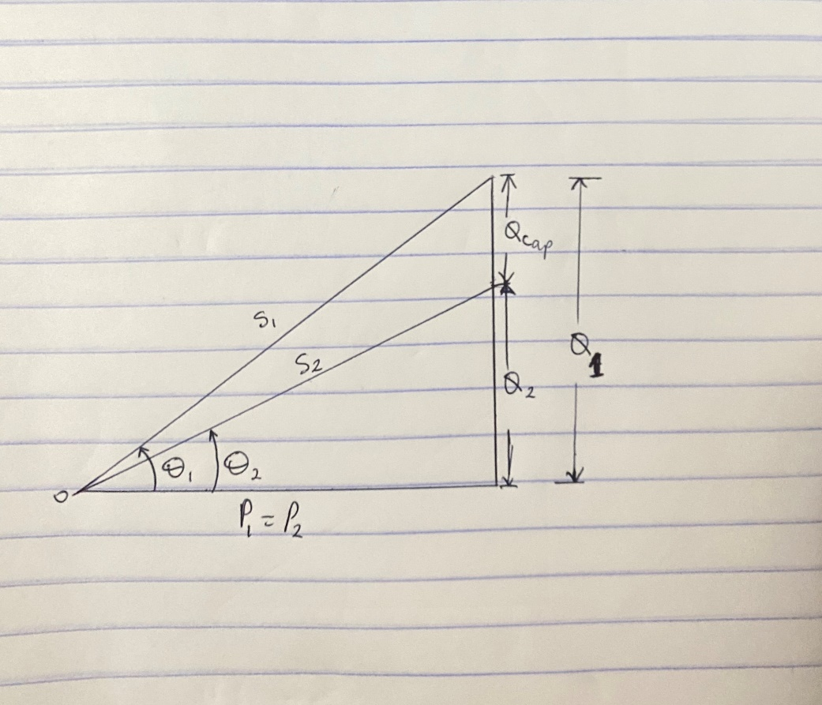

Given : $∅_{1}>∅_{2} , P_{1}=P_{2}$, $Q_{1}>Q_{2}$ and $S_{1}>S_{2}$

The reactive power in a reactor is given by
${Q_{C}=XI }^{2}= \frac{V^{2}}{X}$ at P= 0
$Q_{C}$ = ${\frac{V^{2} }{X}= -wC V}^{2}$ where: V , X and I are rms values

Therefore; C = $\frac{Q_{C}}{-w{ V}^{2}}$

Also ${Q_{C}= Q_{1}-Q_{2 }=P(tanθ}_{1}- tanθ_{2})$

2.
power factor of dangote cement factory at Abajana , Kogi state depends on what percentage of the total load is made up of motors and how the motors are loaded. Motors with variable loads have a lower power factor when not fully loaded. Induction motors, transformers and other inductive loads are what determines if a power factor is good or bad in the dangote cement factory.
Power factor is determined by the ratio of the real power absorbed by the load to the apparent power flowing in the circuit

3.
COS($α-β$) = PF
Where: $α=phase of the voltage$
$β=phase of the current$

- When $(α>β$): the power factor is lagging (inductive)
- When $(β>α$): the power factor is leading (capacitive)
- When $(α=β$): the power factor is unity (1)

PHASOR DIAGRAM REPRESENTATION

- Lagging (inductive) power factor , $(α>β)$
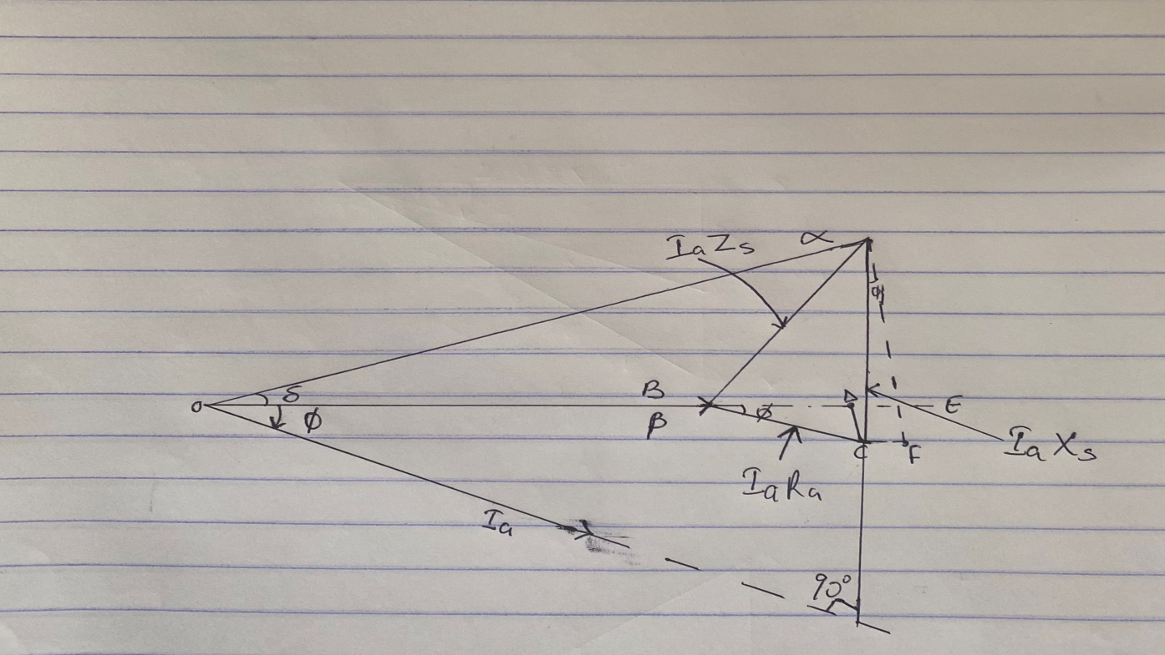

- Leading (capacitive) power factor, $(β>α$)

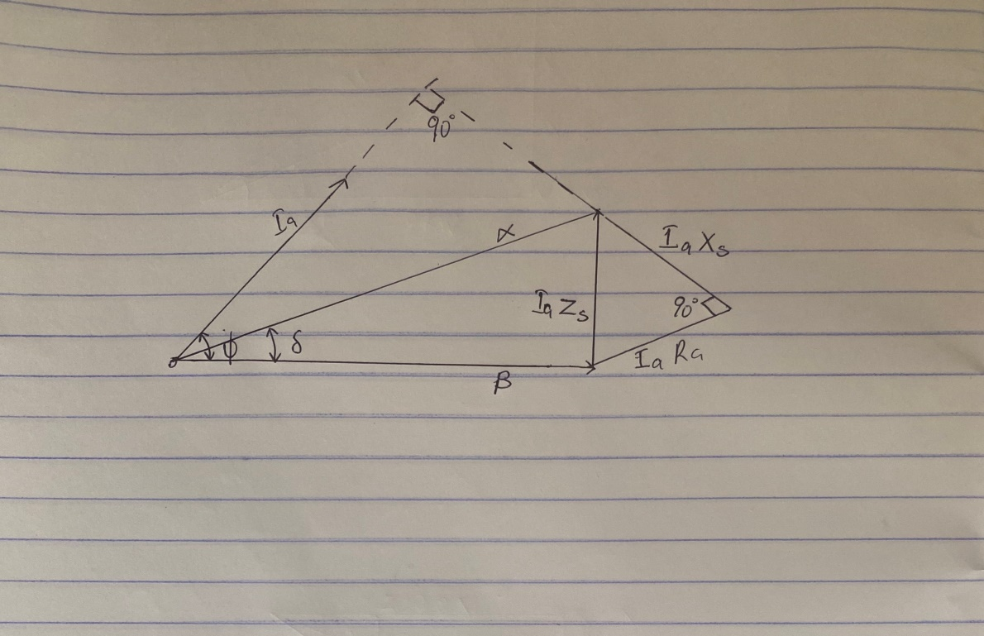

- Unity power factor $(α=β$)

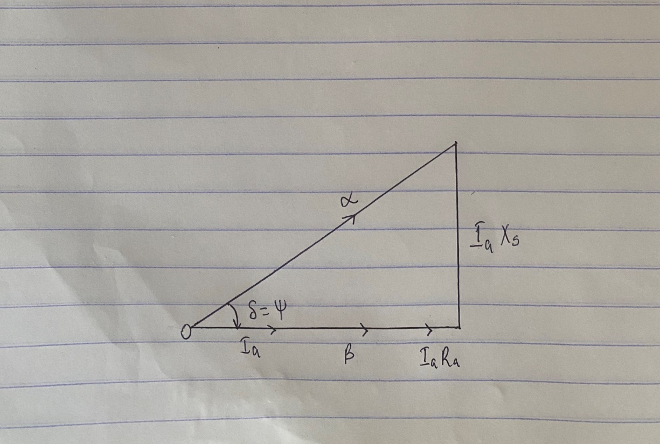

Where : $R_{a}$= armature per phase resistance
$δ=$ angle between the excitation
$∅=$angle between the terminal voltage
$E_{f}=$ excitation voltage. NOTE in the figures above, it is represented as $α$
$V_{t}=$terminal voltage. NOTE in the figures above, it is represented as $β$

4.
For $α>β,$ which indicates a lagging ( inductive ) Power factor
P = S cos ($α ±β$)
Q = S sin($α ±β$) but S =$V_{RMS}*I_{RMS}$

Therefore;
P = $V_{RMS}*I_{RMS}$ cos ($α ±β$)
Q = $V_{RMS}*I_{RMS}$ sin ($α ±β$)

Where: P = real (active) power in W, KW
Q = reactive power in VAR, KVAR

5.
ABUAD, PHCN or an IPP are large scale industries which make use of electricity at large quantity daily and as such the need for power factor correction is highly needed for stable running of the industries.
Power factor correction is the term for any equipment that compensates for reactive power and improves the power factor ratio. It increases the power factor of a load, improving efficiency for the distribution system to which it is attached.
It should be noted that: A high power factor is an indicator that the electrical loads are utilizing power efficiently, while a low power factor indicates that the connected electrical loads are utilizing power inefficiently. A poor power factor results in significant energy wastage, and decreases the capacity of the electrical system. And this can be caused by a phase difference between current and voltage at the terminals of an electrical load, or a distorted current waveform.
And as a result there’s a need to correct power factor because they reduce electricity consumption if there’s a significant proportion of of reactive power in the system and reduces energy charges.
The need for power factor correction is by increasing the load carrying capacity and reducing the demand charge, not only the decreasing of bills, but also allowing for future growth.

6.
Recalling;
- Q represents the Reactive power factor
- Active or True Power (kW) = power that is performing useful work
- Reactive Power (kVAR) = power that is not performing useful work
- Apparent Power (kVA) = The vector sum of Active and Reactive Power. This is what we pay for
- Power factor = the cosine of the angle between Active and Apparent power vectors

Reactive power is considered as ‘wasted power’ as it does not perform useful work in a system. The higher the portion of reactive power, the lower the power factor. Reactive power is essential to move active power through the transmission and distribution system to the customer .Reactive power is required to maintain the voltage to deliver active power (watts) through transmission lines.

SECTION B: APPLICATION OF THEORETICAL FRAME WORK

7.
Given : S = 5 MVA= 5*10⁶ VA , V_{rms} =6 KV

PF₁=40$\%$ =0.4 , PF₂ =85$\%$ =0.85 , Q=? , C=?

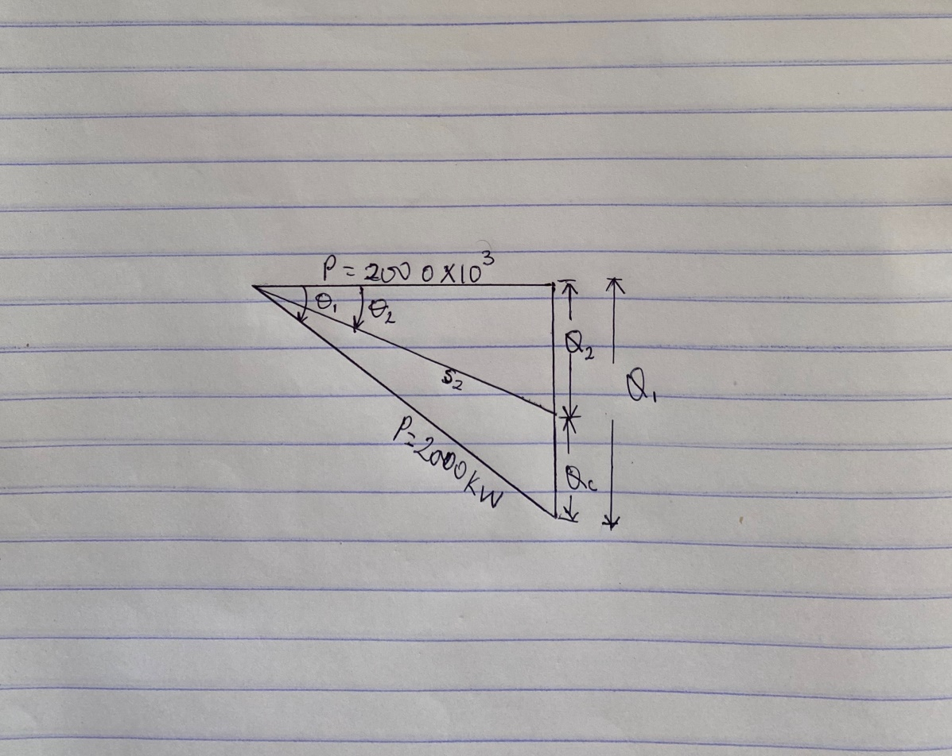

P= COS$θ$*S = 5 x 10⁶ * 0.4 = 2000000 W
$θ_{1}= \cos^{-1}\left(0.4\right)=-66.421°$ ( the angle is negative because the old PF is capacitive )

Hence; $Q_{1}=P\tan{ θ_{1}}$ = $S_{1} sinθ_{1}$

$Q_{1}=2000000*\tan{(-66.421)}$ = -4582396.473VAR

$θ_{1}=$ $\cos^{-1}(0.85$) = -31.7883$°$ ( the angle is negative because the new PF Is capacitive )

$Q_{2}$ = $P\tan{ θ_{2} =2000*{10}^{3}}*$ $\tan{(-31.7883)}$ = -1239487.198VAR

$Q_{c}= Q_{2}-Q_{1}$ = P( tan$θ_{2}-\tan{θ_{1}}$ )

$Q_{c}=$ -1239487.198 – (-4582396.473) = 3342909.275 VAR

C$= \frac{Q_{C}}{W*{(V}_{RMS})^2 }$ but W = 2$πF recallongh F=50Hz$

C $=\frac{3342909.275 }{2π*50*{\left(6*{10}^{3}\right)}^{2}}$ = 2.95578 x 10⁻⁴ F

- correcting equipment will be integrated into the industrial power network for this load by connecting the capacitor banks in parallel

8.

Given: S = 5 MVA= 5*10⁶ VA , V_{rms} =6 KV

PF₁=40$\%$ =0.4 , PF₂ =85$\%$ =0.85 , Q=? , C=?

Recall : cos$θ=\frac{real power, P}{Appatent power,S }$ , P = cos$θ*S$

But PF= cos$θ=0.4$

P =0.4 *5*10⁶ = 2,000,000 W

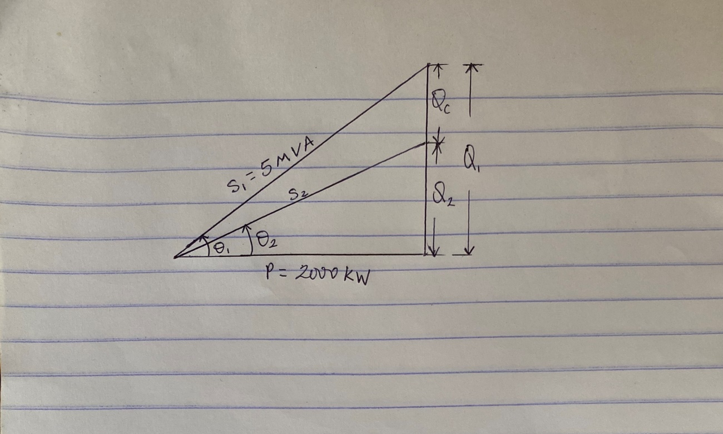

$θ_{1}=\cos^{-1}{(0.4)}=66.421°$

$θ_{2}=$ $\cos^{-1}\left(0.85\right)=31.7883°$

Recall : $Q_{1}=P*tanθ_{1}$ = $S_{1} sinθ_{1}$

$Q_{2}=P*tanθ_{2}$

$Q_{c}= Q_{1}-Q_{2}$ = P( tan$θ_{1}-\tan{θ_{2}}$ )

C$= \frac{Q_{C}}{W*V_{RMS}^{2} }$ where : w= 2$π F but F=50Hz$

$Q_{1}= 2000*{10}^{3}*tan⁡(66.421$) = 4582396.473 =4.58MVAR

$Q_{2}=$ $2000*{10}^{3}*tan⁡(31.78833$) =1239488.647 =1.23 *10⁶ VAR

$Q_{c}=$ 4.58*10⁶ - 1.23 *10⁶ = 3350000 =3.35* 10⁶ VAR

C = $\frac{3350000}{2π*{(6*{10}^{3})}^{2} }=2.96205*{10}^{-4} F$

- correcting equipment will be integrated into the industrial power network for this load by connecting with reactor in series

IN TERMS OF MAGNITUDE

Given that S= $\sqrt{P^{2}+Q^{2}}$

FOR Q7

S= $\sqrt{{(2000*{10}^{3})}^{2}+{(3342909.275)}^{2}}$

S = 3895515.681 VA

FOR Q8

S= $\sqrt{{(2000*{10}^{3})}^{2}+{(3350000)}^{2}}$

S = 3901602.235 VA

The difference between Q7 AND Q8 in terms of magnitude is 6086.554 VA

9.

Given: P = 100KW = 100 x 10³W , V_{rms} = 415 v

PF = cos${ θ}_{1 }$= 0.85 (lagging )

PF = cos${ θ}_{2 }$= 0.95 (lagging )

${ θ}_{1}= \cos^{-1}\left(0.85\right)=31.7883°$

${ θ}_{2}= \cos^{-1}\left(0.95\right)=18.19487°$

Recall: $Q_{1}=P\tan{θ_{1}}$

$Q_{1}=$ $P\tan\left(31.7883 \right)$ = 61974.35988 VAR

$Q_{2}=P\tan{θ_{2}}$

$Q_{2}=$ $P\tan\left(18.19481\right)$ = 32868.41052 VAR

$Q_{C}=Q_{1}-Q_{2}$

$Q_{C}=$ 61974.35988 -32868.41052

$Q_{C}$ = 29105.94848 VAR

C =$\frac{Q_{C}}{W*V_{EMS}^{2}}$ but W = 2$π F$ where: F =50Hz

C =$\frac{29105.94848}{2π*50*{415}^{2}} =$5.37942 x 10⁻⁴ F

10.

s/n | M₁ | M₂
 | Given : PF= 0.85, real power, P =20kw, V_{L}=415 | Given : PF= 0.95, real power, P =20kw, V_{L}=415
1 | Apparent power, s required = $\frac{P}{PF}$ =$\frac{20*{10}^{3}}{ 0.85 }=23529.41176 VA$ | Apparent power, s required = $\frac{P}{PF}$ =$\frac{20*{10}^{3}}{ 0.95 }=21052.63158 VA$
2 | $θ_{1}=\cos^{-1}{(0.85)}$ =31.7883$°$  Reactive power Q₁ =sin $θ_{1}*S$  Q₁ = sin (31.7883) x $23529.41176$  Q₁ =12394.876 VAR | $θ_{1}=\cos^{-1}{(0.95)}$ = 18.1948$°$  Reactive power Q₁ =sin $θ_{1}*S$  Q₁ = sin (18.1948) x $21052.63158$  Q₁ =6573.656853 VAR

Hence ; the induction motor, M₂ is recommended because from the above calculation M₂ has the higher power factor of 0.95 which is much closer to unity power factor and as such it is more efficient and its reactive power (otherwise known as wasted power) is comparatively low as to that of M₁

Recall: the higher the portion of reactive power, the lower the power factor.

It is observed that the reactive power of M₁ is high and as result has a low power factor than that of M_{2.} Hence it (M₁) is comparatively less efficient than M₂

