NAME: YAKUBU NATHAN BALA
MATRIC NO:17/ENG04/076
DEPT: ELECT/ELECT

QUESTION 1
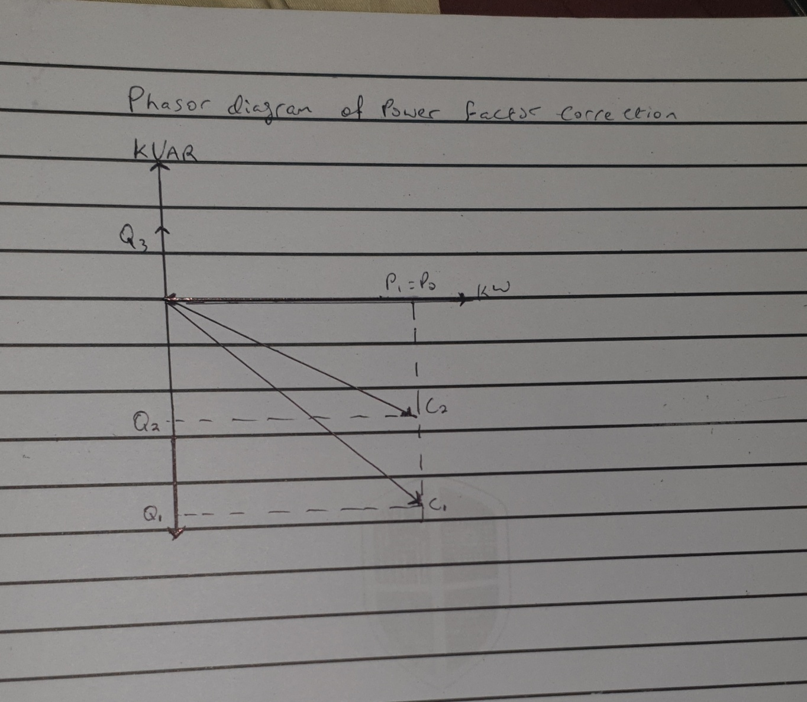
POWER FACTOR CORRECTION PHASOR DIAGRAM

QUESTION 2
The power factor is the ratio of the real power factor that is used to do work and apparent power that is supplied to the circuit. The power factor can get values in the range from 0 to 1. The power factor to apparent power, measured in kilo volts ampere (KVA). Apparent power, also known as demands, is the measure of the amount of power used to run machinery and equipment during a certain period. It is found by multiplying (KVA=VxA). The results are expressed as KVA units
QUESTION 3
When $∝>β$
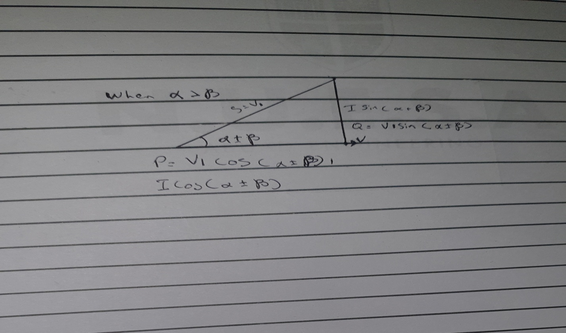
When $β>∝$
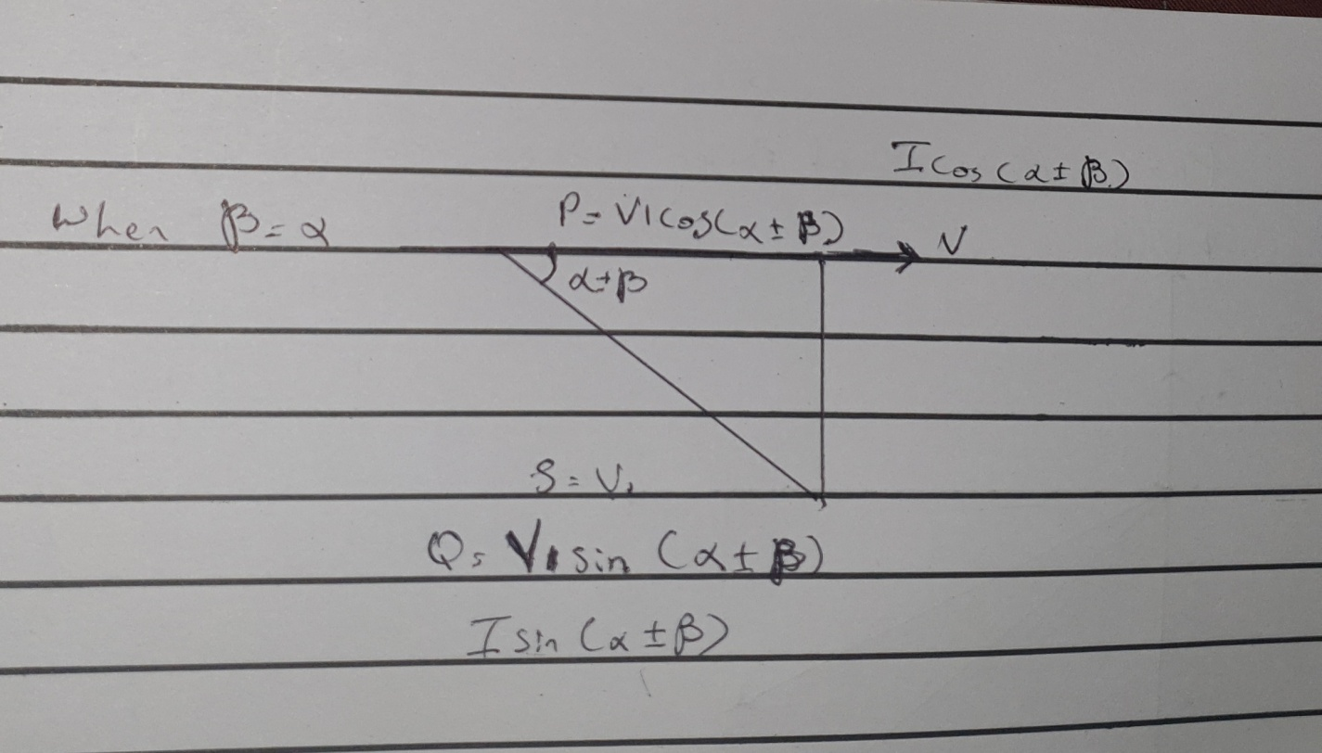
When $∝=β$

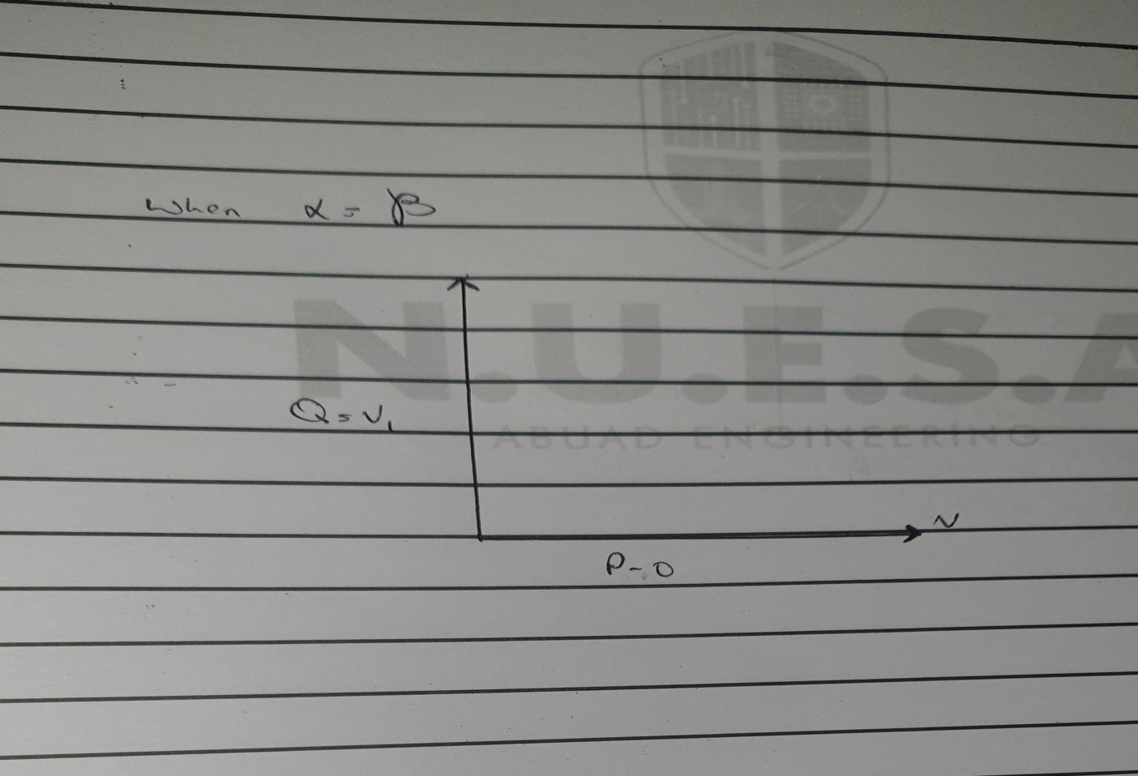

QUESTION 4
P=VI COS ($∝±β$)
Q=VI SIN ($∝±β$)
P= active power
Q= reactive power

QUESTION 5
- To manage full capacity of transformers, switches, conductors as it lowers the capital investment and crucial cost
- To improve voltage
- To reduce the energy loss in the conductors
- To reduce the cost electrical energy when electricity varies with the power facror at the meeting point

QUESTION 6
Reactive power is needed in an industrial complex with numerous induction motors so as to control the voltage in an electrical power system and is important for proper operation for electrical power equipment to prevent damage such as over-heating of generators and motors, to reduce transmission losses and to maintain the ability of the system to withstand and prevent voltage collapse
QUESTION 7
True power= 0.4x5x${10}^{6}$= 2mw
$$θ_{1}=\cos^{-1}{(0.4)}=66.42°$$
$$θ_{2}=\cos^{-1}\left(0.85\right)=37.79°$$
$${\tan{θ}}_{1}=\tan\left(66.42\right)=2.29°$$
$${\tan{θ}}_{2}=\tan\left(37.79\right)=0.78°$$
Required capacitor KVAR(C)= P (${\tan{θ}}_{1}-{\tan{θ}}_{2})$
=2 x${10}^{6}$(2.29-0.78)
=3020KVAR
Reactive power(Q)= p sin ($θ_{1}±θ_{2})$
=2x${10}^{6}\sin{(66.42-37.79)}$
=9.58KVAR

QUESTION 8
The load flow study determines the voltages, current, power, and reactive power in various points and branches of the system under simulated conditions of normal operations. The load studies are essential in optimizing existing network ensuring an economical and efficient distribution of loads and plan failure network

QUESTION 9
$$∝=\cos^{-1}\left(0.85\right)=31.79°$$
$$β=\cos^{-1}\left(0.99\right)=18.19°$$
$$\tan{∝=\tan{31.79=0.62}}$$
$$\tan{β=\tan{18.19=0.33}}$$

Required capacitor KVAR(C)= p ($\tan{∝-\tan{β)}}$
=100x${10}^{3}$(0.62-0.33)
=29KVAR
Reactive power (Q)= p $\sin{(∝-β)}$
100x${10}^{3}\sin{(31.79-18.19)}$
=23KVAR
NB: The NUC should advise the government to accept improved power factor and avoid all punishments

QUESTION 10
Present day improvement of new innovation, hardware, and materials in the field of electrical engineering has permitted a new gander at the issue of expanding financial proficiency, operational unwavering quality, natural execution, and culmination of versatile impetus for helicopter drive trains. Considering the higher prerequisites in regards to unwavering quality and adaptation to internal failure, we utilize positional control or torque control engine regularly and expect criticism to confirm right engine position servo of stepper engines are the best choice for media communications, applications, yet a DC engine with input or an inverter obligation air AC MOTOR with an encoder frequently is utilized for tight torque control in steel or paper line just as comparable applications.

