Name: OLABODE TOBI PELUMI
Department: ELECT ELECT
Matric No: 18/ENG04/082
Course code: EEE 326

1. 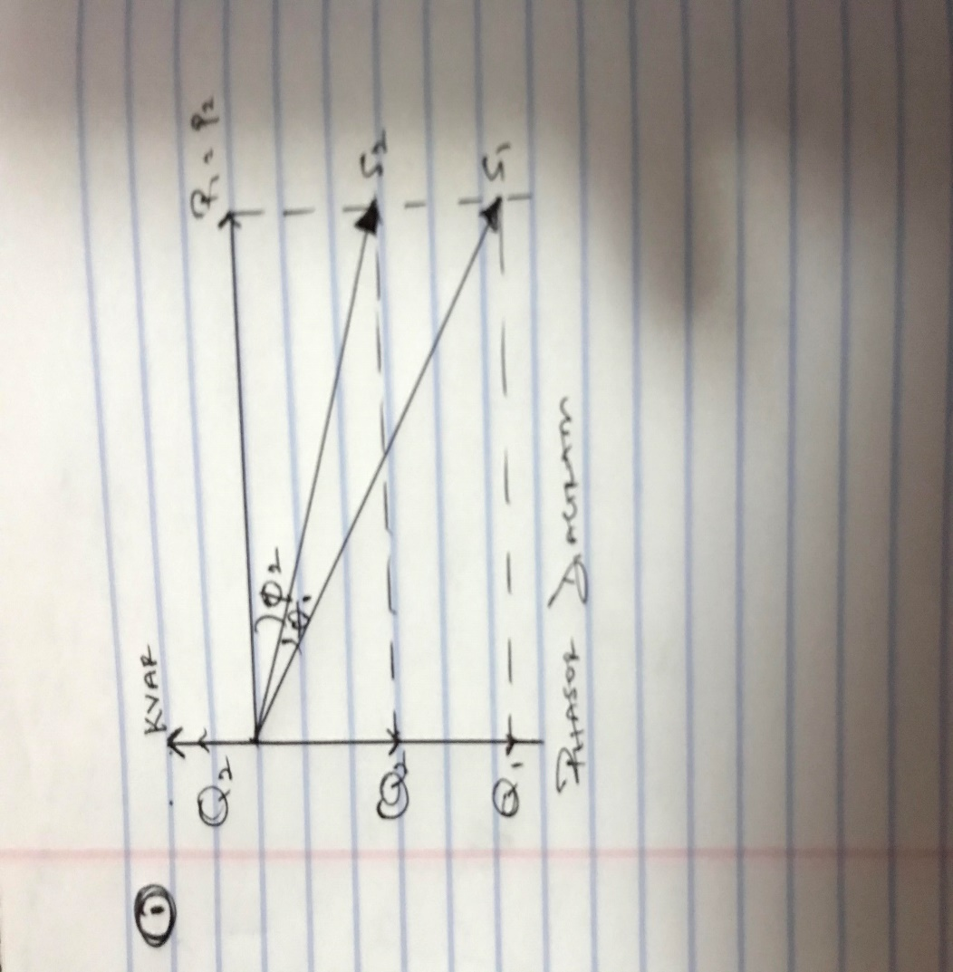

2 . The power factor is determined by taking ratio of the amount of REAL POWER absorbed by the load and the amount of APPARENT POWER flowing in the circuit. The power factor can get values ranging from 0-1
3 . 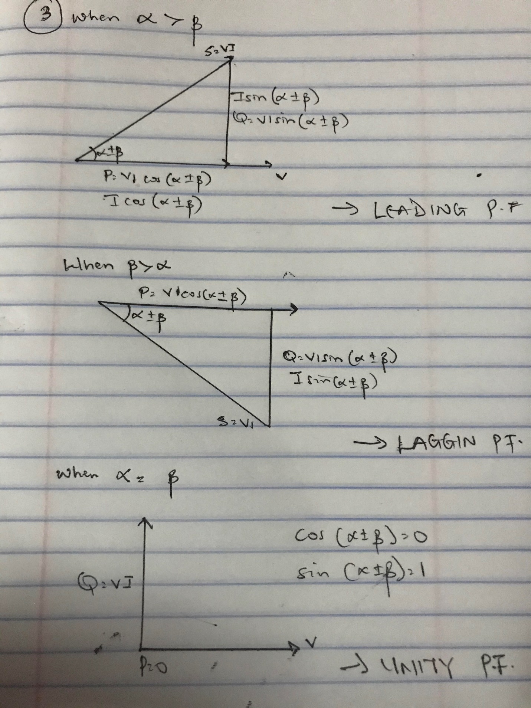

4.P =VIcos( α ± β)
Q = VIsin( α ± β)
p-active power
Q-reactive power

5 .
- REDUCED INSTALLATION SIZE
Installing PFC equipment allows conductor cross-section to be reduced, as less current is absorbed by the compensated installation for the same active power.
- REDUCED VOLTAGE DROPS
Installing capacitors allows voltage drops to be reduced upstream of the point where the PFC device is connected, therefore preventing overloading of the network and reducing harmonics.
- INCREASED AVAILABLE POWER
Fitting PFC equipment on the low voltage side increases the power available at the secondary of a MV/LV transformer. A high power factor optimises an electrical installation by allowing better use of the components.
- SAVINGS ON THE ELECTRICITY BILL

6 . Reactive power is required to maintain the voltage to deliver active power(watts) through transmission lines. Motor loads and other loads require reactive power to convert the flow of electrons into useful work.

7 . True power = 0.4 × 2×10⁶
= 2MW
θ₁ = cos⁻¹ (0.4) = 66.42°;
θ₂ = cos⁻¹(0.85) = 37.79°;

Tan θ₁ = Tan(66.42) = 2.29°
Tan θ₂ = Tan(37.79) = 0.78°

Required capacitor (C) = P (tanθ₁ – tanθ₂)
= 2×10⁶ ( 2.29 – 0.78)
= 3020KVAR

Reactive Power (Q) = P ( sinθ₁ – sinθ₂)
= 2×10⁶ ( 0.92 – 0.61)
= 958KVAR

8 . If this load is an electric motor or most any other industrial AC load, it will have a lagging (inductive) power factor, which means that we’ll have to correct for it with a capacitor of appropriate size, wired in parallel. This correction, of course, will not change the amount of true power consumed by the load, but it will result in a substantial reduction of apparent power. The load flow study determines the voltage, current , power and reactive power in different points of the system under simulated conditions of normal operation. The load study is important in optimizing existing network ensuring an economical and effective distribution of load and planning ahead for future networks.

9 . True power = 100KW
α = cos⁻¹(0.85) = 31.79°.
β = cos⁻¹(0.95) = 18.19°

Tan α = 0.62°
Tan β = 0.33°

Required Capacitor (C) = P (tan α – tan β)
= 100×10³( 0.62 – 0.33)
= 29KVAR

Reactive Power (Q) = P (sinα – sinβ)
= 100×10³ ( 0.53 – 0.31)
= 23KVAR

10 In order to pick the best choice of induction motor, the client must consider the following factors:
- Determine cost-effectiveness AC motors are available in a range of efficiencies. Although the economics will vary by application, replacing an old standard-efficiency motor with a newly installed, premium-efficiency motor under typical operation will often pay for its price in reduced energy bills within a year or two.
Consider downsizing when a motor is operating at less than 40% of its rated output. The following circumstances are opportunities for choosing premium-efficiency motors:
When purchasing a new motor where lower-energy-efficient units can still be sold
Instead of rewinding failed standard-efficiency or energy-efficient motors
To replace an operable-but-inefficient motor for greater energy savings and reliability
- Account for the motor’s impact on power factor Power factor is an indicator of how much of a power system’s capacity is available for productive work. Low power factor is undesirable because it increases the load on a building’s electrical system, and utilities sometimes charge customers a penalty for facilities with low power factor. Because power factor is lower when a motor is lightly loaded, be sure to choose the right-sized motor. You can also specify a motor with a high power factor, but such models sometimes have lower efficiency. The ultimate selection depends, in part, on whether a facility is subject to power factor penalty charges. A facility with a significant number of induction motors and a low power factor can solve the problem with premium-efficiency motors that are properly sized. If new motors are not an option, other power factor–correction methods are available, including static capacitor banks, rotary condensers, and static and dynamic volt-ampere reactive devices.

*8****From the above factors mentioned above, the best and most economical motor choice to go with would be motor 2(M2)*****

