Name: Ojeme Selby
Department: Electrical/Electronics
Matric No: 17/ENG04/052
Course code: EEE 326

1. 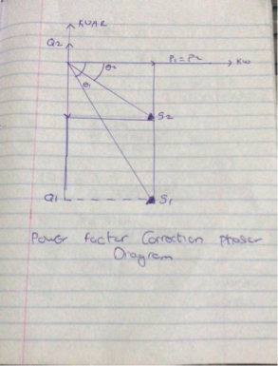

2 . A power factor is calculated by using the ratio of the True power taken in by the amount of Apparent power entering the circuit . Power factors range in value from '0 to 1'

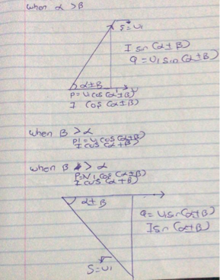

3 .

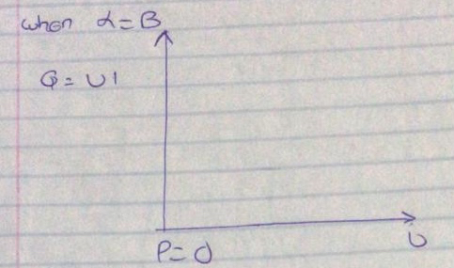

4.
P =VIcos( α ± β)
Q = VIsin( α ± β)

5 .
- Reduced voltage drops
- Less installation sizes
- Increased availability of power
- Lower cost on electricity bills

6 . Reactive power is required to maintain the voltage to deliver active power(watts) through transmission lines. Motor loads and other loads require reactive power to convert the flow of electrons into useful work.

7 . True power = 0.4 × 2×10⁶
= 2MW
θ₁ = cos⁻¹ (0.4) = 66.42°;
θ₂ = cos⁻¹(0.85) = 37.79°;

Tan θ₁ = Tan(66.42) = 2.29°
Tan θ₂ = Tan(37.79) = 0.78°

Required capacitor (C) = P (tanθ₁ – tanθ₂)
= 2×10⁶ ( 2.29 – 0.78)
= 3020KVAR

Reactive Power (Q) = P ( sinθ₁ – sinθ₂)
= 2×10⁶ ( 0.92 – 0.61)
= 958KVAR

8 . The load flow study determines the voltage, current , power and reactive power in different points of the system under simulated conditions of normal operation. The load study is important in optimizing existing network ensuring an economical and effective distribution of load and planning ahead for future networks.

9 . True power = 100KW
α = cos⁻¹(0.85) = 31.79°.
β = cos⁻¹(0.95) = 18.19°

Tan α = 0.62°
Tan β = 0.33°

Required Capacitor (C) = P (tan α – tan β)
= 100×10³( 0.62 – 0.33)
= 29KVAR

Reactive Power (Q) = P (sinα – sinβ)
= 100×10³ ( 0.53 – 0.31)
= 23KVAR

10 .
Regulating cost-efficiency
AC motors are available in a range of efficiencies. Although the economics will vary by application, replacing an old standard-efficiency motor with a newly installed, premium-efficiency motor under typical operation will often pay for its price in reduced energy bills within a year or two.
When purchasing a new motor where lower-energy-efficient units can still be sold
Instead of rewinding failed standard-efficiency or energy-efficient motors
To replace an operable-but-inefficient motor for greater energy savings and reliability
Description for motor impact on power factor
Power factor is an indicator of how much of a power system’s capacity is available for productive work. Low power factor is undesirable because it increases the load on a building’s electrical system, and utilities sometimes charge customers a penalty for facilities with low power factor. Because power factor is lower when a motor is lightly loaded, be sure to choose the right-sized motor.

s/n | M₁ | M₂
 | Given : PF= 0.85, real power, P =20kw, V_{L}=415 | Given : PF= 0.95, real power, P =20kw, V_{L}=415
1 | Apparent power, s required = = | Apparent power, s required = =
2 | =31.7883  Reactive power Q₁ =sin  Q₁ = sin (31.7883) x  Q₁ =12394.876 VAR | = 18.1948  Reactive power Q₁ =sin  Q₁ = sin (18.1948) x  Q₁ =6573.656853 VAR

Therefore; the induction motor, M₂ is recommended because from the above calculation M₂ has the higher power factor of 0.95 which is much closer to unity power factor and as such it is more efficient and its reactive power

