NAME: EKEOGU IZUCHUKWU
MATRIC NO: 17/ENG04/019
ELECT/ELECT ENGINEERING
EEE 326 ASSIGNMENT
SECTION A: THEORETICAL FRAMEWORK
- Develop the theoretical framework required for the correction of the power factor for a multi - sectioned industrial complex from $Cos ∅_{1}$ to $Cos ∅_{2}$ where $∅_{1}>∅_{2}$; $P_{1}=P_{2}$; $Q_{1}>Q_{2}$; and $S_{1}>S_{2}$ to determine the kVAR rating of the capacitor$(Q_{CAP})$ and the magnitude of the capacitor (C) in farads required to correct the power factor of the complex. USE APPROPRIATE PHASOR DIAGRAMS.
Answer:
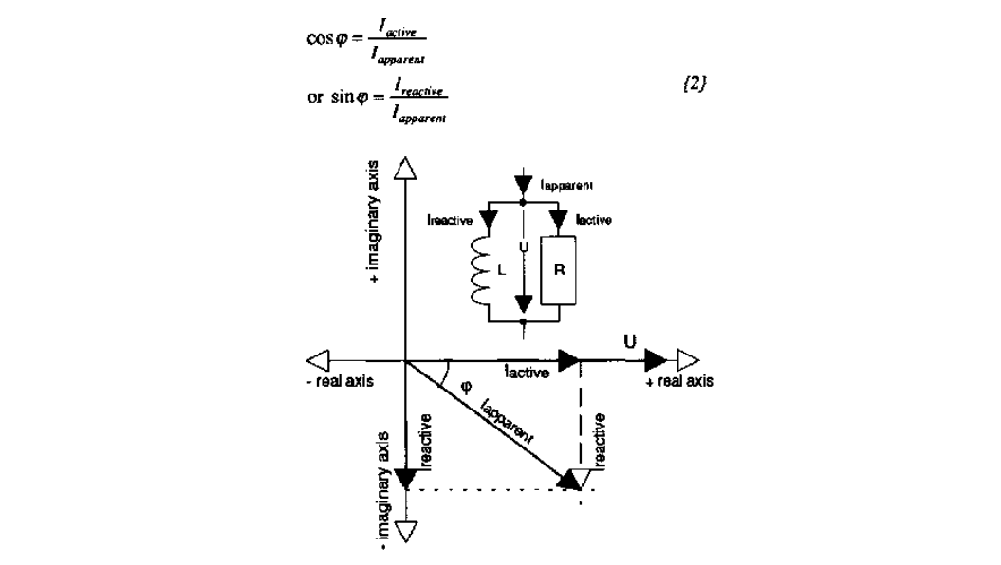

- What determines the power factor of the Dangote Cement Factory at Abajana, Kogi State ?
Answer:
Firstly, Power Factor is a measure of how effectively incoming power is used in your electrical system and is defined as the ratio of Real (working) power to Apparent (total) power. Real Power (kW) is the power that actually powers the equipment and performs useful, productive work. It is also called Actual Power, Active Power or Working Power. Reactive Power (kVAR) is the power required by some equipment (eg. transformers, motors and relays) to produce a magnetic field to enable real work to be done. It’s necessary to operate certain equipment but you don’t see any result for its use. Apparent Power (kVA) is the vector sum of Real Power (kW) and Reactive Power (kVAR) and is the total power supplied through the power mains that is required to produce the relevant amount of real power for the load. The power factor is the ratio between Real Power and Apparent Power. It’s expressed as a value between -1 and 1 and can be either inductive (lagging) or capacitive (leading). If the power factor is 1, then all of the power supplied is being used for productive work and this is called ‘unity’.
- The power factor (pf) of Eleme Petrochemical Industry PortHarcourt is given as $\operatorname{Cos}\left(α±β\right)$; what is the state of the pf of the complex when $α>β$;
$β>α$ and $α=β$. Draw the respective Phasor diagrams.
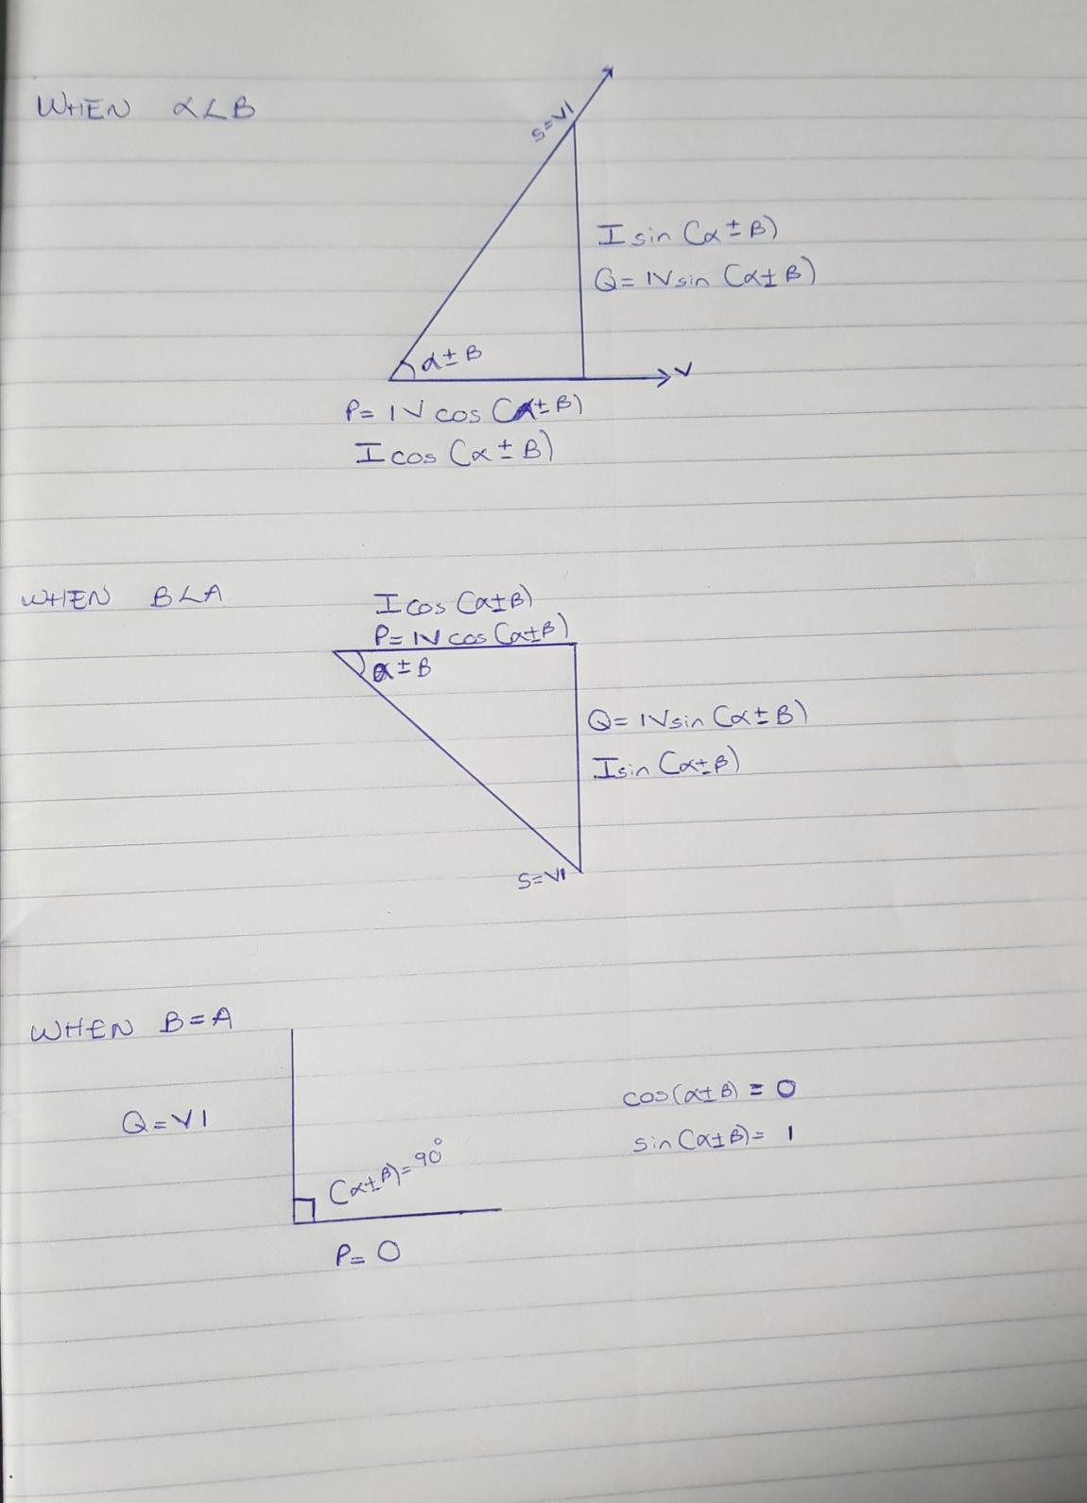
Answer:
- For $α>β$; Write an expression for P and Q respectively with units in W and VAR. What does P and Q represent.
Answer:
P=I*Vcos(α±β)
Q=I*Vsin(α±β)
Where,
P: active power(kW)
Q: reactive power(kVAR)

- Justify the need for power factor correction to ABUAD and PHCN or an IPP.
Answer:
- Savings on the electricity bill
Power factor correction eliminates penalties on reactive energy, decreases demand on kVA, and reduces power losses generated in the transformers and conductors of the installation.
- Increased available power
Fitting PFC equipment on the low voltage side increases the power available at the secondary of a MV/LV transformer. A high power factor optimises an electrical installation by allowing better use of the components.
- Reduced installation size
Installing PFC equipment allows conductor cross-section to be reduced, as less current is absorbed by the compensated installation for the same active power.
- Reduced voltage drops
Installing capacitors allows voltage drops to be reduced upstream of the point where the PFC device is connected, therefore preventing overloading of the network and reducing harmonics.

- Why is Q needed in an industrial complex with numerous induction motors?
- Voltage control in an electrical power system is important for proper operation for electrical power equipment to prevent damage such as overheating of generators and motors, to reduce transmission losses and to maintain the ability of the system to withstand and prevent voltage collapse.
- Decreasing reactive power causing voltage to fall while increasing it causing voltage to rise. A voltage collapse may be occurs when the system try to serve much more load than the voltage can support.
- When reactive power supply lower voltage, as voltage drops current must increase to maintain power supplied, causing system to consume more reactive power and the voltage drops further . If the current increase too much, transmission lines go off line, overloading other lines and potentially causing cascading failures.
- If the voltage drops too low, some generators will disconnect automatically to protect themselves. Voltage collapse occurs when an increase in load or less generation or transmission facilities causes dropping voltage, which causes a further reduction in reactive power from capacitor and line charging, and still there further voltage reductions. If voltage reduction continues, these will cause additional elements to trip, leading further reduction in voltage and loss of the load. The result in these entire progressive and uncontrollable declines in voltage is that the system unable to provide the reactive power required supplying the reactive power demands

SECTION B: APPLICATION OF THEORETICAL FRAMEWORK
- An industrial load absorbs 5 MVA at a pf of 40% capacitive at 6kV. To improve the pf up to 85% capacitive, determine Q and C of the required capacitor. State how the correcting equipment will be integrated into the industrial power network for this load.
Answer
Origial p.f=40%=0.4
Improved p.f=85%=0.85
Apparent power, S=5 MVA
V=6kV
real power=pf * apparent power
=5 MVA*0.4=2MW

Recall, pf=cosθ
Therefore, θ= cos⁻¹(pf)
θ₁=cos⁻¹(0.4)=66.4218
Hence; $Q_{1}=P\tan{ θ_{1}}$ = $S_{1} sinθ_{1}$

$Q_{1}=2000000*\tan{(-66.421)}$ = -4582396.473VAR

$θ_{1}=$ $\cos^{-1}(0.85$) = -31.7883$°$ ( the angle is negative because the new PF Is capacitive )

$Q_{2}$ = $P\tan{ θ_{2} =2000*{10}^{3}}*$ $\tan{(-31.7883)}$ = -1239487.198VAR

$Q_{c}= Q_{2}-Q_{1}$ = P( tan$θ_{2}-\tan{θ_{1}}$ )

$Q_{c}=$ -1239487.198 – (-4582396.473) = 3342909.275 VAR

C$= \frac{Q_{C}}{W*{(V}_{RMS})^2 }$ but W = 2$πF recallongh F=50Hz$

C $=\frac{3342909.275 }{2π*50*{\left(6*{10}^{3}\right)}^{2}}$ = 2.95578 x 10⁻⁴ F

correcting equipment will be integrated into the industrial power network for this load by connecting the capacitor banks in parallel

- An industrial load absorbs 5 MVA at a pf of 40% inductive at 6kV. To improve the pf. Up to 85% inductive, determine Q and C of the required and necessary capacitor. State how the correcting equipment will be integrated into the industrial power network for this load. How different are the values of Q7 and Q8 in terms of magnitude and type of pf correction?
Answer:
Given: S = 5 MVA= 5*10⁶ VA , V_{rms} =6 KV

PF₁=40$\%$ =0.4 , PF₂ =85$\%$ =0.85 , Q=? , C=?

Recall : cos$θ=\frac{real power, P}{Appatent power,S }$ , P = cos$θ*S$

But PF= cos$θ=0.4$

P =0.4 *5*10⁶ = 2,000,000 W
Recall : $Q_{1}=P*tanθ_{1}$ = $S_{1} sinθ_{1}$

$Q_{2}=P*tanθ_{2}$

$Q_{c}= Q_{1}-Q_{2}$ = P( tan$θ_{1}-\tan{θ_{2}}$ )

C$= \frac{Q_{C}}{W*V_{RMS}^{2} }$ where : w= 2$π F but F=50Hz$

$Q_{1}= 2000*{10}^{3}*tan⁡(66.421$) = 4582396.473 =4.58MVAR

$Q_{2}=$ $2000*{10}^{3}*tan⁡(31.78833$) =1239488.647 =1.23 *10⁶ VAR

$Q_{c}=$ 4.58*10⁶ - 1.23 *10⁶ = 3350000 =3.35* 10⁶ VAR

C = $\frac{3350000}{2π*{(6*{10}^{3})}^{2} }=2.96205*{10}^{-4} F$

If this load is an electric motor or most any other industrial AC load, it will have a lagging (inductive) power factor, which means that we’ll have to correct for it with a capacitor of appropriate size, wired in parallel. This correction, of course, will not change the amount of true power consumed by the load, but it will result in a substantial reduction of apparent power.

- The National Universities Commission (NUC) Complex in Abuja has a total load of 100kW. It is powered by a 415 V, three phase, 4 wire power supply. The power factor is 0.85lagging and NUC desires to avoid the payment of penalties for this poor power factor. What Should the facility manager advise NUC management to do? If an improved pf of 0.95 lagging is desired, determine the magnitude of the required Q and C.
Answers
Given: P = 100KW = 100 x 10³W , V_{rms} = 415 v

PF = cos${ θ}_{1 }$= 0.85 (lagging )

PF = cos${ θ}_{2 }$= 0.95 (lagging )

${ θ}_{1}= \cos^{-1}\left(0.85\right)=31.7883°$

${ θ}_{2}= \cos^{-1}\left(0.95\right)=18.19487°$

Recall: $Q_{1}=P\tan{θ_{1}}$

$Q_{1}=$ $P\tan\left(31.7883 \right)$ = 61974.35988 VAR

$Q_{2}=P\tan{θ_{2}}$

$Q_{2}=$ $P\tan\left(18.19481\right)$ = 32868.41052 VAR

$Q_{C}=Q_{1}-Q_{2}$

$Q_{C}=$ 61974.35988 -32868.41052

$Q_{C}$ = 29105.94848 VAR

C =$\frac{Q_{C}}{W*V_{EMS}^{2}}$ but W = 2$π F$ where: F =50Hz

C =$\frac{29105.94848}{2π*50*{415}^{2}} =$5.37942 x 10⁻⁴ F
I’d advice the manager to go with the new power factor and the advantages that accompany it.

- Undertake a comparative analysis as an Electrical Power Management Consultant and use techno – economic facts and data to advice a client (Globacom Nigeria Ltd) requiring a 20kW induction motor to power its intended fruit juice factory from motor choices $M_{1} and M_{2}$ given the following details:
Motor/parameters | $$M_{1}$$ | $$M_{2}$$
kW | 20 | 20
Phases | 3 | 3
Line Voltage | 415 | 415
pf | 0.85 | 0.95
S | $$S_{1}$$ | $$S_{2}$$
Q | $$Q_{1}$$ | $$Q_{2}$$
PREVIOUS METER READING (kWhr) | 23,000
NEW METER READING (kWhr) | 25,000
kWhr charge | #55/kWhr
Demand(kW) Charge | #35/kW
Capacity (kVA) Charge | #70/kVA
Reactive Power (kVAR) Charge | #25/kVAR
Justify clearly your choice of recommended motor.

Answer
In order to pick the best choice of induction motor, the client must consider the following factors:
- Determine cost-effectiveness AC motors are available in a range of efficiencies. Although the economics will vary by application, replacing an old standard-efficiency motor with a newly installed, premium-efficiency motor under typical operation will often pay for its price in reduced energy bills within a year or two.
Consider downsizing when a motor is operating at less than 40% of its rated output. The following circumstances are opportunities for choosing premium-efficiency motors:
When purchasing a new motor where lower-energy-efficient units can still be sold
Instead of rewinding failed standard-efficiency or energy-efficient motors
To replace an operable-but-inefficient motor for greater energy savings and reliability
- Account for the motor’s impact on power factor Power factor is an indicator of how much of a power system’s capacity is available for productive work. Low power factor is undesirable because it increases the load on a building’s electrical system, and utilities sometimes charge customers a penalty for facilities with low power factor. Because power factor is lower when a motor is lightly loaded, be sure to choose the right-sized motor. You can also specify a motor with a high power factor, but such models sometimes have lower efficiency. The ultimate selection depends, in part, on whether a facility is subject to power factor penalty charges. A facility with a significant number of induction motors and a low power factor can solve the problem with premium-efficiency motors that are properly sized. If new motors are not an option, other power factor–correction methods are available, including static capacitor banks, rotary condensers, and static and dynamic volt-ampere reactive devices.

From the above factors mentioned above, the best and most economical motor choice to go with would be motor 2(M2)

