Name: KOLAWOLE JOSEPH .O.
Department: Elect/elect engr
Matric No: 17/ENG04/038
Course code: EEE 326

1. 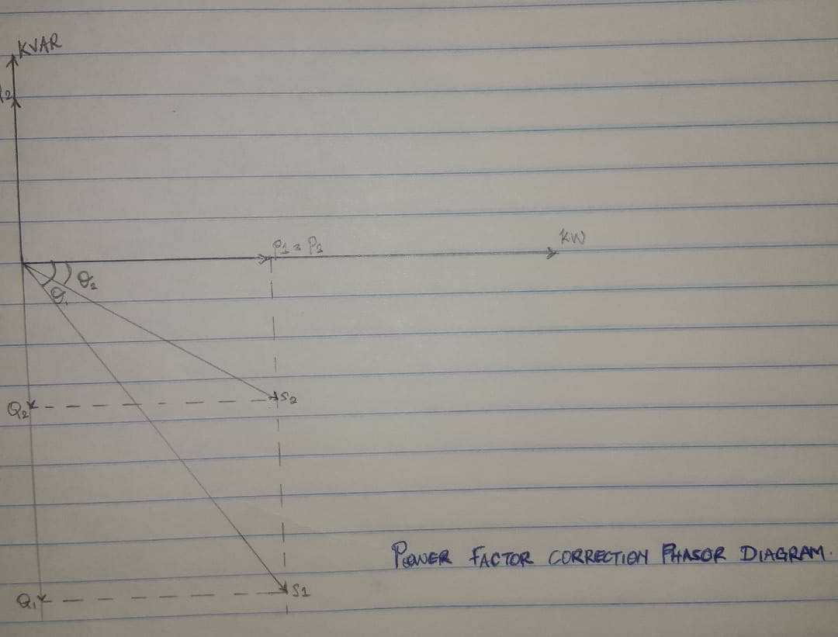

2 . The power factor is the ratio of the real power that is used to do work and apparent power is supplied to the circuit. The power factor ranges in values from '0 to 1'. The power factor to the apparent power is measured in (KVA). The combination of reactive power and true power is called apparent power, and it is the product of a circuit's voltage and current, without reference to phase angle. Apparent power is measured in the unit of Volt-Amps (VA) and is symbolized by the capital letter S.

3 . 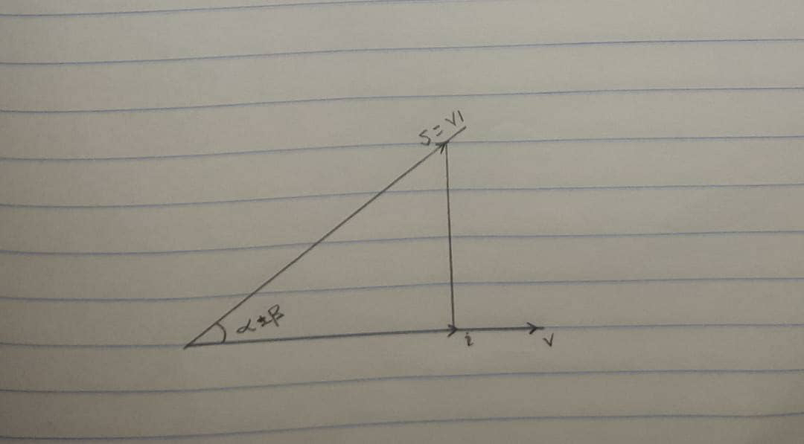
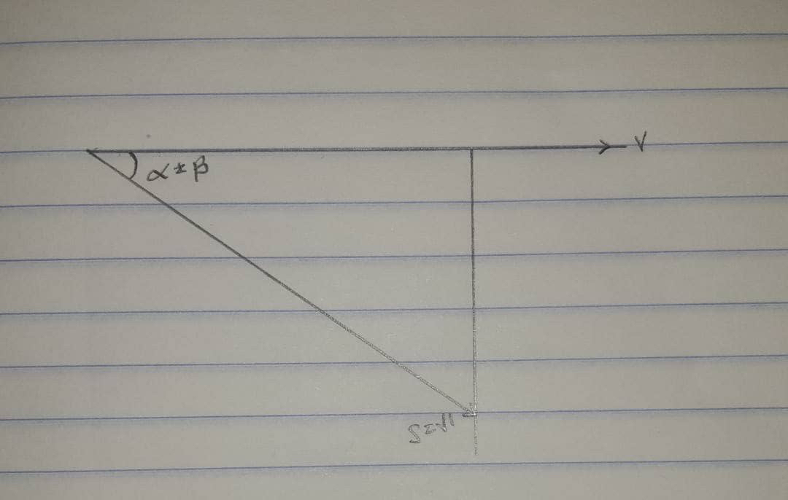
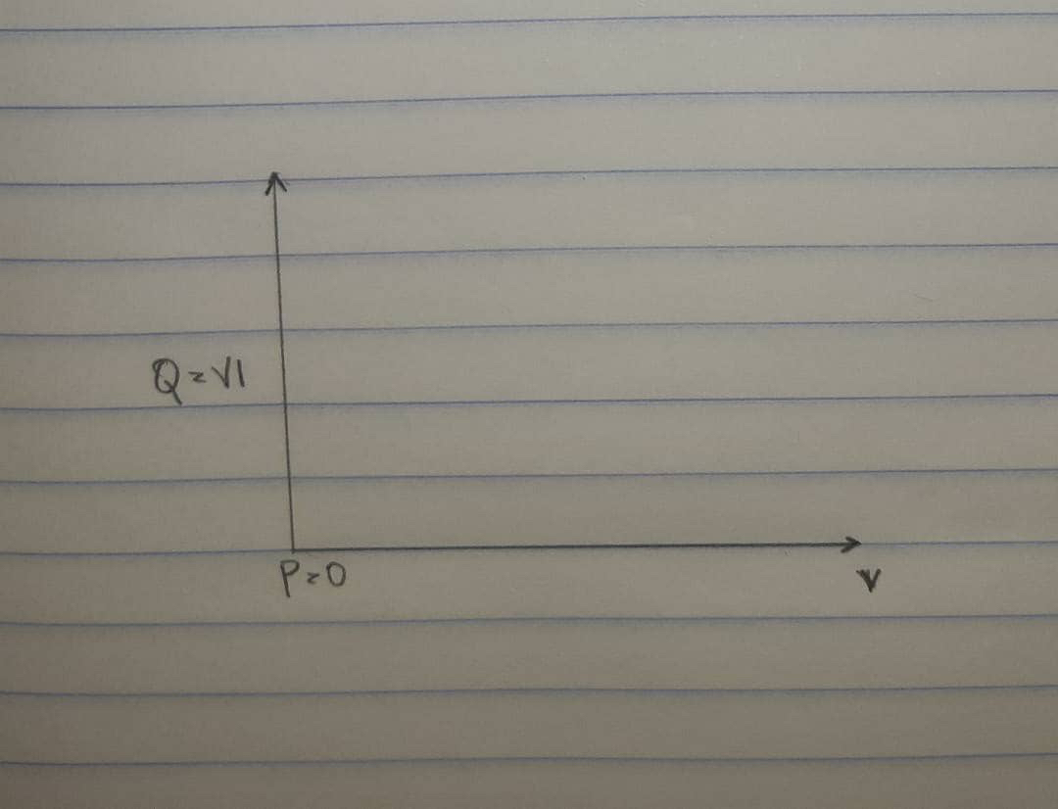

4.
P =VIcos( α ± β)
Q = VIsin( α ± β)

5 .
- To reduce the energy loss in conductors
- To improve voltage
- To utilise the full capacity of transformers, switches, circuit boards , buses and conductors for active power only to help lower the cost of investment capital and cost.
- To lower the cost of electric energy when the electric utility rates vary with the power factor at required rates.

6 . Reactive power is required to maintain the voltage to deliver active power(watts) through transmission lines. Motor loads and other loads require reactive power to convert the flow of electrons into useful work.

7 . True power = 0.4 × 2×10⁶
= 2MW
θ₁ = cos⁻¹ (0.4) = 66.42°;
θ₂ = cos⁻¹(0.85) = 37.79°;

Tan θ₁ = Tan(66.42) = 2.29°
Tan θ₂ = Tan(37.79) = 0.78°

Required capacitor (C) = P (tanθ₁ – tanθ₂)
= 2×10⁶ ( 2.29 – 0.78)
= 3020KVAR

Reactive Power (Q) = P ( sinθ₁ – sinθ₂)
= 2×10⁶ ( 0.92 – 0.61)
= 958KVAR

8 . The load flow study determines the voltage, current , power and reactive power in different points of the system under simulated conditions of normal operation. The load study is important in optimizing existing network ensuring an economical and effective distribution of load and planning ahead for future networks.

9 . True power = 100KW
α = cos⁻¹(0.85) = 31.79°.
β = cos⁻¹(0.95) = 18.19°

Tan α = 0.62°
Tan β = 0.33°

Required Capacitor (C) = P (tan α – tan β)
= 100×10³( 0.62 – 0.33)
= 29KVAR

Reactive Power (Q) = P (sinα – sinβ)
= 100×10³ ( 0.53 – 0.31)
= 23KVAR

10 .

s/n | M₁ | M₂
 | Given : PF= 0.85, real power, P =20kw, V_{L}=415 | Given : PF= 0.95, real power, P =20kw, V_{L}=415
1 | Apparent power, s required = $\frac{P}{PF}$ =$\frac{20*{10}^{3}}{ 0.85 }=23529.41176 VA$ | Apparent power, s required = $\frac{P}{PF}$ =$\frac{20*{10}^{3}}{ 0.95 }=21052.63158 VA$
2 | $θ_{1}=\cos^{-1}{(0.85)}$ =31.7883$°$  Reactive power Q₁ =sin $θ_{1}*S$  Q₁ = sin (31.7883) x $23529.41176$  Q₁ =12394.876 VAR | $θ_{1}=\cos^{-1}{(0.95)}$ = 18.1948$°$  Reactive power Q₁ =sin $θ_{1}*S$  Q₁ = sin (18.1948) x $21052.63158$  Q₁ =6573.656853 VAR

Hence ; the induction motor, M₂ is recommended because from the above calculation M₂ has the higher power factor of 0.95 which is much closer to unity power factor and as such it is more efficient and its reactive power (otherwise known as wasted power) is comparatively low as to that of M₁

Recall: the higher the portion of reactive power, the lower the power factor.

It is observed that the reactive power of M₁ is high and as result has a low power factor than that of M_{2.} Hence it (M₁) is comparatively less efficient than M₂

