NAME: ALEGBELEYE OLUWAFEMI OLADIPUPO
MATRIC NUMBER: 17/ENG04/011
DEPARTMENT: ELECT/ELECT
EEE326 ASSIGNMENT
QUESTIONS/SOLUTIONS

SECTION A: THEORETICAL FRAMEWORK
- Develop the theoretical framework required for the correction of the power factor for a multi - sectioned industrial complex from $Cos ∅_{1}$ to $Cos ∅_{2}$ where $∅_{1}>∅_{2}$; $P_{1}=P_{2}$; $Q_{1}>Q_{2}$; and $S_{1}>S_{2}$ to determine the kVAR rating of the capacitor$(Q_{CAP})$ and the magnitude of the capacitor (C) in farads required to correct the power factor of the complex. USE APPROPRIATE PHASOR DIAGRAMS.
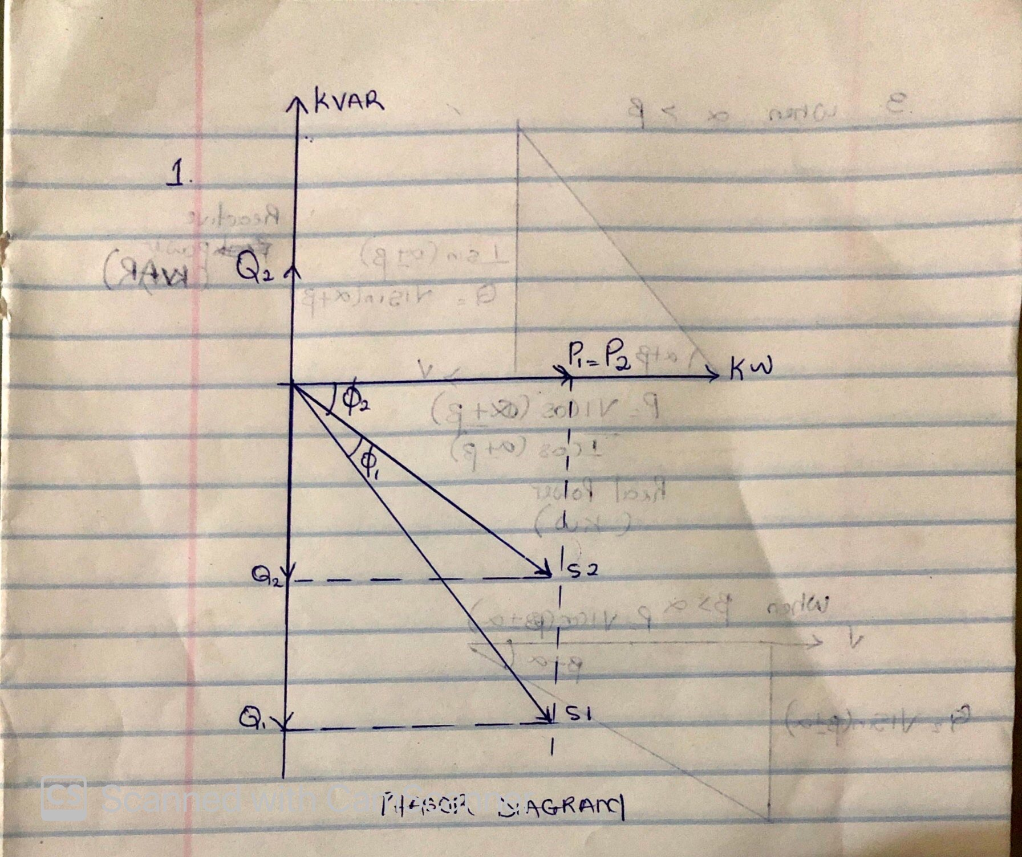
Given : $∅_{1}>∅_{2} , P_{1}=P_{2}$, $Q_{1}>Q_{2}$ and $S_{1}>S_{2}$
The reactive power in a reactor is given by
${Q_{C}=XI }^{2}= \frac{V^{2}}{X}$ at P= 0
$Q_{C}$ = ${\frac{V^{2} }{X}= -wC V}^{2}$
Also ${Q_{C}= Q_{1}-Q_{2 }=P(tanθ}_{1}- tanθ_{2})$
- What determines the power factor of the Dangote Cement Factory at Abajana, Kogi State?
The ratio of real power used to do work in the factory to apparent power supplied to the circuit breakers in the factory.
- The power factor (pf) of Eleme Petrochemical Industry PortHarcourt is given as$\operatorname{Cos}\left(α±β\right)$; what is the state of the pf of the complex when$α>β$; $β>α$ and$α=β$. Draw the respective Phasor diagrams.
- When $(α>β$): the power factor is lagging (inductive)
- When $(β>α$): the power factor is leading (capacitive)
- When $(α=β$): the power factor is unity (1)

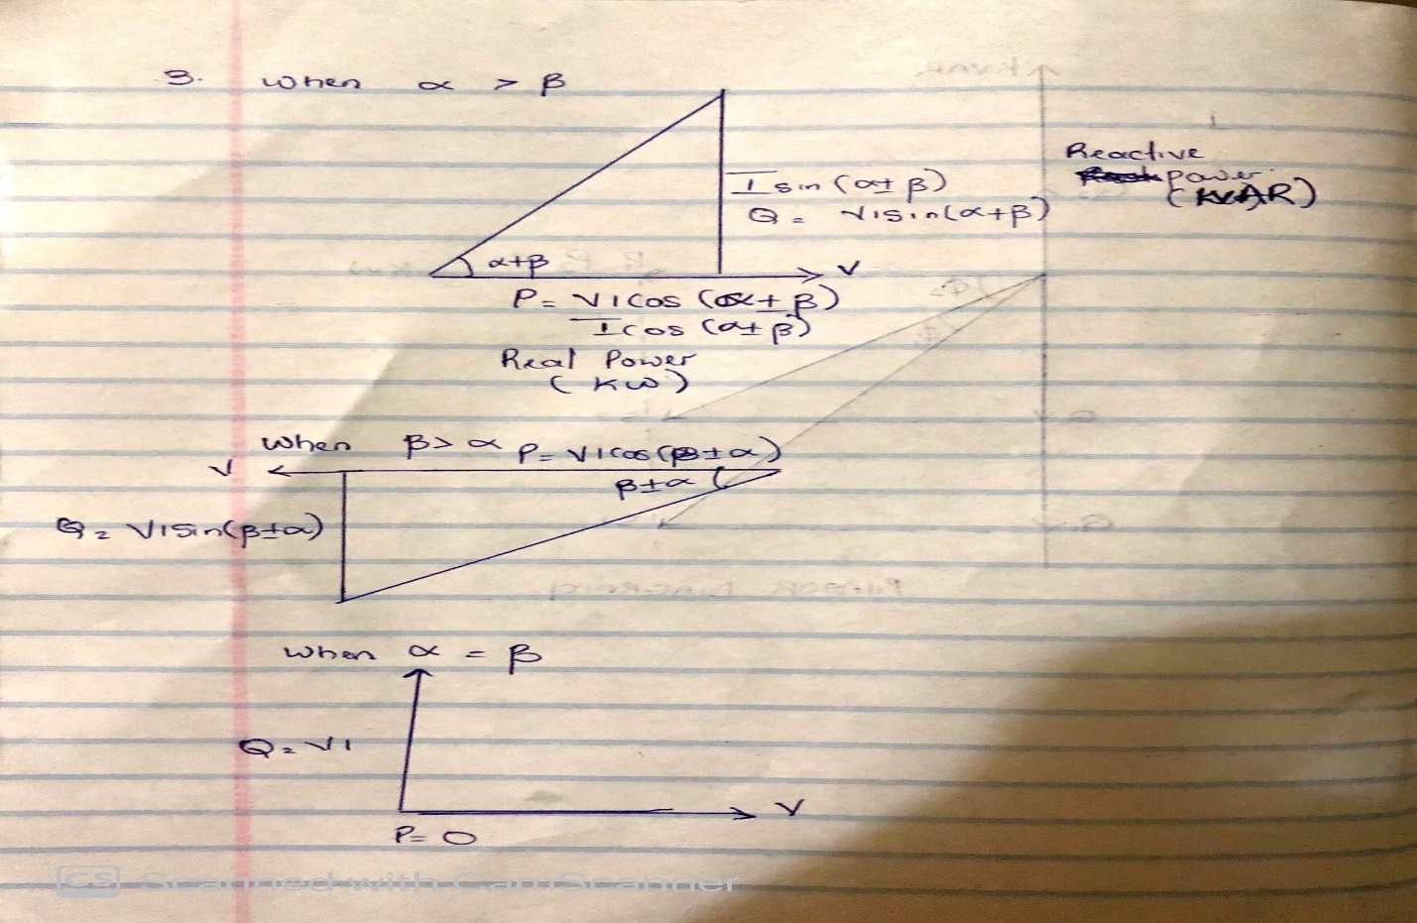

- For $α>β$; Write an expression for P and Q respectively with units in W and VAR. What does P and Q represent?
P = VI x cos ($α$ ±$β$) P (Real Power KW)
Q = VI x sin ($α$ ±$β$) Q (Reactive Power KVAR)
- Justify the need for power factor correction to ABUAD and PHCN or an IPP.
Power factor correction (PFC) aims to improve power factor, and therefore power quality. It reduces the load on the PHCN electrical distribution system, increases energy efficiency and reduces ABUAD electricity costs. It also decreases likelihood of instability and failure of ABUAD equipment.
- Why is Q needed in an industrial complex with numerous induction motors?
Reactive power (VAR) is required to maintain the voltage to deliver active power (watts) through transmission lines. It is required to convert the flow of electrons into useful work.
Reactive power is essential to move active power through the transmission and distribution system to the customer.

SECTION B: APPLICATION OF THEORETICAL FRAMEWORK
- An industrial load absorbs 5 MVA at a pf of 40% capacitive at 6kV. To improve the pf up to 85% capacitive, determine Q and C of the required capacitor. State how the correcting equipment will be integrated into the industrial power network for this load.
Real Power = power factor x Apparent power (VA)
Real Power = 0.4x5x${10}^{6}=$2x${10}^{6} W$
$θ_{1}=\cos^{-1}\left(0.4\right)=-66.42$(The angle is negative because the old PF is capacitive)$θ_{2}=\cos^{-1}\left(0.85\right)=-37.79$(The angle is negative because the old PF is capacitive)
tan $θ_{1}$=tan(-66.42) = -2.29
tan $θ_{2}$=tan(-37.79) = -0.78
Required Capacitor KVAR (C) = P (tan$θ_{1}$ + tan$θ_{1}$)
= 2x${10}^{6}$x sin (66.42-37.79)
Required Capacitor = 958x${10}^{3 }$KVAR

S = 5 MVA= 5*10⁶ VA, V =6 KV
$Q_{1}=2000000*\tan{(-66.421)}$ = -4582396.473VAR
$θ_{1}=$ $\cos^{-1}(0.85$) = -31.7883$°$ (the angle is negative because the new PF is capacitive)
$Q_{2}$ = $P\tan{ θ_{2} =2000*{10}^{3}}*$ $\tan{(-31.7883)}$ = -1239487.198VAR
$Q_{c}= Q_{2}-Q_{1}$ = P (tan$θ_{2}-\tan{θ_{1}}$ )
$Q_{c}=$ -1239487.198 – (-4582396.473) = 3342909.275 VAR
C$= \frac{Q_{C}}{W*{(V}_{RMS})^2 }$ but W = 2$πF f=50Hz$

C $=\frac{3342909.275 }{2π*50*{\left(6*{10}^{3}\right)}^{2}}$ = 2.95578 x 10⁻⁴ F

Correction Equipment
Phase Advancers
They will be integrated into the industrial power network for this load by connecting the capacitor banks in parallel.

- An industrial load absorbs 5 MVA at a pf of 40% inductive at 6kV. To improve the pf. Up to 85% inductive, determine Q and C of the required and necessary capacitor. State how the correcting equipment will be integrated into the industrial power network for this load. How different are the values of Q7 and Q8 in terms of magnitude and type of pf correction?
Real Power = power factor x Apparent power (VA)
Real Power = 0.4x5x${10}^{6}=$2x${10}^{6} W$
$θ_{1}=\cos^{-1}\left(0.4\right)=66.42$(The angle is positive because the old PF is capacitive)$θ_{2}=\cos^{-1}\left(0.85\right)=37.79$(The angle is positive because the old PF is capacitive)
tan $θ_{1}$=tan(66.42) = 2.29
tan $θ_{2}$=tan(37.79) = 0.78
Required Capacitor KVAR (C) = P (tan$θ_{1}$ + tan$θ_{1}$)
= 2x${10}^{6}$x sin (66.42-37.79)
Required Capacitor = 958x${10}^{3 }$KVAR

S = 5 MVA= 5*10⁶ VA, V =6 KV
$Q_{1}=2000000*\tan{(66.421)}$ = -582396.473VAR
$θ_{1}=$ $\cos^{-1}(0.85$) = -31.7883$°$ (the angle is negative because the new PF is capacitive)
$Q_{2}$ = $P\tan{ θ_{2} =2000*{10}^{3}}*$ $\tan{(31.7883)}$ = 1239487.198VAR
$Q_{c}= Q_{2}-Q_{1}$ = P (tan$θ_{2}-\tan{θ_{1}}$ )
$Q_{c}=$ 4.58*10⁶ - 1.23 *10⁶ = 3350000 =3.35* 10⁶ VAR
C$= \frac{Q_{C}}{W*{(V}_{RMS})^2 }$ but W = 2$πF f=50Hz$

C $=\frac{3350000 }{2π*50*{\left(6*{10}^{3}\right)}^{2}}$ = $2.96205*{10}^{-4} F$

Correction Equipment
Static Capacitors
They will be integrated into the industrial power network for this load by connecting with reactor in series.

To find the difference in Mag Given that Apparent Power (S)= $\sqrt{{Real Power (P)}^{2}+{Reactive Power(Q)}^{2}}$
Question 7
S= $\sqrt{{(2000*{10}^{3})}^{2}+{(3342909.275)}^{2}}$
S = 3895515.681 VA
Question 8
S= $\sqrt{{(2000*{10}^{3})}^{2}+{(3350000)}^{2}}$
S = 3901602.235 V
The difference between Question 7 and 8 in terms of magnitude would be
= 3901602.235 V - 3895515.681 VA = 6086.554 VA

- The National Universities Commission (NUC) Complex in Abuja has a total load of 100kW. It is powered by a 415 V, three phase, 4 wire power supply. The power factor is 0.85lagging and NUC desires to avoid the payment of penalties for this poor power factor. What Should the facility manager advise NUC management to do? If an improved pf of 0.95 lagging is desired, determine the magnitude of the required Q and C.
Real power = 100kW
$α$ = $\cos^{-1}\left(0.85\right)=31.79°$
$β$ = $\cos^{-1}\left(0.4\right)=18.19°$
tan $α$ = tan (31.79) = 0.62
tan $β$ = tan (18.19) = 0.33
Required Capacitor KVAR (C) = P (tan$α$ - tan$β$)
= 100x ${10}^{3}$(0.62-0.33)
= 29 x${10}^{3}$ VAR
=29 KVAR
Reactive Power (Q) = P sin ($α$ -$β$)
= 100x ${10}^{3}$ sin (31.79-18.19)
= 23 KVAR
The facility manager should advise the NUC to make use of the power factor correction to increases energy efficiency and reduce electricity costs and also to avoid payment of low power factor penalty.
- Undertake a comparative analysis as an Electrical Power Management Consultant and use techno – economic facts and data to advice a client (Globacom Nigeria Ltd) requiring a 20kW induction motor to power its intended fruit juice factory from motor choices $M_{1} and M_{2}$ given the following details:
Motor/parameters | $$M_{1}$$ | $$M_{2}$$
kW | 20 | 20
Phases | 3 | 3
Line Voltage | 415 | 415
pf | 0.85 | 0.95
S | $$S_{1}$$ | $$S_{2}$$
Q | $$Q_{1}$$ | $$Q_{2}$$
PREVIOUS METER READING (kWhr) | 23,000
NEW METER READING (kWhr) | 25,000
kWhr charge | #55/kWhr
Demand(kW) Charge | #35/kW
Capacity (kVA) Charge | #70/kVA
Reactive Power (kVAR) Charge | #25/kVAR

COMPARATIVE ANALYSIS
From the table above, we can run a comparative analysis for the motors, $M_{1}$ and$M_{2 }$, both the motors are 3-phase motor which have the same real power supplied through them and line voltage, one can see the motors are definitely the same BUT both have different power factor rating, $M_{1}$ and $M_{2 } pf$are 0.85 and 0.95 respectively, which will lead different apparent power ($S_{1}$ and$S_{2 }$) and different reactive power ($Q_{1}$ and$Q_{2 }$).
$Q_{1}$= P tan ($θ_{1}$)
$Q_{1}=$20x${10}^{3}$ tan (0.85) = 296.73 VAR
$Q_{2}$= P tan ($θ_{2}$)
$Q_{2}=$20x${10}^{3}$ tan (0.95) = 331.64 VAR
Apparent power,$S_{1}$ required = $\frac{P}{PF}$ =$\frac{20*{10}^{3}}{ 0.85 }=23529.41176 VA$
Apparent power$,S_{2}$, required = $\frac{P}{PF}$ =$\frac{20*{10}^{3}}{ 0.95 }=21052.63158 VA$

Now, from the analysis above in the table, we can see that before power factor correction for $M_{1}$which had power factor reading of 0.85 gave a meter reading of 23,000kwhr, now increasing the power factor reading to 0.95 gives a reading of 25,000kwhr.
The charges (Demand (kW), Capacity (kVA), and Reactive Power (kVAR)) would be more for the motor will low pf rating which is $M_{1}$

The advice I would give the client is to use TORQUE CONTROL MOTOR which will offer required feedback to verify correct motor power factor.
The chief disadvantage of low p.f is that the current required for a given power, is very high. This leads to two major problems;
- Large kVA for given amount of power
- Poor voltage regulation
It is observed that the reactive power of M₁ is high and as result has a low power factor than that of M_{2.} Hence it (M₁) is comparatively less efficient than M_{2.}

