NWAGWUAGWU TOCHUKWU DAISY
17/ENG04/043
ELECTRICAL ELECTRONICS ENGINEERING
ENG 326 ASSIGNMNENT ON POWERFACTOR CORRECTION

SECTION A: THEORETICAL FRAMEWORK

QUESTION 1
Develop the theoretical framework required for the correction of the power factor for a multi - sectioned industrial complex from $Cos ∅_{1}$ to $Cos ∅_{2}$ where $∅_{1}>∅_{2}$; $P_{1}=P_{2}$; $Q_{1}>Q_{2}$; and $S_{1}>S_{2}$ to determine the kVAR rating of the capacitor$(Q_{CAP})$ and the magnitude of the capacitor (C) in farads required to correct the power factor of the complex. USE APPROPRIATE PHASOR DIAGRAMS.
SOLUTION
Q_{cap}
S
Q_{new}
P
Q_{cap} = p(tan$∅$ - tan$∅$_{new}) = this is the size of the capacitor bank required to compensate the load reactive power to its new value.
Q_{cap} = V²/X_{c} = Wcv² = Reactive power generated by a single phase transformer.

QUESTION 2
What determines the power factor of the Dangote Cement Factory at Abajana, Kogi State?

Power factor is an indicator of energy efficiency. It is generally expressed as a percentage—and the lower the percentage, the less effective power consumption is.
Power factor (PF) is the ratio of working power to apparent power, measured in kilowatts ( kW), calculated in kilovolt amperes (kVA). Apparent power, also known as demand, is the calculation of the amount of electricity used over a given period of time to operate machinery and equipment. This is found through multiplication (kVA = V x A). The result is expressed as units with kVA.
PF represents the ratio of true power to the apparent power supplied to the circuit used in a circuit. A power factor of 96 percent indicates more efficiency than a power factor of 75 per cent. For several countries, PF less than 95 per cent is considered inefficient.

QUESTION 3
The power factor (pf) of Eleme Petrochemical Industry PortHarcourt is given as $\operatorname{Cos}\left(α±β\right)$; what is the state of the pf of the complex when $α>β$; $β>α$ and $α=β$. Draw the respective Phasor diagrams.
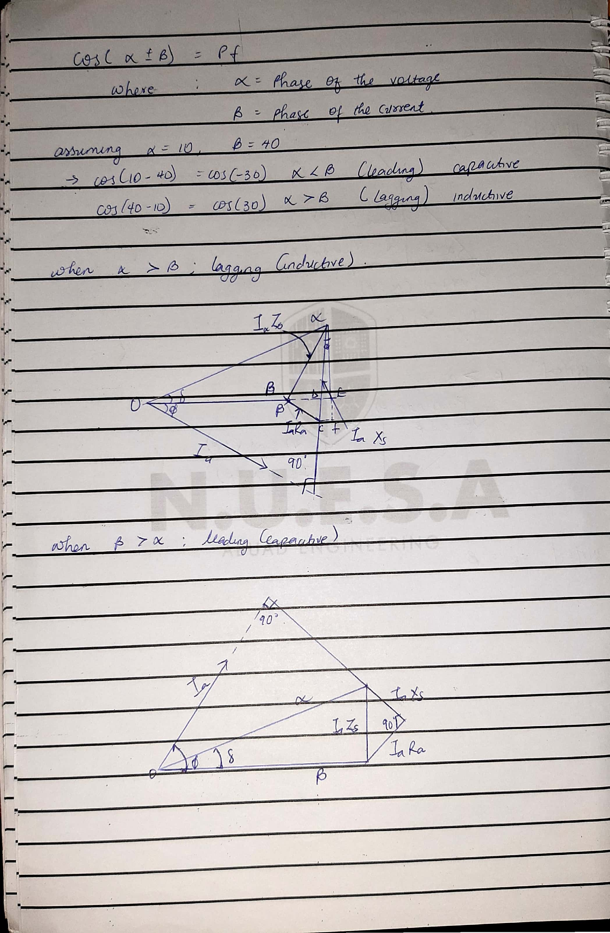
QUESTION 4
For $α>β$; Write an expression for P and Q respectively with units in W and VAR. What does P and Q REPRESENT?
Answer
P = I_{L}*V_{L}*cos($∅$)*$\sqrt{3}$
Q=I_{L}*V_{L} sin($∅$)*$\sqrt{3}$
Where;
P = true power (kW)
Q = reactive power (kVAR)

QUESTION 5
Justify the need for power factor correction to ABUAD and PHCN or an IPP
Answer
- Avoid Power Factor Penalties : Many industrial processing plants use large numbers of induction motors to power their plant pumps, conveyors, and other machinery. For most industrial installations these induction motors cause the power factor to be inherently low. Many electric utilities companies assess a lower power factor penalty (usually less than 0.80 or 0.85). one also incentive high power factor (above 0.95, for example). By adding power factor correction, you can eliminate the power factor penalty from your bill.
- it reduces the load on the electrical distribution system, increases energy efficiency and reduces electricity costs. It also decreases the likelihood of instability and failure of equipment.

Reduced Demand Charges: Many electric utility companies charge for maximum metered demand based either on the highest registered demand in kilowatts (KW meter), or a percentage of the highest registered demand in KVA (KVA meter), whichever is greater. Unless the power factor is small, the proportion of the calculated KVA would be substantially higher than the demand for KW. Improving the power factor through power factor correction will therefore lower the demand charge, helping to reduce your electricity bill.

QUESTION 6
Why is Q needed in an industrial complex with numerous induction motors?

Answer
- Active power is the energy supplied for operating a generator, heating a home or lighting an electric light bulb. Reactive power provides important voltage regulation function.
- Reactive power is essential for moving active power to the customer through the transmission and distribution system. Reactive power is required to maintain the voltage through transmission lines to deliver active power (watts).
- When there is not enough reactive power, the voltage decreases and the power required by the loads cannot be driven through the wires.
- Motor charges and other charges require reactive power to convert the electrons flow into useful work.
- If the voltage on the device is not high enough, it cannot supply active power.
SECTION B: APPLICATION OF THEORETICAL FRAMEWORK
QUESTION 7

An industrial load absorbs 5 MVA at a pf of 40% capacitive at 6kV. To improve the p.f up to 85% capacitive, determine Q and C of the required capacitor. State how the correcting equipment will be integrated into the industrial power network for this load.

Answer
Load(s) = 5000KVA
Power factor = 40% = 0.4 (capacitive)
Frequency = 50Hz
P = ׀s׀cosØ
P = ׀s׀Pf _{(old)} = 5000×10³(0.4) = 2000KW
Ø _{(old)} = cos⁻¹Pf _{(old)} = cos⁻¹ (0.4) = -66.42
The angle will be negative because the old power factor is inductive
Using trigonometry
Tan 𝜃old= Q_{(old)} ̸ P
Q_{old} = Ptan_{(old)} = (2000×10³)(tan(-66.42))
Q_{(old)} = -4582178.329 var
_{(new)} = cos⁻¹Pf_{(new)} = cos⁻¹(0.85) = -31.79 (because also its capacitive)
Tan_{(new)} = Q_{(new)} ̸ P
Q_{(new)} = Ptan𝜃_{(new)} = 2000×10³(tan(-31.79)) = -1239569.332 var
ΔQ = Q_{(new)} – Q_{(old)}
ΔQ = -1239569.332 – (-4582178.329)
ΔQ = 3342608.997 var

C=ΔQ/(2πf (Vs²))
C =
$$\frac{3342608.997}{2×3.142×50×{\left(6000\right)}^{2}}$$
C= 2.96×10⁻⁴
C= 29.6mf

QUESTION 8
An industrial load absorbs 5 MVA at a pf of 40% inductive at 6kV. To improve the pf. upto 85% inductive, determine Q and C of the required and necessary capacitor. State how the correcting equipment will be integrated into the industrial power network for this load. How different are the values of Q7 and Q8 in terms of magnitude and type of pf correction?
Answer
Load(s) = 5000KVA
Power factor = 40% = 0.4 (inductive)
Frequency = 50Hz
P = ׀s׀cosØ
P = ׀s׀Pf _{(old)} = 5000×10³(0.4) = 2000KW
Ø _{(old)} = cos⁻¹Pf _{(old)} = cos⁻¹ (0.4) = 66.42
The angle will be positive because the old power factor is inductive
Using trigonometry
Tan 𝜃old= Q_{(old)} ̸ P
Q_{old} = Ptan_{(old)} = (2000×10³)(tan(66.42))
Q_{(old)} = 4582178.329 var
_{(new)} = cos⁻¹Pf_{(new)} = cos⁻¹(0.85) = 31.79 (because also its inductive)
Tan_{(new)} = Q_{(new)} ̸ P
Q_{(new)} = Ptan𝜃_{(new)} = 2000×10³(tan(31.79)) = 1239569.332 var
ΔQ = Q_{(old)} – Q_{(new)}
ΔQ = 4582178.329 – 1239569.332
ΔQ = 3342608.997 var

C=ΔQ/(2πf (Vs²))
C =
$$\frac{3342608.997}{2×3.142×50×{\left(6000\right)}^{2}}$$
C= 2.96×10⁻⁴
C= 29.6mf
If this load is an electric motor or most any other industrial AC load, it will have a lagging (inductive) power factor, which means that we’ll have to correct for it with a capacitor of appropriate size, wired in parallel. This correction, of course, will not change the amount of true power consumed by the load, but it will result in a substantial reduction of apparent power.

QUESTION 9
The National Universities Commission (NUC) Complex in Abuja has a total load of 100kW. It is powered by a 415 V, three phase, 4 wire power supply. The power factor is 0.85lagging and NUC desires to avoid the payment of penalties for this poor power factor. What Should the facility manager advise NUC management to do? If an improved pf of 0.95 lagging is desired, determine the magnitude of the required Q and C.
Answer

Real power, p=100KW
V=415V 3 phase transformer
Original pf=0.85
Improved Pf desired=0.95
Recall, Pf=cosθ
Therefore, θ= cos⁻¹(pf)
θ₁=cos⁻¹(0.85) =31.7883
θ₂=cos⁻¹(0.95) =18.1949
Tan θ₁=tan (31.7883) =0.6197
Tan θ₂=tan (18.1949) =0.3287
Therefore,
Reactive Power, Q=Psin (θ₁ ± θ₂)
= (100×10³) ×sin(31.7883-18.1949)
=23.503KVAR
Required capacitor, C=P (tan θ₁ ±tan θ₂)
= (100×10³) × (0.6197-0.3287)
=29.1KVAR

QUESTION 10
Undertake a comparative analysis as an Electrical Power Management Consultant and use techno – economic facts and data to advice a client (Globacom Nigeria Ltd) requiring a 20kW induction motor to power its intended fruit juice factory from motor choices $M_{1} and M_{2}$ given the following details:
Motor/parameters | $$M_{1}$$ | $$M_{2}$$
kW | 20 | 20
Phases | 3 | 3
Line Voltage | 415 | 415
pf | 0.85 | 0.95
S | $$S_{1}$$ | $$S_{2}$$
Q | $$Q_{1}$$ | $$Q_{2}$$
PREVIOUS METER READING (kWhr) | 23,000
NEW METER READING (kWhr) | 25,000
kWhr charge | #55/kWhr
Demand(kW) Charge | #35/kW
Capacity (kVA) Charge | #70/kVA
Reactive Power (kVAR) Charge | #25/kVAR
Justify clearly your choice of recommended motor.

Answer
S₁ = 23529.41176 var
S₂ = 21052.63158 var
Where S₁ and S₂ are gotten from the equation P/ Pf
Where P₁ and P₂ = 20×10³
𝜃₁ = cos⁻¹(0.85) = 31.79
𝜃₂ = cos⁻¹(0.95) = 18.19
Q₁ = sin(31.79) × 23529.41176
Q₁ = 12395.46948 var

Q₂ = sin(18.19) × 21052.63158
Q₂ = 6571.981313 VAR
The above equation is to show the different induction motor the amount of reactive power they both posses
In order to pick the best choice of induction motor, the client must consider the following factors:
- Determine cost-effectiveness AC motors are available in a range of efficiencies. Although the economics will vary by application, replacing an old standard-efficiency motor with a newly installed, premium-efficiency motor under typical operation will often pay for its price in reduced energy bills within a year or two.

Consider downsizing when a motor is operating at less than 40% of its rated output. The following circumstances are opportunities for choosing premium-efficiency motors:
When purchasing a new motor where lower-energy-efficient units can still be sold Instead of rewinding failed standard-efficiency or energy-efficient motors. To replace an operable-but-inefficient motor for greater energy savings and reliability
- Account for the motor’s impact on power factor Power factor is an indicator of how much of a power system’s capacity is available for productive work. Low power factor is undesirable because it increases the load on a building’s electrical system, and utilities sometimes charge customers a penalty for facilities with low power factor. Because power factor is lower when a motor is lightly loaded, be sure to choose the right-sized motor. You can also specify a motor with a high power factor, but such models sometimes have lower efficiency. The ultimate selection depends, in part, on whether a facility is subject to power factor penalty charges. A facility with a significant number of induction motors and a low power factor can solve the problem with premium-efficiency motors that are properly sized. If new motors are not an option, other power factor–correction methods are available, including static capacitor banks, rotary condensers, and static and dynamic volt-ampere reactive devices.

From the above factors mentioned above, the best and most economical motor choice to go with would be motor 2(M2)
The calculation solved above showed that MOTOR 2 (M2) is the best option because when the reactive power is low it saves cost and increases efficiency

