Name: Ikpeama John Chiemeziem
Department: Electrical/Electronics
Matric No: 17/ENG04/031
Course code: EEE 326

1. 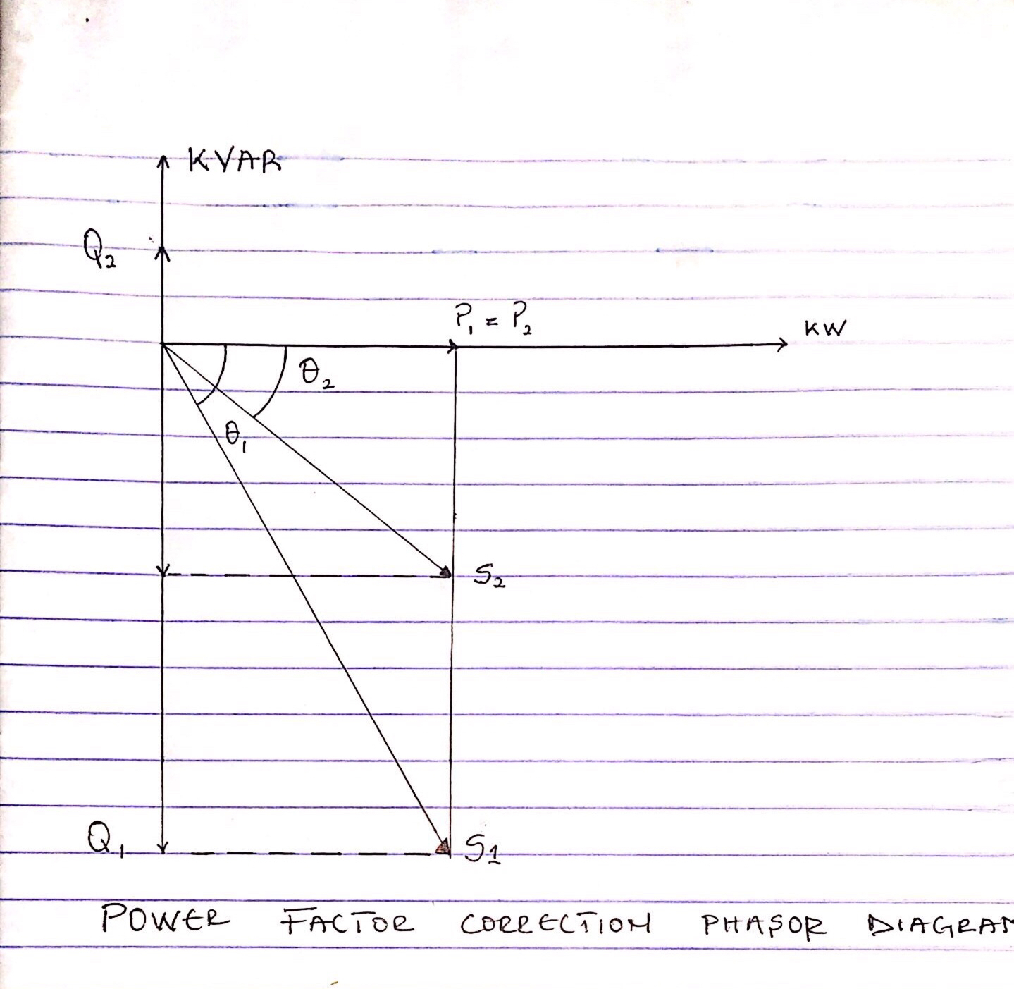

2 .Power factor is determined by the ratio of the real power absorbed by the load to the apparent power flowing in the circuit and the power factors ranges in values from "0 to 1"
Motors with variable loads have a lower power factor when not fully loaded. Induction motors, transformers and other inductive loads are what determines if a power factor is good or bad in the dangote cement factory.

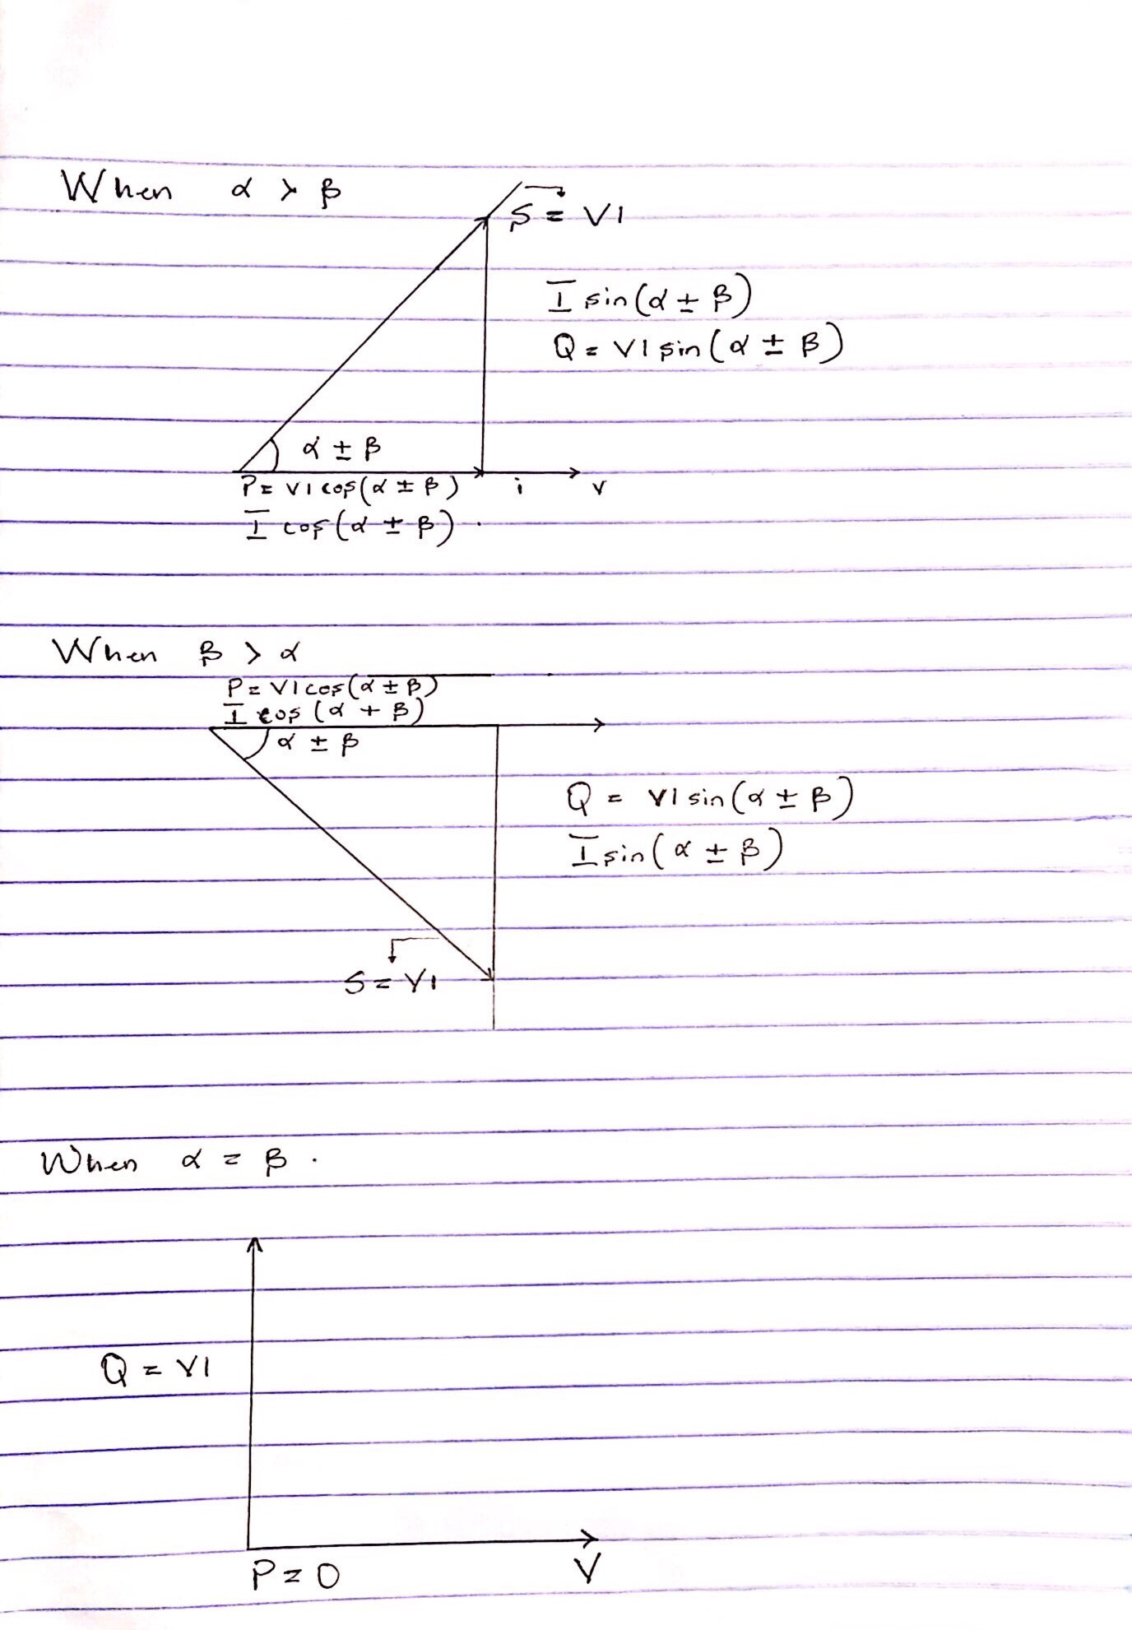

3 .

3. The diagram above detailed as ;
- First diagram shows: Power factor is lagging
- Second diagram shows: Power factor is leading
- Third diagram shows: Power factor is unity (1)

4.
P =VIcos( α ± β)
Q = VIsin( α ± β)

5 .
- Increasing the power factor of a load, improving efficiency for the distribution system to which it is connected to.
- Increasing the load carrying capacity and reducing the demand charge, not only the decreasing of bills, but also allowing for future growth.
- Improving voltage drops

6 .Reactive power is the resultant power in (watts) of an AC circuit when the current waveform is out of phase with the waveform of the voltage, usually by 90 degrees if the load is purely reactive, and is the result of either capacitive or inductive loads.

7 . True power = 0.4 × 2×10⁶
= 2MW
θ₁ = cos⁻¹ (0.4) = 66.42°;
θ₂ = cos⁻¹(0.85) = 37.79°;

Tan θ₁ = Tan(66.42) = 2.29°
Tan θ₂ = Tan(37.79) = 0.78°

Required capacitor (C) = P (tanθ₁ – tanθ₂)
= 2×10⁶ ( 2.29 – 0.78)
= 3020KVAR

Reactive Power (Q) = P ( sinθ₁ – sinθ₂)
= 2×10⁶ ( 0.92 – 0.61)
= 958KVAR

8 . S = 5 MVA= 5×10⁶ VA ,
V_{rms} = 6 KV

​PF₁ = 40≈0.4
PF₂ =85≈0.85

Q=? , C=?

PF= cos

P =0.4×5×10⁶ = 2,000,000 ≈ 2MW

Recall;
C = 3020KVAR
Q = 958KVAR

958KVAR - 3020KVAR
P(tan) = 2,062,000 ≈ 2.062 × 10⁶VAR
For magnitude;
Q7 = 3140320VA
Q8 = 3221714VA
= 81.394KVA

9 . True power = 100KW
α = cos⁻¹(0.85) = 31.79°.
β = cos⁻¹(0.95) = 18.19°

Tan α = 0.62°
Tan β = 0.33°

Required Capacitor (C) = P (tan α – tan β)
= 100×10³( 0.62 – 0.33)
= 29KVAR

Reactive Power (Q) = P (sinα – sinβ)
= 100×10³ ( 0.53 – 0.31)
= 23KVAR

10 .

s/n | M₁ | M₂
 | Given : PF= 0.85, real power, P =20kw, V_{L}=415 | Given : PF= 0.95, real power, P =20kw, V_{L}=415
1 | Apparent power, s required =  =31.7883  Reactive power Q₁ =sin  Q₁ = sin (31.7883) x  Q₁ =12394.876 VAR | Apparent power, s required = =
2 |  | = 18.1948  Reactive power Q₁ =sin  Q₁ = sin (18.1948) x  Q₁ =6573.656853 VAR

M₁ has a lower power factor which is lower than M_{2.} Which indicates that M₂ would be more efficient with a lower reactive power. And M₂ has a power factor close to unity.

