NAME: OJEIKERE OHIKHATEEME
MAT NO: 17/ENG04/051
DEPT: ELECT/ELECT ENG
COURSE: EEE 326 ELECT MACHINES
POWER FACTOR CORRECTION ASSIGNMENT II

SECTION A: THEORETICAL FRAME WORK
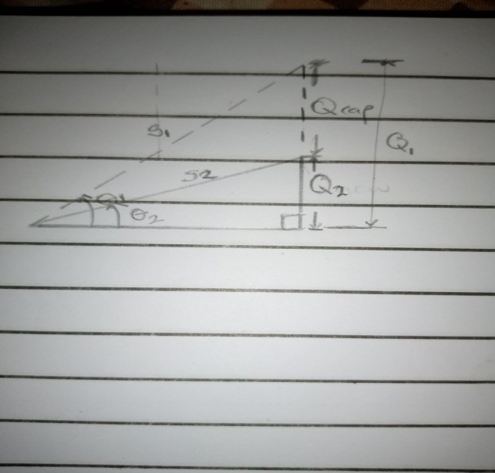
- Given that: $∅_{1}>∅_{2} , P_{1}=P_{2}$, $Q_{1}>Q_{2}$ and $S_{1}>S_{2}$
The reactive power in a reactor is given as
${Q_{C}=XI }^{2}= \frac{V^{2}}{X}$ At P= 0
$Q_{C}$ = ${\frac{V^{2} }{X}= -wC V}^{2}$ where: V, X and I are rms values
Therefore; C = $\frac{Q_{C}}{-w{ V}^{2}}$
Also ${Q_{C}= Q_{1}-Q_{2 }=P(tanθ}_{1}- tanθ_{2})$
- Power factor (PF) is the ratio of working power, measured in kilowatts (kW), to apparent power, measured in kilovolt amperes (kVA). Apparent power, also known as demand, is the measure of the amount of power used to run machinery and equipment during a certain period. It is found by multiplying (kVA = V x A). The result is expressed as kVA units.
PF expresses the ratio of true power used in a circuit to the apparent power delivered to the circuit. A 96% power factor demonstrates more efficiency than a 75% power factor. PF below 95% is considered inefficient in many regions.
Therefore we can say that the power factor of Dangote cement factory at Abajana, Kogi state depends on what total percentage of the load is made up of motors and how the motors are loaded. Motors with variable loads have a lower power factor when not fully loaded. Induction motors, transformers and other inductive loads are what determine if a power factor is good or bad in the Dangote cement factory.

3. COS ($α-β$) = PF
Where: $α=phase of the voltage$
$β=phase of the current$

- When $(α>β$): the power factor is lagging (inductive)
- When $(β>α$): the power factor is leading (capacitive)
- When $(α=β$): the power factor is unity (1)

PHASOR DIAGRAM REPRESENTATION
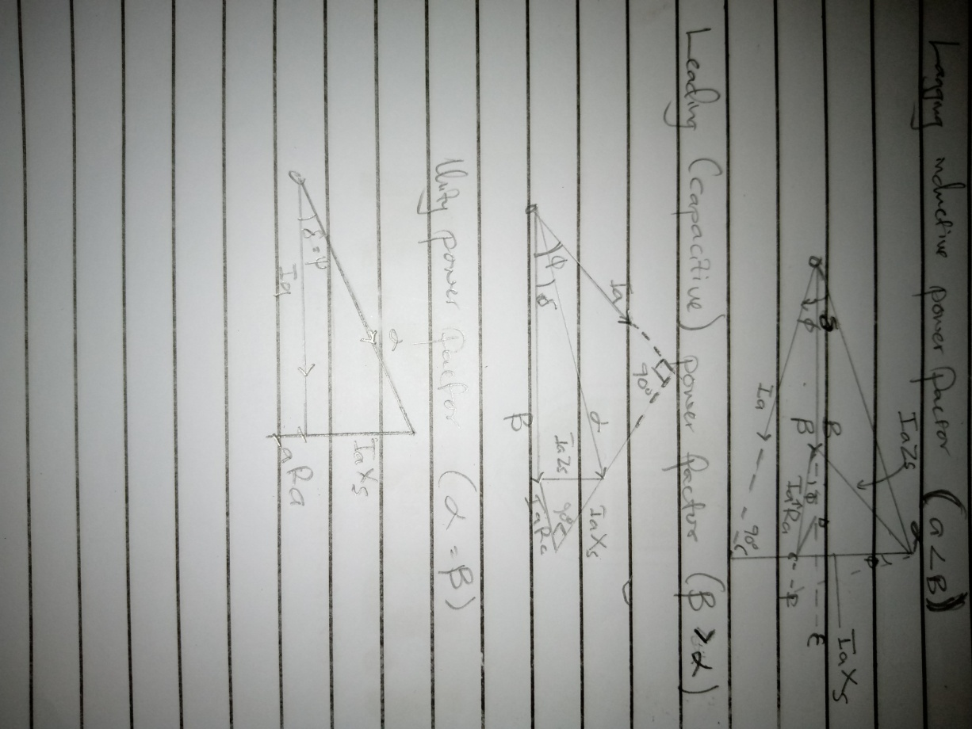

Where: $R_{a}$= armature per phase resistance
$δ=$ angle between the excitation
$∅=$angle between the terminal voltages
$E_{f}=$ excitation voltage. NOTE: in the figures above, it is represented as $α$
$V_{t}=$terminal voltage. NOTE: in the figures above, it is represented as $β$
- For $α>β$ which indicates a lagging (inductive) Power factor
P = S cos ($α ±β$)
Q = S sin ($α ±β$) but S =$V_{RMS}*I_{RMS}$
Therefore;
P= I * V cos (α ± β)
Q= I * V sin (α ± β)
Where: P = real (active) power in W, KW
Q = reactive power in VAR, KVAR
- ABUAD, PHCN or an IPP are large scale industries which make use of electricity on a very large scale on a daily basis thus the need for power factor correction is highly needed for stable running of the industries.
Power factor correction is the term for any equipment that compensates for reactive power and improves the power factor ratio. It increases the power factor of a load, improving efficiency for the distribution system to which it is attached.
The needs for power factor correction are:
- To increase the savings on the electricity bill
- Power factor correction eliminates penalties on reactive energy, decreases demand on kVA, and reduces power losses generated in the transformers and conductors of the installation.
- Increase in available power
- Fitting PFC equipment on the low voltage side increases the power available at the secondary of a MV/LV transformer. A high power factor optimizes an electrical installation by allowing better use of the components.
- Reduction in the installation sizes.
- Installing PFC equipment allows conductor cross-section to be reduced, as less current is absorbed by the compensated installation for the same active power.
- The voltage drops are reduced drastically.
- Installing capacitors allows voltage drops to be reduced upstream of the point where the PFC device is connected, therefore preventing overloading of the network and reducing harmonics.

- Q is needed in an industrial complex with numerous induction motors because:
- If the voltage drops too low, some generators will disconnect automatically to protect themselves. Voltage collapse occurs when an increase in load or less generation or transmission facilities causes dropping voltage, which causes a further reduction in reactive power from capacitor and line charging, and still there further voltage reductions. If voltage reduction continues, these will cause additional elements to trip, leading further reduction in voltage and loss of the load. The result in these entire progressive and uncontrollable declines in voltage is that the system unable to provide the reactive power required supplying the reactive power demands

- Voltage control in an electrical power system is important for proper operation for electrical power equipment to prevent damage such as overheating of generators and motors, to reduce transmission losses and to maintain the ability of the system to withstand and prevent voltage collapse.
- Decreasing reactive power causing voltage to fall while increasing it causing voltage to rise. A voltage collapse may be occurs when the system try to serve much more load than the voltage can support.
- When reactive power supply lower voltage, as voltage drops current must increase to maintain power supplied, causing system to consume more reactive power and the voltage drops further . If the current increase too much, transmission lines go off line, overloading other lines and potentially causing cascading failures.
- First, the transmission system itself is a nonlinear consumer of reactive power, depending on system loading. At very light loading the system generates reactive power that must be absorbed, while at heavy loading the system consumes a large amount of reactive power that must be replaced. The system’s reactive-power requirements also depend on the generation and transmission configuration.

SECTION B: APPLICATION OF THEORETICAL FRAME WORK

7. Given : S = 5 MVA= 5*10⁶ VA , V_{rms} =6 KV
PF₁=40$\%$ =0.4 , PF₂ =85$\%$ =0.85 , Q=? , C=?

P= COS$θ$*S = 5 x 10⁶ * 0.4 = 2000000 W
$θ_{1}= \cos^{-1}\left(0.4\right)=-66.421°$ ( the angle is negative because the old PF is capacitive )

Hence; $Q_{1}=P\tan{ θ_{1}}$ = $S_{1} sinθ_{1}$
$Q_{1}=2000000*\tan{(-66.421)}$ = -4582396.473VAR
$θ_{1}=$ $\cos^{-1}(0.85$) = -31.7883$°$ ( the angle is negative because the new PF Is capacitive )
${ Q}_{2}$ = $P\tan{ θ_{2} =2000*{10}^{3}}*$ $\tan{(-31.7883)}$ = -1239487.198VAR

${ Q}_{c}= Q_{2}-Q_{1}$ = P( tan$θ_{2}-\tan{θ_{1}}$ )
${ Q}_{c}=$ -1239487.198 – (-4582396.473) = 3342909.275 VAR
C$= \frac{Q_{C}}{W*{(V}_{RMS})^2 }$ but W = 2$πF recallongh F=50Hz$
C $=\frac{3342909.275 }{2π*50*{\left(6*{10}^{3}\right)}^{2}}$ = 2.95578 x 10⁻⁴ F
- correcting equipment can be integrated into the industrial power network for this load by connecting the capacitor banks in parallel in the system.

8. Given: S = 5 MVA= 5*10⁶ VA , V_{rms} =6 KV
PF₁=40$\%$ =0.4 , PF₂ =85$\%$ =0.85 , Q=? , C=?
Recalling that: cos$θ=\frac{real power, P}{Appatent power,S }$ , P = cos$θ*S$
But also: PF= cos$θ=0.4$
P =0.4 *5*10⁶ = 2,000,000 W
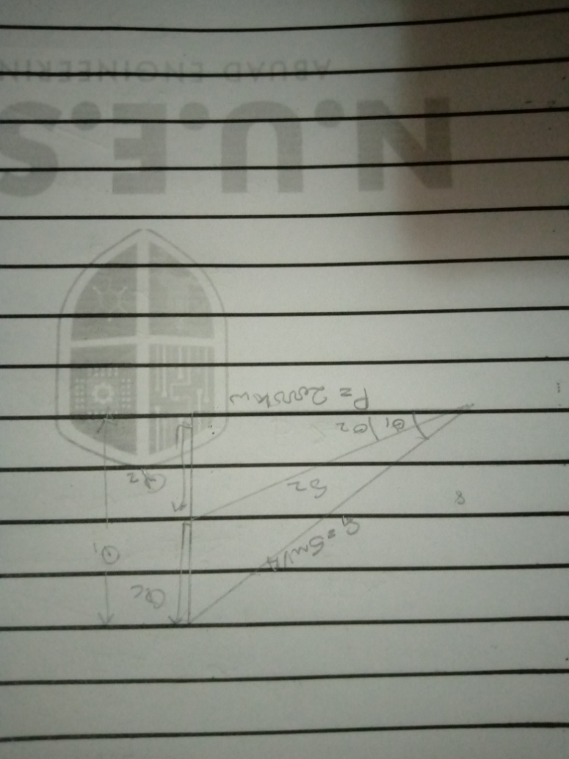
$θ_{1}=\cos^{-1}{(0.4)}=66.421°$
$θ_{2}=$ $\cos^{-1}\left(0.85\right)=31.7883°$
Recall : $Q_{1}=P*tanθ_{1}$ = $S_{1} sinθ_{1}$
$Q_{2}=P*tanθ_{2}$
$Q_{c}= Q_{1}-Q_{2}$ = P( tan$θ_{1}-\tan{θ_{2}}$ )
C$= \frac{Q_{C}}{W*V_{RMS}^{2} }$ where : w= 2$π F but F=50Hz$
$Q_{1}= 2000*{10}^{3}*tan⁡(66.421$) = 4582396.473 =4.58MVAR
$Q_{2}=$ $2000*{10}^{3}*tan⁡(31.78833$) =1239488.647 =1.23 *10⁶ VAR

$Q_{c}=$ 4.58*10⁶ - 1.23 *10⁶ = 3350000 =3.35* 10⁶ VAR
C = $\frac{3350000}{2π*{(6*{10}^{3})}^{2} }=2.96205*{10}^{-4} F$
- correcting equipment will be integrated into the industrial power network for this load by connecting with reactor in series

IN TERMS OF MAGNITUDE
Given that S= $\sqrt{P^{2}+Q^{2}}$
FOR Q7
S= $\sqrt{{(2000*{10}^{3})}^{2}+{(3342909.275)}^{2}}$
S = 3895515.681 VA
FOR Q8
S= $\sqrt{{(2000*{10}^{3})}^{2}+{(3350000)}^{2}}$
S = 3901602.235 VA
The difference between Q7 AND Q8 in terms of magnitude is 6086.554 VA
9. Given: P = 100KW = 100 x 10³W , V_{rms} = 415 v
PF = cos${ θ}_{1 }$= 0.85 (lagging )
PF = cos${ θ}_{2 }$= 0.95 (lagging )
${ θ}_{1}= \cos^{-1}\left(0.85\right)=31.7883°$
${ θ}_{2}= \cos^{-1}\left(0.95\right)=18.19487°$
Recall: $Q_{1}=P\tan{θ_{1}}$
$Q_{1}=$ $P\tan\left(31.7883 \right)$ = 61974.35988 VAR
$Q_{2}=P\tan{θ_{2}}$
$Q_{2}=$ $P\tan\left(18.19481\right)$ = 32868.41052 VAR
$Q_{C}=Q_{1}-Q_{2}$
$Q_{C}=$ 61974.35988 -32868.41052
$Q_{C}$ = 29105.94848 VAR
C =$\frac{Q_{C}}{W*V_{EMS}^{2}}$ but W = 2$π F$ where: F =50Hz
C =$\frac{29105.94848}{2π*50*{415}^{2}} =$5.37942 x 10⁻⁴ F

10. From the information given we can tabulate it out as
s/n | M₁ | M₂
 | Given : PF= 0.85, real power, P =20kw, V_{L}=415 | Given : PF= 0.95, real power, P =20kw, V_{L}=415
1 | Apparent power, s required = $\frac{P}{PF}$ =$\frac{20*{10}^{3}}{ 0.85 }=23529.41176 VA$ | Apparent power, s required = $\frac{P}{PF}$ =$\frac{20*{10}^{3}}{ 0.95 }=21052.63158 VA$
2 | $θ_{1}=\cos^{-1}{(0.85)}$ =31.7883$°$  Reactive power Q₁ =sin $θ_{1}*S$  Q₁ = sin (31.7883) x $23529.41176$  Q₁ =12394.876 VAR | $θ_{1}=\cos^{-1}{(0.95)}$ = 18.1948$°$  Reactive power Q₁ =sin $θ_{1}*S$  Q₁ = sin (18.1948) x $21052.63158$  Q₁ =6573.656853 VAR

Hence; the induction motor, M₂ is recommended because from the above calculation M₂ has the higher power factor of 0.95 which is much closer to unity power factor(1) and as such it is more efficient and its reactive power (otherwise known as wasted power) is comparatively low as to that of M₁

Recall: the higher the portion of reactive power, the lower the power factor.

It is observed that the reactive power of M₁ is high and as result has a low power factor than that of M_{2.} Hence it (M₁) is comparatively less efficient than M₂

