Name: JAGUN OLUWASEYI
MATRIC NO: 17/ENG04/035
Department: Electrical and Electronics Engineering
Course Title: Electrical Machines 2
Course Code: EEE326
Assignment on Power Factor Correction

Section A
Question 1
Develop the theoretical framework required for the correction of the power factor for a multi - sectioned industrial complex from $Cos ∅_{1}$ to $Cos ∅_{2}$ where $∅_{1}>∅_{2}$; $P_{1}=P_{2}$; $Q_{1}>Q_{2}$; and $S_{1}>S_{2}$ to determine the kVAR rating of the capacitor$(Q_{CAP})$ and the magnitude of the capacitor (C) in farads required to correct the power factor of the complex. USE APPROPRIATE PHASOR DIAGRAMS.
Answer
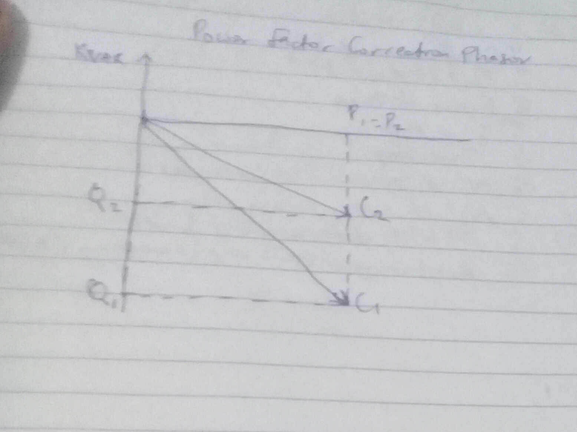

Question 2
What determines the power factor of the Dangote Cement Factory at Abajana, Kogi State?
Answer
Power factor is an expression of energy efficiency. It is usually expressed as a percentage—and the lower the percentage, the less efficient power usage is.
Power factor (PF) is the ratio of working power, measured in kilowatts (kW), to apparent power, measured in kilovolt amperes (kVA). Apparent power, also known as demand, is the measure of the amount of power used to run machinery and equipment during a certain period. It is found by multiplying (kVA = V x A). The result is expressed as kVA units.
PF expresses the ratio of true power used in a circuit to the apparent power delivered to the circuit. A 96% power factor demonstrates more efficiency than a 75% power factor. PF below 95% is considered inefficient in many regions.

Question 3
The power factor (pf) of Eleme Petrochemical Industry PortHarcourt is given as $\operatorname{Cos}\left(α±β\right)$; what is the state of the pf of the complex when $α>β$; $β>α$ and $α=β$. Draw the respective Phasor diagrams.
Answer
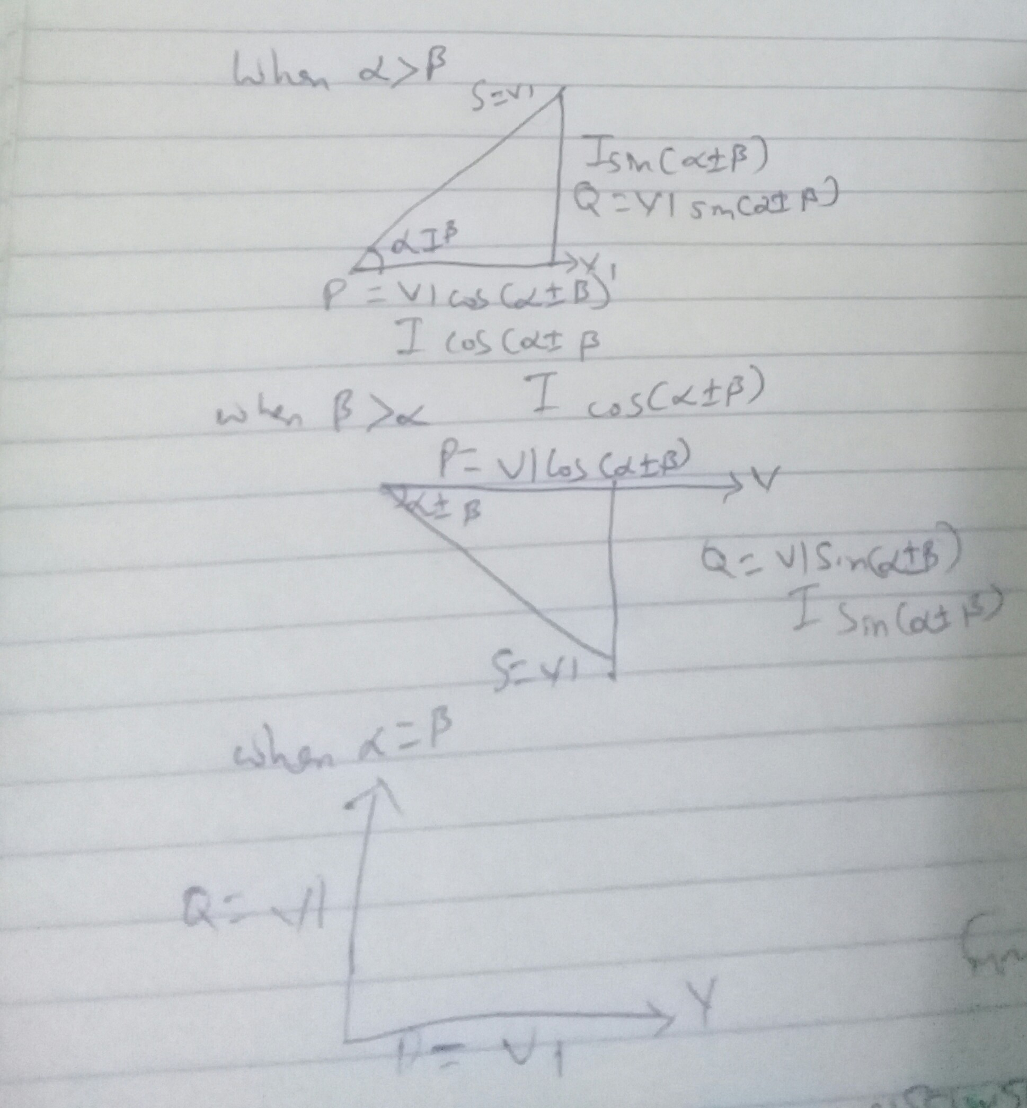

Question 4
For $α>β$; Write an expression for P and Q respectively with units in W and VAR. What does P and Q REPRESENT?
Answer
P=I*Vcos(α±β)
Q=I*Vsin(α±β)
Where,
P: active power(kW)
Q: reactive power(kVAR)

Question 5
Justify the need for power factor correction to ABUAD and PHCN or an IPP
Answer
- Savings on the electricity bill
- Power factor correction eliminates penalties on reactive energy, decreases demand on kVA, and reduces power losses generated in the transformers and conductors of the installation.
- Increased available power
- Fitting PFC equipment on the low voltage side increases the power available at the secondary of a MV/LV transformer. A high power factor optimises an electrical installation by allowing better use of the components.
- Reduced installation size
- Installing PFC equipment allows conductor cross-section to be reduced, as less current is absorbed by the compensated installation for the same active power.
- Reduced voltage drops
- Installing capacitors allows voltage drops to be reduced upstream of the point where the PFC device is connected, therefore preventing overloading of the network and reducing harmonics.

Question 6
Why is Q needed in an industrial complex with numerous induction motors?

Answer
- Voltage control in an electrical power system is important for proper operation for electrical power equipment to prevent damage such as overheating of generators and motors, to reduce transmission losses and to maintain the ability of the system to withstand and prevent voltage collapse.
- Decreasing reactive power causing voltage to fall while increasing it causing voltage to rise. A voltage collapse may be occurs when the system try to serve much more load than the voltage can support.
- When reactive power supply lower voltage, as voltage drops current must increase to maintain power supplied, causing system to consume more reactive power and the voltage drops further . If the current increase too much, transmission lines go off line, overloading other lines and potentially causing cascading failures.
- If the voltage drops too low, some generators will disconnect automatically to protect themselves. Voltage collapse occurs when an increase in load or less generation or transmission facilities causes dropping voltage, which causes a further reduction in reactive power from capacitor and line charging, and still there further voltage reductions. If voltage reduction continues, these will cause additional elements to trip, leading further reduction in voltage and loss of the load. The result in these entire progressive and uncontrollable declines in voltage is that the system unable to provide the reactive power required supplying the reactive power demands
- First, the transmission system itself is a nonlinear consumer of reactive power, depending on system loading. At very light loading the system generates reactive power that must be absorbed, while at heavy loading the system consumes a large amount of reactive power that must be replaced. The system’s reactive-power requirements also depend on the generation and transmission configuration.
.

Section B
ANSWER 7

7) True Power = 0.4 × ${10}^{6}$
= 2mω
$θ_{1 = }\cos^{-1}$(0.4) = 66.42$°$
$θ_{2}$ = $\cos^{-1}$(0.85) = 37.79$°$
${Tanθ}_{1 }=Tan\left(66.42\right)$ = 2.29$°$
${Tanθ}_{2 }=Tan(37.74)$ = 0.78$°$
Required Capacitor KVAR (C) = P (${Tanθ}_{1 }-{Tanθ}_{2 }$)
$=2×{10}^{6}(2.29-0.78)$
$=3020 KVAR$
Reactive Power (Q) = P sin($θ_{1 }± θ_{2})$
$=2×{10}^{6} sin⁡(66.42-37.79)$
$=958 KVAR$

ANSWER 8
The load flow study determines the voltage, current power and reactive power in various points and branches of the system under simulated conditions of normal operation the load studies are essential in optimizing existing network ensuring an economical and efficient distribution of loads and plan failure networks.

ANSWER 9
9) True Power = 100kω
$α= \cos^{-1}\left(0.85\right)=31.79°$
$$β= \cos^{-1}\left(0.99\right)=18.19°$$
$$Tanα=Tan 31.79=0.62$$
$$Tanβ=Tan 18.19=0.33$$
Required Capacitor KVAR (C) = P (${Tanα}_{1 }-{Tanα}_{2 }$)
$=100×{10}^{3} \left(0.62-0.33\right)$
$=29 KVAR$
Reactive Power (Q) = P sin($α-β)$
$=100×{10}^{3} sin⁡(31.79-18.19)$
$=23KVAR$

ANSWER 10
Modern development of new technology equipment and materials in the field of electric power engineering has allowed a fresh look at the problem of increasing economic efficiency operational reliability environmental performance and competitiveness of elastic propulsion if helicopters drive trains considering the higher requirement regarding reliability and fault tolerance. We use positional control or torque control motor offer require feedback to verify correct motor position servo of stepper motor are best option for telecommunication, applications, but a DC motor with feedback or an inverter duty AC motor with an encoder often is used for tight torque control In steel or paper line as well as similar applications.

